Optimizing VAD performance

**001**

**SUCCESSFUL FAST TRACK ANESTHESIA IN LEFT VENTRICULAR ASSIST DEVICE IMPLANTATION - IT IS FEASIBLE!**

Ares K. Menon, Jan Unterkofler, Gereon Schälte, Andreas Götzenich, Nima Hatam, Rüdiger Autschbach

RWTH Aachen, AACHEN, Germany

**Aim:** Left ventricular assist device (LVAD) implantation has become a crucial option in end-stage heart failure therapy. Especially postoperative right ventricular failure (RVF) is feared. Fast track procedures have been well established in cardiac surgery and were proven to be effective. We assumed that”fast track”-LVAD implantation is possible in INTERMACS level 3 and 4 patients and might prevent RVF. **Methods:** From 01/2008 to 11/2012, we implanted 77 continuous flow LVADs. Out of these, 13 patients in INTERMACS level 3 or 4 were treated as 'fast-track'(12 ThoratecHeartmate[TRADEMARK] II, 1 Heartware HVAD[TRADEMARK]). This included extubation in the theatre or up to 6 hours postoperatively. 10/13 patients were male, average age was 61±10 yrs on day of implantation, ITT was DT in 6 and BTT/BTC in 7 cases. The main diagnosis was ICM (10/13). Mean left ventricular EF was 18±4%.9/13 patients suffered from an impaired RV function.

**Results:** All operations were done via a standard sternotomy, with use of CPB and a beating-heart procedure. All patients were extubated within 4 hours (figure 1). The mean stay on ICU was 53±41 hours and the mean stay in hospital after implantation was 23±9days. We did not record any postoperative RV failure. The 30-day survival was 100%. After one year of support, 11 of 13 patients were alive. The current mean time on device is 413 days. **Conclusion:** In thispilot study, we demonstrated the feasibility of “fast-track”anesthesia in LVAD implantation in selected patients. Prospective investigations should examine if this approach contributes to sustainable protection of right ventricular function in a larger trial.

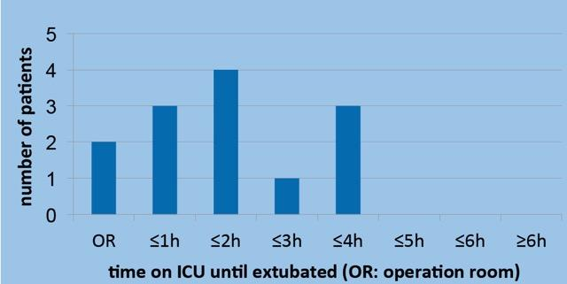

Optimizing VAD performance

**002**

**USABILITY OF A PATIENT-CENTERED CLOUD-BASED INFORMATION-SHARING SYSTEM FOR HOME MANAGEMENT OF PATIENTS WITH LVAD**

Shinichi NOMOTO, Momoe UTSUMI, Kenji MINAKATA, Satoshi SASAYAMA

Kyoto University Graduate School of Medicine, KYOTO, Japan

**Aim：**Advance detection of life-threatening complications is important in the home management of patients with LVAD. However, patients are often only observed on regular out-patient visits. Therefore, we developed a patient-centered medical information-sharing system for LVAD home management with using the iPad (LVAD@home). Herein, we report a case of successful application of the system.

**Methods：**The following data were sent by LVAD@home: the status of drive line (DL) exit site, infection signs, device operating status, and physical condition. The patient was a 60-year-old man implanted with Heartmate II. The primary caregivers were his wife and daughter, who performed the iPad input. Home health status information from the families were shared everyday with physicians using LVAD@home.

**Results：**Input records from March 31 to September 25, 2014, were analyzed. During the 178-day home treatment period, 306 items were input. 82% of the data were input by the families, whereas 17% of them were input by a physician. As for the input contents by the families, 35% accounted for physical condition; 25%, pump parameters (PP); 21%, comments; 18%, images of DL exit site. The comments from the families (201items) included 1) report or questions about PP (81%), 2) concerns about DL such as bleeding (11%) with images, and 3) questions about medication, physical condition (8%). The results of the interview of the families included “Questions to the physicians can be asked easily, which may be difficult over the phone,””I feel relieved when someone checks on my input,”and “Input is easy.”

**Conclusion：**LVAD@home, a patient-centered medical information-sharing system for home management of patients with LVAD, is useful for advance detection of infection sign at the DL exit site and provides a sense of security not only to patients but also to physicians.

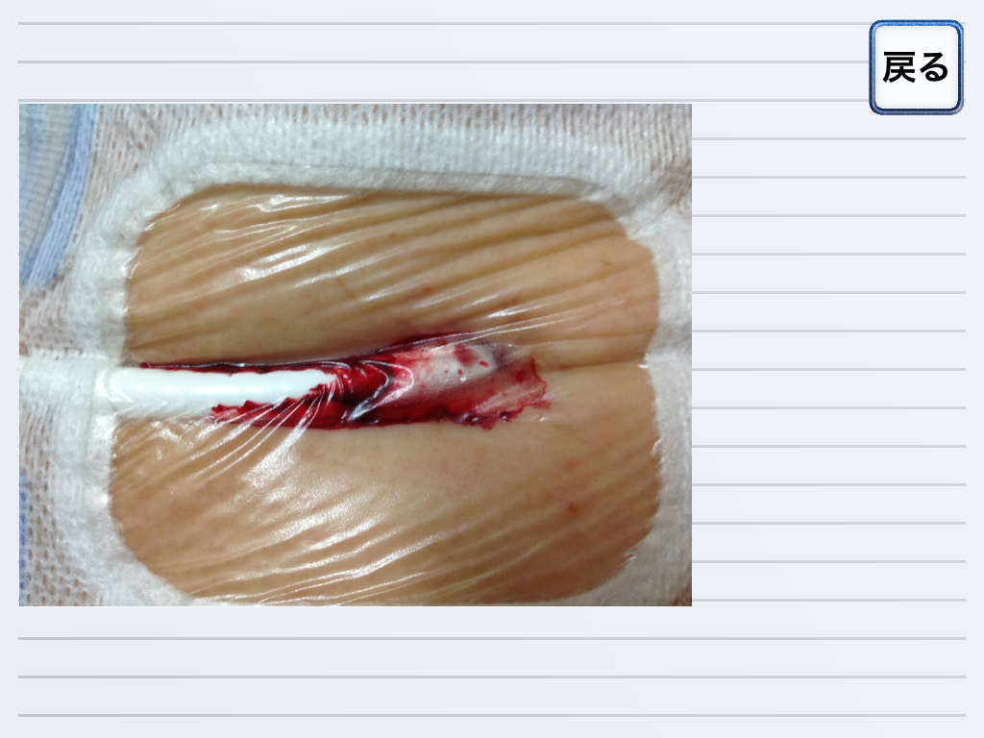  
Picture 1: Image of LVAD exit site sent by LVAD@hom Image of LVAD exit site sent by LVAD@home

Optimizing VAD performance

**003**

**ANTICOAGULATION FOR LVAD PATIENTS: CAN WE IMPLEMENT AN ALGORITHM FOR HOME MANAGEMENT SAFELY?**

Katrien Vandersmissen, Jean Driesen, Hilde Bollen, Klaartje Van den Bossche, Filip Rega, Walter Droogne, Bart Meyns

UZLeuven, LEUVEN, Belgium

**AIM:** To implement safely an algorithm to monitor INR ratio’s for LVAD patients at home. All patients are instrumented to work with a self-monitoring INR test. The algorithm is based on a week doses of warfarin adapting according INR results. It provides a suggestion for the dose of that day, an indication on when to have the next INR measurement and instructions on how to deal with extreme results.

**METHODS:** The algorithm was applied in a cohort of 10 LVAD patients over a total period of 5.4 patient years. We analyzed time within therapeutic INR range (TTR), defined as an INR of 2.0 to 2.5. Secondary end-points included time in sub/supratherapeutic ranges and median weekly warfarin doses. We calculated the same end-points for a control cohort of 10 LVAD patients (10 patient years) measuring home INR daily and adjusting coumadin dose daily on medical prescription.

**RESULTS:** Average TTR of patients who followed the algorithm was 49% (range 35% - 65%). Average times below and above the therapeutic range were 29% (range 17% - 45%) and 21% (range 10% - 36%), respectively. The median weekly warfarin dose was 41 mg (range 16% - 70%). These results are similar to the 53% (range 36% - 67%) average TTR of patients who measured INR daily at home (p=0.359). In this control group, average times in sub/supratherapeutic ranges were 12% (range 1% - 27%) and 39% (range 19% - 62%), respectively.

**CONCLUSION:** Anticoagulation home management based on an automatic algorithm is as safe as daily INR monitoring. The algorithm turns out to be more efficient as it reduces the need for finger pricks and the associated testing cost. We currently implement the algorithm in an on-line and mobile application. This will be more user-friendly and allows the hospital to collect automatically the INR data.

Optimizing VAD performance

**004**

**INFLUENCE OF INTERMITTENT SPEED CHANGES OF LEFT VENTRICULAR ASSIST DEVICES ON INTRAVENTRICULAR FLOW STAGNATION**

Philipp Aigner, Francesco Moscato, Heinrich Schima

Medical University of Vienna, VIENNA, Austria

**Aim**

Left Ventricular Assist Devices (LVADs) alter blood flow patterns in the ventricle as they change the natural flow pathway. When the aortic valve remains closed during the whole cardiac cycle (full support) the altered flow patterns may introduce potential areas of stagnation and thrombosis. Aim of this work was to investigate the influence of periodical intermittent pump speed changes (washout cycle) on intraventricular flow patterns.

**Methods**

A transparent model of an LVAD assisted heart was developed and bioprosthetic heart valves used to maintain the physiologic flow. Three different cardiac contractility states were created (low, medium, high) and three pump speeds were tested combined with/without a washout cycle (2sec: -200rpms, 1sec: +200rpms, 60sec baseline speed) mimicking a broad range of clinical situations. The ventricular simulator allowed visualization of intraventricular flow and the calculation of a stagnation index (SI).

**Results**

Supported hemodynamics similar to clinically observed ones were measured when setting stroke volumes (SV) and pump speeds (ω) at a constant cardiac output of 5 l/min at a mean arterial pressure of 80 mmHg. Increasing LVAD support resulted in higher SI starting from 1.18 s in the partial support situation (SV 27ml, ω 2500rpm), to 1.38 s in the partial support situation (SV 39ml, ω 2700rpm) and finally 1.53 s in the full support situation (SV 50ml, ω 2900rpm). With the washout cycle the SI was hardly influenced and did not show any positive or negative effect, whereas the mean flow remained unchanged.

**Conclusion**

Intra-ventricular flow patterns are strongly influenced by LVADs as the natural pathways are altered completely. The washout cycle as a method to improve washout of the left ventricle showed some slight alterations but an overall positive or negative performance on the washout of the heart could not be proven in the stagnation index.

Optimizing VAD performance

**005**

**MONITORING DURING EXERCISE OF THE ASSISTED CARDIAC HEMODYNAMICS BASED ON PUMP SIGNALS**

Christoph Gross1, Francesco Moscato1, Christiane Marko2, Michael Haller1, Kamen Dimitrov1, Georg Necid1, Thomas Schlöglhofer1, Daniel Zimpfer1, Heinrich Schima1

1Medical University Vienna, VIENNA, Austria

2Pensionsversicherungsanstalt, Zentrum für Ambulante Reha, VIENNA, Austria

Due to the lack of hemodynamic sensors, monitoring based on available pump data offers the only way for investigating the cardiac assisted hemodynamics. Here we report results of an ongoing clinical study about pump derived diagnostics in RBP patients with the focus on exercising and physical capacity testing.

To obtain pump data in patients a previously developed recorder device was used to store the data stream of the HVAD (Heartware, Miami Lakes, FL) at a rate of 50Hz. Algorithms to estimate pump flow with increased frequency content, heart rate, aortic valve opening and suction were applied to the data. From the 12 patients recruited to the study pump data was recorded in 5 patients during cardiac rehabilitation . A total of 24 bicycle ergometry, 19 walking, 11 strength and 17 gymnastic training sessions were analyzed. Intensity for the well documented training was controlled by the subjectively perceived exertion. Furthermore physical capacity testing with ergospirometry (n=2) and stress-echocardiography (n=3) was investigated.

Interval bicycle training triggered the highest response of pump derived parameters representing the cardiac function. During bicycle training an increase in heart rate (5±1 bpm), mean pump flow (0.45±0.2 L/min) and pulsatility (0.5±0.2 L/min), contractility and relaxation indices with respect to baseline were observed (p<0.0004 in all cases). During ergospirometry and stress-echocardiography maximum increase in heartrate (17±12 bpm), pump flow (1.5±0.9 L/min) and pulsatility (1±1.5 L/min) could be observed. Accept dissimilarities in contractility and relaxation indices developed during ergospirometry in one patient no adverse events could be evaluated.

This ongoing study demonstrates that continuous monitoring during exercise provides information that can be used for optimized pump speed adjustments according to the patients demand.

Optimizing VAD performance

**006**

**EXERCISE CAPACITY IN VENTRICULAR ASSIST DEVICE PATIENTS: CONSTANT VERSUS INCREASING PUMP SPEED**

Libera Fresiello1, Roselien Buys1, Katrien Vandersmissen2, Philippe Timmermans2, Jean Driesen2, Walter Droogne2, Eddy Vandezande2, Klaartje Van Den Bossche2, Gianfranco Ferrari3, Bart Meyns1

1KU Leuven, LEUVEN, Belgium

2University Hospital Leuven, LEUVEN, Belgium

3Institute of Clinical Physiology - CNR, ROME, Italy

**AIM**: Exercise capacity in ventricular assist device (VAD) patients is about half of what is expected in normal conditions and the reasons of this are still unclear. In this work we investigated if VAD speed might play a role in improving patient’s exercise performance.

**METHODS**: Six male Heartmate II patients (age 57±14 years, BMI 28±4 kg/m2) underwent two maximal cardiopulmonary exercise tests. Both tests were performed on the same day, with an hour of rest in between. Tests were executed on an upright cycle ergometer with a stepwise load increase of 10W each minute. During one test the VAD speed was kept constant (COST) while during the other test VAD speed was increased by 200 rpm for each 10W added to the ergometer (INCR). The order of the COST or INCR tests was randomly determined. Heart rate (HR), oxygen uptake, carbon dioxide production were measured continuously during the tests. Peak oxygen uptake (VO2p) was defined as the average VO2 of 30 sec at the highest achieved workload. The ventilatory efficiency slope (VE/VCO2-slope) was calculated. Differences between COST and INCR tests were calculated by paired t-tests and Wilkoxon signed-rank test.

**RESULTS**: HR at rest was 84±13 bpm (83±14 bpm) for COST (INCR) tests. During the COST (INCR) tests patients cycled for 527±154 (511±151) seconds. Maximum HR was 134±29 bpm (129±30 bpm) for COST (INCR) tests. VO2p was 13.2±4.6 (13.1±3.8) ml/kg/min for COST (INCR) tests. VE/VCO2-slope was 48.0±13.3 (46.7±10.0) for COST (INCR) tests. No significant differences were found between the COST and INCR tests.

**CONCLUSIONS**: Data collected so far show that patients’ exercise performance with and without increment of VAD speed is comparable. Further investigations should be conducted to assess other possible factors limiting VAD patients’ performance.

This work was supported by Marie Curie Scholarship (PIEF-GA-2013-624296) and by Research Foundation Flanders (FWO).

Apheresis

**007**

**ADVERSE EVENTS IN APHERESIS IN RELATION TO COLLOID REPLACEMENT FLUIDS. DATA FROM THE WAA APHERESIS REGISTRY.**

Bernd Stegmayr1,

1Umea University,, UMEA, Sweden

Co-Authors: for Australia:Newman E (New South Wales); Austria: Witt V(St Anne, Vienna),Derfler K(AKH, Vienna), Leitner G(AKH,Vienna); Belgium: Eloot S,Dhohnt A(Gent),Deeren D(Roeselare); Czech Rep.: Ptak J(Frydek-Mistek),Blaha M, Lanska M(Hradec Kralove),Gasova Z(Prague),Hrdlickova R(Ostrava) ; Germany: Ramlow W,Prophet H(Rostock) ; Italy: Liumbruno G(Livorno) ; Lithuania: Griskevicius A,Audzijoniene J(Vilnius) ; The Netherlands: Vrielink H(Amsterdam),Reuser Kaasenbrood E(Maastricht) ; Norway: Astrid Aandahl(Oslo) ; Macedonia Rep: Sikole A(Skopje) ; Portugal: Tomaz J(Coimbra) ; Croatian Republ.: Lalic K(Zagreb),Mazic S(Zagreb) ; Sweden: Strineholm V(Orebro),Efvergren M(Huddinge),Berlin G(Lonköping),Landerstam I(Lund),Toss F,Axelsson CG(BC,Umea),Mörtzell Henriksson M,Stegmayr B(Nephrol UMEA),Nilsson T(Nephrol,Uppsala),Knutson F(BC,Uppsala),Ramsauer B(Nephrol.,Skövde),Wahlström A(Nephrol,Karlstad)

**The aim** of the study was to clarify what type of colloid replacement fluids were used during the various procedures and to clarify of adverse events can be expected differently in different procedures in relation to the replacement fluid.

**Material and methods:** Data that is entered into the WAA apheresis registry were analysed for colloid replacement fluid and adverse events in relation to the various procedures. A total of 58345 treatments had been registered and were included in the analyses. Data of substitution fluid was missing in 5.9%. Side effects were graded as none, mild, moderate (needing medication), severe (interrupted treatment due to AE, death due to treatment.

**Results:** One patient who suffered from severe epilepsia had a seizure during the plasma exchange and died later. The relation to the procedure could not be clarified. No other patient died related to apheresis. The number of procedures that used colloid replacement fluid with plasma were 8867, albumin 15164 and Hydroxyethyl starch (HES) 478. Most of these fluids were given to patients who performed plasma exchange. Thus of all procedures then plasma were used this was for plasma exchange with centrifugation technique (n=8080) or filtration technique (n=719). The AE graded mild/moderate/severe were for plasma 1.7/5.8/0.8%, albumin 1.5/2.9/0.6% and HES 2.4/2.9/0.3%.

Substitution was by fresh frozen plasma (FFP:71%), Liquid stored plasma (LSP:21%), Octoplasm® (O:5%), cryoprecipitate poor plasma (CPP:3%).

The relation of replacement used and severe AE was for FFP 0.7%, LSP 1.3%, CPP 0.7%, Octoplas® 1.1% (n=375), albumin 0.6% and HES 0.3%.

Significant differences were found between extent of AE and replacement fluid used.

**Conclusion:** The replacement fluid used varies between centres. There are differences in extent of side effects.

Apheresis

**008**

**MARS AS LIVER SUPPORT THERAPY IN ACUTE-ON-CHRONIC LIVER FAILURE (ACLF): FROM THE LITERATURE TO THE CLINICAL PRACTICE**

Roberto Marangoni, Giorgio Bellati, Alberto Colombo

S. Anna Hospital, COMO, Italy

OBJECTIVES To establish guide-lines for the use of MARS (Molecular Adsorbent Recirculating System) in the treatment of ACLF, on the basis of both the available literature and our clinical experience.PATIENTS AND METHODS 115 patients affected by ACLF have been treated with MARS. Grade 1 encephalopathy was present in 12 and grade 2 in 6. Usual parameters pertinent the liver failure have been assessed before, during and after MARS cycle. 40 patients lamented severe pruritus and showed scratching skin lesions. Treatment modalities: 2-7 daily sessions according to patient’s need; session time 5 hours; blood flow 220+-20 ml/min, albumin flow 150 ml/min; dialysate flow (in the albumin dialyzer) 500 ml/min; MARS monitor connected with GAMBRO ULTRA machine arranged in hemodialysis mode.RESULTS After MARS cycle clinical conditions and liver function improved in 90 patients (group A) and remained unchanged in 25 (group B). The two groups differed at the beginning of MARS treatments only as concerns coagulant activity: INR < 3 in group A and INR > 3 in group B. The improvement ratio (patients vs primary liver disease) was: chronic hepatitis C 34/41, chronic hepatitis B 9/12, alcoholic liver disease 28/29, primary biliary cirrhosis 6/9, hepatorenal syndrome 7/13, severe cholestasis after graft 2/3, recurrent hepatitis C after graft 1/2, autoimmune cholangitis 2/3, chronic hepatitis B+D 1/3. Coma regressed only in group A; pruritus disappeared in all patients after 3 treatments.CONCLUSIONS Our data, in accordance with those described in the literature, confirm that, among the clinical pictures of ACLF, that secondary to alcoholic liver disease gains more benefits by MARS. All patients affected by ACLF take advantage by a liver support (MARS), except those with high deterioration of coagulation factors (end-stage liver failure, INR>3).

Apheresis

**009**

**A NANOSTRUCTURED MONOLITH ADSORBENT DEVICE TO AUGMENT HAEMODIALYSIS**

Susan Sandeman1, Yishan Zheng1, Ganesh Ingavle1, Carol Howell1, Sergey Mikhalovsky1, Steve Tennison2, Andrew Davenport3, Owen Boyd4, Kolitha Basnayake4

1University of Brighton, BRIGHTON, United Kingdom

2Mast Carbon International, BASINGSTOKE, United Kingdom

3Royal Free Hospital, LONDON, United Kingdom

4Brighton and Sussex University Hospitals NHS Trust, BRIGHTON, United Kingdom

**Aim:** A suitable method to address the life-reducing complications associated with poor removal of protein bound and high molecular weight uraemic toxins during haemodialysis has yet to be found. The introduction of adsorbent therapeutics into haemodialysis circuitry is one method by which this may be addressed. It has previously been shown that marker uraemic toxins and inflammatory cytokines which remain in haemodialysed blood samples may be removed by adsorption using phenolic resin derived monoliths with a unique trimodal nanoporous structure. The aim of the following study was to characterise the haemocompatibility of the small prototype adsorbent monolith, scale up the device to a clinically relevant size and assess maintenence of porous profile and efficacy for adsorption of marker toxins.

**Methods:** 7 mm and 30 mm diameter monoliths were characterised by porosimetry and SEM. Small prototype haemocompatibility was assessed by flow cytometry and ELISA, measuring complement, platelet, granulocyte and t-cell activation following perfusion of healthy donor blood samples through the devices over time. Adsorption of biotoxin markers p-CS, IS, IL-6 and TNF was measured in a spiked healthy donor blood perfusion study using clinically scaled 30 mm diameter prototype monoliths and a flow rate of 300 ml/min.

**Results:** Small prototype monoliths did not stimulate blood activation markers and produced no significant adverse effects on blood biochemistry when compared to tubing only controls. The large monoliths removed protein bound uraemic toxins IS and p-CS to negligible levels and reducing cytokine production by 50% after 90 minutes circulation. Pressure drop across the monoliths was negligible.

**Conclusions:** A phenolic resin derived nanoporous monolith has been scaled up and tested at haemodialyzer perfusion rates. The device was haemocompatible and maintained efficacy for marker biotoxins which are poorly removed by current haemodialysis therapy.

Apheresis

**010**

**EVALUATION OF NANOPOROUS CARBON MATERIALS FOR UREMIC TOXIN REMOVAL**

Denys Pavlenko1, Esmee Van Geffen1, Karin Gerritsen2, Dimitra Giasafaki3, Georgia Charalambopoulou3, Theodore Steriotis3, Dimitrios Stamatialis1

1UTwente, ENSCHEDE, Nederland

2University Medical Center Utrecht, UTRECHT, Netherlands

3National Center for Scientific Research „Demokritos„, ATHENS, Greece

**Aim:** Patients with kidney malfunction suffer from accumulation of uremic toxins in their blood. One promising concept of blood purification is the use of so-called mixed matrix membranes, which combine filtration and adsorption in one step. An important point there is the selection of the proper adsorptive particles, which can influence the performance of the whole process. In this study, we compared the performance of various nanoporous carbon materials, including home-made mesoporous carbons and commercial Norit A Supra activated carbon, with respect to the removal of the key uremic toxins and cytokines from human plasma.

**Methods:** Structural and porous properties of the nanoporous carbons were characterized by scanning electron microscopy (SEM) and nitrogen adsorption-desorption isotherms at 77 K. The adsorption capacity of all carbons was evaluated for a range of uremic toxins, middle molecules and cytokines. Concentrations of these compounds were analysed by means of UV-vis, HPLC and ELISA.

**Results:** Activated carbon particles with small diameter and pore size around 2 nm show high adsorption capacity of small water-soluble molecules such as creatinine, and protein-bound toxins, for instance indoxyl sulfate. Additionally, mesoporous particles (pore size > 2 nm) can adsorb better middle molecules and cytokines. The home-made mesoporous carbons remove 85% of indoxyl sulfate, 94% of hippuric acid and 55% of p-cresyl sulfate from uremic human plasma with 1:160 carbon to plasma ratio.

**Conclusions:** The new home-made mesoporous carbon seems to be suitable material for removing a broad range of uremic toxins and cytokines from human plasma and would be used for fabrication of new mixed matrix membranes.

**Acknowledgement:** This work is financially supported by the EU Marie Curie ITN - BIOART Project.

Apheresis

**011**

**DEVELOPMENT OF BIOACTIVE MEMBRANES FOR BIOARTIFICIAL KIDNEY**

Natalia Chevtchik1, Wim Tamboer2, Michele Fedecostante2, Milos Mihajlovic2, Jitske Jansen2, Martijn Wilmer2, Johan Van der Vlag2, Rosalinde Masereeuw2, Dimitrios Stamatialis1

1Twente University, ENSCHEDE, Netherlands

2Radboudumc, NIJMEGEN, Netherlands

**Aim**

The development of cell based Bioartificial Kidney device (BAK) could improve existing dialysis therapies. A key requirement for such device is the formation of a “living membrane”consisting of a tight kidney cell monolayer with preserved functional organic ion transporters, on suitable artificial membrane surfaces. Here, we investigate coating strategies to achieve a tight monolayer of conditionally immortalized human Renal Proximal Tubular Epithelial Cells (ciPTECs) on polymeric membranes.

**Methods**

We investigate the application of L-dopamine and Collagen IV (L-dopa/CIV) double coating (Schophuizen et al, Acta Biomat., 14 (2015), 22-32) and glycosaminoglycan (GAG) based coatings on polyethersulfone (PES) membranes which are suitable for blood/plasma filtration. Several ciPTECs seeding densities and culturing under static and dynamic conditions are studied. The properties of the new bioactive membranes are analyzed in detail, including transport of albumin and immunoglobulinG solutions. CiPTEC monolayer morphology is investigated via expression of tight junction protein Zonula Occludens-1 (ZO-1)). The organic cation transporter 2 (OCT2) is evaluated using a fluorescent substrate, 4-(4-(dimethylamino)styryl)-N-methylpyridinium iodide (ASP+).

**Results**

Both coatings, L-dopa/CIV and GAGs, improve ciPTEC adhesion on the PES membranes. After one week of culture, reproducible cell monolayers are formed, when using L-dopa/CIV, whereas the reproducibility of the cell monolayer seems to be dependent on the type of GAG coating. Preliminary results with L-dopa/CIV coated membranes indicate active ASP+ uptake, most likely, mediated by the OCT2.

**Conclusions - outlook**

The application of L-dopa/CIV and/or GAG coatings seems a promising approach to obtain bioactive membranes suitable for BAK device. Future work will include further characterization of ciPTECs function on the membranes and upscaling.

**Acknowledgement**

This work is funded by the EU Marie Curie ITN - BIOART Project.

Apheresis

**012**

**EVALUATION OF NEW LEUKOCYTE REMOVAL COLUMN USING A RAT CARDIOPULMONARY BYPASS MODEL**

Yutaka Fujii

National cerebral and cardiovascular Center Research Institute, SUITA, Japan

Aim: Extracorporeal life support devices, such as the cardiopulmonary bypass (CPB), preserve the patient's life by providing adequate oxygen supply and blood flow to vital organs. However, previous studies have suggested that the interaction of blood and large artificial surface induces inflammatory response during CPB. As a result of series of chain reactions, the numerous powerful inflammatory mediators, including hormones and autacoids, are formed and released. 　　　　　　Therefore, we developed the new leukocyte removal column (LRC) for attenuating the systemic inflammatory response during CPB.

Methods: Rats were divided into the CPB group and the CPB with LRC group. CPB pump flow was maintained at 70 ml/kg/min. Blood samples were collected before (baseline), and 30 min and 60 min after initiation of CPB. We measured the differential count of leukocytes, inflammatory markers (TNF-α, IL-6, IL-10) and biochemical markers (LDH, ALT, AST). Moreover, we also measured the wet-to-dry weight (W/D) ratio of the lung 60 min after the initiation of CPB.

Results: In the CPB group, the pro-inflammatory cytokines and increased significantly, reaching a maximum (TNF-α: 1347 ± 75 pg/ml, IL-6 : 1763 ± 112 pg/ml) at the end of experiment. In addition, the levels of biochemical markers significantly increased (LDH: 794±85 U/L, AST : 182±32 U/L, ALT : 81±11 U/L) 60 min after the CPB initiation. Moreover, the level of W/D ratio was lower in the CPB with LRC group than in the CPB group (CPB group: 6.02 ± 0.07, CPB with LRC group : 5.49 ±0.10)

Conclusion: The data suggest that the new leukocyte removal column is useful for reducing the inflammatory response and lung edema during CPB. Additionally, this rat model is useful for basic research of extracorporeal circulation device evaluation.

Tissue engineering of bone

**013**

**MULTILAYERS OF POLY-L-LYSINE AND HYALURONIC ACID COMBINED WITH ORDERED NANOSTRUCTURES AFFECT STEM CELL RESPONSE**

Marcus S. Niepel1, Fadi Almouhanna1, Bhavya K. Ekambaram1, Vladimir Prokopovic2, Dmitry Volodkin2, Thomas Groth1

1Martin Luther University Halle-Wittenberg, HALLE (SAALE), Germany

2Fraunhofer Institute for Cell Therapy and Immunology, POTSDAM-GOLM, Germany

**Aim**

Topographical and mechanical signals are important regulators of cell behavior in body tissues. This study aims to design a unique system with precise viscoelastic and geometric parameters using laser interference lithography (LIL) and layer-by-layer (LbL) technique to affect stem cell response by mechanical stimuli for potential applications in regenerative medicine.

**Methods**

Round, hexagonally arranged gold nanostructures of different size were obtained by LIL using various angles of incidence. Multilayers of poly-L-lysine (PLL) and hyaluronic acid (HA) were spray-coated on top of the nanostructures. Moreover, their viscoelasticity was tuned by cross-linking using 1-ethyl-3-(3-dimethylaminopropyl) carbodiimide (EDC) and N-hydroxysuccinimide (NHS). Pristine and modified nanostructured surfaces were characterized using atomic force (AFM) and scanning electron microscopy (SEM) as well as water contact angle (WCA) measurements. Adhesion, growth, and differentiation of human adipose-derived stem cells (hADSC) was studied to learn about the effect of nanostructures on cell fate.

**Results**

Initially hydrophobic nanostructured surfaces became hydrophilic after modification with PEM. AFM using colloidal probes revealed the lowest viscoelasticity in PEM cross-linked with the highest EDC concentration. Adhesion and proliferation of hADSC were clearly affected by size and distance of nanostructures and a period of 518 nm was favored. Further, the pitch of the structures had a clear effect on the orientation of cells with more elongated cells on the smallest features. Focal adhesion kinase (FAK) as indicator for mechanical tension on the cytoskeleton was found in the periphery of hADSC and primarily allocated to the nanostructures again with an optimal period of 518 nm. The small GTPase RhoA was evenly distributed within hADSC with no obvious dependence on the feature dimensions.

**Conclusion**

We present a novel technique for reproducible design of nanostructures in combination with viscoelastic surface coatings that can be used in future to control differentiation of mesenchymal and other stem cells.

Tissue engineering of bone

**014**

**BIOLOGICAL ACTIVITY OF NANOSTRUCTURED HYDROXYAPATITE PARTICLES**

Elena Krylova1, Sergey Krylov1, Igor Agapov2, Olga Agapova2

1Biomed, MOSCOW, Russian Federation

22Federal V.Shumakov Research Center of Transplantology and Artificial Organs,, MOSCOW, Russian Federation

**Objectives:** In this work we study structural properties and cytotoxic activity of Mg- substituted hydroxyapatite calcium (HA) prepared with Zn and Se ions. The effect of Zn and Se ions addition on Mg, Ca HA formation was investigated. Finally, the processing technique of uniform, spherical HA/Alginate (ALG) microgranules (MG) with encapsulated HA particles distributed throughout the matrix structure were considered.

**Methods:** The suspension of particles was produced from aqueous solutions by co-precipitation method. After separating and annealing at 150oC precipitated powders were investigated by XRD, FTIR, TEM and elemental analysis. HA/ALG MG with diameter ranged from 250 to

1000 μm were produced using Buchi encapsulator. Cytotoxic activity of particles was determined by MTT- test method in range of concentrations from 0.001 to 0.5wt.% using kidney cells human embryo НЕК-243 and cell lines human lung adenocarcinoma А549.

**Results:** The presence of Mg ions affects the crystallization yield of nanostructured amorphous HA. In general, all samples exhibited an amorphous phase (90-99 wt.%). Although for all samples we detect no significant structural difference, the results of MTT test illustrates the effect of Zn and Se addition. We observed, that Mg,Ca HA nanoparticles are non-toxic both for НЕК-243 as well as for А549 cells. For Zn-ions containing nanoparticles we have observed strong inhibition of growth of both А549 and НЕК-243 cells. Selective effect on cell growth was confirmed for Se-ions containing nanoparticles. The nanoparticles induce the concentration dependent inhibition of А549 cell growth, however they are non-toxic regarding to НЕК-243 cells line. At concentration of 0.5% a slightly toxic effect was observed. This tendency was also detected for HA/ALG MG.

**Conclusion:** Se, Mg,Ca HA nanoparticles proved to selectively effect on cell growth. The effect seems to be related to the presence of Se in HA structure.

TEM image of Se, Mg, Ca HA nanoparticles

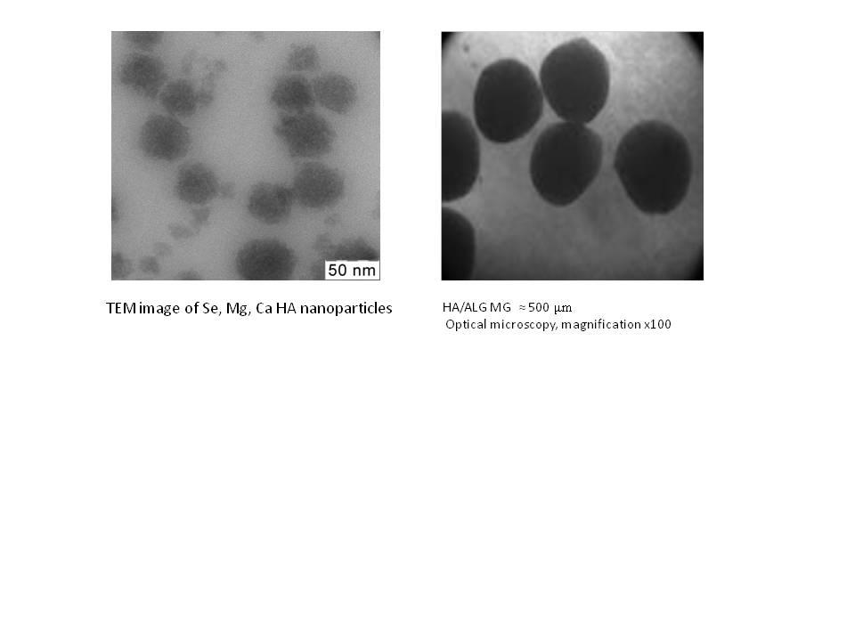

Tissue engineering of bone

**015**

**ELECTROSPINNING FOR BONE/TENDON TISSUE ENGINEERING, MECHANICAL STRESS INFLUENCE ON DIFFERENTIATION.**

Timothée Baudequin1, Ludovic Gaut2, Cécile Legallais1, Delphine Duprez2, Murielle Dufresne1, Fahmi Bedoui1

1University of Technology of Compiègne, COMPIÈGNE, France

2Sorbonne Universités, UPMC Univ Paris 06, IBPS-Developmental Biology Laboratory, PARIS, France

**Aim:** Electrospinning is a versatile method for polymer fibers production. We investigated here the relevance of several electrospun scaffolds varying by their compositions and structures to rebuilt tendon- and bone-like tissues. Such substitutes with a sheet-like shape could be « tailor made » *in situ*, with a manipulation by surgeons to adapt them to the injured areas constraints, particularly to the geometric complexity of the maxillofacial area. After dynamic cell culture on the fibers, we analyzed biological and mechanical properties of the hybrid tissue.

**Methods:** We studied the influence of various scaffold production parameters: polymer (Polyvinyl Alcohol, Polylactic acid, Polycaprolactone), additional factors (calcium nanoparticles) and fibers’ morphology (size, nanostructuration). Preosteoblasts (MC3T3) and mesenchymal stem cells (C3H10T1/2) lines were cultured on scaffolds for 5 days with or without mechanical loading (10 minutes of 1-Hz stretching every 6 hours, Bose Biodynamic) before analysis. We focused on cell differentiation (ALP staining), proliferation and spreading (SEM), cell morphology, viability (fluorescence microscopy) and gene expression (RTq-PCR).

**Results:** Polymer nature and structure were critical to allow cells to grow and spread. The effect of additional factors appeared to be different depending on the aimed differentiation state (e.g. calcium nanoparticles promoting osteoblast lineage), while some materials enhanced the development of both cell lines (e.g. Polycaprolactone alone, Fig. 1). Most scaffolds showed a dry Young Modulus within a range of 0,5-1 MPa, and the mechanical stretching improved the expression of the studied genes (e.g. scleraxis and tenomodulin for tendon, runx2 and osteocalcin for bone) compared to static culture.

**Conclusion:** It is essential to analyze all production parameters in order to define the optimal electrospun scaffold for a specific application. Studying two differentiation lineages was promising for the further development of multilayer substitutes promoting both bone formation and muscle adhesion on the rebuilt tissue.

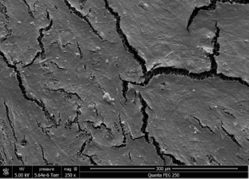  
Picture 1: Figure 1: SEM observation of MC3T3 cells on polycaprolactone electrospun scaffold after a 5-day stati Figure 1: SEM observation of MC3T3 cells on polycaprolactone electrospun scaffold after a 5-day static culture.

Tissue engineering of bone

**016**

**PHOTO-CROSSLINKABLE HYDROGEL PRECURSORS FOR TARGETED TISSUE ENGINEERING**

Ine Van Nieuwenhove1, Sandra Van Vlierberghe1, Achim Salamon2, Kirsten Peters2, Peter Dubruel1

1UGENT, GENT, Belgium

2University of Rostock, ROSTOCK, Germany

**AIM**

The acute lack of available organs for transplantation is a worldwide issue which is even expected to worsen as the world population ages1. Tissue engineering aims at bridging this gap by offering a regenerated approach2-6. The present work is situated in this field as it focuses on the development of biomaterials which can be applied as scaffolds to support the adhesion, proliferation and differentiation of adipose-tissue derived stem cells (adMSCs). In addition, bio-active coatings, including fibronectin, were applied in order to investigate their influence on stem cell differentiation.

**EXPERIMENTAL METHODS**

**Synthesis of photo-crosslinkable biopolymers**

Photo-crosslinkable gelatin- and starch-based hydrogel precursors and their corresponding networks were synthesized in combination. Subsequently, the materials developed were characterized in depth via HR-MAS 1H-NMR spectroscopy, IR mapping and rheology.

*In vitro* **biocompatibility assays**

adMSCs were derived from adipose tissue through liposuction followed by cell-seeding onto the scaffolds developed. In order to proof both the adipogenesis- as well as the osteogenesis-supporting potential of the materials, the hydrogel films developed were compared regarding material characteristics and behaviour of stem cells *in vitro*. Moreover, fibronectin- and aggrecan-coatings were also applied on the gelatin hydrogel films. The presence of an additional starch phase in the gelatin matrix resulted in a decrease of the cell adhesion, with locally even cell detachment 7.

**RESULTS AND DISCUSSION**

The mechanical strength and the cell-interactivity of the scaffolds were achieved by the self-structuring property of the biopolymer gelatin, while starch and the ECM polymers influenced the cell adhesion, proliferation. Moreover, the hydrogels developed allowed *in vitro* adipogenic and osteogenic differentiation of the adMSC.

**CONCLUSIONS**

The hydrogels developed were shown to be biocompatible and supported cell adhesion of adMSCs. In addition, by varying the mechanical properties of the gelatin hydrogels developed, both adipogenic as well as osteogenic differentiation could be upregulated.

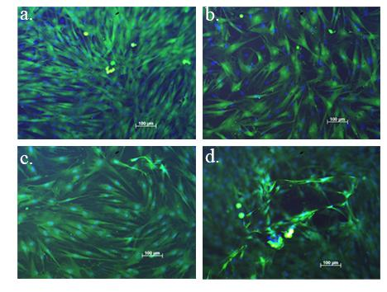Picture 1: Figure 1 Vita Figure 1 Vital cell staining on gelatin hydrogels revealing homogeneous cell coverage (A and B) and gelatin-starch hydrogels reavealing C) a high dens

Tissue engineering of bone

**017**

**BIOMIMETIC EVALUATION OF SCAFFOLD PERFORMANCE FOR BONE TISSUE ENGINEERING**

Giuseppe Falvo D’Urso Labate1, Francesco Baino2, Mara Terzini2, Chiara Vitale Brovarone2, Patrick Segers3, Alberto Audenino2, Rodolfo Quarto4, Gerardo Catapano1

1University of Calabria, RENDE (CS), Italy

2Politecnico di Torino, TORINO, Italy

3University of Ghent, GHENT, Belgium

4University of Genova, GENOVA, Italy

**Aim:** The capacity of porous scaffolds for bone tissue engineering (BTE) to promote osteointegration is generally characterized through their microstructural, mechanical and transport properties, and qualitatively compared to hypothetical ideal requirements. Such characteristics of natural bone tissue widely vary with species, anatomical site and age. This makes BTE scaffolds seldom resemble the bone they should replace. In this work, a biomimetic score was developed to quantitatively estimate to what extent a BTE scaffold mimics natural bone, to produce biological substitutes matching the performance of the missing bone tissue.

**Methods:** Samples of two commercial hydroxyapatite scaffolds with different morphometry were characterized and compared with trabecular equine bone tissue from two different anatomical sites. Large mammals are good preclinical models of human therapies and may benefit of BTE therapy. Images of samples were acquired by micro-computed tomography. Morphometric properties related to biological/transport (porosity, average pore size, pore size distribution, permeability) and structural performance (connectivity density, degree of anisotropy) were computationally evaluated. Mechanical properties (compressive Young’s modulus, ultimate compressive strength) were experimentally estimated. Biomimetic scores were defined as the weighted 1-p, Eulerian and ∞-p distance between the estimated performance properties of artificial scaffolds and natural tissues.

**Results and conclusions**: Properties of artificial scaffolds and natural tissues significantly differed from the common ideal requirements and from one another. The biomimetic score based on the weighted Eulerian performance distance was most effective in identifying scaffolds and tissues exhibiting similar performance. Score values evidenced that commercial artificial scaffolds are available that closely resemble a specific natural bone tissue and may be suitable candidates to replace it, at least in equines. The score may be modified to include biocompatibility parameters.

**Acknowledgments:** Study co-funded by the Italian Ministry of Instruction and University (MIUR) (Project PRIN 2010, MIND). One author (GFDL) was supported by a European ARUE scholarship.

Tissue engineering of bone

**018**

**DEVELOPMENT OF HYBRID BIO-ARTIFICIAL ANTERIOR CRUCIATE LIGAMENT**

Alastair Campbell Ritchie1, Neeraj Jambu2, Jennifer Paxton2, Anqi Wang2, Liam Grover1, Rachel Sammons2

1University of Nottingham, NOTTINGHAM, United Kingdom

2University of Birmingham, BIRMINGHAM, United Kingdom

Aim: To develop a bio-artificial ligament prosthesis as an alternative to current autograft based therapies.

Methods: Hybrid bio-artificial ligaments were fabricated using a combination of a titanium spring and a fibrin gel/fibroblast construct. The ends of the ligament prosthesis were incorporated into a brushite cement anchor to allow fusion with the host bone. The ligament constructs were mechanically conditioned in a mechatronic bioreactor using cyclic tensile strain at a magnitude of 2.5%. Cell attachment to the titanium spring was examined using scanning electron microscopy, while tendon development was examined histologically (Masson's Trichrome).

Results: Mechanically conditioned constructs were found to have a significantly higher tensile modulus and a significantly higher failure stress than unstimulated controls. Without reinforcement, constructs were observed to fail at the anchor-ligament junction, while the titanium spring reinforcement was seen to assist in even transmission of the load to the ligament, with no consistent trends in the position at which failure occurred. Cells were seen to be attached to the titanium spring, and fibroblasts on the fibrin gel construct were mostly found on the surface of the contracted gel, without penetrating deeply into the matrix.

Conclusion: Unreinforced constructs displayed considerably improved strength as a result of mechanical conditioning compared to static controls, but incorporation of a biocompatible reinforcement gave improved load distribution throughout the ligament construct, and significantly increased strength. The results suggest that the hybrid approach used here shows promise in developing improved therapies for connective tissue injuries.

Development in mechanical support I

**019**

**PRELIMINARY DEVELOPMENT OF CONTROL SYSTEM OF A MINIATURIZED MAGLEV BLOOD PUMP**

Yin Chengke1, Chen Chen1, Hsu Po-Lin1, ma Yunshan2, Tan Xuedan2, Ma Xiao2

1Soochow University, SUZHOU, China

2CH Biomedical Inc., SUZHOU, China

**Aim**

We are developing a miniaturized magnetically levitated (maglev) rotary blood pump. The Maglev pump enhances the blood compatibility compared to the pumps with contact bearings and its compact system allows less invasive implantation. However, magnetic interferences generated by the actuator coils on the nearby eddy current position sensor coils usually harms the stability of the maglev control system. This work presents development of a control system with anti-interference methods for the miniaturized maglev pump.

**Method**

A maglev control system was initially built with commercially available self-exciting eddy current position sensors. Transfer function from actuator to sensor coils was measured and analyzed to identify unwanted parasitic magnetic interferences. Several special anti-interference technique were adopted. 1) A new type eddy current signal conditioning circuit with modulation and demodulation method was developed with implemented anti-aliasing filters to remove actuator’s harmonics. 2) High power filters in actuator’s switch amplifier were designed to suppress harmonics. 3) All clocks, especially actuator’s switch clock and eddy current sensor’s clock, were synthesized from a single oscillation source and were phase locked with each other. 4) The frequencies of actuator’s switch clock and eddy current sensor’s clock were chosen to demodulate the actuator’s harmonics by eddy current conditioning circuit to zero or far above circuit’s bandwidth.

**Result**

The total power loss in maglev coils was less than 400 mW and the sensitivity of the proposed anti-interference control system was lower than 8 dB which satisfied ISO 14839, demonstrating the stability and freedom from interference.

**Conclusion**

Magnetic interferences in miniaturized blood pumps are so significant that common eddy current conditioning methods would fail. This work has demonstrated the employment of special techniques can successfully remove the interference to guarantee a smooth operation of the maglev pump.

Development in mechanical support I

**020**

**EVALUATION OF THE DOPPLER FLOW CURVE ON CONTINUOUS LVADS IMPLANTED ON NORMAL HEARTS. AN ANIMAL STUDY.**

Carlos Amoros1, Alvaro Pedraz1, Angela Irabien1, Begoña Quintana1, Monica Barranco1, Manuel Ruiz1, Juan Francisco Cañizo2

1Hospital general universitario Gregorio Marañon, MADRID, Spain

2Laboratorio de circulacion artificial, MADRID, Spain

**AIM**

To observe the behavior of the continuous wave (CW) Doppler of the inflow cannula in normal pig hearts implanted with a continuous flow LVAD and study its relationships with myocardial contractility and other causes of elevated velocity.

**METHODS**

6 minipigs, mean weight of 43.83 +- 9,0 Kg were implanted with Biomedicus centrifugal pump. Cannulas were placed on the ascending aorta and the apex of the LV. Before the implantation LVEF was evaluated with epicardial echocardiography. After implantation the CW Doppler of the inflow cannula was observed on full and partial support. Position of the cannula was controlled by echocardiography. During the experience hemodynamic and analytical measurements were recorded to analyze what influences the behavior of the continuous wave Doppler of the inflow cannula.

**RESULTS**

None of the subjects presented important obstruction of the LV canula. 5 (83,3%) had a normal LVEF and 1 (17,7%) presented akinesia of the inferior wall of the LV and ST but the LVEF was normal. The mean Doppler velocity found was 3,05 +- 2,0 m/s, range 0,9 to 8 m/s. On partial support the mean velocity was 2,11 +- 0,93 m/s. On total support the mean was 3,98 +- 2,02 m/s. 91% of the Doppler measurements were above 2,0 m/s independent of type of support. The systolic pressure of the inflow cannula was in all cases positive (mean 71,25 +- 36,91 mmHg) while the mean of the diastolic pressure was -102,58 +- 111,44 mmHg.

**CONCLUSIONS**

CW doppler velocity of the inflow cannula of continuous flow LVADs tends to be higher than 2,0 m/s in normal hearts.

The positivization of the inflow cannula pressure during systole may support a contribution from contractility to the filling of the device.

More studies that compare CW velocity with different degrees of myocardial dysfunction are needed.

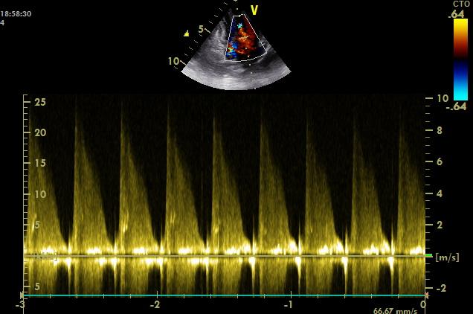Picture 1: CW doppler of LV cannula on total suppor CW doppler of LV cannula on total support

Development in mechanical support I

**021**

**IN VITRO SIMULATION OF ACUTE MYOCARDIAL INFARCTION UNDER MECHANICAL LVAD SUPPORT IN A HYBRID MOCK CIRCULATORY LOOP**

Sebastian Schwandtner1, Daniel Rüschen2, Christoph Nix3, Jef Geens4, Leonhardt Steffen2, Marian Walter2

1RWTH Aachen University, AACHEN, Germany

2Philips Chair for Medical Information Technology, RWTH Aachen University, 52074 AACHEN, Germany

3Abiomed Europe GmbH, 52074 AACHEN, Germany

4University Hospitals Leuven, Department of Cardiac Surgery, 3000 LEUVEN, Belgium

**Aim**

A novel Mock Circulatory Loop (MCL) that combines computer simulations with an electro-mechanically controlled circulation is presented. With the introduction of the Hardware-In-the-Loop (HIL) concept, the presented MCL allows the investigation of interactions between LVADs and the circulatory system under variable hemodynamic conditions.

**Methods**

Acute myocardial infarction was induced using a novel microsphere model in sheep. Prior inducing infarction all sheep were instrumented with ECG and invasive AoP, LVP, CVP and PAP pressure gauges to collect data in vivo pre and while LVAD support. Subsequently the LVAD was integrated into the novel MCL. The obtained pressure traces were applied with the MCL to the LVAD to verify MCL dynamic performance.

A lumped parameter cardiovascular computer simulation was implemented in Matlab/Simulink and extended by a myocardial infarction model. The obtained in vivo data were used to identify the infarction model. The computer model and the MCL were combined applying the HIL method whereat MCL internal pressures were measured back to complete HIL closed loop control. The LVAD was operated in the MCL while applying computer simulation data to assess the physiologic effects of LVAD support.

**Results**

The playback of the recorded animal data from myocardial infarction, fibrillation, defibrillation and manual cardiac massage demonstrated excellent MCL dynamic performance. The effect of Impella CP pumps was successfully studied with the HIL Mock Circulatory Loop under various physiologic and pathophysiologic hemodynamic conditions. In particular, the in vitro results matched exceptionally to obtained animal data.

**Conclusion**

The novel hybrid Mock Circulatory Loop provides a powerful tool that enables the in vitro assessment of mechanical heart support systems under variable hemodynamic conditions. Moreover, it satisfies the recent demand to study the hemodynamic effects of mechanical heart support in reproducible hemodynamic scenarios at the benefit of a significantly reduced in vivo study effort.

Development in mechanical support I

**022**

**IMPROVED PERFORMANCE OF NEWLY SHAPED INTRA-AORTIC BALLOONS AT THE SEMI-RECUMBENT POSITION, IN VIVO**

Christina Kolyva1, Konstantinos Malliaras2, John R Pepper3, Apostolos E Papalois4, John Nanas2, Ashraf W Khir1

1Brunel Institute for Bioengineering, UXBRIDGE, United Kingdom

23rd Department of Cardiology, University of Athens, ATHENS, Greece

3Royal Brompton Hospital, LONDON, United Kingdom

4Experimental Research Center, Elpen Pharmaceuticals, ATHENS, Greece

**Aim**: The major hemodynamic benefits of the intra-aortic balloon pump (IABP) are reduced when the IAB is operated at the semi-recumbent position. We previously tested in vitro several novel IAB shapes and showed that this deterioration can be moderated with IABs that deviate from the traditional cylindrical shape. The 2 novel IAB shapes (*Shape_1* and *Shape_2*) with the best in vitro hemodynamic performance were subsequently identified, and in this work we aim to compare their hemodynamic results to those of the traditional IAB in vivo.

**Methods**: Seven anaesthetised, open-chest Landrace pigs (weight 89 ± 4 kg) underwent coronary artery occlusion for 1 hour, followed by reperfusion. During reperfusion, each animal received, in sequence, IABP support with the cylindrical IAB and with either Shape_1 (Group 1, n = 3) or Shape_2 (Group 2, n = 4). All nominal IAB volumes were 35cc. Aortic root pressure (Pao) was recorded during IABP support with frequency 1:1 at 0o, 30 o and 45 o. Diastolic Pao augmentation (Paug) and end-diastolic Pao reduction with respect to baseline (edP) were calculated. Values are presented as mean ± standard deviation.

**Results**: The superiority of both Shape_1 and Shape_2 at the angled positions is demonstrated in the figure. At 45o there was 97% improvement in edP for Shape_1 and 27% improvement for Shape_2, all compared to the cylindrical IAB. A difference between the novel IAB shapes and the traditional balloon was not as noticeable in Paug, but upon increasing the operating angle, the performance of Shape_1 gradually exceeded that of the cylindrical IAB.

**Conclusion**: In an ischemia-reperfusion animal model, we showed that the hemodynamic performance of 2 novel IABs is superior to the traditional IAB at angled positions. These novel IABs could allow for better efficacy of IABP therapy when patients are nursed at the semi-recumbent position.

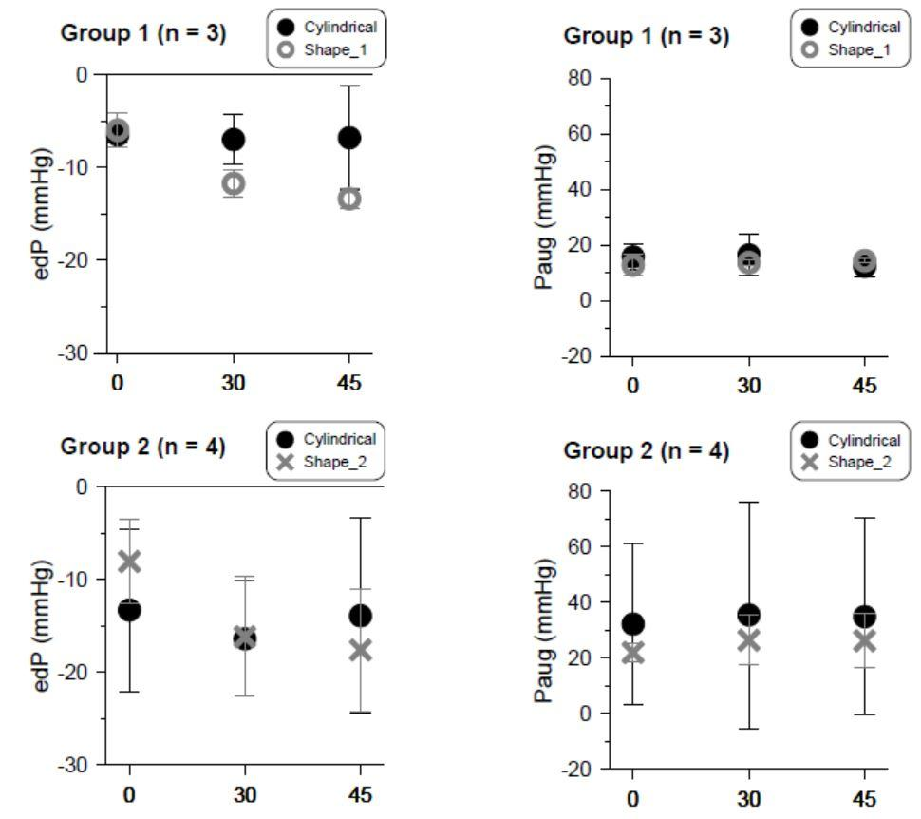Picture 1: Figure Figure 1

Development in mechanical support I

**023**

**IABP SUPPORT IN ISCHAEMIC AND NON-ISCHAEMIC EX-VIVO HEARTS**

Stephanie Schampaert1, Marcel Van 't Veer2, Marcel Rutten3, Lokien Van Nunen2, Sjoerd Van Tuijl4, Frans Van de Vosse3, Nico Pijls2

1Philips, BEST, Nederland

2Catharina Ziekenhuis, EINDHOVEN, Nederland

3TU Eindhoven, EINDHOVEN, Nederland

4LifeTec Group, EINDHOVEN, Nederland

**Aim:** The intra-aortic balloon pump (IABP) induces diastolic blood pressure augmentation and systolic afterload reduction. These blood pressure changes are expected to create clinical improvement in terms of coronary perfusion and myocardial oxygen consumption, but reportedly, the effects are inconsistent and ambiguous in human and experimental studies. The aim of this study was to investigate the influence of persisting ischaemia on IABP efficacy in healthy hearts, and in shock.

**Method:** Twelve slaughterhouse pig hearts were isolated, prepared, and connected to an external circulatory system. Through coronary reperfusion and controlled cardiac loading, physiologic cardiac performance was achieved. Deteriorating heart function, from normal contractile state to cardiogenic shock, was simulated in hearts 1-6, by step-wise administration of negative inotropic drugs, while adapting systemic vascular resistance. In hearts 7-12, a large myocardial infarction with different degrees of pump failure was mimicked by gradually creating severe global myocardial ischaemia superimposed on the decreased contractile state. IABP support was applied in all hearts under all conditions and evaluated by measuring coronary blood flow, cardiac output, and myocardial oxygen consumption.

**Results:** Without ischaemia, the IABP induced a significant increase in coronary blood flow and cardiac output. These effects were strongly augmented in the presence of persisting ischaemia, where coronary blood flow increased by 49±24% (p<0.01) and cardiac output by 17±6% (p<0.01) in case of ischaemia and severe pump failure. Myocardial oxygen consumption increased in case of ischaemia(21±17%; p<0.01), while it slightly decreased without ischaemia(-3±6%; p<0.01).

**Conclusion:** In case of progressive pump failure due to persistent myocardial ischaemia, the IABP increased hyperaemic coronary blood flow and cardiac output significantly, and reversed the hemodynamic deterioration instantly. This suggests that IABP therapy in acute myocardial infarction is most effective in patients with viable myocardium, suffering from persistent myocardial ischaemia after adequate epicardial reperfusion therapy.

Development in mechanical support I

**024**

**MINIATURE CARDIOPULMONARY BYPASS FOR RATS TO UNDERGO HYPOTHERMIC CIRCULATORY ARREST**

Akira Kawaguchi1, Gen Kawaguchi1, Tatsuaki Okubo1, Ryo Yokoi2, Koshiro Sato2

1Tokai University School of Medicine, ISEHARA, Japan

2Fuji Systems Corporation, YOKOHAMA, Japan

**Aim**

Although hypothermic circulatory arrest (HCA) has been used in pediatric heart and adult aortic surgery, optimal measures for neurological protection has not been fully assessed due mainly to limitation in experimental evaluation. We develop a miniature cardiopulmonary bypass (CPB) for rats to undergo HCA in order to evaluate neurological functions.

**Methods**

A CPB system consists of 1.02 mm (ID) tubing connecting venous and arterial online reservoirs and thermometer, 2.06 mm (ID) roller pump-head and a miniature silicone -membrane lung (80 cm2, Fuji Systems Corporation). Another membrane lung was connected in line as a heat exchanger and irrigated by a servo-controlled water cooling/heating (c/h) system (core c/h) parallel to a water pad under the animal (surface c/h). The CPB circuit (priming volume 2.0 ml) is connected to a venous catheter (ID1.25 mm with side holes, Hakko, Japan) in the right atrium advanced from the right jugular vein with the arterial return (ID0.41 mm) to the right carotid artery through a neck incision. Rats were orally intubated, ventilated, core- and surface-cooled down to 20�-�C (rectal), when HCA is started by induced ventricular fibrillation and cardioplegic arrest with the chest closed. At the end of HCA, rats are rewarmed by CPB until 28�-�C (rectal) when the circuit is emptied to terminate CPB.

**Results and Summary**

It takes about 15 min to cool and twice as much to rewarm, resulting in 45 min plus the duration of HCA. Infused volume consists of 2 ml for priming, 1-2 ml for cardioplegia and 0-4 ml from a reservoir, totaling 8 ml at most which is less than half of the circulating blood volume of rats weighing 200g. Using the CPB system, recovery from HCA is quick and survival is high to allow successive neurological testing.

Biomaterials & scaffold engineering

**025**

**ELECTROSPUN PIEZOELECTRIC PVDF SCAFFOLDS WITH DIFFERENT SOLUTION PARAMETERS FOR NERVE REGENERATION**

Fedaa AL Halabi1, Lena Freund3, Alexandros Repanas2, Peter Behrens2, Sara Knigge2, Kirsten Haastert-Talini3, Birgit Glasmacher2

1Leibniz University of Hannover/Institute for Multiphase Processes, HANNOVER, Germany

2Institute for Multiphase Processes, Leibniz University Hannover, Hannover, Germany

3Institute of Neuroanatomy, Hannover Medical School, Germany

Aim

Polyvinylidinefluoride (PVDF) is a promising biomaterial for nerve tissue engineering because of its proven biocompatibility and piezoelectric properties that can possibly stimulate Schwann cell ingrowth and axonal elongation. Here we report on changed mechanical and physical properties of PVDF-scaffolds using different solvents during their production by electrospinning.

Methods

Electrospun scaffolds (flow-rate: 2 ml/h, electrical-field: 1 kV/cm) were produced from PVDF-25% dissolved in DMF 4:1 Acetone (S1), DMSO 4:1 Acetone (S2) and DMAc 6:4 Acetone (S3), respectively. Analysis of scaffold morphology and mechanical properties was performed with SEM and a tensile testing instrument (Electroforce LM1, BOSE), respectively. The presence of the crystalline nonpolar alpha-phase and piezoelectric polar beta-phase was characterized using FTIR and DSC. Neonatal rat Schwann cell viability and growth behaviour on the scaffolds was evaluated *in vitro*.

Results

S1 and S2-scaffolds exhibited a more homogeneous morphology than S3-scaffolds. S2 showed the highest tensile strength (270 kPa) compared to S3 (176 kPa) and S1 (135 kPa). The highest elongation at break was recorded for S1 (186%) compared to S3 (80%) and S2 (33%). The scaffolds hydrophilic nature increased using DMSO:Acetone (110°) and DMF:Acetone (120°) as solvents. All PVDF-scaffolds exhibited a piezoelectric polar beta-phase formation. The beta-phase adsorption ratios were, however, different and most prominent in S1-scaffolds with 70% (at 841 cm-1) in the FTIR-spectrum. Cytotoxicity for Schwann cells could be excluded and the glial cells demonstrated their typical growth behaviour on all scaffolds evaluated.

Conclusion

Mechanical and physicochemical properties of electrospun PVDF-scaffolds can be manipulated and their piezoelectric properties can be demonstrated with FTIR and DSC. In vitro tests with peripheral glia cells, Schwann cells, reveal their potential as scaffolds for nerve tissue engineering. Future experiments have to evaluate this potential in more detail in organotypic cell culture models *in vitro* and rat sciatic nerve repair models *in vivo*.

Biomaterials & scaffold engineering

**026**

**DEVELOPMENT OF CHEMICALLY CROSS-LINKED BIOPOLYMER BASED BURN WOUND DRESSINGS WITH ANTIMICROBIAL PROPERTIES**

Birgit Stubbe1, Mohaddeseh Amiri Aref2, Henk Hoeksema3, Frank Vanhaecke1, Stan Monstrey3, Piet Van Espen2, Karolien Dewael2, Sandra Van Vlierberghe1, Peter Dubruel1

1Ghent University, GHENT, Belgium

2University of Antwerp, ANTWERP, Belgium

3Ghent University Hospital, GHENT, Belgium

**Aim**

Despite the development of novel diagnostic tools and treatments and the consequential increase in survival rates of burn wound victims, patients still suffer physically, psychologically and financially. Therefore, the aim of the present work is to develop novel, biopolymer based burn wound dressings with antimicrobial properties. For this purpose various UV cross-linking strategies were evaluated as well as different strategies to study the incorporation of the antimicrobial agent.

**Methods**

Gelatin and alginate were modified with cross-linkable moieties using methacrylic anhydride, N-acryloxysuccinimide and 4-pentenoic anhydride. Next, covalently cross-linked hydrogel films were prepared via film casting upon the addition of a photo-initiator and the application of UV-irradiation. Furthermore, thiol-ene cross-linking was tested using multifunctional thiols. The cross-linking kinetics and physico-chemical properties of the resulting films were characterized using rheology, texturometry and swelling experiments.

Interestingly, poly(vinylpyrrolidone)-iodine (PVP-I) was incorporated via incubation to introduce antimicrobial properties. The uptake and release of (PVP-)iodine is currently studied via XRF and electrochemistry. The results will be presented at the conference.

**Results**

Rheology during in situ UV curing and texturometry measurements demonstrated the low efficiency of the pentenoate-thiol cross-linking and the weaker mechanical properties. Acrylamide cross-linking proceeded the fastest, however the final mechanical properties were comparable to the gelatin-methacrylamide hydrogel films. Swelling experiments indicated high gel fractions were obtained for all derivatives.

At present a calibration method for the determination of the iodine content in hydrogel films via XRF has been developed and samples are currently being analyzed. In addition, the potential of applying electrochemistry to study the incorporation of (PVP-)iodine is being evaluated.

**Conclusion**

In the present work, biopolymer-based hydrogels have been synthesized and characterized. The effect of different UV-initiated cross-linking methods on the final hydrogel properties has been evaluated thoroughly. Additionally, the potential of XRF and electrochemistry to study the incorporation of PVP-I was evaluated.

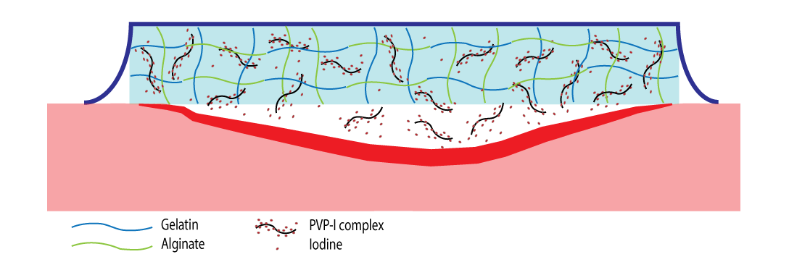  
Picture 1: Schematic representation of the aim of the present work: biopolymer based burn wound dressings wit Schematic representation of the aim of the present work: biopolymer based burn wound dressings with antimicrobial properties

Biomaterials & scaffold engineering

**027**

**POLYETHYLENE BARRIER LAYERS TO REDUCE WATER TRANSMISSION OF LOADED MEMBRANES IN A TOTAL ARTIFICIAL HEART**

Catharina Lierath1, Felix Gräf1, Daniel Schlemmer2, Thomas Finocchiaro1, Ulrich Steinseifer1

1Institute of Applied Medical Engineering, AACHEN, Germany

2Fraunhofer Institute of Process Engineering and Packaging IVV, FREISING, Germany

**Aim:** Water transmission through polymer membranes cause undesired effects in medical devices, especially when membranes separate blood and electrical components, like done in total artificial hearts (TAH). Applying common barrier coatings as silicon oxide or amorphous hydrocarbon to a TAH membrane is disadvantages, since it affects hemocompatibility and durability. Therefore, a sandwich construction was chosen as utilized in the food industry as fluid barriers. As barrier material different polyethylene layers (PE) were used in this study.

**Methods:** The original membrane of the ReinHeart TAH is made of three 0.2 mm polyurethane (PU) layers. The structure was replaced by a sandwich construction in which the intermediate layer was changed to PE layer. In this way hemocompatibility of the membrane could be preserved. PE layers of different thicknesses and different degrees of cross-linking density were used to compare the water barrier properties and the mechanical behavior under dynamic conditions. Furthermore the modified membranes have been tested in an accelerated dynamic durability tester. They have been loaded under physiological pressure conditions with a frequency of 8 Hz over 28 million pumping cycles. Water transmission has been determined by long term tests. The results were evaluated against the untreated membranes and those with barrier coatings.

**Results:** The water transmission was reduced by up to 75 % compared to original and by up to 35 % compared to coated membranes, respectively. Although the intermediate layer showed some cracks, the barrier properties remain unaltered. Thereby the damage of the PE foils was less compared to coated membranes after the same amount of pumping cycles.

**Conclusion:** Further the results suggest, that sandwich designed membranes are more robust with respect to the coated ones.

Biomaterials & scaffold engineering

**028**

**REPLICATION OF HUMAN LIVER DEVELOPMENT WITH HUMAN LIVER ORGANOIDS: A NOVEL MODEL FOR DRUG TERATOGENESIS IN VITRO?**

Pedro Baptista1, Dipen Vyas2, Anthony Atala2, Shay Soker2

1Instituto de Investigacion Sanitaria de Aragon (IIS Aragon), ZARAGOZA, Spain

2Wake Forest Institute for Regenerative Medicine, WINSTON-SALEM, United States of America

Bioengineering of hepatic tissues has been hindered with the absence of simultaneous development of hepatic and biliary tissue. This has produced hepatic organoids devoid of biliary ducts, compromising their representativeness of native liver tissue. Hence, the goal of this study was to develop a system that would efficiently recapitulate the liver embryonic development, using decellularized liver extracellular matrix (ECM) as scaffolds with primary human fetal liver progenitor cells (hFLCs).

hFLCs were seeded on decellularized liver ECM discs and were cultured for up to 3 weeks. Immunofluorescence microscopy was used to determine the extent of progenitor cell differentiation into hepatocytes and cholangiocytes. A γ-secretase inhibitor was added to the culture media and bile duct and hepatocyte development was monitored.

hFLCs seeded on acellular liver ECM discs differentiated into hepatocytes and ductal structures. The cells showed predominant albumin expression along with loss of α-fetoprotein expression at 3 weeks (Fig. 1D,E). Cells also expressed other mature hepatocyte markers (Fig. 1B-E) and perform drug metabolism. Cells in ductular structures expressed bile duct specific markers, demonstrating differentiation towards cholangiocyte lineage along with maintaining apico-basal polarity (Fig. 1B-E). Ductal structures were also found to precisely mimic the several stages of development of bile ducts of the human liver in the hepatic organoids. The addition of a γ-secretase inhibitor severely impacted the number of bile ducts formed and their maturation, mirroring a biliary atresia model.

Our results demonstrate the efficient generation of bioengineered human liver tissue with hFLC that recapitulates stepwise development of hepatocyte and bile duct formation (Fig. 1A). Altogether, this study demonstrates the potential of this technology to study and mimic human liver development. These models provide novel approaches for liver bioengineering, drug discovery and toxicology (including drug teratogenesis evaluation *in vitro*), and ultimately for the treatment of liver disease.

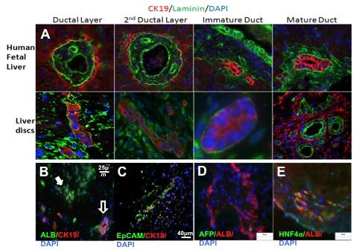Picture 1: Figure 1 Figure 1 - Hepatoblast differentiation in decellularized liver matrix mimics hepatic development.

Biomaterials & scaffold engineering

**029**

**PHOTO-CROSSLINKABLE POLYSACCHARIDES AS BUILDING BLOCKS FOR ARTIFICIAL EXTRACELLULAR MATRICES**

Matthias Schnabelrauch, Jana Becher, Torsten Walter, Juergen Weisser

INNOVENT e. V., JENA, Germany

**Aim**

The extracellular matrix (ECM) of mammalian cells is composed of polymeric networks providing mechanical support to the cells and regulating biological functions important for cell growth, wound healing, and fibrosis. It is hypothesized that water-soluble polysaccharides and glycosaminoglycans (GAGs) are potent materials to generate gel-like materials mimicking the native ECM. Photo-initiated network formation and structuring represent a promising approach to create artificial ECM usable in tissue reconstruction.

**Methods**

Photo-crosslinkable polysaccharide and GAG derivatives based on dextran, hyaluronan, and chondroitin sulfate were synthesized by acylation with reactive (meth)acrylate derivatives varying the reaction conditions in order to control the degree and pattern of photoactive substituents. In addition, synthetic routes to crosslinkable GAGs with multiple substitutents (e. g. both sulfate and (meth)acrylate groups) were elaborated. The synthesized macromers were characterized using conventional analytical techniques. Their crosslinking ability was tested employing different photoinitiators. The mechanical properties of the resulting hydrogels were studied and their cytocompatibility was evaluated using an established live/dead viability test and the WST-1 cytotoxicity assay.

**Results**

Methacrylate-containing macromers of the mentioned biopolymers with varying degree of substitution were obtained by conventional esterification of the biopolymers. A novel procedure was developed to synthesize photo-crosslinkable hyaluronan acrylates with controlled degree of substitution using phase-transfer catalysis. Hyaluronan derivatives containing both growth factor sequestering sulphate groups and cross-linkable acrylate functions were synthesized by sulfation of hyaluronan followed by introducing the acrylate groups. The macromers form stable and cytocompatible hydrogels. Using selected examples it will be illustrated that the prepared macromers can be successfully processed via additive manufacturing processes like soft lithography and 3D-printing to fabricate microstructured surfaces or 3D scaffolds soft tissue engineering scaffolds.

**Conclusion**

Photo-crosslinkable polysaccharide and GAG derivatives are promising candidates to fabricate 3D-structured hydrogels which are able to provide, similar to the native ECM, both support and biological activity to cells.

Biomaterials & scaffold engineering

**030**

**HETEROTOPIC TRANSPLANTATION OF DECELLULARIZED HEART IN LARGE ANIMAL MODEL**

Hiroto Kitahara, Hiroshi Yagi, Kazuki Tajima, Kenta Inomata, Kazuma Okamoto, Ryo Aeba, Mikihiko Kudo, Akihiro Yoshitake, Yuko Kitagawa, Hideyuki Shimizu

Keio University Hospital, TOKYO, Japan

Aim

At present, the only treatment for severe heart failure is heart transplantation. However, shortage of donor heart has raised a long waiting list and limited its benefit. As an alternative of heart transplantation, regeneration of heart with organ decellularization technique has been applied. Our ultimate goal is to create a whole beating heart fabricated based on an organ scaffold for human heart transplantation.

Methods

A porcine heart was harvested, following cardiac arrest induced by high-potassium solution, which was stored in freezer -80°C for 24 hours. After thawing in 37°C water bath, the porcine heart was completely decellularized with 1% SDS and 1% TX-100 under the control of perfusion pressure, maintaining temperature of 37°C. Decellularized whole heart scaffold was sterilized with gamma irradiation. Finally, the whole-heart scaffold was transplanted in a pig under systemic anti-coagulation treatment with heparin by surgical anastomosis using vessel grafts; an ascending aorta was anastomosed to an abdominal aorta of recipient porcine, and superior vena cava to inferior vena cava of recipient porcine (Fig 1). Angiography of the transplanted heart graft was performed on the operative day and the 3rd postoperative day, respectively.

Results

The scaffold was well perfused without bleeding. Angiography revealed patent right coronary artery and aortic valve regurgitation mildly on the operative day. Injected contrast was appeared 10 seconds later in the right atrium. The transplanted heart scaffold was harvested on day three after transplantation. Histological report showed that blood clot was accumulated in coronary artery. However, blood perfusion was maintained through left to right intra-cardiac shunt.

Conclusion

To the best of our knowledge, this is the first study of heterotopic transplantation of decellularized whole porcine heart. It is required to analyze histological features of transplanted decellularized scaffold and optimize the system with recellularization to apply this unique technology for clinical applications.

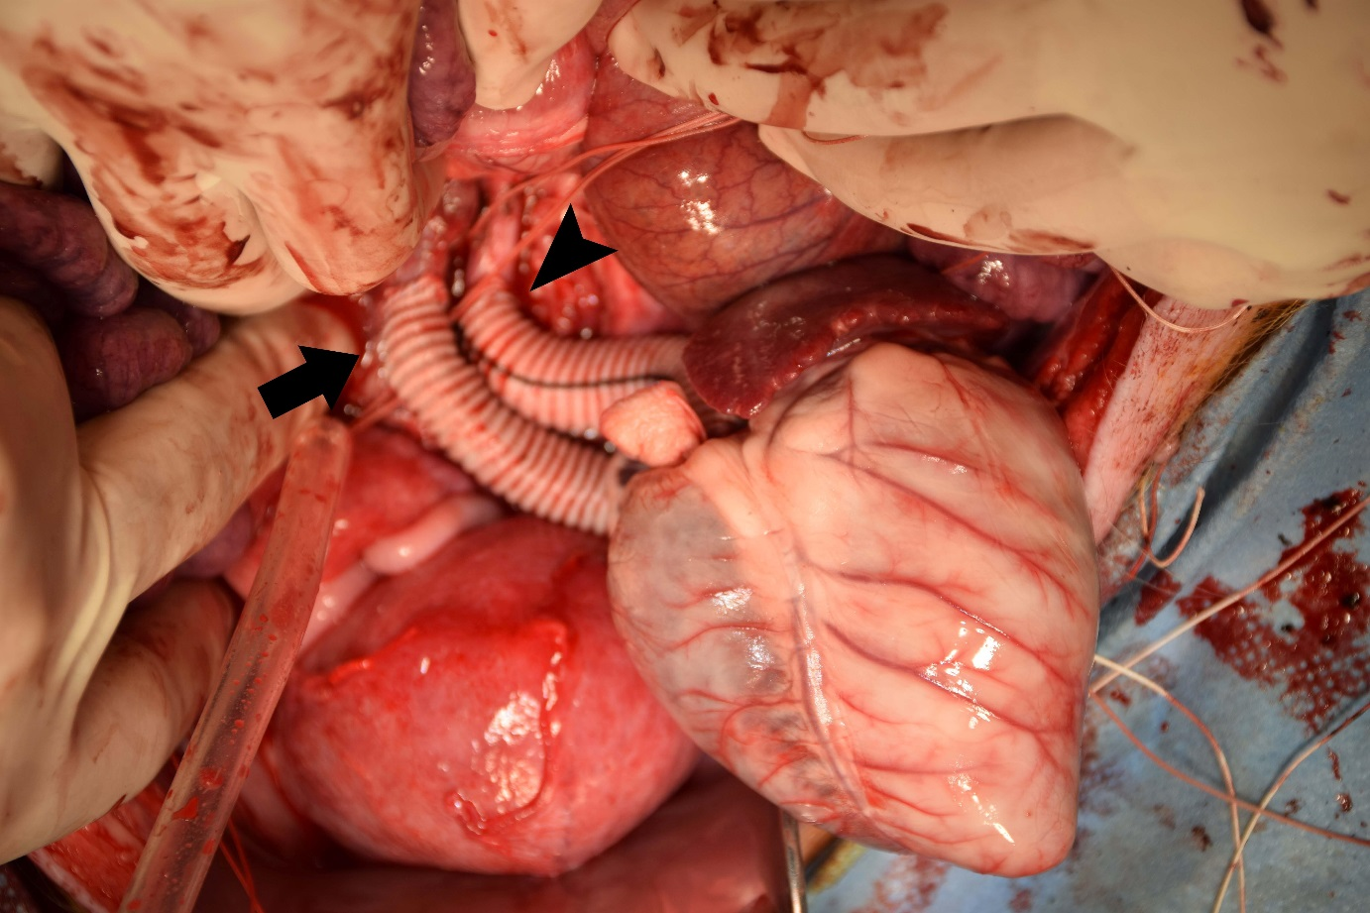Picture 1: Heterotopic transplantation. Anastomosises of abdominal aorta and graft, inferior vena cava and graft ar Heterotopic transplantation. Anastomosises of abdominal aorta and graft, inferior vena cava and graft are shown.

Vascular access for haemodialysis

**031**

**COMPUTATIONAL FLUID DYNAMIC STRATEGIES FOR THE STUDY OF BLOOD FLOW IN THE VASCULAR ACCESS FOR HEMODIALYSIS**

Andrea Remuzzi1, Michela Bozzetto2, Bogdan Ene-Iordache2

1University of Bergamo, DALMINE (BERGAMO), Italy

2Mario Negri Institute, BERGAMO, Italy

**AIM:** Creation of arteriovenous fistulae (AVF) for hemodialyis has high failure rates. Juxta-anastomotic vein (JAV) stenosis due to neointimal hyperplasia (NH) is the major cause of failure. Previous studies (Remuzzi, *CJASN*2013) have shown development of transitional flow with high-frequency oscillation of shear stress in the JAV. While simulating the transitional flow would be better using turbulence models or direct numerical simulation, recent studies show that “high-resolution”(HR) CFD may detect flow instabilities, not well resolved by “normal-resolution”(NR). Our study was aimed at finding an HR CFD strategy to characterize transitional flow in AVFs.

**METHODS:** We used the *OpenFOAM* CFD toolbox and a previously used patient-specific computational mesh of an end-to-end AVF. Blood flow was imposed at the inflow, stress-free at outflow and no-slip condition on the walls. NR simulations were run using *icoFoam* solver, setting timestep number per cardiac cycle between 2-6,000 and using the PISO algorithm. HR simulations were performed with the *pimpleFoam*solver and the PISO-SIMPLE algorithm, that automatically adjusted variable timesteps per cardic cycle (Courant number=1) between 10-30,000. Time discretization used in all cases was first order Euler implicit scheme. We characterized the flow phenotype by means of λ2 criterion, and disturbed flow patterns by hemodynamic wall metrics.

**RESULTS:** The NR ran with 6,000 fixed timesteps (Δt=0.15 ms) and CPU time of 6 hrs. The HR ran with a median timestep of 0.09 (range 0.05-0.12) ms and CPU time was 4.75 hrs. Higher resolution of flow phenotype patterns was obtained with HR than with NR CFD (Fig.1), as estimated by λ2 isosurface and shear stress oscillatory index maps (OSI).

**CONCLUSIONS:** HR simulation detected more specifically the physics of transitional flow as compared to NR, allowing correct characterization of disturbed flow. This technique may be useful for elucidating the role of hemodynamic forces in the initiation of NH.

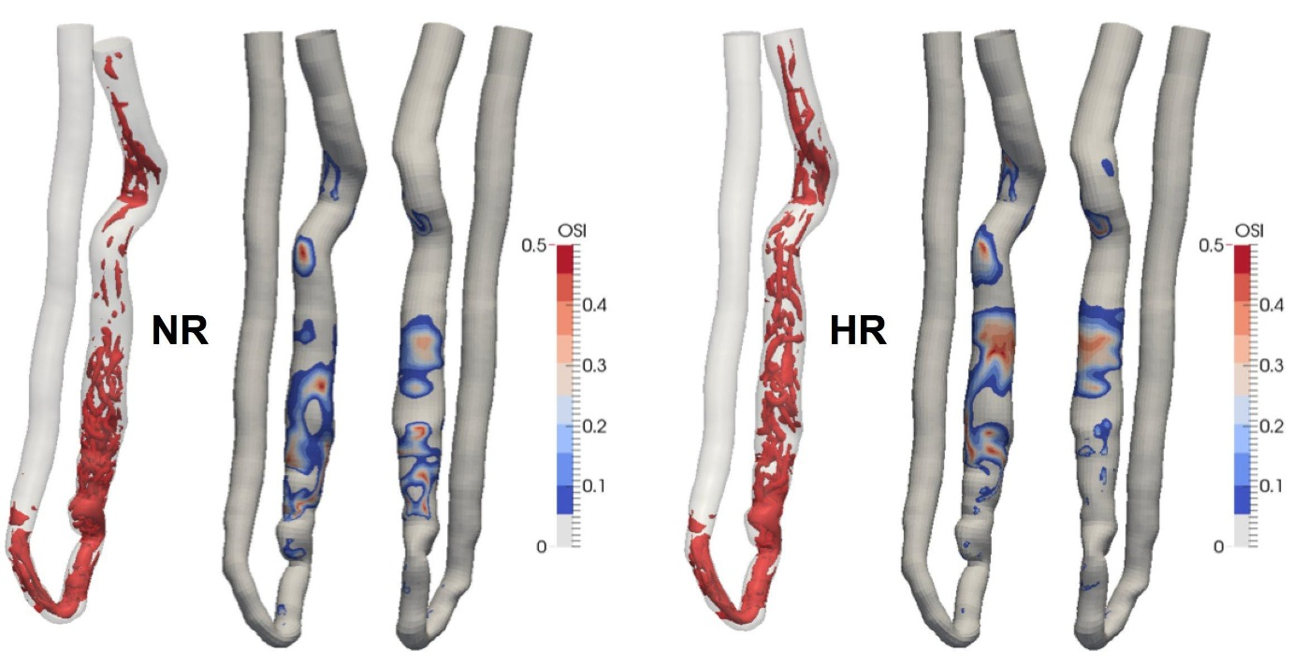Picture 1: Figure 1. Flow phenotype by λ2 criterion at peak systole and OSI patterns (front and rear views). Left, N Figure 1. Flow phenotype by λ2 criterion at peak systole and OSI patterns (front and rear views). Left, NR simulation; right, HR simulation.

Vascular access for haemodialysis

**032**

**SIMULATIONS OF THE UNSTEADY BLOOD FLOW THROUGH MATURE AND IMMATURE ARTERIOVENOUS FISTULAS**

Damian Obidowski, Daniel Jodko, Piotr Reorowicz, Krzysztof Józwik

Lodz Univeristy of Technology, LODZ, Poland

Aim: The aim of this study is to compare the flow parameters and the wall shear stress (WSS) distribution in mature and immature arteriovenous fistulas used for haemodialysis. Computational fluid dynamics methods were used for an analysis of the blood flow in the patient’s specific fistula models.

Methods: DICOM images of four well-functioning mature fistulas, obtained from the angio-computed tomography, were the data source used for a reconstruction of 3D geometrical fistula models. Because of the lack of previous investigations, those models were also used for development of the hypothetical virtual geometry of immature fistula models, in which constant typical value of the cephalic vein diameter was assumed. Blood was assumed to be a non-Newtonian fluid and the Shear Stress Transport model of turbulence was employed. Blood vessel walls were assumed to be rigid. Mesh independence tests were conducted.

Results: The simulated pulsating blood flow was disrupted in all anastomoses, in which maximal abnormal values of the blood velocity and the WSS were identified. Flow patterns, velocity fields, WSS and viscosity changes were shown versus time in animations. The WSS was spatially and time averaged in particular fistula regions: artery, anastomosis and cannulated vein.

Conclusions: This study shows a strong influence of the mesh precision in the boundary layer region on the results concerning the WSS. High and oscillating values of the WSS were obtained at the anastomoses. It may initiate stenosis that can lead to the vein thrombosis and further dysfunctions of the fistula. The WSS values in the vein receiving blood from the arteriovenous fistula are a few times lower in mature fistulas when compared to the immature ones. The WSS is thought to be an important homeostatic factor in the vein remodelling during the maturation of the fistula.

Vascular access for haemodialysis

**033**

**HAEMODYNAMIC COMPARISON OF METAL NEEDLES AND PLASTIC CANNULAE IN HAEMODIALYSIS**

David Fulker, Zakir Sayed, Anne Simmons, Tracie Barber

University of New South Wales, SYDNEY, Australia

**Aim:**

The use of metal needles is standard practice for accessing the vascular system for haemodialysis. Plastic cannulae have been used successfully in Japan for the last 40 years mainly because they have reduced the incidence of over advancing the needle and puncturing the floor of the fistula. The return of blood via the venous needle of a haemodialysis circuit can produce potentially damaging wall shear stresses and recirculating flows in the cannulation segment which may lead to venous stenosis. This study used computational fluid dynamics to compare the haemodynamics of blood flow through metal needles and plastic cannulae.

**Methods:**

Transient computational fluid dynamic simulations were conducted on an idealised cephalic vein with a 15G Gambro metal needle and the Covidien Argyle 15G cannula (see Figure 1). Blood was modelled as a Newtonian fluid with density and viscosity of 1045 kg/m3 and 0.0035 Pa.s, respectively. Blood flow rates of 200 ml/min, 300 ml/min and 400 ml/min were passed through the venous needle/cannula. The haemodynamics were compared by assessing the wall shear stresses on the blood vessel wall.

**Results:**

Minimal difference was found for the time averaged wall shear stress between the metal needle and plastic cannula in the TAWSS along the floor of the vessel. However, the recirculating flow and particle residence time produced by the high speed exiting venous flow was reduced in the plastic cannula.

**Conclusion:**

This study highlights the potential benefits of using plastic cannula over metal needles due to favourable haemodynamic conditions, which occur because of the tapered outlet and additional side holes which reduce the velocity of the high speed venous flow.

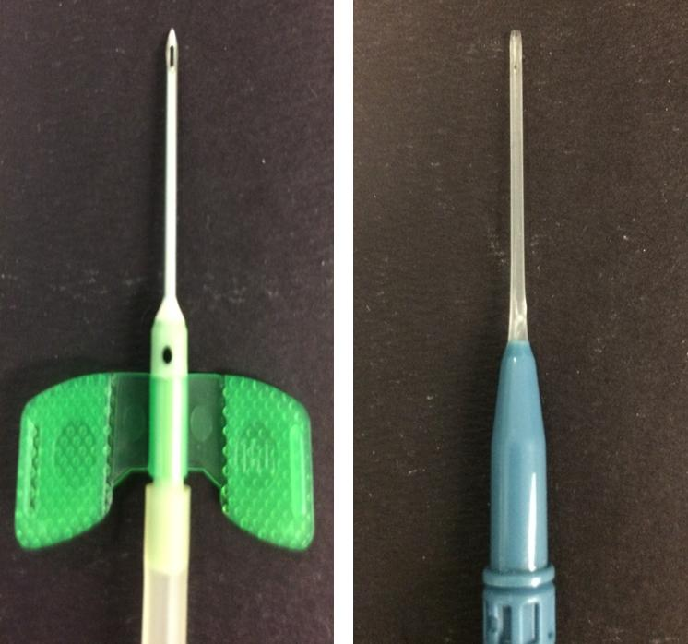Picture 1: Figure 1 a) Gambro 15G Metal Needle b) Covidien Argyle 15G Cannul Figure 1 a) Gambro 15G Metal Needle b) Covidien Argyle 15G Cannula

Vascular access for haemodialysis

**034**

**TUNNELED HEMODIALYSIS CATHETER OUTCOMES IN ELDERLY PATIENTS**

Vesna Gerasimovska, Biljana Gerasimovska-Kitanovska, Aleksandar Sikole

University Clinic of Nephrology, SKOPJE, Macedonia

The growing population of elderly and advanced age appears as an exclusive factor negatively influencing dialysis practice. This retrospective study evaluated tunneled catheter outcomes in an elderly patient population (>65 years) and compare them with those in a younger control group.

MATERIAL AND METHODS :

We looked at the outcome of a group of 170 patients (pts) receiving chronic HD treatment via a 262 tunneled-cuffed catheters (femoral, jugular and femoral) . Criteria for catheter removal were (1) persistant bloodstream infection -CRBI (2) catheter dysfunction and (3) elective removal. Catheter-related bloodstream infection rates were calculated per 1,000 catheter days, and Kaplan Meier analysis was estimated for THC cumulative survival between two groups of pts. A Cox proportional hazards regression analysis for sex, comorbidites(diabetes/malignancy), dialysis vintage,catheter site, and total number of prior vascular access was performed between nonelderly (18-64 years) and elderly (>65 years) patients.

RESULTS AND DISCUSSION:

Sixty-one tunneled catheters were placed in Group 1 -51 elderly patients (28 men and 33 women; mean age 76.5years).The mean number of catheters per patient was 1,91 ± 2,1 (range 1-7).Duration of catheter (median) was 155,4 days (range,6-267). Two hundred and one catheters were identified in the control group Group 2 - 119 patients (50 men and 69 women, mean age 50,9 years. Duration of catheter (median) was 185,2 days (range 4-565).There was no statistically significant difference in the mean number of catheters per pts(p=0,83) between the two groups.There was no significant difference between the two groups in the indication for catheter removal or exchange : CRBI ( p=0,65), malfunction of catheter (p=0,78) and elective removal of cateheter ( p=0,71).

Conclusion:

Tunneled catheter outcomes in pts aged 65years and older undergoing hemodialysis do not vary significantly compared with those in younger cohort.

Vascular access for haemodialysis

**035**

**MICROEMBOLIES OF AIR ARE DEPOSITED IN LUNGS, BRAIN AND HEART IN PATIENTS.**

Thomas Brännström1, Ulf Forsberg2, Per Jonsson2, Christofer Stegmayr2, Johan Hultdin1, Bernd Stegmayr2

1Umea University,, UMEA, Sweden

2Public Health and Clinical Medicine, Umea University,, UMEA, Sweden

Previous studies show that microembolies of air develop in the haemodialysis circuit but also in the fluid infused into patients.

**The aim** of this study was to clarify if such air embolies are immediately adsorbed when they enter blood or if they remain in circulation, to what extent such microembolies may enter into organs such as lungs, brain and heart.

**Material and method**: Post-autopsy tissue from a total of 43 autopsied patients were investigated for the presence of microembolies of air. Group 1 consisted of 24 haemodialysis patients while Group 2 consisted of 19 patients who died from amyotrophic lateral sclerosis. To discriminate between air bubbles caused by artificial contamination during autopsy versus in vivo deposited microembolies (ME) we stained the tissue with a fluorescent antibody against fibrinogen. If a microbubble of gas is covered by a fibrin embolus it is counted as positive. Twenty-five microscopic fields (600 x) were investigated for each tissue preparation Only one tissue preparation was used for each available organ.

**Results:** The Table shows ME’s found/tissue section, given as median and range. Number of patients (n)

In 2 of 23 of the HD patients and 10 of 19 ALS tissue without ME’s were found (p=0.002).

Significantly more ME’s were found in lungs versus heart or brain.

**Conclusion:** Data indicate that many patients are exposed to deposits of ME during hospital stay. In haemodialysis patients the risk is significantly greater for microembolies of gas. Repeated exposure such as 3 times/week in HD patients will result in accumulation of ME over time and add on to tissue injury. We recommend careful handling of infusions and injections as well as using optimal air traps in HD.

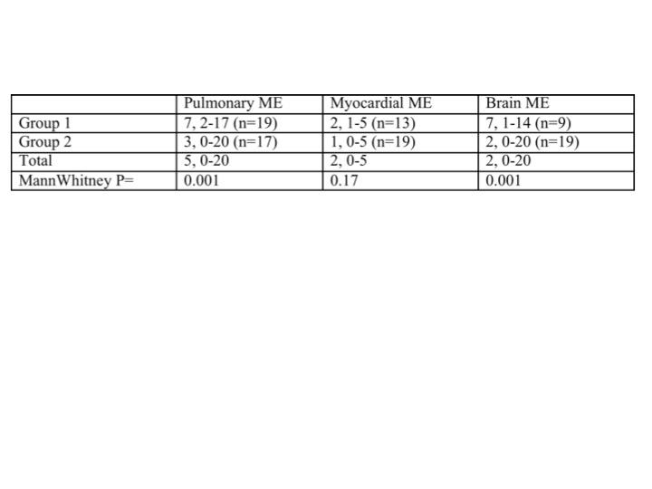Picture 1: Tabl Table

Vascular access for haemodialysis

**036**

**MICROBUBBLES IN HAEMODIALYSIS: AN ANALYSIS ON THE PERFORMANCE OF THE AIR TRAP**

Gholamreza Keshavarzi, Anne Simmons, Guan Yeoh, Tracie Barber

UNSW, KENSINGTON, SYDNEY, Australia

Due to the chronic nature of the haemodialysis (HD) treatment, minor imperfections in the extracorporeal system may cause significant consequences over time. Clinical studies have highlighted the possibility of small microbubbles travelling through the HD device to the patient. These bubbles lead to further pathophysiological complications (primarily seen in the lungs and brain). Microbubbles of different sizes can be generated throughout the extracorporeal HD circuit and the size of the bubble is a major factor in the type of complications affecting the patient. The performance of the air trap; the only mechanism for removing air bubbles, is therefore critical. Chronic exposure to various sizes of microbubbles was analysed in detail and the performance of the haemodialysis air trap has been evaluated. Our results show that bubbles larger than 0.5mm in diameter are likely to be removed by the air trap, however some of the smaller microbubbles are shown to pass through and enter the bloodstream. While the presence of various bubble sizes before and after the air trap have been investigated in previous studies, these bubbles were only counted and not tracked. The performance of the air trap for removing different bubble sizes is not understood. Here, the performance of the air trap in filtering bubbles and the possibility of different bubble sizes passing through the air trap has been evaluated. The modelled air trap is shown to be ineffective for filtering small micro bubbles.

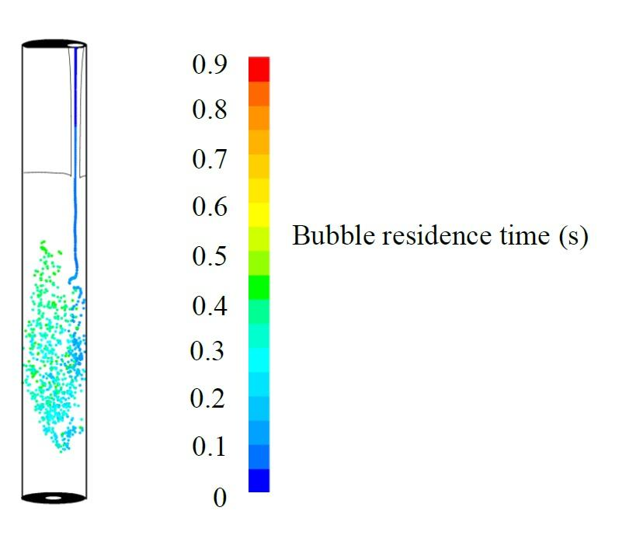Picture 1: Distribution of the microbubbles injected in the air trap flo Distribution of the microbubbles injected in the air trap flow

Tissue engineering - cell therapy

**037**

**OPTIMIZING IMMUNOSUPPRESSANT'S FOR STEM CELL THERAPY IN MUSCULAR DYSTROPHY MICE MODELS VIA NONINVASIVE IMAGING**

Bryan Holvoet, Mattia Quattrocelli, Sarah Belderbos, Lore Pollaris, Olivier Gheysens, Rik Gijsbers, Jeroen Vanoirbeek, Catherine Verfaillie, Maurilio Sampaolesi, Christophe Deroose

KU Leuven, LEUVEN, Belgium

**Introduction**

Muscular dystrophies are a group of myopathies, characterized by muscle weakness and degeneration. Currently no curative treatment is available. Mesoangioblasts (MABs) have been implicated as a therapy for improving muscle strength (1,2). To enhance cell survival, different immunosuppressive therapies, like cyclosporine A (CsA) or costimulation-adhesion blockade therapy (costim), can be used. We evaluated the effect of these different immunosuppressants on cell survival with non-invasive multimodal imaging.

**Methods**

Murine MABs were transduced with a lentiviral vector containing firefly luciferase and the human sodium iodide transporter. One million MABs were injected bilaterally in the femoral arteries of α-sarcoglycan knockout (Sgca-/-) and nude mice with cardiotoxin damaged muscles. The Sgca-/- mice either received CsA continuously or a short-term regimen (day 0, 2, 4 and 6 post-transplantation) of costim. While nude mice were treated with anti-asialo. Follow-up was done using bioluminescence imaging (BLI) and positron emission tomography (PET). T-cells were isolated from Sgca-/- spleenand analysed via flow cytometry.

**Results**

We were able to visualize the cells via PET for three days and with BLI until day 21 in the Sgca-/- mice. The first seven days no differences in BLI signal could be observed. From day seven on a steeper decrease in signal could be observed in CsA treated animals. In nude mice, the MABs could be stably visualized for 35 days, indicating T-cell involvement. In cell treated animals there was an increase in cytotoxic T-cells. Furthermore, animals treated with costim had lower cytotoxic T-cells compared to CsA treated animals.

**Conclusions**

We have developed a quantifiable, non-invasive, longitudinal technique to study the kinetics and biodistribution of the MABs *in vivo* using BLI and PET. We demonstrated that T-cells play an important role in cell survival and that costim is a superior immunosuppressant compared to CsA. Stable cell survival could however not yet be achieved.

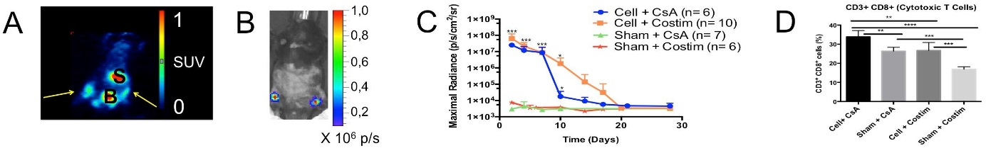Picture 1: In vivo Visualization and Quantification of Mesoangioblasts and Quantification of Cytotoxic T Cells In vivo Visualization and Quantification of Mesoangioblasts and Quantification of Cytotoxic T Cells.

Tissue engineering - cell therapy

**038**

**IMMUNE-MODULATORY CAPACITY OF MESENCHYMAL STEM CELLS (MSCS)**

Michael Bernhard Fischer1, Dominique Zlabinger2, Beate Rueger2, Eva Rossmanith1, Genia Yanagida2, Eva Steinhauer3, Hannes Stockinger3, Alexander Giurea4, Michael Bernhard Fischer1

1Danube University Krems, KREMS, Austria

2Klinik for Blood Group Serology and Transfusion Medicine, VIENNA, Austria

3Department for Molecular Immunology, VIENNA, Austria

4Clinic for Orthopedic Surgery, VIENNA, Austria

**Aim:** MSCs are multipotential adult progenitor cells with a capacity to differentiate along the mesenchymal lineage to form cartilage, adipose, marrow-stroma, and bone tissue and because of their capacity to secrete trophic factors that contribute to repair via the promotion of vascularization and the inhibition of cell death MSCs have a therapeutic effect in tissue and organ repair. MSCs are hypo-immunogenic and have been successfully transfused across the human leukocyte antigen barrier to treat autoimmune disease or severe graft-versus-host disease.

**Methods:** MSCs isolated from bone marrow aspirates, cancellous bone, or adipose tissue were cultivated by plastic adherence or in hanging droplets. The immune suppression assay involved purified CD4+ T cells stimulated with OKT3 and CD28 and MSCs or Treg cells as immono-regulators. MSCs were also stimulated with rhTNFa and rhIFNg, or Concanavalin (Con)A, and expression of FoxP3 was determined by FACS, Western blotting and laser confocal microscopy.

**Result:** MSCs like T regulatory (Treg) cells showed an immune-modulatory capacity to suppress an OKT3-mediated proliferative response of pCD4+ T cells. In this immune-suppression assay 1250 - 5000 MSCs showed the same capacity to suppress OKT3-stimulated pCD4+ T cells than 25 000 - 50 000 Treg cells. Immune modulation of MSCs depended on expression of forkhead box P3 (FoxP3) protein, a transcription factor to form transcriptional repression. When MSCs were activated with inflammatory mediators TNFa and IFNg, inducing phosphorylation of signaling molecules STAT1 and STAT3, or ConA no further expression of FoxP3 could be obtained. When MSCs were isolated alternatively from cancellous bone or adipose tissue no detectable foxP3 expression and very little immune modulatory capacity were observed.

**Conclusion:** MSCs from bone marrow have strong immune modulatory capabilities that depend on the expression of the transcription factor FoxP3, which cannot be found in MSCs from other tissue sources.

Tissue engineering - cell therapy

**039**

**FLUORESCENCE PROPERTIES OF CURCUMIN-LOADED NANOPARTICLES FOR TRACKING CELLULAR THERAPY.**

Katherine Carvalho1, Bassam Felipe Mogharbel1, Letícia Mazzarino2, Julio Cesar Francisco1, Elenara Lemos-Sennab2, Redouane Borsali3

1Pelé Pequeno Príncipe Research Institute, CURITIBA, Brazil

2Universidade Federal de Santa Catarina, FLORIANÓPOLIS, Brazil

3CERMAV, CNRS, University J. Fourier, GRENOBLE, France

AIM. The aim of this study was to analysis the feasibility to use the curcumin nanoparticles for tracking cellular therapy on histophatological analysis.

MATERIAL AND METHODS. Curcumin-loaded polycaprolactone nanoparticles (Cur-NP) were prepared using the nanoprecipitation technique as described by Mazzarino et al (2012). Nanoparticle suspensions were characterized in terms of mean particle size, polydispersity and zeta potential using a Zetasizer Nano Series. Curcumin content and entrapment efficiency were determined by UV/VIS spectrophotometry at 420 nm.

*In vitro* studies were conducted on Vero CCL-81 cell line. Cells were cultured in DMEM high glucose supplemented with 10% FBS, 100U/mL penicillin, and 0.1mg/mL streptomycin. Cells were incubated with DMEM containing 40 µM Cur-NP in a 24-wells plate for 72 hours. Subsequently, wells were washed with PBS and photomicrographswere taken with the DAPI fluorescence filter.

*In vivo* studies, Cur-NPs were injected in the *substantia nigra* of the adult rat by stereotaxic surgery using the followings coordinates from the bregma (anteroposterior -5.0mm, dorsoventral 7.7mm, mediolateral ± 2.1mm). It was injected 2.0µL of Cur-NP (0.426 mg/mL) using a Hamilton syringe. After 24h, the rat was euthanized by a lethal dose of anesthetic and the brain removed and frozen in liquid nitrogen. Tissue sections were cut using cryostatic microtome and analyzed by fluorescence microscopy Zeiss Axio Vert.A1.

RESULTS. Nanoparticles displayed a mono disperse distribution with a mean particle size around of 200 nm, and zeta potential close to zero. Cur-NPs showed a drug content of 426 µg/mL and high entrapment efficiency, demonstrating their suitability in the encapsulation of curcumin.The Cur-NPs could be identified in Light optical and by fluorescence microscopies with the DAPI fluorescence filter *in vitro* as well in tissue biopsy after transplantation.

CONCLUSION. Cur-NPs have a natural fluorescence and could be used for tracking cellular therapy on histopathological analysis.

Tissue engineering - cell therapy

**040**

**EFFECTS OF LIPOSOME-ENCAPSULATED HEMOGLOBIN ON SKIN WOUND HEALING IN DIABETIC DBDB MICE**

Akira Kawaguchi1, Tsuyoshi Fukui1, Nobumichi Saito1, Gen Kawaguchi1, Muneo Miyasaka1, Rica Tanaka2

1Tokai University School of Medicine, ISEHARA, Japan

2Juntendo University School of Medicine, TOKYO, Japan

**Aim**

Liposome-encapsulated hemoglobin with extremely high O2-affinity (h-LEH, P50O2=10 mmHg) has been reported to accelerate skin wound (ulcer) healing in normal mice. We examined the effects of h-LEH in wound healing of diabetic dB/dB mice which exhibit severe wound-healing impairments as in human diabetics.

**Methods**

Full thickness dorsal wound of 6 mm in diameter with surrounding silicone stent (Fuji Systems Corporation, Yokohama, Japan) was created in diabetic dB/dB mice (Day 0, n=14). Two days after wounding (Day 2), animals were randomized to receive intravenous h-LEH (10 mL/kg, n=7) or saline (n=7) as the 1st dose, which was repeated on Day 4 as the 2nd dose. The size and healing of the ulcer were analyzed by digital photometry, Laser-Doppler flow detection and blood sampling for cytokines, repeated on Day 2, Day 4 and Day 7 post wounding, when animals were sacrificed for histological studies.

**Results**

The ulcer size reduction was significantly retarded in dB/dB mice compared to normal mice. While ulcer size reduction remained retarded in saline-treated dB/dB mice, wound healing was significantly accelerated in h-LEH-treated dB/dB mice on Day 4 as well as on Day 7, when the level was equivalent to the normal mice treated with saline (Figure). Blood perfusion as detected by Lazar-Doppler flowmeter was significantly improved in mice treated with h-LEH. These differences became significant on Day 7, when the cytokines, IL-6 and IFNγ were suppressed significantly in h-LEH-treated dB/dB mice. Histological examination favored for the mice treated with h-LEH, which showed less inflammation and more granulation.

**Conclusion**

The results suggest that h-LEH (10 mL/kg, hemoglobin 600 mg/kg) early after skin excision may accelerate wound healing in diabetic dB/dB mice equivalent to the normal mice. The mechanism(s) of action appeared to be more related to the early suppression of inflammation rather than accelerated aerobic metabolism.

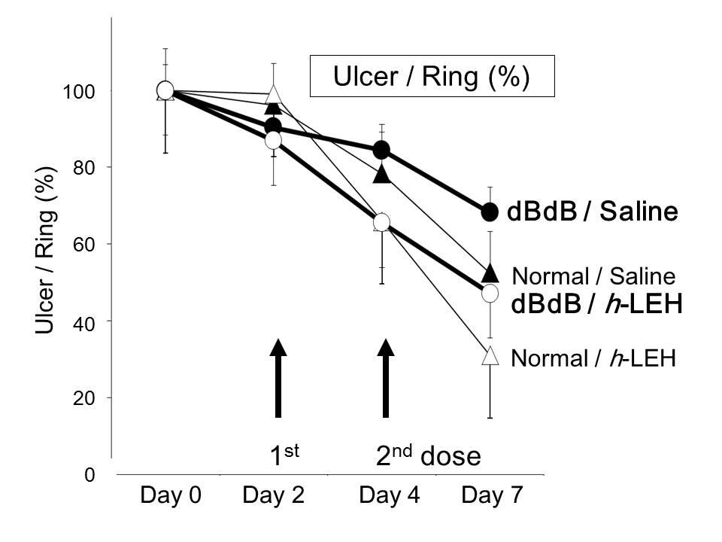Picture 1: % Ulcer Size Reductio % Ulcer Size Reduction

Tissue engineering - cell therapy

**041**

**3DISCO AS THE METHOD OF CHOICE FOR CLEARING BIO-ARTIFICIAL MUSCLE**

Melanie Gerard, Lieselot Decroix, Dacha Gholobova, Linda Desender, Lieven Thorrez

KULeuven Campus Kulak Kortrijk, KORTRIJK, Belgium

**Aim**

Recently, several clearing techniques have been published or revisited, aiming at 3D visualization of unsectioned tissue. The efficacy of these methods is mostly demonstrated for brain tissue, which has a different structural and biochemical composition compared to skeletal muscle. Therefore, we evaluated the effect of four clearing methods, Sca*l*eA2, ClearT2, CLARITY and 3DISCO, on both native and bio-artificial muscle (BAM).

**Methods**

Native skeletal muscle was obtained from eGFP-positive mice. BAMs were made by mixing human myoblasts in a fibrin hydrogel, which was cast into custom-made silicone rubber molds with end attachment sites to stimulate myofiber alignment. After seven days, BAMs were fixed and cleared with four different methods. Myofibers were imaged by confocal fluorescence microscopy.

**Results**

ClearT2 did not improve visualization depth while Sca*l*eA2 performed significantly better with a visualization depth of ~300 µm versus ~150 µm for uncleared tissue. The best results were obtained with 3DISCO and CLARITY, both allowing imaging over 400 µm deep, making the microscope hardware a limiting factor rather than the transparency of the tissue. With the main objective reached, other issues determined the best clearing method for skeletal muscle. First, cleared tissue was obtained much faster with 3DISCO than with CLARITY. Second, the tissue became softer and therefore more difficult to handle during CLARITY. A hardening was observed during 3DISCO, which also better preserved the original shape of the tissue. Third, the tissue respectively expands or shrinks during CLARITY and 3DISCO. Although ideally, the clearing does not change the dimensions of the tissue, shrinkage results in an even deeper visualization.

**Conclusions**

The above observations all point to 3DISCO as the method of choice when clearing (bio-artificial) skeletal muscle. Using 3DISCO, the full impact of further structural improvements can be evaluated, providing a unique 3D perspective in the way engineered tissues are formed.

Tissue engineering - cell therapy

**042**

**EFFECTS OF LIPOSOME-ENCAPSULATED HEMOGLOBIN ON CARDIOPULMONARY EXERCISE TESTING IN THE RAT**

Akira Kawaguchi, Hitoshi Endo, Hiroyuki Furuya

Tokai University School of Medicine, ISEHARA, Japan

**Aim**

Since liposome-encapsulated hemoglobin (LEH), cellular artificial oxygen (O2) carrier, is known to increase O2 content in the plasma fraction, LEH may supply extra O2 for enhanced exercise tolerance at cardiopulmonary exercise testing (CPE)

**Methods**

Eight rats implanted with a telemetry underwent CPE [rest (5 min), 5 m/min run (5 min), 10 m/min run (10 min) and rest (5 min)] on a metabolic treadmill to monitor heart rate (HR), blood pressure (BP), whole-body O2 consumption (VO2) and CO2 production (VCO2). After the 1st run, each animal received infusion of one of, LEH with high O2 affinity (h-LEH, P50O2=10mmHg), LEH with low O2 affinity (h-LEH, P50O2=45 mmHg), homologous blood (RBC), saline or none as the control. The animals were returned to their cage for 2 hours, when each rat underwent the same CPE as the 2nd run to compare the difference. Animals underwent the CPE-set (1st run+medication+2nd run) one week apart to test each treatment in a random sequence, 5 CPE-sets over 4 weeks.

**Results**

While VO2 increased in response to CPE, it increased more after treatment with h-LEH or RBC in response to 2nd run (Figure-top) while HR decreased compared to the 1st run in animals treated with h-LEH or RBC (Figure-middle). As the result, VO2/HR (equivalent to stroke volume: Figure-bottom) increased significantly after treatment with h-LEH or RBC compared to the other treatments. BP, VCO2 or lactate level did not differ significantly among treatments.

**Summary**

While O2-content increase in the unit of blood is supposed to be equivalent among rats treated with h-LEH, RBC or h-LEH, h-LEH may act as an “artificial O2 carrier”better than h-LEH, suggesting enhanced aerobic metabolism and improved tissue perfusion, resulting in attenuated sympathetic response or suppressed HR response to the CPE.

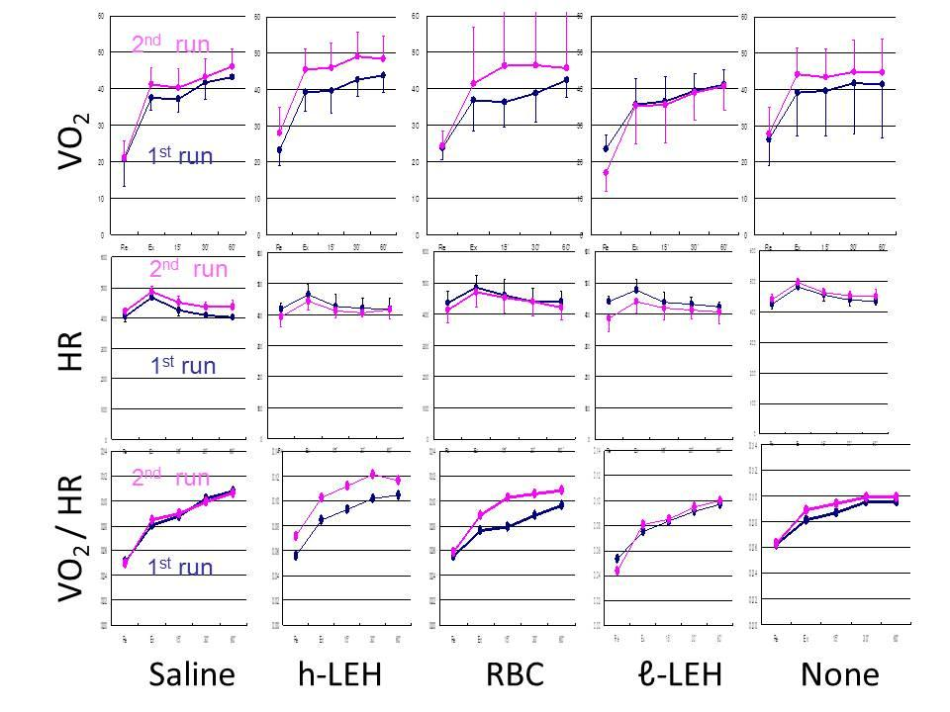

Development of valves & robots

**043**

**TAILORING EXPERIMENTAL SET-UP TO COMPARE DIFFERENT TECHNOLOGIES OF VALVE PROSTHESES**

Claudio Capelli1, Claus Rath2, Akash Pattani1, Alfred Kocher3, Martin Andreas3, Silvia Schievano1, Gaetano Burriesci1

1University College London, LONDON, United Kingdom

2Centre for Anatomy and Cell Biology&Department of Surgery - Medical University, VIENNA, Austria

3Division of Cardiac Surgery, Department of Surgery, Medical University, VIENNA, Austria

Aim

Sutureless bioprostheses for aortic valve replacement have been recently introduced as an effective option to expedite the implantation procedure compared to the standard, sewed-in counterparts. However, understanding of how their hydrodynamic performance compares with standard solutions is still limited. *In vivo* post-operative data, as acquired with ultrasound techniques, cannot accurately capture small differences of velocity and pressure. I*n vitro* tests can replicate conditions which might be too ideal compared to physiological contexts. Aim of this study is therefore improving an experimental set-up to assess bioprosthetic valves’ performance by taking into account more representative conditions as device anchoring and patient-specific geometry.

Methods

A sewed-in (Carpentier-Edwards Magna Ease) and a sutureless (EDWARDS INTUITY) valve of same size were included in this study. The two prostheses, commercially available, are identical in the design of the valve frame and leaflets, but they differ in the proximal anchoring system, with the sutureless device including a balloon-expandable stent in the proximal position. The hydrodynamics performance of the two devices was assessed in a pulse duplicator system (ViVitro Labs Inc, Canada), under standard operating conditions (i.e. ISO 5840). The sewed-in valve was tested with and without pledget-armed sutures (Figure 1a). All set of tests were performed using an idealised and a patient-specific aortic root (Figure 1b).

Results

Pressure gradients and effective orifice areas were measured for each tested valve and condition. Standard experiments showed an overall equivalent performance of the two valves tested under identical and ideal conditions. The presence of pledget-armed sutures, however, worsened the performance of the sewed-in valve (Figure 1c). Finally, the new patient-specific block was successfully manufactured and integrated within the system, providing results comparable to clinical scenarios.

Conclusions

This study confirms the importance to adapt the standard tests to include settings which are more representative of the in vivo working conditions.

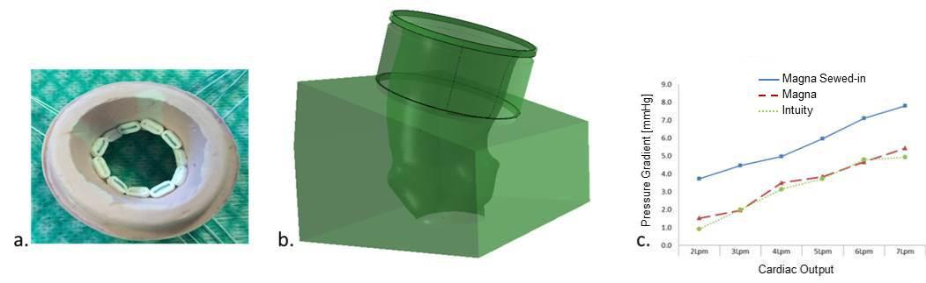Picture 1: Figure 1 a. Holder for the sewed-in valve; b. Block designed for housing a patient-specific aortic root; c Figure 1 a. Holder for the sewed-in valve; b. Block designed for housing a patient-specific aortic root; c. Mean pressure gradient of tested valves

Development of valves & robots

**044**

**ENDOSCOPIC INVESTIGATION OF A HEART VALVE IMPLANTATION IN AN ISOLATED PIG HEART**

Martin Buesen1, Lisa Liebenstund2, Rene Tolba2, Ulrich Steinseifer1, Simon Sonntag1

1Institut of Applied Medical Engineering, AACHEN, Germany

2Institut for Laboratory Animal Science & Experimental Surgery, AACHEN, Germany

**Aim**

The isolated heart apparatus recently has become a method to investigate cardiovascular devices or hemodynamic mechanisms *ex vivo*. In principal a pig heart is arrested by cardioplegia and explanted. The heart is then reperfused either with blood or a crystalloid physiologic solution (Krebs-Henseleit buffer), both tempered and oxygenated. The purpose of this study was to investigate the implantation procedure of a TAVI heart valve prostheses in an isolated pig heart with video endoscopy.

**Methods**

After euthanasia of a pig from an animal trial, the thorax has been opened and 1l of cold cardioplegic solution (HTK) has been administered to the coronaries. The heart was transported, cannulated and prepared under cardioplegic and cold conditions (0-4°C). After preparation the vessels were connected to a custom made isolated heart apparatus and reperfusion was achieved with Krebs-Henseleit buffer. Hemodynamic parameters, like heart rate, pressures and flow rates have been recorded. A flexible endoscope was inserted to the heart and a TAVI heart valve prostheses was implanted in aortic position.

**Results**

The reperfusion of the pig heart with Krebs-Henseleit buffer was successful and the hemodynamics were in an acceptable range. Endoscopic videos of the implantation procedure could be recorded, due to the transparent solution.

**Conclusion**

The isolated heart apparatus is a suitable platform to investigate heart valve prostheses implantation with endoscopy. It provides new insides to the implantation procedure and valve behavior, which usually only can be observed under x-ray imaging.

Development of valves & robots

**045**

**TELEOPERATION CONTROL SYSTEM FOR REMOTE SURGERY WITH PIONEER, TOUCHLESS USER INTERFACE**

Kostka Pawel1, Zbigniew Nawrat2, Zbigniew Malota2

1Silesian Univeristy of Technology, ZABRZE, Poland

2Foundation for Cardiac Surgery Development, ZABRZE, Poland

**Aim:** A novel control system supporting long-distance teleoperation by means of Robin Heart surgery robot used in presented project was equipped with functionality allowing connection of multiple type man-machine interfaces (MMI) both contact and touchless. Most existing motion capture systems relay on markers worn by the object during motion recording, which complicate the measurements, is not very precise and can interface with the object natural movements. The aim of described project was to develop an optimal, user friendly, touch-less interface for polish Robin Heart® surgery robot, based on new, available on the marked LeapMotion® controller to compare it to earlier MMI-s like e.g. hand or foot Master controllers.

**Methods:** Presented project uses a touch-less 3D object capture technology provided by Leap Motion and patented by David Holz. A special software was developed by authors to integrate it with control system of polish surgery telemanipulator Robin Heart. A whole master-slave control system with a surgeon gesture reading interface works in a loop repeating with 200-1000 [Hz], which controls a 4 DOFs robotic arm RHVision® for endoscopic camera holding.

**Results:** A special testing stand with prepared tracks to follow, for remote robot arm, with landmarks to reach was used to verify time and precision of given task realization and compare it with other man-machine interfaces like medical joystick and foot-controller. For a testing group of novice subjects, who carried out the test three times, learning rate was evaluated, where average progress of task time performing was on the level of 30% between 1st and 2nd trial and 10% from 2nd to 3rd one. Comparable best results was reached for hand joystick and gesture MMI.

**Conclusions:** Presented system, positively verified touchless MMI, integrated into main telemanipulator control system, what can be especially useful e.g. in the environment of sterilize operation room.

Development of valves & robots

**046**

**DEVELOPMENT OF AN AUTOLOGOUS VALVED CONDUIT (TYPE IX BIOVALVE) USING A CAGED MOLD**

MARINA FUNAYAMA, Maya Furukoshi, Takeshi Moriwaki, Yasuhide Nakayama

National Cerebral and Cardiovascular Center, OSAKA, Japan

**Aim**

Pediatric patients with congenital heart disease would benefit from replacement heart valves. We developed an autologous valved conduit (Biovalve), formed by in-body tissue architecture technology (IBTA) using subcutaneously embedded plastic molds. Biovalves might potentially serve as pediatric replacement valves because they are composed of mainly autologous fibroblasts and collagen fibers. However the small-diameter Biovalve required for pediatric patients generally tends to be thin connective tissue which need careful surgical handling. Accordingly, we aimed to develop a caged mold with a paling structure to enhance IBTA for producing small-diameter Biovalves with robust conduits.

**Methods and Results**

The caged mold consisted of a two-layer structure. The inner part (outer diameter, 14 mm), which mainly formed the leaflets, was surrounded by the paling (width, 2 mm) that lined the conduit at equal intervals of 1.0 mm (total length, 20 mm). A 1-mm space was designed between the inner and outer parts as the conduit wall. After the embedding period, the space for the conduit wall was completely filled with connective tissue from outside the mold via the palings. After trimming the excess peripheral tissues and removing the mold, completely formed Biovalves with approximately 1-mm conduit walls (inner diameter, 14 mm) were obtained. There was a smooth and clear boundary between the conduit and leaflets, which consisted of mainly fibroblasts and collagen fibers. The mold allowed maintenance of the structure, including the lumen, and greatly improved handling of the Biovalves.

**Conclusion**

The paling structure facilitated the formation of approximately 1-mm thick conduit wall and leaflets through a small aperture inside the inner portion. The caged mold with a two-layer structure enabled better handling of the Biovalves, and may eventually lead to clinical applications. We hope that Biovalve with robust conduits wall will be clinically used in heart valve replacement even in pediatric patients.

Development of valves & robots

**047**

**ANALYSIS OF THE FLOW FIELD BEHIND A MEDTRONIC COREVALVE PROSTHESIS IN THREE DIFFERENT IMPLANTATION HEIGHTS VIA PIV**

Desiree Pott, David Arnolds, Martin Buesen, Christoph Schmitz, Simon Sonntag, Ulrich Steinseifer

Institute of Applied Medical Engineering, RWTH Aachen University, AACHEN, Germany

**Aim:** The flow field behind a TAVI Medtronic corevalve prosthesis was investigated in three different implantation heights (normal, too high, too low) to analyze the impact of the implantation height on the flow field and on the flow through the coronary arteries.

**Methods:** A silicon model of the aorta, including the sinuses of Valsalva and both coronary arteries was manufactured. The prosthesis was inserted in the correct implantation position and then approximately 8mm higher and lower. For the flow measurements, the CVE pulse duplicator was used to produce physiological flow and pressure curves (5L/min and 120/80mmHg) through the prosthesis. The flow field was investigated by particle image velocimetry technique. Two high-speed cameras recorded the particles (ILA GmbH, Jülich, Germany) in the fluid (water/glycerine mixture with a viscosity of 3.6mPas at 37°C), illuminated by a laser (Nd:YAG, Pegasus, New Wave Research Inc.). The flow field was divided into six planes with 5mm distance to each other. The recorded data was post-processed using the software dynamic studio (Dantec, Denmark) and Tecplot (USA).

**Results:** The analysis showed that for each position, a central jet of the same maximum velocity developed in early systole. Depending on the implantation height, a different amount of fluid passed through the coronary arteries over one heart cycle. Furthermore, the inflow direction of the fluid in the near proximity of the pulmonary arteries inside the sinuses of Valsalva varies depending on the implantation height.

**Conclusion:** The amount of flow through the coronary arteries and the inflow direction highly depends on the implantation height of the prosthesis.

Development of valves & robots

**048**

**IMPROVEMENT AND EVALUATION OF A BIOVALVE WITH STENT FOR TRANSCATHETER PULMONARY VALVE IMPLANTATION**

Hirohito Sumikura, Yasuhide Nakayama, Kentaro Ohnuma, Yoshiaki Takewa, Eisuke Tatsumi

National Cerebral and Cardiovascular Center Research Institute, OSAKA, Japan

**Aim.**

We are developing an autologous heart valve-shaped tissue with a stent (stent-biovalve) for transcatheter pulmonary valve implantation by using 'in-body tissue architecture' technology. In previous study, the leaflet shape of the developed stent-biovalve remains basically open form (OF-SBV), since the stent-biovalve was fabricated using a simple cylinder-shaped acrylic mold. As a result, the leaflets of open form could not close rapidly and it was involved in increasing the regurgitant volume.

In this study, we designed a novel mold for fabricating the stent-biovalve with closed form leaflet (CF-SBV) to reduce the regurgitant volume and evaluated the hydrodynamic performances of developed CF-SBV in in vitro testing for its application to the pulmonary valve (PV).

**Methods.**

A specially designed, self-expandable, stent-mounted, acrylic mold with three projections for CF-SBV was placed in a dorsal subcutaneous pouch of a goat, and the implant was extracted 2 months later. Only the acrylic mold was removed from the implant, and a tubular hollow structure of membranous connective tissue impregnated with the stent strut was obtained. Half of the tubular tissue was completely folded in half inwards. Here, the acrylic mold was designed such that the half of the tubular tissue which is folded inwards becomes the closed form leaflets. The 3 commissure parts were connected to form 3 leaflets, resulting in the preparation of the CF-SBV (25-mm ID).

The CF-SBV was fixed to a specially designed pulsatile mock circulation circuit under pulmonary circulation conditions using 37°C saline.

**Results.**

The leaflet shape was found to significantly affect the hydrodynamics of stent-biovalve. The leaflet of the CF-SBV closed more rapidly compared to the conventional OF-SBV, and reduced regurgitation rate was obtained under pulmonary circulation conditions.

**Conclusion.**

The developed completely autologous CF-SBV may be useful for PV replacement.

Mechanical support outcome

**049**

**VENO-VENOUS ECCO2-REMOVAL: A PILOT STUDY**

Harlinde Peperstraete, Sunny Eloot, Pieter De Puydt, Carl Roosens, Annemieke Dhondt, Stefaan Claus, Jonathan De Rudder, Eric Hoste

Ghent University Hospital, GHENT, Belgium

**AIM**

Patients with Acute Respiratory Distress Syndrome (ARDS), should be treated with lung protective mechanical ventilation (MV). Lung protective MV includes lowering of tidal volume (VT) and plateau pressure (PPLAT). It is less harmful for the lungs and associated with better outcomes. However, it is also associated with decreased lung clearance of CO2, resulting in respiratory acidosis. Extracorporeal CO2-removal (ECCO2-R) is a new veno-venous therapy allowing CO2 clearance. The aim of this pilot study was to evaluate whether this therapy was able to treat respiratory acidosis allowing reduction of PPLAT and VT .

**METHODS**

In this single centre trial, we included patients who met the Berlin definition of ARDS and who had respiratory acidosis. The first 2 hours blood flow was at 300ml/min, after which it was increased to 400ml/min. During ECCO2-R (Abylcap®, Bellco) we aimed at lowering PPLAT and VT.

**RESULTS**

We included 9 patients, 4 female, with a median age of 50 y [22.8 ; 66.5]. All patients showed a decrease of pCO2 after 2 hours of treatment, median reduction was 28.2% [11. 6; 31.0]; p=0.008. Five patients (56%) achieved a decrease in pCO2 of more than 20%. The median reduction in PPLAT after 5 days (D5) of treatment was 8.5cmH2O [5.3 ; 12.5]; p=0.012. Median reduction in VT at D5 was 1.52ml/kg predicted body weight [0.65 ; 1.85]; p=0.017. In all patients pH could be corrected to normal range values, the median difference of pH at D5 was 0.23 [0.21 ; 0.27]; p=0.012. Three patients needed a blood transfusion because of bleeding.

**CONCLUSION**

Veno-venous ECCO2-R is a very promising extracorporeal technique to remove CO2, allowing MV of ARDS patients with lung protective strategies. An explanation for the inter-patient variation in efficiency of CO2 removal could not be found in our patient cohort.

Mechanical support outcome

**050**

**THE CURRENT SITUATION OF RESEARCH AND DEVELOPMENT OF PEDIATRIC VAD IN JAPAN: A CASE STUDY**

Haruka Nakada1, Mamoru Arakawa2, Eisuke Tatsumi1

1National Cerebral and Cardiovascular Center, OSAKA, Japan

2Jichi Medical University, Saitama Medical Center, SAITAMA, Japan

**Aim:** A clinical trial for the pediatric ventricular assist device (VAD), which has already been approved worldwide, is underway in Japan. To extract regulatory issues on clinical trials of pediatric ventricular assist device and discuss the current situation of research and development (R&D) of pediatric VAD in Japan.

**Methods:** We extracted regulatory issues from one case: Japanese government eased the selection criteria for the trial after a pediatric patient died, who was excluded from the trial because she had not been registered for heart transplantation. After the patient expired, her family published a message in the media, in which they sincerely hoped for early approval of the pediatric VAD in Japan. Consequently, an academic society submitted an official request to the government for early approval of pediatric VADs. Originally, the participants in the trial must be registered for heart transplantation, however, according to the new government’s instructions, patients who were not registered for heart transplantation may be enrolled in the trial based on the physicians’ decision. We also discussed other issues surrounding R&D of pediatric VAD in Japan.

**Results:** Fundamental issue is thatno pediatric VAD is approved in Japan.While easing the selection criteria of the trial could expand an access to investigational devices for patients with severe heart failure who do not have other treatment options, it violates the rigidness of clinical trial protocols. Furthermore, the access to the investigational device is strictly limited. According to the demand of pediatric VADs, our center has decided to reproduce a pediatric VAD which was approved in 1990 and out of production due to the small number of pediatric patients suitable for the device.

**Conclusion:** The best way to ensure widespread access to investigational pediatric VAD is to shorten the time to make the device clinically available.

Mechanical support outcome

**051**

**SURVIVAL OUTCOMES IN CHILDREN LESS THAN 10 KG BRIDGED TO TRANSPLANT WITH THE BERLIN HEART EXCOR**

Gianluca Brancaccio, Arianna Di Molfetta, Sergio Filippelli, Roberta Iacobelli, Stefano Morelli, Isabella Favia, Paola Cogo, Antonio Amodeo

Pediatric hospital bambino gesu, ROMA, Italy

Objective: Although the remarkable advances with the use of ventricular assist devices (LVAD) in adults, and the well established experience with adolescents, pneumatic pulsatile support in small children is still limited. The aim of this work is to report a retrospective review of our experience on the use of VADs in very small children (<10 kg of body weight).

Methods: Data of 30 consecutive children weighing less than 10 kg undergoing mechanical support with Berlin Heart (Berlin Heart AG, Berlin, Germany) as a bridge to heart transplant from March 2002 to March 2015 were retrospectively collected.

Results: The mean patient age was 12.7±10.8 months. The mean patient weight was 6.5±1.7 Kg. Prior to VAD implantation, all children were managed by multiple intravenous inotropes or extracorporeal membrane oxygenation (13%). Three patients required biventricular mechanical support (among patients implanted before 2010) and two patients had single ventricle physiology. The mean duration of VAD support was 115.8±64.7 days and increases over the time from 2002 to 2015. Eight (27%) deaths occurred. However, in the last 20 patients (implanted between 2010 and 2015), mortality decreased to 4 patients (20%). Cause of death was neurological complication (13%) and sepsis (7%). Sixteen patients (53%) were successfully bridged to heart transplantation and six other patients (20%) are still on VADs waiting for heart transplantation. Two (7%) patients required surgical revision for a large haematoma around the aortic cannula, while 16 patients (53%) required at least one pump change.

Conclusions. Mechanical support in smaller children with end-stage heart failure is an effective strategy for bridging patients to heart transplantation.

Mechanical support outcome

**052**

**RUSSIAN AXIAL-FLOW LEFT VENTRICULAR ASSIST DEVICE: RESEARCH, TECHNICAL SPECIFICATION AND CHARACTERISTICS**

Dmitry Telyshev, Sergey Selishchev

National Research University of Electronic Technology, MOSCOW, Russian Federation

**Aim:** At the terminal stages of heart failure medications and therapeutic methods are useless, and there is only one way of patient’s life saving - heart transplantation (only 100 operations per year in Russia annually) or implantation of a left ventricular assist device (LVAD). Actual problem of the severe heart failure treatment on the one hand and international experience of using VADs on the other hand formed the basis for the development of the Russian LVAD.

**Methods:** Rotor type blood pump is designed to provide blood flow to help left ventricle of patient’s heart. The implantable pump continuously transmits fluid’s energy flowing through it. The pump consists of moving parts - the impeller (rotor with three blades) and stationary parts - straight device. Blade’s geometry creates profiled impeller, and the straight device is behind it. The pump is driven by an external source of power supply (two rechargeable modules in a portable version of LVAD) by electric cable going through a percutaneous lead in the patient’s skin that is protected with a membrane connected to electronic control unit.

**Results:** From 2009 to 2014 there were consistently conducted development of the prototype, in vivo and in vitro tests, there was carried out a full cycle of certification and clinical testing. The Result is the implantation of ten LVADs in Russia (December 2014).

**Conclusion:** The results, obtained in the research process and the positive clinical experience of LVAD’s implantation is the basis for further research of the VADs development and improvement. National Research University of Electronic Technology (MIET) conducts research to develop the circulatory support system that provides adaptive changes in flow characteristics depending on the intensity of blood pumping by the heart that allow personalizing treatment of acute heart failure and increase survivability and life expectancy with implanted circulatory support system.

Mechanical support outcome

**053**

**SINGLE CENTER EXPERIENCE: 100 HEARTMATE II IMPLANTATIONS; WHAT DID WE LEARN?**

Steven Jacobs, Klaartje Van Den Bossche, Walter Droogne, Filip Rega, Bart Meyns

KULeuven, LEUVEN, Belgium

**Objective:** Continuous flow ventricular assist devices have gained their place in treatment of end-stage heart failure in the last decade. Over the last years the outcomes have improved significantly with one year survival reaching 80%. When reaching the 100th consecutive HeartMate II (HM II) implant in our hospital we conducted a review of our own series. Goal was to identify key points for improved survival.

**Methods:** Between 2007 and 2014, one hundred HMII assist devices were implanted in the University Hospital Leuven, Belgium. 83 male and 17 female patients with a mean age of 50,3 ± 14,0 years (range 11,7-72). All patients were classified according to the INTERMACS classification, 34% were in class I and 66% class II or higher. Eight patients were on ECMO before receiving a HM II.

Kaplan Meier survival analysis and Cox proportional Hazard regression analysis were done.

**Results:** Overall one year survival was 75,3%. A significant lower survival could be found for the time of pump implantation (first 20 patients versus next 80; (p=0,006)), prior ECMO support (p=0,04), the age at the time of assist implantation (p=0,03) and the preoperative level of creatinine (p=0,01). Even after correction for ECMO support, age and preoperative creatinine time of implant remained a significant risk factor for death. The number of reinterventions for bleeding was higher in these first 20 patients (40% vs. 18%; p<0.05).

**Conclusion.** We observed an explicit learning curve in our patient series. Retrospective analysis of our data show that the patient demographics of early versus late implantation was not different. There was however a significant reduction in the number of reinterventions for bleeding. We believe that optimizing our perioperative anticoagulation protocol played an essential role in optimizing patient survival.

Mechanical support outcome

**054**

**EXERCISE CAPACITY IN FULL SUPPORT AND PARTIAL SUPPORT PATIENTS: A COMPARATIVE ANALYSIS**

Libera Fresiello, Roselien Buys, Joeri Van Puyvelde, Steven Jacobs, Bart Meyns

KU Leuven, LEUVEN, Belgium

**AIM**: ventricular assist device is a consolidated therapy for end-stage heart failure, but some questions about patients’ quality of life still remain. In this work we compared the exercise capacity of full support (FS) and partial support (PS) patients.

**METHODS**: 27 FS patients (24 Heartmate II and 3 HeartWare HVAD) and 7 PS patients (Circulite Synergy Micropump) underwent maximal cardiopulmonary ergometer tests. Maximum heart rate (HRmax), heart rate reserve (CR), peak oxygen uptake (VO2p) and ventilatory efficiency slope (Ve/VCO2) were calculated for each test. Data were expressed as percentage of expected values (%HRmax, %CR, %VO2p and %Ve/VCO2) calculated according to patient’s gender, age and weight. Student t-test and Wilcoxon test were used to compare FS and PS groups.

For each patient, the slopes %HRmax/time, %CR/time, %VO2p/time and %Ve/VCO2/time were calculated with a regression between the values of these variables at different exercise tests and the time these tests were performed (days after VAD implantation). One sample t-test and Wilcoxon test were used to evaluate if these slopes were different than zero, that would indicate a change of these variables over time.

**RESULTS**: the analysis of slopes reveal that all variables do not change over time for both FS and PS. Only %CR/time for FS that is significantly different than zero (0.043±0.129, p<0.05). No significant differences were found between FS-PS for %VO2p (48±13%-45±7%), %Ve/VCO2 (154±38%-133±22%) and %CR (59±26%-42±24%). %HRmax was statistically different in the two groups (77±14%-65±16%, p=<0.05). A correlation analysis of PS and FS data together showed a relationship %CR-%VOp2 (r=0.531, p<0.01) and %HRmax-%VO2p (r=0.448, p<0.01).

**CONCLUSIONS**: FS and PS patients show a comparable exercise performance. Further analysis should be conducted in a larger population to better evaluate the role of HR and the impact of FS and PS on it.

This work was supported by Marie Curie Scholarship (PIEF-GA-2013-624296).

Tissue engineering - modelling

**055**

**PROBE MOLECULES LOADING INTO RED CELLS TROUGH HYDRODYNAMIC FOCUSING: A COMPUTATIONAL EVALUATION**

GIUSTINA CASAGRANDE, Elena Bianchi, Monica Piergiovanni, MariaLaura Costantino

POLITECNICO DI MILANO, MILANO, Italy

Aim: This work aims at studying the fluid-dynamic conditions allowing the encapsulation of probing molecules (PM) into Red Blood Cells (RBCs) by applying shear stresses (τ) on their membrane. Indeed, it is well-known in the literature that this process enhances the opening of the pores, thus allowing the diffusion of solutes. In our microdevice τ were applied through a single passage in a sheath flow focuser, designed to drift the cells to a controlled τ solicitation zone.

Methods: A computational model using Comsol Multiphysics was developed; the geometry is a cross-shaped microchannel (MC) with 50*50μm cross-section and 87mm length. Velocity (v), volume fraction of dispersed phase (rd) and τ for a suspension of RBCs and PM (FITC-Dextran) in a Phosphate Buffer were evaluated, varying the flow rate of RBCs suspension (Qb), sheath flow (Qf) and Ht. When the pair of τ values and time results sub-haemolytic (according to Tillman Diagram (TD)), and the RBCs transit time is higher than the time required for PM diffusion into RBCs, encapsulation can be promoted. A dedicated efficiency index was used to evaluate the flow conditions (v, rd, τ) that are thought to increase the encapsulation rate.

Results: Taking into account the efficiency index, the position on TD and the overall pressure drop, suitable fluid-dynamics conditions were: Qb=40μl/min, Qf=7μl/min, PM 2mM for Ht=5% or Qb=33μl/min, Qf=5,5μl/min, PM 4Mm, and Ht=10%. In these conditions the area occupied by RBCs is the 75% of the channel section. The resistance of the MC and their connections to the pumping system to the high pressure evaluated through CFD (respectively of 4 and 3atm) was verified.

Conclusions: The model allows the characterization of RBCs fluid-dynamic in simple microfluidic devices and to identify the optimal conditions to promote PM encapsulation. This model will be used to define appropriate test conditions.

Tissue engineering - modelling

**056**

**MODELLING AND QUANTIFYING THE FLUID TRANSPORT THROUGH POLYLACTIC ACID SCAFFOLDS**

Margo Steuperaert

Ugent, GHENT, Belgium

AIM

As part of our research on understanding the determinants of intraperitoneal (IP) chemotherapy, we are developing controlled environments in which tumor cells can be seeded and cultured in order to test the therapeutic effects of cytotoxic drugs. In this work, we aim to mimic tumor tissue by developing scaffolds, of which the permeability characteristics can be theoretically predicted based on its printing parameters.

METHODS

Three polylactic acid (PLA) scaffolds were printed using a target filament thickness of 400 µm and an interfilament distance of 500 µm (Fig. 1a). To measure the scaffold permeability experimentally, a gravity-based setup was built to perfuse the scaffold with a constant fluid height of 20 cmH2O (*ΔP*) and measure the resulting flow (*Q*; Fig. 1b). The Darcy permeability *k* [m²] was calculated based on the Darcy equation for porous media as follows for a cylindrical scaffold with length *l* [m], area *A* [m²] and *µ* the dynamic viscosity [Pa.s]:

k= *- (Q*·*l*·*µ*)/(*A·ΔP*)

Next to the experimental approach, a virtual 3-dimensional scaffold model was created in pyFormex using the printing parameters and meshed in ICEM. Subsequently, CFD simulations were performed to calculate the theoretical permeability, allowing comparison with the experimental results (Fig. 1c&d).

RESULTS

Theexperimentallymeasured permeabilities of the scaffolds are 7.27 ± 0.10 ·10-10, 6.89 ± 0.05 ·10-10 and 7.70 ± 0.14 ·10-10 m2, respectively, resulting in an overall average of 7.29 ± 0.36·10-10 m2. The theoretical permeability obtained from the CFD simulation was 7.85·10-10 m2.

CONCLUSION

In this work, a framework is presented for developing scaffolds of which the permeability characteristics can be predicted based on their printing parameters. Comparison of the experimental and virtual permeability values showed that values were in the same order of magnitude, but virtual permeability was slightly overestimating the experimental values.

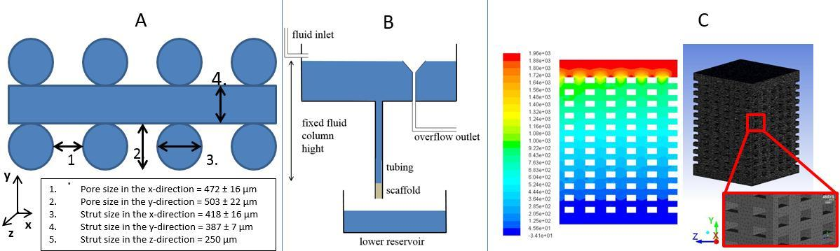Picture 1: Schematic representation of scaffold geometry (a) and experimental setup (b). Volume mesh of CF Schematic representation of scaffold geometry (a) and experimental setup (b). Volume mesh of CFD geometry and pressure distribution along yz-plane (c)

Tissue engineering - modelling

**057**

**DESIGN CRITERION FOR RADIAL FLUX UNIFORMITY IN RADIAL-FLOW PACKED BED BIOREACTORS FOR BONE TE BASED ON A 2D FLOW MODEL**

Danilo Donato1, Giuseppe Falvo D'Urso Labate2, Charlotte Debbaut1, Patrick Segers1, Gerardo Catapano2

1University of Ghent, GENT, Belgium

2University of Calabria, RENDE, Italy

**Aim:** Osteogenic cells cultured in clinical-scale annular porous scaffolds in radial flow packed-bed bioreactors (rPBBs) may be effectively used to engineer clinical-scale bone tissue substitutes. Although generally neglected, the distribution of radial flux depends on the design of rPBB void spaces and construct transport properties. Uniform radial flux distribution along the construct length is essential to enable uniform cell survival, proliferation, differentiation and tissue formation. Criteria for the optimization of rPBB geometry (its inner hollow cavity, construct and peripheral annulus) to ensure flux uniformity are not yet available. In this study, a model-based criterion is proposed to optimize rPBB geometry to ensure uniform radial flux distribution for steady operation.

**Methods:** A 2D mathematical model was developed to describe stationary medium transport in the three compartments of axisymmetric rPBBs according to the Navier-Stokes and Darcy-Brinkman equations. Conservation equations were solved numerically for construct geometries and conditions typical of bone tissue engineering. Flux uniformity was assessed in terms of the average difference between model-predicted local and length-averaged fluxes.

**Results and Conclusions:** Model predictions showed that radial flux distribution along the construct depends on construct length and permeability, inner hollow cavity radius and peripheral annulus thickness as well as on operating conditions. Geometries giving total axial pressure drop along the rPBB void spaces lower than 10% of that radial across the construct at any operation yield less than 10% deviation from ideally uniform radial flux distribution. We conclude that meeting this pressure drop requirement is a feasible criterion to design rPBB geometries yielding a uniform radial flux distribution along the construct length under any operating condition.

**Acknowledgments:** Study co-funded by the Italian Ministry of Instruction and University (MIUR) (Project PRIN 2010, MIND). DD and GFDL were supported by grants of the European Social Fund and ARUE, respectively.

Tissue engineering - modelling

**058**

**PERSONALIZING BONE TISSUE ENGINEERING TREATMENTS: FINDING AN OPTIMAL TIME WINDOW TO ENHANCE BONE HEALING**

Aurélie Carlier, Nick Van Gastel, Geert Carmeliet, Liesbet Geris, Hans Van Oosterwyck

KU Leuven, LEUVEN, Belgium

AIMIn this study we improved an existing computational model of bone regeneration to correctly predict the vascularized fibrous tissue that is formed in the central callus area of a non-healing large segmental defect. In addition, we explored the efficacy of a delayed injection of mesenchymal stem cells (MSCs) and/or osteochondrogenic growth factors to enhance bone healing. METHODSIn order to improve the correspondence of the computational predictions with the histological data, the following parameter values were altered: increase of VEGF production by fibroblasts, increase of the duration of fibroblast invasion and increase in the rate of fibroblast proliferation. An adapted logistic growth function was used to account for limitations on available space for cellular growth and matrix deposition. Chemotaxis was the only driving force for endothelial cell migration.RESULTSThe novel model correctly predicted the formation of vascularized fibrous tissue in the central callus area. Next, we investigated the optimal timing for a single injection of MSCs and/or growth factors (Fig 1). We found that the injection of only growth factors did not improve bone formation. The injection of MSCs was found to be morebeneficial between post fracture day (PFD) 21 and 35 since by that time the vasculature in the interfragmentarygap was already partially restored, in this way sustaining the viability of the injected cells. Similar conclusions could be drawn for the combined injection. At later time points, injection did not have any positive effect, because of the presence of excessive (vascularized) fibrous tissue that prevented bone formation.CONCLUSIONOur simulation results suggest that there is an optimal time window for cellular injections to enhance bone regeneration, which seems to be related to (partial) revascularization and absence of excessive fibrous tissue formation. Future work will focus on the validation of the existence of such a window and its dependence on the patient-specific host environment.

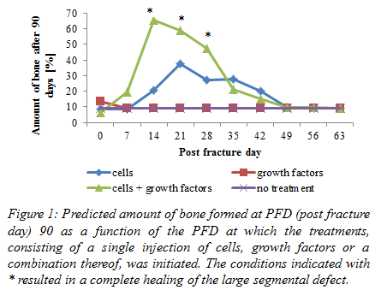

Tissue engineering - modelling

**059**

**MODELLING MASS TRANSFER IN AN EXTRACORPOREAL BIOARTIFICIAL LIVER DEVICE**

Shervin Khakpour1, Alberto Di Renzo2, Loredana De Bartolo1

1National Research Council of Italy, RENDE, Italy

2University of Calabria, DIATIC, RENDE, Italy

**Aim:** Development of extracorporeal bioartificial liver devices is often hindered by hepatocytes’ peculiar requirements. High oxygen uptake and wide range of metabolic functions in turn necessitate enhanced mass transfer rates. Unfortunately, local concentrations of nutrients and cellular products are currently impossible to measure. In this study, mass transfer modelling is employed to evaluate the cellular microenvironment in a hollow fiber membrane bioreactor (HFMBR).

**Methods:** In our convection-enhanced HFMBR, provision and removal of culture medium is realized through separate hollow fibers (HFs) in a crossed configuration, mimicking the blood capillary network. Numerical analysis of the mass transfer model for dissolved oxygen concentration (DOC) was performed using COMSOL Multiphysics. Two types of cellular compartments were considered: spheroids trapped between HFs, and a cellular layer surrounding the HFs. Advection was limited by the maximum shear stress tolerated by hepatocytes.

**Results:** Sufficient oxygen supply to a mass of cells depends on the number of constituent cells, represented here by the spheroid diameter and the layer thickness. Preliminary results indicate sufficient oxygen supply to large spheroids (400µm diameter) with DOC dropping 60% to 106μmol/L at the center, i.e. higher than DOC in periportal zone *in vivo.* However, investigation of DOC in the cellular layer suggests that the thickness should not exceed 100µm (Dlayer/Dmembrane 1.4).

**Conclusion:** The model provides deep insight into DOC in an HFMBR. It significantly facilitates optimization of the operative culture conditions, spheroid size, and seeded cell density in each system. Consequently, an *in vivo*-like microenvironment can be achieved to prolong viability/functionality of hepatocytes.

*Acknowledgement:* *Current research is funded by Marie Curie ITN “BIOART”(Project No. 316690).*

Development in mechanical support II

**060**

**AN ANATOMICAL MOCK HEART CIRCULATION LOOP WITH CONTRACTING SILICONE VENTRICLES AND AN ANATOMICAL AORTA**

So-Hyun Jansen-Park, Indra Müller, Daniel Miesel, Moritz Lommel, Simon Johannes Sonntag, Ulrich Steinseifer

Institute of Applied Medical Engineering, AACHEN, Germany

**Aim:**Mock circulation loops (MCLs) are often used as in vitro test bench to investigate VAD assisted heart circulation systems. To investigate the effect of different assisting methods on the flow distribution in the ventricle/aorta, the MCL should reproduce important natural characteristics. Besides auto regulation also contraction of the ventricles, anatomical shape of the aorta and clinical inflow/ outflow cannulation method of a VAD are of interest.

**Methods:**A MCL with systemic and pulmonary side was developed and tested. Ventricle molds were produced based on MRI data and cast with silicone, likewise for the anatomical aorta. Aramid fibers on the silicon ventricle forced the ventricle torsion. Both apexes were connected to a rotating hollow shaft enabling the rotation of the ventricle and the connection of a VAD. Each ventricle was placed in a tank filled with water and air simulating a definite compliance while the connected linear motor was expanding the ventricles throughout diastole. During that, the torsion angle (αmin, αmax) was measured at the apex and a pressure-volume loop was measured by a catheter inserted in the left ventricle.

**Results:**The aramid fibers (E-modulus: 105GPa) could partially prevent dilation of the silicon ventricle during diastole, and a contraction of the ventricle was achieved. The torsion angle had a value of αmin=3’ and αmax between 30’-45’ depending on the type of ventricle (aramid fiber angle, density and ventricle silicon thickness). Physiological pressure-volume loops with clear four phases were reached with and without connected VAD (inflow: apex, outflow: ascending aorta).

**Conclusion:**An MCL with a contracting Mock-Heart and an anatomical aorta was constructed enabling clinical cannulation methods of VADs under physiological and pathophysiological conditions. The transparent design enables following the catheterization process offering a good method for clinical training of the pressure-volume measurement system. Furthermore, detailed investigations of flow characteristics inside the ventricle/aorta become possible.

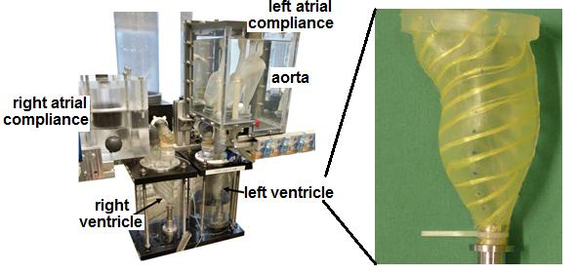  
Picture 1: An anatomical mock heart circulation loop with contracting silicone ventricles and an anatomical aort An anatomical mock heart circulation loop with contracting silicone ventricles and an anatomical aorta

Development in mechanical support II

**061**

**PIV FLOW MEASUREMENTS IN AN ELASTIC MODEL OF THE AORTIC ARCH WITH ADJUSTABLE COMPLIANCE**

Martin Buesen, Christian Arenz, Ulrich Steinseifer, Simon Sonntag

Institut of Applied Medical Engineering, AACHEN, Germany

**Aim**

The Particle Image Velocimetry (PIV) is a common optical measurement technique to perform in vitro flow investigations with a high spatial and temporal resolution. In order to provide optical accessibility the measurements have to be carried out in transparent models. These models usually lack of elasticity, which is an important property, especially of the aorta. The purpose of this study was to build a transparent elastic aortic model with an adjustable compliance, fulfilling the requirements to PIV models and to perform flow measurements on this model.

**Methods**

A transparent silicone replica of the aorta has been manufactured and fixed in a fluid filled box of Plexiglas. A mock circulation loop was connected to the aorta, in order to simulate the pulsatile heart inflow. An adjustable air chamber was connected to the fluid filled box, enabling an adjustable aortic compliance. A particle seeded transparent blood analogue fluid was used (water-glycerol). A laser light sheet illuminated the aortic outlet cross section. A camera positioned orthogonal to this plane recorded particle images and wall movements. Pressure was recorded simultaneously. The recorded images have been analyzed, regarding compliance and 2D flow fields.

**Results**

Time-resolved flow fields behind the aortic mechanical valve could be measured. Pressure curves and diameter changes of the aorta were recorded simultaneously. Herewith, the compliance could be calculated and was found to be in a range of 0.13 - 0.17 % / mmHg, which is comparable to a person of 55 - 65 years (literature data).

**Conclusion**

PIV flow measurements could be performed in a fully transparent model of the aortic arch with an adjustable compliance, overcoming present limitations in the field of aortic in vitro flow investigations regarding compliance.

Development in mechanical support II

**062**

**PROTOTYPE DEVELOPMENT AND HEMODYNAMIC ANALYSIS OF A FULL-JACKET CARDIAC ASSIST DEVICE FOR DILATED CARDIOMYOPATHY**

Yoshiaki Saito, Yasuyuki Suzuki, Ryosuke Kowatari, Norihiro Kondo, Ikuo Fukuda

Hirosaki University School of Medicine, HIROSAKI, Japan

Background and study objective

Ventricular assist devices including total artificial hearts are potent alternative or bridge therapy to heart transplants for dilated cardiomyopathy patients. However, ventricular assist devices have problems of biocompatibity, hemocompatibility, and thromboembolic events especially in younger patients. The present study examined jacket-type direct cardiac compression device using artificial rubber muscles to determine hemodynamic effects in young swine models of dilated cardiomyopathy.

Methods

Dilated cardiomyopathy was established in 6 pigs (6 - 8 weeks of rapid right ventricular pacing, average weight of 22.6 ± 2.1 kg). The device was designed using pneumatic rubber muscle (Fluidic Muscle, FESTO, Esslingen, Germany). The device can be synchronized swine hearts by sensing atrial amplitude through atrial pacemaker electrodes. Hemodynamic parameter was monitored under baseline conditions, after the assistance, and after inducing ventricular fibrillation. The device was implanted through median sternotomy. Hemodynamic data was acquired using PiCCO2, left ventricular pressure monitoring, and epicardiac echo.

Results

The device worked powerfully, coordinating with native hearts’ movements.

Direct epicardiac assistance showed significant improvement in hemodynamic data. Cardiac output improved from 1.39 ± 0.24 L/min to 1.96 ± 0.46 (p = 0.02). Stroke volume (14.5 ± 3.2 ml versus 20.1 ± 4.3 ml, p = 0.04) and ejection fraction (25.2 ± 3.6% versus 47.7 ± 7.8%, p < 0.01) were also improved after assistance. Left ventricular end-diastolic volume and pulmonary arterial wedge pressure didn’t significantly change with treatment. After inducing ventricular fibrillation by ejection of potassium chloride, cardiac output maintained 1.33 ± 0.28 L/min and systemic arterial systolic pressure maintained 74.5 ± 21.7 mmHg.

Conclusion

Jacket-type direct epicardiac assistant device demonstrated improvement in hemodynamic data in dilated cardiomyopathy model. Although there are still needs for improvements in device component, direct cardiac assistance may be a good alternative to recent heart failure device therapies.

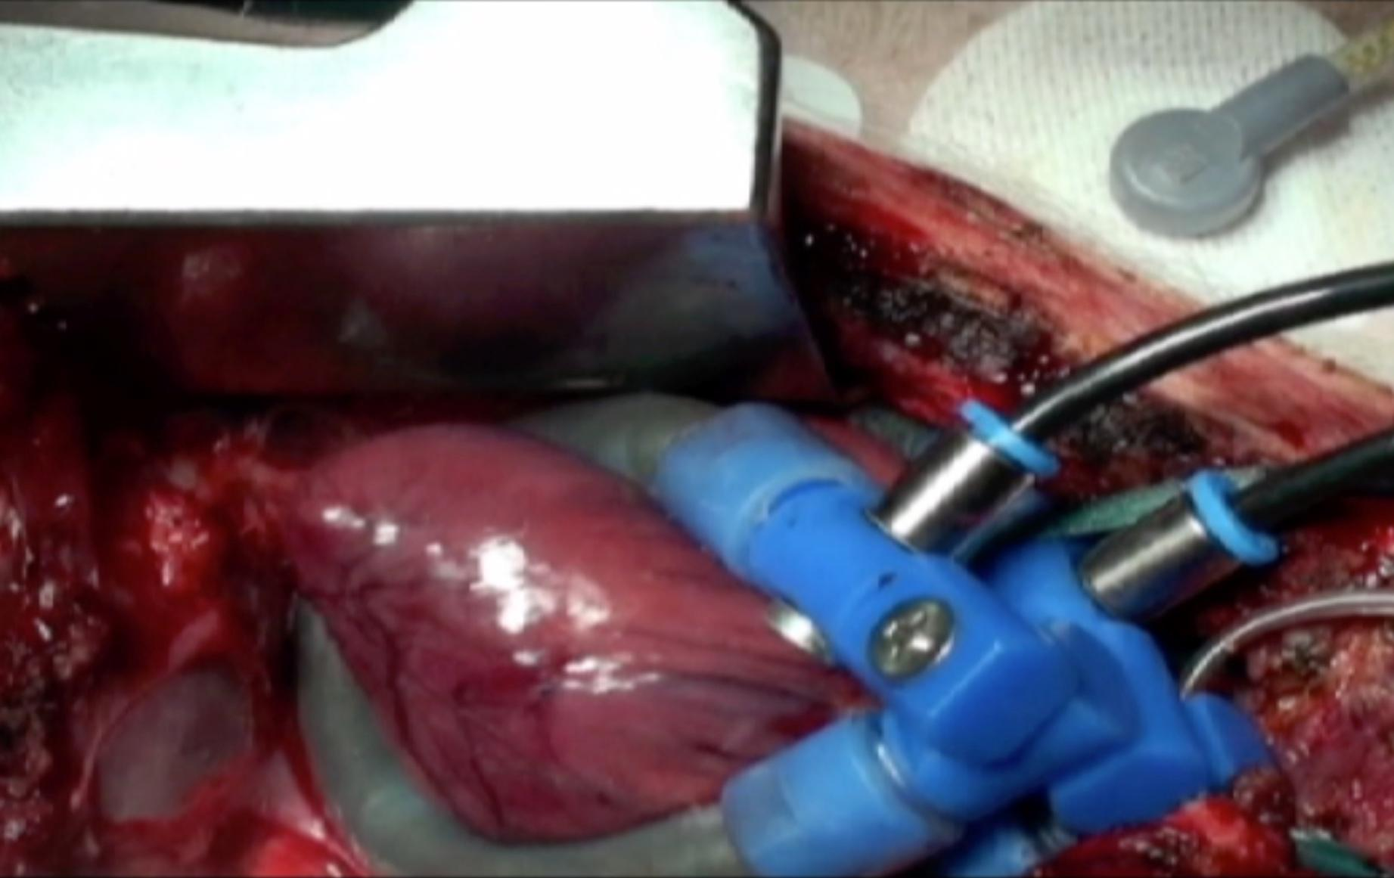

Development in mechanical support II

**063**

**GASTROINTESTINAL BLEEDING AND CONTINUOUS BLOOD FLOW: COULD HYPOPERFUSION EXPLAIN THIS RELATIONSHIP?**

Álvaro Pedraz Prieto1, Manuel Ruiz Fernández1, Carlos Amorós Rivera1, Begoña Quintana Villamandos1, Juan Francisco Del Cañizo López2

1Hospital General Universitario Gregorio Marañón, MADRID, Spain

2Laboratorio de Circulación Artificial, MADRID, Spain

Aim

It is recognized the relationship of gastrointestinal bleeding events and the loss of pulsatility of the blood flow, as seen with continuous blood flow VADs and severe aortic stenosis. What still remains unknown is the physiopathological mechanism. One of the hypothesis coined is the associated hypoperfusion of the small intestine with the consequent hypoxia and the development of angiodysplasias. In this experimental model, we analyze and compare the perfusion of the small intestine with pulsatile and non-pulsatile blood flow.

Material and Methods

22 minipigs with a mean weight of 29,5 +/- 9,6 Kg were assigned to receive one LVAD. We used two types of pulsatile VAD (Berlin Heart EXCOR® and a Tubular Pump designed in our laboratory), and one type of non-pulsatile device (BIO-MEDICUS®). For analyzing the small intestine perfusion we used coloured microspheres.

Once the pig was anesthetized and intubated, a median sternotomy was carried on. The aorta and the left ventricle apex were cannulated. Three kinds of coloured microspheres were delivered in the left atrium in three moments: before initiation of assistance (white), after 30 minutes of total assistance (orange) and after another 30 minutes of partial assistance (violet). Finally, the pig was sacrificed and biopsies of the small intestine at the terminal ileum were taken.

Results

After comparing the quantity of microspheres in partial and total assistance with the quantity of microspheres before initiation of assistance (basal conditions), no statistically significant differences were observed. Moreover, comparing the quantity of microspheres between the different pumps did not find any difference. Results are expressed as a percentage relative to basal conditions.

Conclusions

Attending to our results, non-pulsatile blood flow is not associated with hypoperfusion of the small intestine Therefore, the greater incidence of gastrointestinal bleeding events in patients with continuous blood flow cannot be explained by this situation.

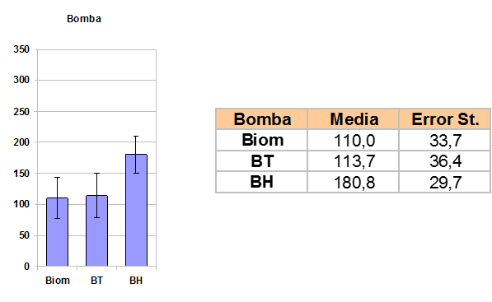  
Picture 1: Percentage of microspheres relative to basal conditions with the different LVAD in the small intestin Percentage of microspheres relative to basal conditions with the different LVAD in the small intestine

Development in mechanical support II

**064**

**TURBULENCE LENGTH SCALES IN A HEARTMATE II ROTARY BLOOD PUMP**

Chan Yong Schüle1, Max Kossatz2, Klaus Affeld1, Ulrich Kertzscher1

1Charité Universitätsmedizin Berlin, BERLIN, Germany

2Technische Universität Berlin, BERLIN, Germany

Aim

Corpuscular components of blood can be damaged or activated when exposed to external forces caused by shear. Typical fluid dynamic based models for the prediction of blood damage in artificial organs consider the mean flow shear whereas the proper incorporation of turbulence remains unclear. It is believed that the ratio of the size of turbulent structures to the size of the corpuscular blood components affects the transmission of force. Thus the objective of this work is to find out which eddy sizes are found in a clinically used rotary blood pump, which is the HeartMate II (HM II).

Methods

As the original HM II rotary blood pump does not permit turbulence measurements, a 3:1 up-scaled model with an acrylic housing is used for the research. This enables the use of a two component laser Doppler anemometry system to measure the time resolved velocity fluctuations inside the pump. Measurements were taken up- and downstream of the rotor blades. The turbulence spectrum in terms of wavenumber and turbulence energy were then evaluated at the center of the flow in order to obtain information on the size of turbulent structures or so called turbulent eddies.

Results

The Kolmogorov length scale represents the size of the smallest turbulent eddies. It was estimated to be ≈70-80 µm corresponding to ≈25µm in an original sized HMII pump model. Additional data on mean flow profiles and rms-velocity fluctuations were obtained.

Conclusion

Turbulence length scales were measured in an up-scaled model of a HM II rotary blood pump. The size of turbulent eddies is found to be larger than the largest corpuscular blood components in the center of the flow. The existence of a universal equilibrium range could be shown. Information about the length scales inside the boundary layers of the experimental model was not obtained.

Development in mechanical support II

**065**

**ESTIMATION OF LEFT VENTRICULAR PRESSURE WITH THE PUMP AS 'PRESSURE SENSOR' IN PATIENTS WITH A CONTINUOUS FLOW LVAD.**

Kim Pennings1, Frans Vosse van de2, Bas Mol de1, Marcel Rutten2

1Academic Medical Center, Amsterdam, EINDHOVEN, Netherlands

2Eindhoven University of Technology, EINDHOVEN, Nederland

**Aim** Long-term ventricular support with Left Ventricular Assist Devices (LVADs) requires intensive and frequent monitoring of the patient. To date, ventricular function is measured through echoscopic examination of ejection fraction. This yields limited information on the remaining functionality of the ventricle with the supporting pump. In this study, we aim to assess ventricular function by determining left-ventricular pressure (plv), using the LVAD as a sensor.

**Methods**The input parameters of this method are pump flow, aortic pressure and properties of the outflow graft (resistance and inertance).Pressure drop was estimated over the outflow graft (dpoutflow graft). Pressure head (dplvad) was estimated from pump flow with a static and a dynamic pump model. The estimated dpoutflow graft and dplvad and measured aortic pressure were used to calculate left ventricular pressure. Moreover, the parameters dp/dtmax and mean, minimum and maximum left ventricular pressure were derived. The method was validated with a porcine ex-vivo beating heart model, instrumented with a continuous flow VAD. Measurements were done on four hearts supported with a Micromed DeBakey VAD and three hearts supported with a Heartmate II. Data were collected at the baseline, without LVAD support and with an increasing level of LVAD support. During each measurement aortic and left ventricular pressure (pao and plv in mmHg), pump flow (Qlvad in L/min) and outlet pressure of the LVAD (dpout in mmHg) were recorded.

**Results** The estimation of left ventricular pressure was accurate for both pumps. Mean and minimum pressure were estimated with high accuracy. The degree of accuracy of the estimated plv was proportional to the degree of accuracy of the pump model.

**Conclusions** With the model, left ventricular pressure in LVAD supported patients can be monitored sufficiently reliably in case pump flow, aortic pressure and the properties of the outlet graft are determined accurately.

Build-up of vascularized tissue by 3D-Printing technologies – ArtiVasc 3D

**066**

**ARTIFICIAL BLOOD VESSEL SCAFFOLDS MADE BY 3D PRINTING**

1Sascha Engelhardt1, Nadine Nottrodt1, Jan Janhsen1, Oliver Refle², Jessica Günthel², Arnold Gillner1

Fraunhofer Institute for Laser Technology, Aachen, Germany

²Fraunhofer Institute for Manufacturing Engineering and Automation, Stuttgart, Germany

**Aim**:

For the development of multi-layered soft tissue, e.g. full-skin equivalents vascularization for cell nutrition is one of the main challenges in tissue engineering. Today most tissue engineering approaches develop tissue, which needs no vascularization like cartilage or thin cell layers. ArtiVasc 3D uses Additive Manufacturing (AM) tech-nologies, inkjet printing and stereolithography to build up branched, porous blood vessel structures which should provide cell nutrition supply.

**Methods**:

The inkjet printing and Stereolithography combination are under investigation to position photocurable materials and to build up larger vessel structure with an inner diameter of approximately 2 mm by inkjet. Process parameters which allow photocuring either by a UV-lamp or by laser based stereolithography (STL) have to be evaluated. The STL process allows structuring of thin vessel walls with a thickness of approx. 10 µm. By STL pores can be struc-tured in the vessel walls which allow the nutrition exchange between the blood and the surrounding cells.

**Results**:

It was shown that porous blood vessels can be structured in the given design just using the single STL process. Combination experiments with the inkjet printing and STL show that linear tube structures can be build.

Conclusion:

Linear and branched elastic scaffolds for blood vessels can be build. Those vessels will be used to build up a mul-ti-layered vascularized tissue.

The ArtiVasc 3D project is funded by the European Commission under the grant agreement n°263416.

Build-up of vascularized tissue by 3D-Printing technologies – ArtiVasc 3D

**067  
DEVELOPMENT OF A THREE LAYERED SKIN MODEL CONSISTING OF A FATTY TISSUE LAYER WITH DERMIS AND EPIDERMIS**

Birgit Huber1, Sandra Gehrke², Petra Kluger³ 4, Nadine Nottrodt5

1University of Stuttgart, Institute of Interfacial Process Engineering and Plasma Technology IGVP

²Beiersdorf AG, Research and Development, Hamburg, Germany

³Fraunhofer Institute for Interfacial Engineering and Biotechnology IGB, Stuttgart, Germany

4Hochschule Reutlingen, Process Analysis & Technology (PA&T), Reutlingen

5Fraunhofer Insitute for Laser Technology ILT, Aachen, Germany

**Aim**:

In vitro engineering of autologous full-skin equivalents is still a major challenge for the treatment of congenital deformities, tumor resections or high-graded burns. To date, no suitable replacement is available. Here, we evaluated the suitability of mature adipocytes and adipogenic differentiated stem cells in co-culture with fibro-blasts and keratinocytes for the composition of a full-skin equivalent.

**Methods**:

Cells were isolated from human skin tissue. Full-skin equivalents were built up by encapsulating mature adipo-cytes or stem cells into an extracellular matrix like hydrogel. This layer was overlaid by a dermis consisting of fibroblasts and an epidermis consisting of keratinocytes. Cells in the full-skin equivalents with stem cells were differentiated into the adipogenic lineage for 14 days. Subsequently, cultivation under airlift conditions for 14 days allow a stratification of the epidermis. To determine tissue morphology H&E staining was performed and compared to native skin. The expression of cell-specific markers was evaluated. To test functionality, release of several adipokines was measured.

**Results**:

Current results demonstrate that adipocytes and differentiated stem cells are suitable for the composition of full-skin equivalents. Under optimized media conditions, all cells stayed morphologically stable and a successful differentiation of the epidermal layer was possible. The tissue morphology was comparable to native skin. Ma-ture adipocytes and stem cells differentiated into the adipogenic lineage released specific adipokines. Cells in the full-skin equivalent expressed cell specific markers.

**Conclusion**:

The composition of a full-skin equivalent is possible when using mature adipocytes or adipogenic differentiated stem cells for the composition of the subcutaneous fatty tissue. Our long-term goal is the composition of large vascularized full-skin equivalents supplied by a vascular system and cultured in a bioreactor.

The ArtiVasc 3D project is funded by the European Commission under the grant agreement n°263416.

Build-up of vascularized tissue by 3D-Printing technologies – ArtiVasc 3D

**068**

**ADDITIVE MANUFACTURING (AM) BASED VASCULARISED SCAFFOLD DESIGN FOR SOFT TISSUE ENGINEERING**

Xiaoxiao Han, Chuhee Lee, Russell Harris, Richard Bibb, Julien Courseau, Jaeger Raimund, Jamel Khamassi, Claas Bierwisch, Eero Huotilainen, Jouni Partanen

**Aim**

The aim is for modelling and design of an additive manufacturing based vascular system that effectively delivers nutrients from blood to the surrounding tissue. Detailed aims can be divided as:

1. To investigate the nutrient permeation within the vascular system to the cells.

2. To identify the requirements for the blood flow through the system and provide an informed design specification.

3. To develop design tools for generating highly complex 3D CAD models of optimum vascular systems.

4. To translate 3D models into an appropriate data format for the latter additive manufacturing processes.

**Method**

Figure 1 describes the main tasks that were happened in our WP of the project. In order to obtain an optimised vascular vessel network in which nutrient can permeate and be consumed by cells sufficiently, simulations were carried out avoiding time consuming experiments. Simulation division established two main models which are 1) nutrient diffusion and 2) CFD in vascular vessels. Design criteria were obtained thanks to simulations which will guide the design work. A 2D vascular vessel topology was obtained and transferred into its 3D form ready for manufacturing using computer aided design techniques. Further customised data format are obtained from the 3D model and will be used for various manufacturing processes such as ink jetting or SLA. Printed samples were available for either biological or physical testing. A feedback would available helping optimising the simulations and parameter selections.

**Results**

Output from design and modelling work includes an established CFD model for vascular branching, a diffusion model for porous vascular wall; an automatic 3D modelling tool; and a direct slicing tool.

**Conclusion**

Simulations carried out in this project played an important role to guide designing the vascular vessel network in the skin patch. Optimised 3D vascular vessel network were obtained which gave sufficient and distributed nutrient profile.

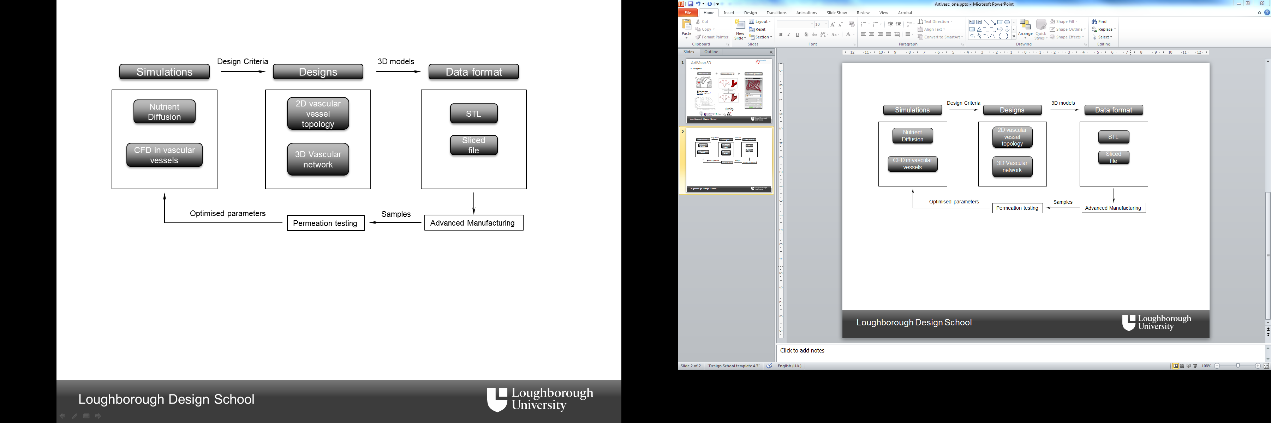

Build-up of vascularized tissue by 3D-Printing technologies – ArtiVasc 3D

**069**

**NOVEL POLYMERIC SCAFFOLDS FOR SOFT TISSUE ENGINEERING**

Matthias Schnabelrauch, Minna Malin, Jukka Seppälä, Nadine Nottrodt, Wolfdietrich Meyer

Fraunhofer Institute for Lasertechnology, Aachen

**Aim**: ArtiVasc 3D is a multinational, interdisciplinary project aiming to develop an artificial vascularized skin substitute. The three layered-skin model consists of dermal and epidermal cell layers completed with vascu¬larized bioartificial fatty tissue. The generation of such a complex tissue substitute sets high demands for material syntheses, properties and processing. The scaffold material should fulfill the requirements for soft tissue engineering and serve as a framework for cell co-culturing and proliferation. A material for 3D printing of a functional vascular network is needed.

**Methods**: Polymeric biomaterials play an important role in engineering of tissue constructs. In this new approach vascularized soft tissue scaffolds are produced of hydrogels combined with electrospun meshes and 3D printed vascular structures. First screening of suitable materials was based on their chemical, physical, ther¬mal and mechanical properties followed by studies related to processability, stability and cytocompatibility. Further studies on biofunctionalization, cell cultivation and in vivo behavior are ongoing.

Results: Hydrogel formation of a variety of photochemically crosslinkable biopolymers crylated/methacrylated hyaluronic acid and methacrylated gelatin) and their stability is proven. Electrospinning parameters for many biodegradable thermoplastic polymers have been clarified and materials processed into fleeces. Typically the fleeces consist of fibers with micrometer scale fiber diameters. Photocurable materials have been developed with tailored viscosity profiles and crosslinking rates for 3D printing of elastic vessel structures. Cytocompati¬bility has been evaluated for the most promising materials.

**Conclusion**: Within ArtiVasc 3D project we have been able to successfully produce materials for each scaffold component, i.e. vascular structure, hydrogel and surrounding fleece, with respect to processing methods. These materials will be further optimized to build up a multilayered vascularized tissue.

The ArtiVasc 3D project is funded by the European Commission under the grant agreement no263416.

Build-up of vascularized tissue by 3D-Printing technologies – ArtiVasc 3D

**070**

**BIOPLOTTING OF INTERCONNECTED HYDROGEL SCAFFOLDS BASED ON MODIFIED PLURONIC F-127**

Mieke Vandenhaute1, Elien Gevaert1, Ria Cornelissen1, Cathérine Verfaillie2, Peter Dubruel1

1Ghent University, GENT, Belgium

2University of Leuven, LEUVEN, Belgium

**AIM** Hydrogels composed of Pluronic® F127 derivatives were investigated as possible HepG2 cell supports to assess their applicability for tissue engineering purposes. To enable the production of complex three-dimensional and fully interconnected scaffolds, the Bioplotter[TRADEMARK] technology was applied.

**METHODS** For the synthesis of photo-polymerizable Pluronic® F127-BMA and F127-Ala-L, methacryloyl chloride was applied, thereby introducing methacrylate end-groups. For the bio-inspired enzymatic pathway, phenolic end-groups were introduced (F127-SATA and F127-PNCTA). The macromonomers were characterized for their micelle formation and gelation behaviour. The hydrogels were characterized for their sol/gel fractions, their temperature-dependent swelling properties, their mechanical properties (i.e. texturometry) and drug release profiles. The 3D construction of the scaffolds occurred in a laminar fashion through a computer-controlled deposition of the material. Finally, the hydrogels were applied as encapsulation matrices for HepG2 cells and cell viability studies were performed.

**RESULTS** The Pluronic® derivatives were successfully synthesized, showing a high degree of substitution (>90%). The hydrogels developed were characterized in depth and were suitable to be applied as starting materials to fabricate 3D scaffolds using the Bioplotting[TRADEMARK] process (see fig. 1). Preliminary biocompatibility and cell viability studies using HepG2 indicated that the enzymatic crosslinking strategy showed a significant positive effect on the cell viability of the HepG2 cells.

**CONCLUSIONS** The results indicated that 3D scaffolds can be successfully developed starting from various Pluronic® F127 derivatives and by applying different crosslinking strategies. At present, the potential of the scaffolds developed to function as cell carriers is further evaluated. Future work will focus on the fine-tuning of the biocompatibility as well as on the 3D Bioplotting of hydrogels containing encapsulated cells.

**ACKNOWLEDGEMENT** The authors would like to acknowledge the research Foundation Flanders (FWO-Flanders) and the IWT (Agency for Innovation by Science and Technology, Belgium, IWT-SBO HEPSTEM project) for the financial support.

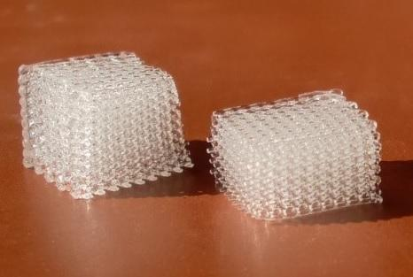  
Picture 1: Fig. 1: Hydrated 3D scaffolds based on Pluronic® F127-BMA, fabricated by th Fig. 1: Hydrated 3D scaffolds based on Pluronic® F127-BMA, fabricated by the Bioplotting[TRADEMARK]process

Build-up of vascularized tissue by 3D-Printing technologies – ArtiVasc 3D

**071**

**ADDITIVE MANUFACTURING OF CERAMICS-BASED BIOMATERIALS FOR APPLICATIONS IN BONE TISSUE ENGINEERING**

Martin Schwentenwein, Johannes Homa

Lithoz GmbH, VIENNA, Austria

Due to their high precision and accuracy, additive manufacturing (AM) technologies based on photopolymerization have gained increasing interest for the application in tissue engineering (TE). Because of the nature of photopolymerization, scaffolds based on this fabrication technology were usually based on polymers. Nonetheless, due to the similarity to native bone tissue, compounds based on bioresorbable ceramic materials such as tricalcium phosphate (TCP) would have preferable properties for this application.

This work presents results regarding the shaping of TCP-based materials by means of the recently introduced Lithography-based Ceramic Manufacturing (LCM) technology, which is a slurry-based process that relies on the selective curing of photosensitive ceramic suspension.

The layer-by-layer principle of this method enables the fabrication of highly intricate structures with virtually no limitations regarding geometrical complexity and enables the fabrication of highly complex architectures. Features like defined channels with diameters around 200 µm or a wall and strut thickness of down to 150 µm can already be realized. By using newly developed non-toxic photocurable monomers it is also possible to produce highly biocompatible and bioresorbable composites based on TCP. By treating the fabricated composites at elevated temperatures it is also possible to remove the organic matrix and sinter the TCP particles together to give the neat ceramic bodies. By optimizing the slurry preparation und adding various dopants it was possible to achieve improved bending strength of 33 MPa while still maintaining the same level of microporosity of 15 % for the neat TCP. Results of currently ongoing in vitro- and in vivo-studies show good biocompatibility of these new materials and underline the potential of this new manufacturing paradigm for TE applications.

Scaffolds, cellular structures or parts with defined macroporosity can be shaped by means of LCM in order to provide environments for cells to adhere, migrate and proliferate throughout the structure.

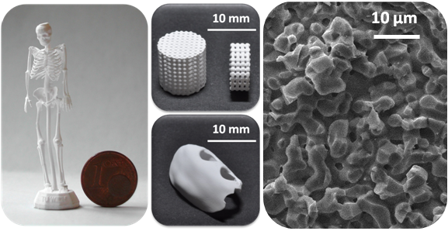  
Picture 1: Photographs and SEM images from TCP parts manufactured using LCM technolog Photographs and SEM images from TCP parts manufactured using LCM technology

Modelling VAD's

**072**

**VERIFICATION OF A NUMERICAL MODEL TO SIMULATE THE CAVO-PULMONARY ASSISTANCE IN FONTAN CIRCULATION**

Arianna Di Molfetta1, Ferrari Gianfranco2, Fresiello Libera3, Maria Giovanna Trivella2, Amodeo Antonio1

1Pediatric Hospital Bambino Gesù, VATICAN CITY, Italy

2Institute of Clinical Physiology, CNR, ROME, Italy

3Catholic University of Leuven, LEUVEN, Belgium

AIM: The use of ventricular assist devices (VAD) for the cavopulmonary assistance in Fontan is challenging. The lack of an established experience leads to the needs of dedicated VADs development and animal experiments. A dedicated numerical model could support clinical and experimental strategies design and new VADs testing. This work aims at performing a preliminary verification of a lumped parameter model of the cardiovascular system to simulate Fontan physiology and the effect of cavo-pulmonary assistance using experimental data reported in literature.

METHODS: Echocardiographic and haemodynamic data of 4 pigs were used to simulate animals baseline, Fontan circulation and cavopulmonary assisted condition to compare measured (Me) and simulated (Sim) data.

RESULTS: Numerical models can well reproduce experimental data (cardiac output [l/min]: Me= 2.8±1.7, Sim=2.8±1.8; ejection fraction [%]: Me=57±17, Sim=54±17; arterial systemic pressure [mmHg]: Me= 41.8±18.6, Sim=43.8±18.1; pulmonary arterial pressure [mmHg]: Me=15.4±8.9, Sim=17.7±9.9; caval pressure [mmHg]: Me=6.8±4.1, Sim=7±4.6) . In addition, the model permits to evaluate the trend of some haemodynamic variables: the diastolic elastance remains quite constant, whilst the systolic elastance, the arterial systemic and the arterial pulmonary resistances increase (10%,69%,100%) passing from the biventricular circulation to the Fontan physiology and then decrease (21%, 39%, 50%) once the VAD was implanted. From energetics point of view the ventricular external work decreases (71%) passing from the biventricular circulation to the Fontan physiology and it increases three times after the VAD implantation in parallel with the VAD power consumption.

CONCLUSION: A numerical model could support clinicians in an innovative and challenging field as the use of VAD to assist the Fontan physiology and, in particular, it could be helpful to personalize the VAD insertion on the base of ventricular systo-diastolic function, circulatory parameters such as peripheral and pulmonary resistances and energetic variables such as ventricular external work and VAD power consumption.

Modelling VAD's

**073**

**INFLUENCE OF A FLEXIBLE INLET VALVE ON THE FLOW PATTERN INSIDE THE PAEDIATRIC VENTRICULAR ASSIST DEVICE**

Damian Obidowski1, Piotr Reorowicz1, Przemyslaw Klosinski1, Roman Kustosz2, Artur Kapis2, Krzysztof Józwik1

1Lodz Univeristy of Technology, LODZ, Poland

2Foundation of Cardiac Surgery Development, ZABRZE, Poland

Aim: In the present study, a new flexible valve for the Paediatric Ventricle Assist Device (PVAD) is shown and evaluated. A tilting artificial mechanical valve has been replaced by a specially designed flexible one in the form of an elliptical petal. Mechanical artificial valves generate usually relatively high shear stresses and cause an excessive blood backflow. The new valve has to solve these problems, especially in the paediatric device. An evaluation of this new flexible valve by means of an estimation of the blood backflow, as well as a determination of potential blood stagnation areas are the main aims of the conducted analysis. Advanced numerical simulations have been used to visualize the flow pattern inside the PVAD.

Methods: Numerical simulations under unsteady conditions in the time domain have been used to model a pulsating character of the artificial ventricle operation. A combination of three techniques has been used to simulate the flow pattern inside the chamber. A controlled deformation of the mesh has been used to obtain volume of the chamber changing in time. An Immersed Body technique has been implemented to simulate the motion of the outlet valve. The Fluid Structure Interaction (FSI) method has been used to model the operation of the newly designed flexible inlet valve. The viscosity of blood has been modelled versus shear rate.

Results: A combination of three methods - mesh deformation, Immersed Body technique, and FSI - has allowed one to visualise the real operation of the PVAD. The designed flexible valve strongly influences the flow pattern inside the chamber.

Conclusions: The results of conducted simulations have shown that the newly designed flexible inlet valve has improved the flow structure inside the chamber. The obtained areas of stagnation zones have significantly lower values.The valve applied in the PVAD has decreased the blood backflow.

Modelling VAD's

**074**

**TOWARDS A BETTER UNDERSTANDING OF HEMOLYSIS: PARTICLES' SHEAR STRESS HISTORIES IN A VENTRICULAR ASSIST DEVICE (VAD)**

Lena Wiegmann, Diane De Zelicourt, Vartan Kurtcuoglu

University of Zurich, ZÜRICH, Switzerland

Aim

Hemolysis is an important risk factor that leads to increased morbidity and mortality of patients with artificial organs. Hemolysis has been associated with shear stress, but little is known about the exact impact of these fluid stresses on erythrocyte survival. This is in part due to the large parameter space, with its relevant shear stress levels and temporal variations; too large to be probed experimentally. Using the example of a continuous flow VAD, we show how computational flow modeling coupled with systematic analysis of possible erythrocyte flow paths through the device can be used to reduce this parameter space, enabling subsequent experimental analysis.

Methods

Transient flow fields inside the VAD under normal operating conditions were simulated in StarCCM+, a commercial computational fluid dynamics code, using a rotation speed of 4500rpm and 100mmHg adverse pressure gradient. To probe possible erythrocyte paths, 5700 particles were seeded at the inlet and passively advected by the flow. Particle location, velocity and shear stress were extracted at each time step.

Results

The shear stress history of erythrocytes is inherently related to their paths (upper figure). Identified parameters of interest include shear stress magnitude, temporal gradients, number of exposures to mid or elevated stresses and frequency of these exposures. The lower figure shows the potential for post-processing: A finite number of levels is defined for each parameter based on all recorded particle histories, setting ranges for experimental investigations, while correlations between parameters (e.g. absolute vs. temporal shear stress gradients) provide a probability measure for these events.

Conclusion

Our analysis allows for a device-specific assessment of the shear stress patterns that are actually experienced by erythrocytes flowing through a VAD. Such analysis sets the frame for future experimental investigations, and might ultimately help us to identify the exact conditions leading to hemolysis.

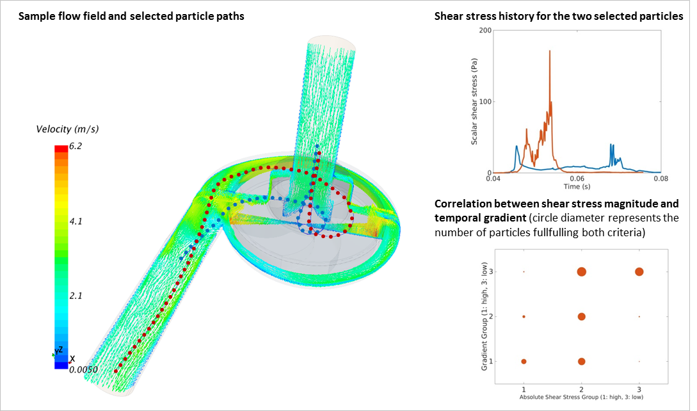

Modelling VAD's

**075**

**CFD BASED OPTIMIZATION OF A SEMI-OPEN IMPELLER CENTRIFUGAL PUMP FOR CIRCULATORY SUPPORT**

Dariusz Wozniak, Damian Obidowski, Adam Papierski

Lodz University of Technology, LODZ, Poland

Aim: In many cases, the use of rotary circulatory ventricular assist devices is followed by mechanical blood trauma. It has been demonstrated that both the exposure magnitude and time affect the haemolytic effect of shear stress. The optimization of a semi-open impeller of the centrifugal pump is presented. The objective function is the red blood cell plasma rupture minimization by means of the CFD model correlating the exposure time and shear stress. It is to be obtained by modification of main impeller geometrical parameters.

Methods: A parametrized geometrical model of a semi-open impeller of the centrifugal pump was used to generate a series of model variants. A mesh was generated and a CFD analysis was conducted in each geometrical variant. A multiobjective optimization procedure was used to minimize the shear stress vs. the time of blood cell exposition. Stagnation areas, recirculation zones, excessive velocity gradients and cavitation were minimized. The quasi-Newton gradient method enabled an application of the Implicit Filtering algorithm in the case of the objective function characterized by some noise.

Results: A sensitivity study was performed and variables having the highest influence onto the objective function were selected on the basis of the results of numerical simulations. Knowing these variables, the optimization procedure was divided into levels. In the first step, optimization was performed for selected variables having the highest impact onto the objective function. In the next step, other variables were used to minimize the objective function.

Conclusions: It has been shown that through the selected optimization procedure, it was possible to improve flow parameters. The multilevel approach allowed one to shorten significantly the computational time needed to obtain the final solution.

Modelling VAD's

**076**

**OPTIMISATION OF CFD HAEMOLYSIS MODEL COEFFICIENTS TO ENABLE ACCURATE PREDICTION OF HAEMOLYSIS PERFORMANCE IN VADS**

Alessandra Molteni1, Kate Fraser1, Haitham Yousef2, Kenny Low2, Sam Rolland2, Graham Foster1

1Calon Cardio- Technology LTD, SWANSEA, United Kingdom

2Astute, Swansea University, SWANSEA, United Kingdom

**Aim:**

Previously our CFD model was able to provide an estimate for haemolysis that showed a good relative correlation to lab data, but it was inaccurate in absolute terms, one order of magnitude greater. This study aimed to investigate a numerical haemolysis formulation capable of an improved absolute blood damage prediction across a range of operational conditions and in VADs with significant geometrical differences.

**Method:**

The normalized index of haemolysis (NIH) was computed using a scalar transport model and a particle tracking model. Mathematically, haemolysis was modelled as a power law function of shear stress (τ) and exposure time (Δt). The model parameters are determined from fitting the VADs experimental haemolysis values. Haemolysis experiments were carried out at different flow rates and pump speeds. It was found that the model coefficients are dependent on the operating conditions. Fitting was carried out in two stages: fitting flow rate dependency followed by fitting pump speed dependency. The fitted haemolysis equation, below, includes a scaling factor that is a function of flow rate (m) and pump speed (Ω), and it was used in conjunction with CFD particle tracking,

NIH=C'·(Ωn/m)·(∑ Δt·τβ/α)α

The scalar transport method used a formulation described by Taskin et al. (2012) with a modified source term (S),

S=ρ·(Hb·C'·(Ωn/m)·τβ)1/α , Hb= plasma free hemoglobin

**Results:**

So far we had significantly improved the absolute haemolysis estimate [g/100L] when modelling the Centrimag:

1l/min; 2250rpm- NIHLAB=0.001817; NIHPT=0.001775;

5l/min; 2250rpm- NIHLAB=0.000300; NIHPT=0.000299; NIHST=0.000229;

5l/min; 3300rpm- NIHLAB=0.003250; NIHPT=0.003250; NIHST=0.002723;

10l/min; 2250rpm- NIHPT=0.000161; NIHST=0.000098;

**Conclusion:**

This work is currently ongoing. The absolute haemolysis estimate has been significantly improved compared to our previous CFD model. The PT is predicting absolute haemolysis to within 5% of the lab value and the ST within 25%. Next steps are to expand the geometries of pumps tested including Calon new MiniVAD.

Modelling VAD's

**077**

**HAEMODYNAMIC EFFECTS OF VAD IMPLANTATION ON NORWOOD, GLENN AND FONTAN CIRCULATION: A SIMULATION STUDY**

Arianna Di Molfetta1, Ferrari Gianfranco2, Gagliardi Maria Giulia1, Toscano Alessandra1, Fresiello Libera3, Maria Giovanna Trivella2, Amodeo Antonio1

1Pediatric Hospital Bambino Gesù, VATICAN CITY, Italy

2Institute of Clinical Physiology, CNR, ROME, Italy

3Catholic University of Leuven, LEUVEN, Belgium

AIM: The growing population of failed single ventricle (SV) patients might benefit from VAD support as a bridge to heart transplantation. However, the documented experience is limited to isolated case reports. Considering the complex and different physiopathology of Norwood, Glenn and Fontan patients and the lack of established experience, the aim of this work is to realize and test a lumped parameter model of the cardiovascular system able to simulate SV haemodynamics and VAD implantation effects to support clinical decision.

METHODS: Haemodynamic and echocardiographic data of 30 SV patients (10 Norwood, 10 Glenn and 10 Fontan) were retrospectively collected and used to simulate patients baseline. Therefore, the effect of VAD implantation was simulated.

RESULTS The numerical model can well reproduce patients baseline. Simulation results suggest that the implantation of VAD: (a) increase the cardiac output and the mean arterial systemic pressure in all the three palliation conditions with the highest increment in the case of Norwood palliation (Norwood 41.8% and 31.6%, Glenn 27.6 and 24% and Fontan 18.7% and 15.3%); (b) decreases the SV external work with the highest decrement in the case of Fontan physiology (Norwood 13.1%, Glenn 27% and Fontan 44.5%); (c) decreases the pressure pulsatility index more evidently in the Norwood palliation (Norwood 82.7%, Glenn 69.9% and Fontan 67.8%); (d) increase the pulmonary arterial pressure in particular in the Norwood circulation (Norwood 31.6%, Glenn 11.5% and Fontan 5%).

CONCLUSION: The use of numerical models could be helpful in this challenging and innovative field to study the effect of VADs implantation on SV physiology patients and in particular to support patient and VAD selection to optimize the clinical outcome.

Uremic toxicity

**078**

**A NOVEL, HUMAN, IN VITRO MODEL TO EVALUATE TOXICITY OF UREMIC RETENION SOLUTES( AND DRUGS).**

Tino Vollmer1, Andreas Fröhlich2, Vera Jankowski3, Griet Glorieux4, Leif Abramsson5, Raymond Vanholder4, Joachim Jankowski3, Bernd Stegmayr2

1Umea University,, UMEA, Sweden

2Dept. Public Health and Clinical Medicine, Umea University, UMEA, Sweden

3Institute for Cardiovascular Research, RWTH Aachen University, AACHEN, Germany

4Nephrology Section, Department of Internal Medicine, Uiversity of Ghent, GHENT, Belgium

5Surgical and Perioperative Science, Urology and Andrology, Umea University,, UMEA, Sweden

Substances retained in the body of patients with chronic kidney disease are denominated uremic retention solutes (URS). Since not all may cause toxic effects their biological effects have to be evaluated .

**The aim** of this study was to develop an “in vivo”method, using human spermatozoa, to estimate toxic effects of various URS.

**Material and methods:** Semen from healthy donors were used as well as ultrafiltrate derived from the blood of uremic patients performing hemodialysis. The semen was diluted to optimal concentration of spermatozoa to allow investigation of the motility and vitality of the spermatozoa under various conditions. The motility over time of spermatozoa was counted using a Bürker chamber and video recording. Incubation was performed to evaluate the effect of the buffer and the URS. Vitality was analyzed at different time intervals, using a Sperm VitalStainÔ kit. Adjustment calculations for the time-effect on motility and vitality were used.

**Results:** The semen was investigated for spermatozoa function in the presence of various buffers used for dilution. The buffer maintaining the best motility over time was selected. Vitality was similarfor all tested buffers. The ultrafiltrate obtained from dialysis patients was prepared with sepharose into 6 different fractions. The more hydrophobic fraction 5 exhibited an overall significant toxic effect while such effect was not obvious for the first more hydrophilic fractions. Additional investigation was performed in the presence of four different drugs, at concentrations that are administered to uremic patients. Drug A resulted in a significant reduction of spermatozoa motility but not vitality, while such negative effect was not found with the other drugs.

**Conclusion:** This novel “in vivo”model consistently demonstrated toxic/non-toxic effects on motility and vitality of spermatozoa. It is useful to investigate biological effects of URS but also of various drugs.

Uremic toxicity

**079**

**PLASMA ADROPIN LEVEL IS ASSOCIATED WITH RESIDUAL DIURESIS AND PROTEIN-ENERGY WASTING IN HEMODIALYSIS PATIENTS**

Leszek Niepolski1, Anna Sowinska2, Grzegorzewska Alicja E.3

1B.Braun Avitum Poland, NOWY TOMYSL, Poland

2Department of Computer Science and Statistics, University of Medical S, POZNAN, Poland

3Department of Nephrology, Transplantology and Internal Diseases, Poznan Unive, POZNAN, Poland

**Aim**: Adropin is a recently identified protein that has been implicated in the maintenance of energy homeostasis and insulin resistance in subjects with preserved renal function. In end-stage renal disease, nutritional status and the insulin requirement are associated with residual diuresis (RD).We aimed to check whether plasma adropin is involved in mentioned relationships in hemodialysis (HD) patients.

**Methods**: HD patients (n = 50, age 65±12 years, 27M, 25 with type 2 diabetes mellitus-T2DM, dialysis vintage 36.6±29.4 months) were assigned into groups according to the tertiles of RD (mL/24hrs): RD < 250, RD 250 - 799, and RD ≥ 800. Anthropometric measures were taken. Plasma samples were collected for adropin (enzyme-linked immunosorbent assay)and for routine biochemistry. Insulin resistance was assessed by the Homeostasis Model Assessment for Insulin Resistance (HOMA-IR).

**Results**: In whole HD group, there was a correlation (r = -0.339, p = 0.015) between plasma adropin level (3.38±1.84 ng/mL) and RD (657±635 mL/24 hrs).HD patients showing RD < 250 mL/24hrs had plasma adropin concentration higher (4.43±2.05 ng/mL) than that (2.74±1.7 ng/mL) shown in subjects with RD≥ 800 mL/24hrs (p = 0.018), whereas their mean annual plasma albumin concentration was lower (3.57±0.32 vs 3.89±0.23 g/dL, p = 0.011).There was no significant difference (p = 0.7) in plasma adropin level between T2DM group (3.34±1.78 ng/mL) and non-diabetics (3.33±1.93 ng/mL), but only in the latter group plasma adropin level showed correlations with plasma insulin level (r = -0.460, p = 0.02), HOMA-IR (r = -0.414, p = 0.039), body dry weight (r = -0.410, p = 0.041), and borderline with BMI (r = -0.390, p = 0.053).

**Conclusion**: In HD patients, plasma adropin concentrationis inversely related to RD associated protein wasting. In non-diabetic HD patients, higher plasma adropin concentrations additionally indicate lower insulin resistance and anthropometric nutritional indices.

Uremic toxicity

**080**

**VISCERAL ADIPOSITY AS A RISK FACTOR FOR HYPOGONADISM IN MALE CHRONIC KIDNEY DISEASE PATIENTS**

Gabriela Cobo1, Antonio Carlos Cordeiro2, Fernanda Cassullo Amparo2, Celso Amodeo2, Paloma Gallar3, Bengt Lindholm1, Peter Stenvinkel1, Juan Jesus Carrero1

1Karolinska Institutet, STOCKHOLM, Sweden

2Dante Pazzanese Institute of Cardiology, SAO PAULO, Brazil

3Severo Ochoa Hospital, MADRID, Spain

**Aim**: Testosterone deficiency (hypogonadism) is a common endocrine disorder among patients with chronic kidney disease (CKD) that associates with comorbid complications and increased mortality. The risk factors underlying this condition in CKD are still not well characterized. In the general population, visceral adiposity is proposed to contribute to testosterone deficiency via aromatization to estradiol and leptin-effects on testosterone production. We here tested whether visceral adiposity is associated with low testosterone levels in male patients with CKD.

**Methods**: Cross-sectional study including 172 consecutive non-dialyzed men [median age 61 (45-75) years] with CKD stages 3-5, and serum testosterone assessment. Hypogonadism was defined as testosterone <10 ng/ml. Visceral adiposity was quantified by abdominal CT scanning, and indirectly by the measurement of waist circumference.

**Results**: Median testosterone level was 11.7 (7.3-18.4) nmol/L. As many as 52 (30%) patients had hypogonadism. Hypogonadal men presented higher BMI [29 (24-38) vs 28 (22-34) kg/m2; p=0.03], waist circumference [101 (85-122) vs 97 (83-112) cm; p=0.03]; and visceral adiposity [200 (65-356) vs 166 (39-287) cm2; p=0.01) than patients with testosterone >10 ng/ml. In linear multivariate regression analysis controlling for known confounders, testosterone levels were independently associated with both visceral adiposity and waist circumference. Further adjustment for estradiol as a mediator did not materially modify this, while the statistical significance was lost after adjustment for leptin concentration.

**Conclusion**: Higher visceral adiposity was associated with lower testosterone levels in men with chronic kidney disease, suggesting that factors linked to obesity may reduce circulating levels of testosterone. This association was independent of levels of circulating estrogen implying that conversion of testosterone to estrogen in the adipose tissue may not be a main mechanism.

Uremic toxicity

**081**

**THE NEW UREMIC TOXINS DIADENOSINE PENTAPHOSPHATE AFFECTING THE GLOMERULAR FILTRATION RATE**

Vera Jankowski1, Andreas Patzak2, Joachim Jankowski1

1RWTH University of Aachen, AACHEN, Germany

2Charité, BERLIN, Germany

**Introduction:** Mechanisms and participating substances responsible for the reduction of glomerular filtration (GFR) rate in contrast induced acute kidney injury (CI-AKI) are still matter of debate. Here we hypothesize that diadenosine polyphosphates are released by the action of contrast media and may act on glomerular arterioles thereby reducing GFR.

**Methods:** Rat tubules were freshly isolated using a modified iron oxide sieve technique and treated with iodixanol (47 mg iodine/ml) at 37°C for 20 min. The supernatant was analyzed regarding the content of ApnA (n=3-5) by using reversed phase chromatography, affinity chromatography and Maldi-MS. Concentration response curves for ApnA (n=3-5, 10-12-10-5 mol/l) were measured in isolated perfused glomerular arterioles. The GFR was obtained in conscious mice by inulin clearance.

**Results:** Treatment of tubules with iodixanol increased the concentration of ApnA (n=3-5) significantly in the supernatant. ApnA (n=3-5) reduced afferent arteriolar diameters dose dependent, but did not influence efferent arterioles. Ap5A acted strongest; its effect weakened with time. Suramin blocked the Ap5A effect. Further, application of Ap5A in conscious mice significantly reduced the GFR.

**Conclusion:** The data indicate that contrast media induced release of Ap5A act differentially on glomerular arterioles resulting in the reduction of the GFR. This mechanism may add to the reduced GFR in CI-AKI.

Uremic toxicity

**082**

**WHAT POROSITY IS REQUIRED FOR OPTIMAL MIDDLE TO LARGE MOLECULAR WEIGHT & ALBUMIN BOUND URAEMIC TOXIN MARKERS REMOVAL?**

Yishan Zheng1, Susan Sandeman1, Carol Howell1, Ganesh Ingavle1, Elisaveta Snezhkova2, Oleksandre Kozynchenko3, Sergey Mikhalovsky4

1University of Brighton, BRIGHTON, United Kingdom

2RE Kavetsky Institute of Experimental Pathology, Oncology and Radiobiology, KIEV, Ukraine

3MAST Carbon International Ltd, BASINGSTOKE, United Kingdom

4School of Engineering, Nazarbayev University, ASTANA, Kazakhstan

**Aim:** Standard medical grade activated carbons (ACs) with micropores (<2nm) and small mesopores (2-10nm) cannot adsorb many of the high molecular weight and protein bound biotoxins most detrimental to health. The removal of these molecules remains one of the key challenges in the optimisation of haemoperfusion devices. This study aims to explore the impact of increasing the porosity of polymer resin derived AC beads on haemocompatibility and adsorption profile in order to optimise the porosity of these beads for use in haemoperfusion.

**Method:** A selection of AC beads synthesised with varying pore size distribution ranging from 75 to 560 nm mean diameter were characterised using SEM and mercury porosimetry. The impact of increasing pore size distribution and dextran coating on dust formation and adsorption efficacy were investigated for biotoxin size markers bilirubin, vitamin B12, IL-6 (1ng/ml), TNFα (1 ng/ml), p-CS (250 µM) and IS (125 µM) using spiked human plasma. Platelet activation and fibrinogen adsorption were measured in healthy blood donor studies using flow cytometry and coagulometry, assessing platelet activation and fibrinogen adsorption.

**Results:** Increasing the pore size distribution of the AC beads into the macroporous range increased dust formation and reduced adsorption of marker biotoxins. A slight reduction in fibrinogen occurred with increased macroporosity. No platelet activation was observed. Coating reduced dust formation, did not affect biotoxin adsorption, fibrinogen adsorption or platelet activation.

**Conclusion:** The nanoporous AC beads with a mean diameter of 75 nm were optimal haemoadsorbents, showing low dust formation, high adsorption capacity and good haemocompatibility. Surprisingly, increasing porosity into the macroporous range (>100 nm) reduced adsorption efficacy for large biomolecules and increased dust formation. Dust formation was reduced by dextran coating without effecting haemocompatibility.

Uremic toxicity

**083**

**EXPLORING PROTEIN BINDING OF URAEMIC TOXINS IN CHRONIC KIDNEY DISEASE AND HAEMODIALYSIS PATIENTS**

Olivier Deltombe1, Wim Van Biesen1, Griet Glorieux1, Ziad Massy2, Annemie Dhondt1, Sunny Eloot1

1Ghent University, GENT, Belgium

2Amiens University Hospital, AMIENS, France

**Aim** Several protein-bound uraemic toxins are known to accumulate in patients with chronic kidney disease (CKD). As protein binding is not well understood neither in CKD progression, nor during a haemodialysis session, we studied protein binding in two cross-sectional studies.

**Methods** Ninety-five CKD2-5 patients were included from Amiens University Hospital (France), and ten stable haemodialysis patients from Ghent University Hospital (Belgium). Blood samples were taken during routine ambulatory visit (CKD patients) and from inlet blood line at 0, 30, 60, 120, and 240min and from outlet blood line at 30 and 120min during dialysis (HD patients). Total and free concentrations were determined of *p*-cresylglucuronide (pCG) (only in HD patients), hippuric acid (HA), indole-3-acetic acid (IAA), indoxyl sulphate (IS) and *p*-cresylsulphate (pCS). Percentage protein binding (%PB) was calculated from measured total and free concentrations.

**Results** Over the stages of CKD, %PB was in the range 38-43% (HA), 60-68% (IAA), 77-92% (IS), and 93-94% (pCS). For the highly bound IS, %PB was inversely correlated with renal function (R=-0.64; P<0.001). During an HD session, %PB of the weakly bound pCG was not changing, while it was increased after 120min for HA, and after 240min for the highly bound IAA, IS, and pCS. During one-pass through the dialyser, %PB for pCG was again not changing, while it was increased at 120min for HA, and at 30 and 120min for IAA, IS and pCS.

**Conclusion** Percentage protein binding of IS was higher in more advanced CKD. %PB was also increased during one-pass through the dialyser as well as during the dialysis session, most pronounced for the highly bound solutes IAA, IS, and pCS. These findings imply that there is a slow release of bound solute from the ligand-protein, resulting in fast exhaustion of free (dialysable) solutes and hampered removal.

Cardiac tissue & blood vessels

**084**

**MACROSCOPIC MODIFICATIONS OF ELECTROSPUN VASCULAR GRAFTS TO AVOID KINKING**

Marc Mueller, Michael Bode, Benjamin Krolitzki, Alexandros Repanas, Holger Zernetsch, Birgit Glasmacher

Leibniz Universitaet Hannover, HANNOVER, Germany

**Aim**

A major challenge in vascular tissue engineering is to develop a graft which avoids a life-threatening stenosis induced by graft kinking. In general, mechanical properties of electrospun scaffolds are stiffer compared to the surrounding native tissue. This study aims to develop a method to modify macroscopic scaffolds structure in order to fabricate a highly flexible vascular scaffold.

**Methods**

Tubular scaffolds were spun from polycaprolactone (170 mg/ml) dissolved 2,2,2-trifluoroethanol. Mandrel collectors were structured using four different screw-like patterns (30°-, 60°-, 90°-, 120° V-thread). A flow-bending test setup had to be developed to measure decrease in volume flow at different bending angles. In addition, macroscopic graft structure, fiber deposition and mechanical properties were determined using scanning electron microscopy and uniaxial tensile testing.

**Results**

Scaffolds fabricated with a 30° - 90° collector showed great appearance of gap-spinning whereas a homogeneous fiber deposition leading to a perfect matching part of the collector could be observed for the 120°. Force at break and strain at break increased with the increase of flank angle, showing comparable results between the 120° collector (31.8 N and 4.99 mm/mm) and the unstructured control scaffold (35.6 N and 3.94 mm/mm). The volume flow through unstructured grafts reduced to more than 50% after bending to an angle of 55°, which demonstrated the low flexibility of commonly used electrospun grafts. The use of a 90° or 120° collector lead to decrease of only 15 % or 45 % when bended to 140°.

**Conclusion**

Structured collectors were successfully used to fabricate grafts with different shapes and a high flexibility. Finally the results pointed out that grafts fabricated with the 120° collector showed a homogeneous fiber deposition and an appropriate mechanical strength combined with a high resistance to kinking.

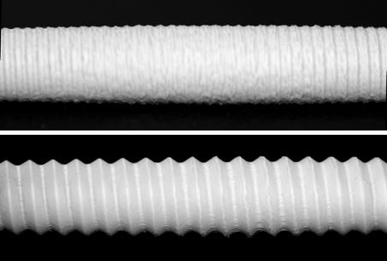Picture 1: Screw-shape Screw-shaped electrospun vascular grafts intended to avoid kinking (top 30°, bottom 120°)

Cardiac tissue & blood vessels

**085**

**HIGH PATENCY OF AN IN VIVO TISSUE-ENGINEERED MICROVASCULAR GRAFT (MICROBIOTUBE) IN A RAT MODEL**

Daizo Ishii1, Masataka Hayashi1, Jun-ichiro Enmi1, Takeshi Moriwaki1, Mari Kobayashi2, Hidehiro Iida1, Tetsu Satow1, Jun C Takahashi1, Yasuhide Nakayama1

1National Cerebral Cardiovascular Center, OSAKA, Japan

2Panasonic Healthcare, TOKYO, Japan

**Purpose:** As presented in the past ESAO congresses, Biotubes, autologous tubular connective tissues formed by in-body tissue architecture technology, a novel and practical approach in regenerative medicine based on the tissue encapsulation phenomenon, have high performance potential as vascular replacement grafts with a diameter ranging from several mm to cm. In this study, MicroBiotubes with a diameter less than 1 mm were firstly developed, and their patency was evaluated in a rat model by optical coherence tomography (OCT) and magnetic resonance angiography (MRA) for several months.

**Method and Results:** MicroBiotubes was prepared by subcutaneous embedding the molds, assembled with stainless wires (length 30 mm; diameter 0.5 mm) covered with silicone tubes (length 22 mm; internal diameter 0.5 mm; outer diameter 0.6 mm), into rats. After 2 months, the molds were harvested and MicroBiotubes (length 20 mm; internal diameter 0.6 mm) were obtained as tubular connective tissues by trimming the excessive connective tissues and removing the molds. MicroBiotubes (10 mm) were implanted in bilateral femoral arteries (0.6 mm) of rats by end-to-end anastomosis. Cross-sectional OCT (Panasonic Healthcare) imaging noninvasively demonstrated the patency of MicroBiotubes immediately after implantation. Histological examination performed 1 month after implantation showed no thrombi in the lumen of the MicroBiotubes. Neovascularization developed from the native arteries to the MicroBiotube walls, and entire endothelialization occurred on the MicroBiotubes’ luminal surfaces. In follow-up 7-Tesla MRA 1 month after implantation, high patency (75%, n=4) was obtained without any transformation.

**Conclusion:** Biotubes had high patency for several months even in ultra-small caliber of 0.6 mm. Biotubes may be useful also in neurosurgery and plastic surgery areas in addition to cardiovascular surgery area.

Cardiac tissue & blood vessels

**086**

**A TWO-LAYER ELECTROSPINNING APPROACH TO ENHANCE CELL ADHESION AND INFILTRATION OF VASCULAR GRAFTS**

Marc Mueller1, Michael Bode1, Lutz Dreyer1, Benjamin Krolitzki1, Dagmar Pfeiffer2, Alexandros Repanas1, Ingrid Wang2, Holger Zernetsch1, Birgit Glasmacher1

1Leibniz Universitaet Hannover, HANNOVER, Germany

2Medical University Graz, GRAZ, Austria

**Aim**

Scaffolds for vascular tissue engineering need to fulfil manifold requirements. They have to mimic the morphology of the extracellular matrix, match biomechanical properties appropriate for the implantation site and exhibit high compatibility to blood cells and vascular tissue. Pore size and porosity are known to strongly influence cell adhesion and seeding. This study aims to use a multi-layer fabrication concept to promote an efficient endothelial cell adhesion and smooth muscle cell infiltration.

**Methods**

Grafts were spun from polymeric solutions with a total concentration of 100 mg/ml and 200 mg/ml. Lower concentrations were used for the inner and higher concentrations for the outer layers. Pure polycaprolactone (PCL) as well as a blend of PCL and polylactide (PLA, w/w=2:1) were dissolved in 2,2,2-trifluoroethanol. A custom-made nozzle enabled a gradual polymer shift to avoid layer separation. Fiber diameter, pore size, cross-section (scanning electron microscopy) and mechanical properties (uniaxial tensile testing) were analyzed. Fluorescence staining was used for multi-layer visualization.

**Results**

Fiber diameter and pore size decreased with polymer concentration as well as with the addition of PLA. Layers consisting of the PCL/PLA (100 mg/ml) had an average fiber diameter of 0.8 µm and a pore size of 5.6 µm while values of 2.1 µm and 13.7 µm were measured for PCL (200 mg/ml). Tensile tests revealed higher values of Young’s modulus (22 N/mm² to 7 N/mm²), tensile strength (7.2 N/mm² to 3.5 N/mm²) and strain at break (6.0 mm/mm to 2.2 mm/mm) for scaffolds spun from pure PCL. High concentrations of PCL/PLA lead to instabilities in the electrospinning process causing a layer separation, which was proved by fluorescence imaging.

**Conclusion**

Our results show that a combination of PCL/PLA (100 mg/ml, inner layer) and PCL (200 mg/ml, outer layer) presents the best morphological structure to enhance endothelial and smooth muscle cell adhesion.

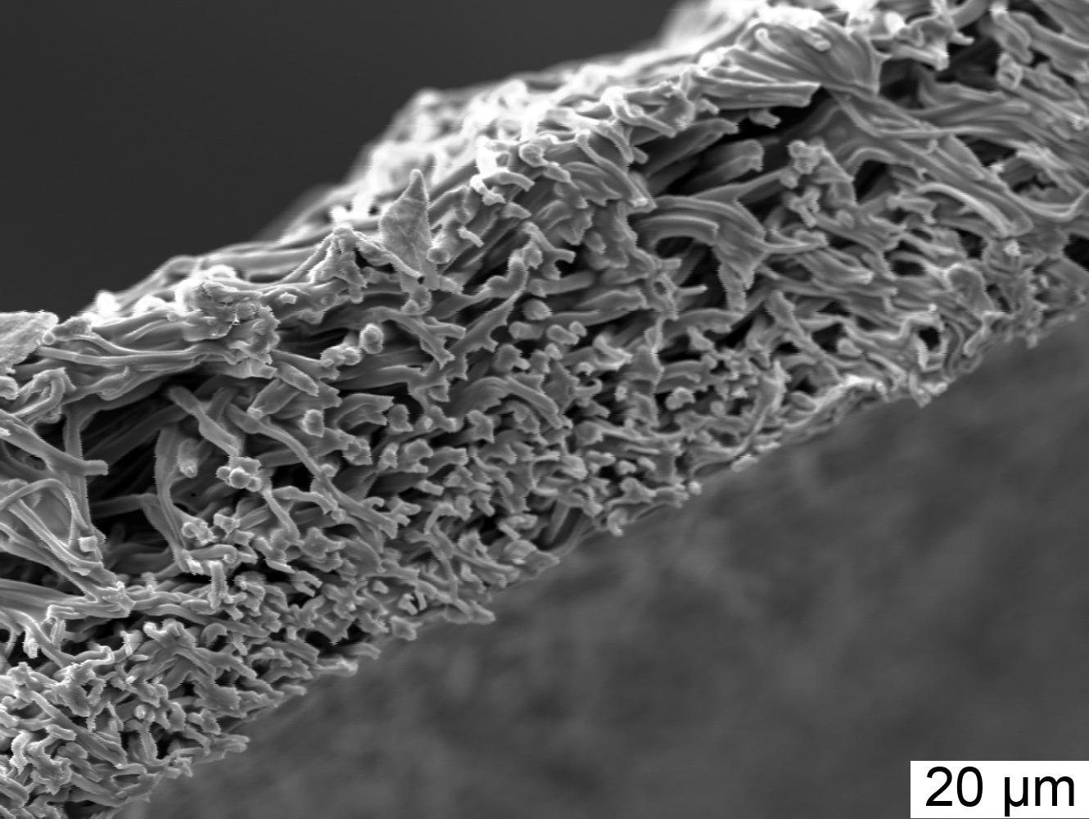Picture 1: Cross-section of a two-layered electrospun vascular graft Cross-section of a two-layered electrospun vascular graft.

Cardiac tissue & blood vessels

**087**

**GROWTH POTENTIAL OF IN VIVO TISSUE-ENGINEERED 'BIOTUBE' VASCULAR GRAFTS**

Maya Furukoshi, Ryosuke Iwai, Takeshi Moriwaki, Yasuhide Nakayama

National Cerebral and Cardiovascular Center, SUITA, OSAKA, Japan

**Purpose**

In pediatric surgery, size mismatch between implanted vascular grafts and native vessels is problem that occurred after the growth of patients. Biotubes are autologous connective tissue tubes formed by “in body tissue architecture”technology, which is regenerative medicine based on tissue encapsulation phenomenon in living bodies. Several months after implantation, biotubes can be reconstructed to vascular structure, therefore the growth potential of biotubes was expected. However, the rapid growth of animals prevents evaluation in animal models. In this study, allogenic biotube implantation of pre-prepared biotubes was performed in adult to juvenile beagles. And then, evaluated the growth potential of biotubes by examining their caliber adaptation to growing native arteries after implantation.

**Methods and Results**

Biotubes (internal diameter; 3 mm) were prepared in adult beagles (age, 1 year; body weight; 10 kg) subcutaneous embedding silicone molds (outer diameter; 3 mm) for 8 weeks. After treatment with argatroban, allogenic biotubes were implanted into carotid arteries (internal diameter; 2 mm) of juvenile beagles (age; 12 weeks, body weight; 3 kg, n=6) by end-to-end anastomosis. After 1 month, implanted biotubes showed a tendency to reconstruct vascular structure. Angiographic observation performed every month, that revealed diameter of the host arteries were gradually dilated 3 mm, however, little change was observed in diameter of implanted biotubes in 3 months. Thereafter, biotubes were continuously expanded in diameter, similarly to native arteries with little size-mismatching. At 6 months, juvenile beagles achieved to adult size (body weight; 10 kg) and implanted biotubes and host arteries diameter reached approximately 4 mm.

**Conclusion**

Several months after implantation, biotubes were vascular reconstruction, and then they could be dilated according to the growth of native arteries. This is the first study to confirm the growth potential of biotubes, and this result showed they have a high potential usefulness in pediatric surgery.

Cardiac tissue & blood vessels

**088**

**DEVELOPMENT OF A NOVEL AUTOLOGOUS BIOPROSTHESIS FOR A TAILOR MADE VALVE SURGERY**

Yoshiaki Takewa1, Yasuhide Nakayama1, Hirohito Sumikura1, Noritsugu Naito1, Keiichi Kanda2, Tsutomu Tajikawa3, Takaharu Tanaka4, Eisuke Tatsumi1

1National Cerebral and Cardiovascular Center, OSAKA, Japan

2Kyoto Prefectural University of Medicine, KYOTO, Japan

3Kansai University, OSAKA, Japan

4GOODMAN Co., Ltd., AICHI, Japan

- Aim: We are developing a novel autologous heart valve prosthesis (Biovalve) with a unique in-body tissue engineering method. This enables us to select a tailor made valve replacement to fit the each patient’s shape and keep biocompatibility. In this study, we made 3 types of heart valve and tested their feasibility in a large animal model.

- Methods: We made many designs and sizes of molds for Biovalves by plastic rods using 3D printer easily and quickly considering the recipient character. In this study, we selected 3 types (a conventional type, a full-root type and a valve with a metalic stent for transcatheter implantation) and embedded them in the subcutaneous spaces of adult goats for 1-2 months. After extracting the molds and capsulised tissue en bloc and removing the plastic rods only, Biovalve with tri-leaflets similar to those of the native valves were constituted from completely autologous connective tissues and fibroblasts. Five cases of conventional Biovalves were implanted in the aorta under cardiopulmonary bypass, 8 cases of full-root type were implanted in the apico-aortic bypass, and 24 stent valve type were implanted with transcatheter technique into in situ the aortic and pulmonary valves (17 and 7, respectively).

- Results: In each type, Biovalves were successfully implanted and showed smooth movement of the leaflets with a little regurgitation in angiogram, and the maximum duration reached to 2 months in fullroot type and 6 months in stent valve type. Histological examination of the Biovalves showed the autologous cells covering the laminar surface of the valve leaflets and also getting into the connective tissues.

- Conclusion: The Biovalves have a potential to be used for tailor made therapy in valve surgery and satisfy the higher requirements of the systemic circulation maintaining the histological character as autologous tissues.

Cardiac tissue & blood vessels

**089**

**CELL SEEDING ON GRGDS-BIOFUNCTIONALIZED PDMS FOR APPLICATION AS ARTIFICIAL BLOOD GAS BARRIER IN A BIOHYBRID LUNG**

Nicole Finocchiaro1, Jonas Rose1, Christian Cornelissen1, Barbara Dittrich2, Martin Moeller2, Stefan Jockenhoevel1

1Institute of Applied Medical Engineering, AACHEN, Germany

2DWI Leibniz Institute for Interactive Materials, AACHEN, Germany

**Aim**

Patients suffering from severe lung diseases can be supported by extracorporeal membrane oxygenation (ECMO) based on hollow fiber membranes. Unspecific protein adsorption, resulting in a decrease of gas transfer and other side effects limit the application to short-term. However, as a bridge-to-decision or a bridge-to-transplant a system applicable for weeks to months is needed. Relevant biocompatibility can be obtained with a physiological gas-exchange surface made of an endothelialized flat membrane. Cell coating requires cell adhesive surfaces with high gas permeability, e.g. binding of pentapeptide GRGDS on PDMS.

**Methods**

Human endothelial cells were isolated from umbilical veins and cultivated in EGM-2 medium (Lonza). PDMS surfaces were prepared from ELASTOSIL (Wacker Chemie) in 96 and 24 well plates. Two approaches were followed to covalently bind the peptide sequence Gly-Arg-Gly-Asp-Ser (GRGDS, Bachem): a) A solution of Sulfo-SANPAH (Pierce) in DMSO/H2O at different concentrations was added to PDMS surfaces and exposed to UV light (320-500 nm, 30 min). After washing of PDMS, GRGDS in PBS was added and incubated for 24 h. Surfaces were characterized by IR and contact angle measurement; b) Glas cover slips were coated with PDMS, surfaces activated in ammonia plasma and functionalized with star shaped polyethylene glycol (starPEG) by spin coating and subsequent reaction with an aqueous GRGDS solution. HUVECs were seeded on the surfaces, characterized by CD31, vWF (van Willebrand factor) and CD 29 staining, XTT test and cell density determined with CellProfiler 2.2.1 software by nuclei staining with 4’,6’-Diamidin-2-phenylindol (DAPI).

**Results**

Both biofunctionalisation approaches and subsequent seeding with HUVECs was successfully performed. Cell proliferation and density was higher as on untreated PDMS and showed similar values as on gelatin.

**Conclusion**

GRGDS-biofunctionalized PDMS may serve as suitable membrane in an endothelialized oxygenator (Endoxy). Further tests require HUVEC cultivation under static and dynamic conditions under relevant shear stress.

Cardiac remodelling symposium

**090**

**PARTIAL RIGHT VENTRICULAR SUPPORT INDUCES REVERSE REMODELING IN THE CHRONIC PRESSURE OVERLOADED RIGHT VENTRICLE**

Tom Verbelen1, Piet Claus1, Erik Verbeken1, Daniel Burkhoff2, Marion Delcroix1, Filip Rega1, Bart Meyns1

1UZ Leuven, LEUVEN, Belgium

2Columbia University, NEW YORK, United States of America

**Aim**

Supporting the failing right ventricle (RV) can be a life-saving option in patients with pulmonary arterial hypertension. Therefore we assessed the effects of long-term RV support on the chronic pressure overloaded RV.

**Methods**

The pulmonary artery was banded in 16 sheep. Eight weeks later, heart function was assessed by MRI. Subsequently a Synergy® micro-pump was implanted in 8 sheep, draining blood from the right atrium to the pulmonary artery. Hemodynamics were recorded before and after pump implantation. Eight weeks later, heart function in all animals was assessed by the same means. At sacrifice, RV and left ventricular (LV) weight were measured and samples were taken for histology.

**Results**

Although total cardiac output (CO) did not change significantly during 8 weeks of support, the RV contribution to the total right sided CO significantly increased from 21±11% to 43±10% (p<0.001). Ejection fraction and stroke work of the supported RV improved from 20±7% to 41±25% (p<0.05) and from 96±60ml.mmHg to 531±226ml.mmHg (p<0.01), respectively.

After pump explantation, MRI analysis showed significant decreases of RV end diastolic and end systolic volume (from 129±33 to 101±24ml and from 88±29 to 62±20ml, respectively, p<0.05 in both) and significant increases of LV CO and ejection fraction (from 2.8±0.9L/min to 3.6±1.2L/min and from 45±8% to 57±10%, respectively, p<0.05 in both).

RV pressure-volume analysis showed an increased end systolic elastance.

Comparison with the control group at 16 weeks showed a significant lower ratio of RV/LV weight (0.47±0.13 vs 0.65±0.14; p<0.05) and significant lower diameters of RV myocytes (34±4 vs 37±3µm; p<0.0001).

**Conclusions**

Long term partial support of the chronic pressure overloaded RV has a favorable effect on RV and LV hemodynamics and on RV contractility. Our findings indicate a good recovery of the chronic pressure overloaded RV after long term mechanical support with the potential of reverse remodeling.

Blood trauma

**091**

**DEVELOPMENT OF A TWO-STAGE ROTARY BLOOD PUMP WITH LOW BLOOD TRAUMA**

Bente Thamsen, Michael Lommel, Philip Preikschat, Ricardo Mevert, Klaus Affeld, Ulrich Kertzscher

Charité Universitaetsmedizin Berlin, BERLIN, Germany

Aim: Implantable left ventricular assist devices (LVAD) became the therapy of choice in treating end-stage heart failure. Although survival improved substantially, complications related to blood trauma as a result of high shear stresses are still frequently observed. Aim of this project was to develop a rotary blood pump with lower blood trauma. With two impeller stages blood velocities are lower so that lower shear stresses result.

Methods: Using the principles of turbomachinery, a diagonal impeller with an outer diameter of 22mm was designed to be employed as two stages of a rotary blood pump. The first stage starts with a flow straightener and terminates with a diffusor, while a volute casing behind the second stage is utilized to guide flow to the outlet. Stabilizing of the rotor is realized by cup-socket ruby bearing. With the help of computational fluid dynamics (CFD) using the STAR CCM+ package (Adapco) the pump was analyzed and optimized.

Results: A two-stage blood pump with a flow straightener, diagonal impellers, a diffusor and a volute casing was developed resulting in a priming volume of 10.7mL. The pump is capable of generating a physiological pressure head of 70mmHg and a flow rate of 5L/min at 3300rpm with throttle curves similar to centrifugal pumps. CFD results reveal smooth flow fields without critical areas of recirculation or swirls and low shear stresses (0.1vol% above 150Pa, 0.03vol% above 200Pa).

Conclusion: The two-stage blood pump achieves similar operating points at lower circumferential velocities compared to current one-stage rotary blood pumps on the market. These lower circumferential velocities yield lower shear stresses in the gap between the rotating impeller and static housing which is the critical region for blood trauma. Hence, blood trauma with the design may be reduced.

Blood trauma

**092**

**INVESTIGATION OF SHEAR-INDUCED INTERFERENCE ON PRIMARY HEMOSTASIS BY ROTARY BLOOD PUMPS**

Michael Lommel, Jens Schaller, Klaus Affeld, Ulrich Kertzscher

Charité Berlin, BERLIN, Germany

**Aim**

In the last years continuous flow left ventricular assist devices (LVADs) have evolved from short time therapy into permanent or destination therapy. One complication in long term usage is bleeding, which is presumably attributed to shear-induced interference on the coagulation system. In our study, we investigated the impact of shear stresses similarly occurring in rotary blood pumps on the primary hemostasis. For these Investigations a novel shear device was designed. It simulates typical shear stresses in rotary blood pumps, which are very high, of short duration and repeatedly occurring. The PFA-100 (Platelet Function Analyzer) test device was chosen to evaluate the clotting ability of the blood.

**Methods**

With the novel shear device blood is sheared in an 180µm gap between a static inner and a rotatable outer cylinder. The blood was exposed to sine half-wave shaped shear stresses in a range of 40-200Pa maximum with exposure times of 25-65ms and up to 25 repetitions. 74 samples of citrate human whole blood were taken from 4 different donators.

**Results**

A damaging model of the PFA closure time based on the power law including shear stress and exposure time could be established. Even after few repetitions a significant decrease of the blood clotting ability could be determined. Furthermore a dependency of the integral of shear stress over time and the increased closure time has shown of maximum stresses above 20Pa.

**Conclusion**

The shear device enables investigations of shear stresses occurring in rotary blood pumps on blood under controlled conditions. In this case the reduction of the clotting ability could be estimated using the PFA closure time. In future the influence of short time stresses on other blood parameters can be investigated with this method to deduce design criteria for rotary blood pumps.

Blood trauma

**093**

**IN VITRO HEMOLYTIC PERFORMANCE EVALUATION OF A NEW IMPLANTABLE CENTRIFUGAL HEART PUMP WITH AN OPTIMIZED DESIGN**

Caglar Ozturk1, Suat Comert1, Ibrahim Basar Aka1, Ozlem Yalcin2, Nazli Atac2, Suha Kucukaksu3, Ismail Lazoglu1

1College of Engineering, Koc University, ISTANBUL, Turkey

2School of Medicine, Koc University, ISTANBUL, Turkey

3Medical Park Goztepe Hospital, ISTANBUL, Turkey

**Aim:** Heart failure is one of the most common disease causing death in the developed countries. The left ventricular assist devices (LVAD) are used to support heart failure patients by providing enough blood flow to the human body. A new centrifugal type LVAD is under development as an alternative to heart transplantations. This study presents the results of the validation process including designing, manufacturing, analyzing and in vitro blood tests.

**Methods:** 3D pump geometries were designed in the CAD environment and analyzed with CFD method. In CFD analyses, hemolytic performance of the device has also been simulated by calculating the shear stress affecting to red blood cells. The design has been optimized by CAD-CFD iterations. Optimized model is manufactured in our high-precision 5-axis CNC machining facility after conducting CFD analyses. In vitro blood tests were conducted in various conditions with different prototypes according to the American Society for Testing and Materials (ASTM) F 1841-97 standards.

**Results:** Four different prototypes have been tested with in vitro experiments. Last prototype presented the most promising results in terms of hemolysis. It provided sufficient output up to 7 l/min and maximum pressure 200mmHg. In vitro blood tests were conducted up to 12 hours with adequate pump performance. The N.I.H. result of the prototype was near 0.003 g/100L which is considered as antitraumatic.

**Conclusion:** The prototype pump indicates sufficient pump performance. CFD studies provide a good estimation in terms of hemolysis before conducting in vitro blood test. The N.I.H. result shows that the prototype does not cause clinically significant hemolysis. These promising results also raise great hope for the next stage, in vivo experiments. However, validation studies will be continued first by including Cardiovascular Mock Loop to investigate the dynamic pump performance under realistic physiologic flow-pressure conditions.

Blood trauma

**094**

**IN VITRO BENCHMARKING STUDY OF VENTRICULAR ASSIST DEVICES**

Ina Laura Pieper1, Chris Chan1, Gemma Radley1, Holley Love2, Hendrik Milting3, Catherine Thornton4, Graham Foster1

1Calon Cardio-Technology Ltd, SWANSEA, United Kingdom

2Texas Heart Institute, HOUSTON, United States of America

3HDZ NRW, BAD OEYNHAUSEN, Germany

4Swansea University, SWANSEA, United Kingdom

**Aim:** The aim of this study is to develop a blood damage profile of ventricular assist devices (VADs) in current clinical use including the HVAD (HeartWare), HeartMate 2 and CentriMag (HM2; CMAG; both Thoratec) in comparison to a new VAD in development, the MiniVAD (Calon Cardio-Technology).

**Methods:** Several explanted HVADs and HM2s were carefully cleaned and inspected and tested *in vitro* against the MiniVAD in a standard 500 ml mock circulatory loop using bovine blood. The CMAG was used as a control pump due to its low blood damage profile. Pump flow was maintained at 5 L/min and pressure at 100 mmHg. Samples were collected at regular intervals and complete blood counts were analysed: automated haematology counts; haemolysis by Harboe assay; leukocyte microparticles (MP) and platelet activation by flow cytometry; and von Willebrand factor by immunoblotting. We recognise that the use of explanted pumps is a limitation of the study.

**Results:** This study is ongoing with a targeted completion date in June 2015. Preliminary results show plasma-free haemoglobin (g/L) & NIH (g/100L) at 360 min of 1.4±0.32 & 0.02±0.006 (HM2, n=7); 0.34±0.02 & 0.006±0.0006 (HVAD, n=3); 0.07±0.02 & 0.001±0.0003 (MiniVAD, n=3); 0.06±0.019 & 0.001±0.0005 (CMAG, n=16). Leukocyte MP levels expressed as fold change to static control are 30.6±6.9 (HVAD); 27.3±5.5 (HM2); 13.7±6.9 (MiniVAD); 4.3±1.9 (CMAG).

**Conclusion:** These preliminary results indicate that it is possible to observe differences between different pump designs during *in vitro* testing that might translate to clinical performance. This study shows the importance of developing standard *in vitro* testing methods against which device developers could report data to progress the overall research field.

Blood Trauma

**095**

**THE ROLE OF ACQUIRED VON WILLEBRAND SYNDROME IN OCCURRENCE OF BLEEDING EVENTS IN PATIENTS ON A CONTINUOUS FLOW LVAD.**

Katrien Vandendriessche, Steven Jacobs, Filip Rega, Bart Meyns

KU Leuven, LEUVEN, Belgium

**Aim:** Left ventricular assist devices (LVADs) have become a valuable treatment option in end-stage heart failure. However, bleeding is one of the most common adverse events post-implantation and is a major cause of morbidity in these patients. Though the use of anticoagulation therapy is undoubtedly a contributing factor, there is increasing evidence that an acquired von Willebrand syndrome (AVWS) exists in all patients with LVADs. We sought to analyse whether there was a correlation between the bleeding events and AVWS in our patients.

**Methods**: Ninety-eight patients received a continuous flow LVAD implantation (HeartMate II; Thoratec) between 2007 and 2014. Since 2011, von Willebrand factor antigen (VWF:Ag) and von Willebrand factor ristocetin (VWF:Rco) activity were recorded prospectively both before implantation and at fixed timepoints throughout the first year on LVAD. As found in literature, a vWF Rco/vWF Ag ratio < 0.8 was considered diagnostic for AVWS. Mean age was 49.9 ± 13.9 years (81 male, 17 female).

**Results:** 53.06% of patients experienced at least one type of bleeding. The most common types of bleeding were: epistaxis (39.5% of bleeding events), surgical bleedings needing revision (30.6%), GI bleeding (13.9%). Of 63 patients with vWF measurements, 88.89% had a vWF Rco/vWF Ag ratio < 0.8 (criterium for AVWS). No correlation was found between bleeding events and levels of vWF antigen, vWF ristocetin, or pump speed.

**Conclusion**: Bleeding events are common after LVAD implantation. AVWS is present in almost all LVAD patients. Analysis of our data shows that the absolute values of routinely available biochemical parameters to test for the presence of AVWS are of no predictive value towards the occurrence of bleeding events.

Renal assist -dialysis

**096**

**EVODIAL PLUS CITRATE CONTAINING DIALYSATE IS NON-INFERIOR TO REGIONAL CITRATE ANTICOAGULATION.**

Christoph Metalidis, Annelore De Winter, Pieter Evenepoel, Dirk Kuypers, Björn Meijers

University Hospitals Leuven, LEUVEN, Belgium

**Aim:**

Heparin is widely used to prevent clotting of the extracorporeal circuit during hemodialysis. In patients at high risk of bleeding, heparin-free hemodialysis can be achieved using either regional citrate anticoagulation (RCA), heparin-grafted dialyzers or saline flushes. In some centers citrate containing dialysate is used, as citrate containing dialysate also provides a modest local anticoagulant effect. RCA is hampered by technical complexity and labor intensiveness. Other heparin-free dialysis techniques frequently lead to premature clotting. We studied the efficacy of the combination of a heparin-grafted dialyzer and a citrate-containing dialysate for prevention of circuit clotting in comparison to conventional RCA.

**Methods:**

We performed a prospective, open-label randomized trial including 25 chronic hemodialysis patients. Patient characteristics are summarized in table 1. Regional anticoagulation was achieved using either RCA (Polyflux 170® membrane; n=13; 367 sessions) in the control arm versus the combination of a heparin-grafted AN69ST dialyzer (Evodial®) and a citrate-containing dialysate (SelectBag Citrate®; n=12; 331 sessions) in the treatment arm. At the end of each four hour dialysis session, the dialyzer was scored semiquantitatively for visible signs of thrombus formation (0, no clotting, to 4, severe clotting).

**Results:**

Clotting necessitating premature termination of the dialysis treatment, was encountered in 8.99% of sessions using RCA and in 4.23% of treatments using Evodial plus SelectBag Citrate (p = 0.01). Mean dialyzer clotting scores were 1.58 ± 0.70 (RCA) and 1.18 ± 0.69 (treatment arm) (p < 0.01). A Cox proportional hazard analysis of premature clotting supported non-inferiority of the combination treatment to conventional RCA (p = 0.12).

**Conclusion:**

For prevention of extracorporeal circuit clotting during intermittent hemodialysis, combining a heparin-grafted dialyzer with a citrate-containing dialysate is non-inferior to conventional RCA. The incidence of circuit clotting in the RCA group was comparable to previously published data.

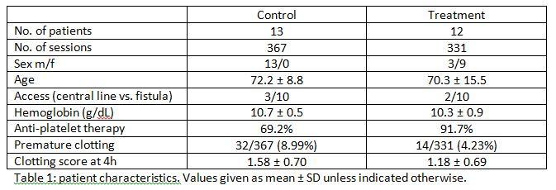Picture 1: Table Table1

Renal assist - dialysis

**097**

**WHERE AND WHEN TO INJECT LOW MOLECULAR WEIGHT HEPARIN IN HAEMODIAFILTRATION?**

Annemieke Dhondt, Ruben Pauwels, Katrien Devreese, Sunny Eloot, Griet Glorieux, Raymond Vanholder

Ghent University Hospital, GENT, Belgium

Aim

Low molecular weight heparins (LMWHs) are small enough to pass large pore dialysis membranes. Removal of LMWH if injected before the start of the session is possible during high-flux dialysis and haemodiafiltration. The aim of this study was to determine the optimal mode of tinzaparin administration during postdilution haemodiafiltration.

Methods

In 13 patients, 3 approaches of injection were compared: i) before the start of the session at the inlet blood line filled with rinsing solution (IN0), ii) 5 min after the start at the inlet line filled with blood (IN5) and iii) before the start at the outlet blood line (OUT0). Anti-Xa activity, thrombin generation, visual clotting score and reduction ratios (RR) of urea and beta2microglobulin were measured.

Results

Anti-Xa activity was lower with IN0 compared with IN5 and OUT0, and also more thrombin generation was observed with IN0. No differences were observed in visual clotting scores and no clinically relevant differences were observed in solute RR.

An anti-Xa of 0.3 IU/mL was discriminative for thrombin generation. Anti-Xa levels below 0.3 IU/mL at the end of the session were associated with worse clotting scores and lower RR of urea and beta2microglobulin.

Conclusions

Injection of tinzaparin at the inlet line before the start of postdilution haemodiafiltration is associated with loss of anticoagulant. An anti-Xa above 0.3 IU/mL at the end of the session is associated with less clotting and higher dialysis adequacy.

Renal assist - dialysis

**098**

**THE EFFECT OF LOCAL HEMATOCRIT AND HEMATOCRIT CHANGES ALONG THE FIBERS ON PRODUCING HEMOLYSIS IN A DIALYZER**

Ali Poorkhalil1, Ghassem Amoabediny2, Foivos Leonidas Mouzakis1, Ali Kashefi1, Khosrow Mottaghy1

1RWTH Aachen University, AACHEN, Germany

2Research Center for New Technologies in Life Science Eng., University of Tehran, TEHRAN, Iran

**Aim**

Blood flowing through artificial organs is exposed to different types of mechanical stress causing blood trauma. Specifically, uremic patients frequently undergoing dialysis treatment (approx. three times a week) are confronted by the potential accumulation of various blood trauma consequences, such as free plasma hemoglobin. In the case of dialyzers, two important phenomena take place, both affecting the concentration of erythrocytes. On one hand, hematocrit increases along the fibers because of ultrafiltration. On the other hand, velocity profile influences the distribution of RBC leading to the existence of “local”Hct values. The aim of this study is to evaluate the effect of local hematocrit and to examine the way hematocrit changes along the fibers, in order to determine the hemolysis level in a dialyzer which was achieved by means of an innovative Couette flow system.

*Methods*

A setup consisting of two dialyzers in a series configuration was prepared and samples were taken to measure hematocrit and free plasma hemoglobin. The sequential arrangement of the two dialyzers enables 3-point sampling, which enhances filtration visualization by demonstrating the course of hematocrit along the fibers’ length. Conditions in the Couette system were adjusted to match those of the dialyzer circuit and the hemolysis level were compared. Freshly drawn heparinized pig blood was used in both cases and inlet hematocrit values were adjusted.

*Results*

This study enables us to investigate the changes of hematocrit inside the dialyzer. It was clearly shown that hematocrit will sharply increases in the point where backfiltration starts. At this point hematocrit is significantly higher than inlet and even outlet. Since the impact of increasing of hematocrit in heightening of viscosity and consequently enhancement of hemolysis.

**Conclusion***:* the results demonstrate this method delivers more realistic hemolysis results by investigating hematocrit changes in dialyzer as well as local hematocrit values.

Renal assist - dialysis

**099**

**EFFECTS OF MARATHON CYCLING ON CYTOKINES AND ADIPOKINES IN KIDNEY TRANSPLANT RECIPIENTS**

Maria Cappuccilli1, Marco De Fabritiis2, Chiara Donadei1, Manuela Trerotola3, Valentina Totti4, Giulio Sergio Roi4, Gaetano La Manna1, Alessandro Nanni Costa4, Giovanni Mosconi2

1University of Bologna, BOLOGNA, Italy

2Nephrology and Dialysis, Morgagni-Pierantoni Hospital, FORLÌ, Italy

3Italian National Transplant Centre, ROME, Italy

4Isokinetic Medical Group, BOLOGNA, Italy

**Aim.** The clinical-laboratory frame of transplant recipients is characterized by chronic inflammation affecting cardiovascular outcome. Physical activity seems to improve health and inflammatory status, but the role of intense training has not been fully elucidated. We evaluated the effect of a 130 km road cycling race on inflammatory cytokines and adiponectin in kidney transplant recipients (KTR).

**Methods.** Serum levels of TNF-α, IL-6, IFN-γ, and adiponectin were assayed one day before race, at the end and after 18-24 hours, in 81 healthy *vs* 22 transplanted cyclers, all male and matched for age, BMI and previous preparation workout. KTR had stable renal function (creatinine: 1.25±0.40 mg/dL; eGFR: 61±25 mL/min).

**Results.** Renal function parameters showed a significant increase after race, returning back to baseline levels after 18-24 hours.Circulating TNF-α was unaffected by training in both groups. Conversely, IL-6 levels were 6 to 8-fold increased at the end of race in all participants, but at a significantly greater extent in KTR, and it dropped, without returning to basal levels, the day after. Circulating IFN-γ was similar in healthy subjects and KTR before race. Marathon triggered a greater increase in KTR compared to healthy cyclists, but it declined to levels very close to the baseline within 18-28 hours following performance. The trend in adiponectin variations was fairly similar to that of IFN-γ in healthy subjects and TR at all the 3 measurements of the competition.

**Conclusions.** Our data show that TR in good clinical conditions and properly trained can benefit from physical activity, even at a competitive level. The changes in renal function inflammation parameters were transient and rapidly with no remarkable differences with the healthy cyclists. Our succeeding analysis intends to clarify whether the long-term benefits of sport after transplant might counterweigh these temporary modifications of some parameters during acute exercise.

Renal assist - dialysis

**100**

**EXTENDED MULTIPASS VERSUS STANDARD HAEMODIALYSIS IN THE HOME SETTING**

Sunny Eloot1, Wim Van Biesen1, Mette Axelsen2, Robert Smith Pedersen3, James Goya Heaf4

1Ghent University Hospital, GENT, Belgium

2Aarhus University, AARHUS, Denmark

3Flexdialysis Aps, COPENHAGEN, Denmark

4Herlev Hospital, University of Copenhagen, COPENHAGEN, Denmark

**Aim** Single-pass haemodialysis modalities, requiring large amounts of prepared dialysate, are less suitable for home use. Multipass haemodialysis (MPHD) on the contrary consumes only a small volume of dialysate (50% of estimated body water) which is repetitively recycled. Dialysis regimes of 6x8h/week resulted in an increased removal of small water soluble solutes and middle molecules compared to standard haemodialysis (SHD). Since protein-bound solutes (PBS) exert important pathophysiological effects, we investigated whether MPHD results in improved PBS removal as well.

**Methods** A cross-over study was performed in nine HD patients with, at midweek, a single session of either 4h SHD (dialysate flow 500mL/min) or 8h MPHD. Blood and dialysate samples were taken hourly to determine concentrations of p-cresylglucuronide (PCG), hippuric acid (HA), indole acetic acid (IAA), indoxyl sulfate (IS), and p-cresylsulfate (PCS) (%binding in the range 10-99%), and dialyser extraction, reduction ratio, and solute removal were calculated.

**Results** Already at 60min, dialyser extraction ratio was a 1.4-4x lower with MPHD versus SHD, resulting in significantly smaller reduction ratios and lower solute removal during one session. Even when extrapolating our findings to 3 times 4h SHD and 6 times 8h MPHD per week, the latter modality was at best similar in terms of total solute removal for most protein-bound solutes, and worse for the highly protein-bound solutes IS and PCS. However, when efficiency was calculated as solute removal/litre of dialysate used, MPHD was found superior to SHD.

**Conclusion** A treatment regime of 6x8h/week MPHD is an acceptable alternative for 3x4h/week SHD, with more efficient use of dialysate, but at the expense of a lower removal of highly protein-bound solutes. This new method can thus successfully be used when high water consumption is a concern.

Renal assist - dialysis

**101**

**A NEW METHOD TO PERSONALIZE DIALYSIS THERAPY**

Camilla Bianchi

Politecnico di Milano, MILANO, Italy

**Aim:** Health conditions and quality of life of uremic patients treated with hemodialysis could be improved by tailoring the treatment on each patient, whereas dialysis is usually based on standard not patient-specific parameters.

This work aims at adapting a mathematical model, describing fluid and solutes kinetics to single patient’s characteristics, in order to simulate the patient reaction to the therapy and allow the clinician an offline evaluation of the settings and prescriptions to improve the treatment outcome.

**Methods:** A multi-compartmental model was adopted and data from 70 patients (recorded both at Ospedale Regionale di Lugano and at A.O. della provincia di Lecco, Italy) were used to estimate each patient’s parameters. A Bayesian approach was used.

The parameters are related to the mass exchange across the patient-specific cellular and capillary membranes and to the dialyzer membrane efficiency.

Parameters were computed using a MCMC (Markov Chain Monte Carlo) algorithm.

**Results:** Solutes concentrations and volume profiles simulated in about 400 dialysis sessions by the kinetic model optimized through the Bayesian method, show to better fit clinical data, than using the non-optimized model. The effects of different parameter settings are highlighted in terms of different molecules removal efficiency.

The simulation error of the model, estimated in the preliminary tests, comparing the output to the clinical trends, is 6 ±0.5% for the solute concentrations (urea and the most important plasmatic electrolytes were considered) and 7 ±0.5% for the blood volume trend.

**Conclusions:** the kinetic model, coupled with a robust method to identify patient-specific parameters, allows a better prediction of electrolytes and fluid transfer during dialysis, and the possibility of evaluating the effects of different therapy settings. These results will be beneficial to improve dialysis therapy planning.

Fibrogelnet

**102**

**PROTEIN ORGANISATION TO ENGINEER THE HEALING MICROENVIRONMENT**

Manuel Salmeron-Sanchez

University of Glasgow, GLASGOW, United Kingdom

*Aim*

We aim at engineering the cellular microenvironment by a combination of synthetic materials, extracellular matrix proteins and growth factors which are organized to direct stem cell differentiation and promote tissue healing.

*Methods*

MSCs will be seeded on the engineered matrices and characterized for the short-term (adhesion, signaling) and long-term phenotypic expression (PCR). The organization of proteins at the material interface will be assessed using AFM.

*Results*

Most cells assemble rich protein matrices via an integrin-dependent mechanism that incorporates e.g. fibronectin (FN) molecules into matrix fibrils. The process involves integrin binding and activation of cell contractility to extend FN and expose cryptic domains that promote protein-protein interactions. We have shown that this process can occur by simple adsorption of individual protein molecules onto particular surface chemistries - in absence of cells. FN - material interactions would induce exposure of self-assembly sites to drive FN assembly, a process that we have named material-driven fibronectin fibrillogenesis. This FN matrix assembled at the material interface involves conformational changes of FN upon adsorption and enhanced FN-FN contacts on the material surface. The resulting material-driven FN matrix assembled at the material interface consists of a protein network with enhanced biological activity: it supports cell adhesion, matrix remodeling, and trigger cell differentiation. Moreover, it provides a robust platform to engineer advanced microenvironments in combination with growth factors to tune stem cell differentiation and promote tissue repair.

*Conclusions*

We have shown the organisation of ECM proteins directed by the material interface to enhance cellular processes relevant for tissue healing, including osteogenesis and vascularisation.

Fibrogelnet

**103**

**INJECTABLE COMPOSITES OF LOOSE MICROFIBERS AND GELATIN FOR SOFT TISSUE ENGINEERING**

Gloria Gallego-Ferrer1, Sara Poveda-Reyes1, Aleixandre Rodrigo-Navarro1, Tatiana C. Gamboa-Martínez1, José C. Rodíguez-Cabello2, Luis Quintanilla-Sierra2, Ulrica Edlund3

1Universitat Politècnica de València, VALENCIA, Spain

2BIOFORGE Group. Universidad de Valladolid, VALLADOLID, Spain

3Fibre and Polymer Technology, Royal Institute of Technology (KTH), STOCKHOLM, Sweden

**Aim**

Enzymatically gellable gelatin hydrogels from tyramine conjugates have been proposed for soft tissue regeneration due to their injectability. Their low mechanical properties limit their application. Our aim was to prepare injectable gelatin composites reinforced with poly-L-lactid acid (PLLA) loose fibers with a hydrophilic grafting to enhance interfacial interaction with the hydrogel.

**Methods**

Loose PLLA microfibers were obtained by injecting a PLLA solution into highly agitated cold ethanol and subsequent hydrophilic grafting was performed by UV irradiation. Two series of 3% w/v hydrogel composites with different quantities of grafted and non-grafted fibers were prepared using gelatin tyramine conjugates. Hydrophilic grafting was characterized by FTIR and 1H-RMN, mechanical properties and morphology of the composites by rheometry and SEM. Cell viability, distribution and shape of encapsulated mouse L929 fibroblats were evaluated by MTS and fluorescence microscopy.

**Results**

FTIR and 1H-NMR show successful grafting. All hydrogel composites are porous, with pores of about 20 µm. The storage moduli of the gels increased proportionally to the quantity of grafted fibers. No significant increase in storage modulus is observed in the non-grafted fiber composites. L929 viability increased until the 7th day of culture for the gelatin and until the 14th day for the composites. Fibroblasts in the composites are more dispersed and have a more elongated shape than in pure gelatin.

**Conclusion**

Reinforced gelatin composites with a very good interfacial interaction between the PLLA microfibers and the gelatin were obtained. Fibers do not compromise injectability, cell encapsulation and proliferation, making these materials promising *in situ* hydrogels for the regeneration of soft tissues.

**Acknowledgments**

EU-FP7 PIAP-GA-2012-324386 and MINECO MAT2013-46467-C4-1-R projects, BES-2011-046144 grant and CIBER-BBN-Instituto de Salud Carlos III are acknowledged.

Fibrogelnet

**104**

**HUMAN MESENCHYMAL STEM CELLS BEHAVIOR IN NANOFIBROUS ENVIRONMENT**

Dencho Guutkov1, Johan Gustavsson1, Jeremy Forget2, Manuel Salmeron-Sánchez3, George Altankov4

1IBEC, L'HOSPITALET DE LLOBREGAT, Spain

2BioElpida, LYON, France

3Division of Biomedical Engineering, School of Engineering, University of Glasgow, GLASGOW, Spain

4ICREA (Institucio Catalana de Recerca i Estudis Avançats), BARCELONA, Spain

**Aim:**In a series of recent studies we strive to learn how mesenchymal stem cells (MSCs) respond to spatially organized signals from the extracellular matrix (ECM) culturing them in an artificial nanofibrous environment. **Methods:**Here we report on the development and characterization of new type hybrid fibrinogen/poly- L, DL-lactic acid (FBG/PLA) nanofibers combining the good mechanical properties of PLA with the excellent cell recognition of native FBG. For biological characterization we were particularly interested on the dorsal and ventral response of human mesenchymal stem cells (MSCs) of adipose tissue origin to the nanofibers organization, namely: randomly deposited and aligned nanofibers.**Results:**Upon ventral contact with random nanofibers the cells developed a stellate-like morphology expressing multiple projections onto the differently oriented fibres. Well-developed focal adhesion complexes suggest successful cellular interaction. Time-laps analysis, however, shows significantly restricted cell movements on random nanofibers resulting in relatively short distance that they traverse in multiple directions. Conversely, an elongated cell shape and significantly increased cell mobility were observed on aligned nanofibres. To follow the dorsal cell response artificial wounds were created on confluent human MSCs layers and either random or aligned nanofibers were dorsally applied. Time-laps analysis showed significantly faster wound coverage (within 12 h) of MSCs on aligned samples versus almost absent of directional migration on random ones. No significant difference in cell growth was observed, however, qPCR data for the expression of Collagen 2, Collagen 10 and SOX9 at 35th day of culture in chondrogenic medium shows that MSCs possess lowered cartilage production on aligned NFs apart from random were the expression of differentiation markers was relatively higher. **Conclusion:**Collectively, our studies show that randomly organized nanofibers support the differentiation of MSCs into chondrogenic lineage while aligned configuration favours directional cell locomotion that could be used for guided colonization of implants.

Fibrogelnet

**105**

**CHONDROGENIC RESPONSE OF HUMAN MESENCHYMAL STEM CELLS TO THE GEOMETRY OF ELECTROSPUN NANOFIBERS**

George Altankov1, Dencho Gugutkov2, Johan Gustavsson2

1ICREA (Institucio Catalana de Recerca i Estudis Avançats), L'HOSPITALET DE LLOBREGAT, Spain

2Institute for Bioengineering of Catalonia (IBEC), BARCELONA, Spain

**Aim:**We seek to understand how mesenchymal stem cells (MSCs) respond to the spatially organized signals from the extracellular matrix (ECM) and one way to learn this is to expose them in vitro to a synthetic nanofibrous environment. Electrospinning is a technique capable of producing nanofibers (NFs) with dimensions similar to those of the fibrilar components of natural ECM. An advantage of this method is that NFs can be further designed for their orientation and cell binding properties.

**Materials and Methods:**Here we report on the production of a novel type of hybrid, fibrinogen/poly-L,D-lactic acid (FBG/PLA) NFs that were recently developed in our Lab and their use to obtain a control over the differentiation potential of human MSCs to chondrogenic lineages. These NFs, combining the good cell recognition properties of native FBG with the excellent mechanical properties of PLA, were further arranged as random or aligned and combined with adipose tissue derived human MSCs to arrange constructs that provide culturing of cells at 2D and/or 3D (sandwich-like) environment.

**Results:**The well-developed focal adhesion complexes and actin cytoskeleton confirm the proper interaction of MSCs with NFs. When constructs were further cultured in complete chondrogenic medium for 50 days we obtained an alizarin red positive stained cartilage-like tissue. qPCR for Collagen 2, Collagen 10 and RUNX9 genes was used to quantify the efficacy of cells differentiation to chondrogenic lineage. Our results show that human MSCs produce more and better organized cartilage in 2D environment and the random NFs tend to override aligned in respect to collagen 2 genes activation.

**Conclusion:**Collectively, our studies show that NFs organization (random vs. aligned) and dimensionality (2D vs. 3D) may provide a kay for controlling the differentiation of human MSC to chondrogenic lineage.

Fibrogelnet

**106**

**BIOACTIVE MULTILAYERS IMPROVE OSTEOBLAST RESPONSE**

Deepak Guduru1, Manuel Salmerón-Sánchez2, Thomas Groth1

1Martin Luther University Halle-Wittenberg, HALLE, Germany

2Division of Biomedical Engineering, School of Engineering, University of Glasgow, GLASGOW, United Kingdom

**Aim:**

A novel method called layer-by-layer (LbL) technique allows the build-up of multilayers on substrates by alternating depositing of polycations and polyanions like synthetic and biogenic polyelectrolytes (e.g. proteins or glycosaminoglycans). Surface properties and composition of multilayers can be used to control adhesion and function of cells on materials for a variety of medical applications like implants, catheters, tissue engineering scaffolds.

**Materials and Methods:**

Biogenic polyelectrolyte (PE) pairs used in this study were poly-l-lysine (PLL)/fibrinogen (FBG) and avidin (AVI)/biotinylated chondroitin sulfate (BCS). Additionally a synthetic polyallylamine hydrochloride (PAAH)/polystyrene sulfonate (PSS) were used for multilayer formation. Water contact angle (WCA), surface plasmon resonance (SPR) and atomic force microscopy (AFM) were used to study layer growth and surface topography. The MG63 osteoblast cell line was applied to characterize biocompatibility and osteogenic activity of multilayers.

**Results:**

Layer growth and surface properties were highly dependent on type of PE pair. Studies with MG63 cells showed that none of the multilayer systems had adverse effect on cell behavior. Additionally these layers promoted a significant increase in the activity of alkaline phosphatase - a marker of osteogenic activity with PAAH/PSS yielding highest values.

**Conclusion:**

The comparative study of biocompatibility of synthetic and biogenic polyelectrolyte multilayer systems revealed that both provide surface coatings of high biocompatibility with lack of toxic effects, promotion of cell growth and osteogenic differentiation. In conclusion of this study, multilayer systems made by LbL are useful for coating implants or tissue engineering scaffolds for repair of bone.

VAD's in paediatric and adult congenital heart disease

**107**

**THE POTENTIAL OF VAD SUPPORT IN THE SYSTEMIC RIGHT VENTRICLE.**

Joeri Van Puyvelde, Libera Fresiello, Steven Jacobs, Tom Verbelen, Filip Rega, Bart Meyns

KU Leuven, LEUVEN, Belgium

Aim: Transposition of the great arteries (TGA) occurs in approximately 25 per 100000 live births. The standard treatment up to the late 1970’s was an atrial switch procedure. These patients however continue to live with a systemic right ventricle that often fails in the course of their lifetime. The aim of this review is to report on the current experience with mechanical support for the failing systemic right ventricle.

Methods: We searched the literature as well as our own database for patients with a failing systemic right ventricle receiving a ventricular assist device (VAD).

Results: We identified 36 unique cases (32 and 4). The median patient age was 35 years (13 to 66 years). The mean duration of VAD support was 312 days (5 to 988 days). Twenty-two (61%) patients had a history of TGA after atrial switch and fourteen (39%) congenitally corrected TGA patients (ccTGA) were supported. All patients had end-stage systemic right ventricular failure and twelve patients (33%) had pulmonary hypertension (PHT). Eleven patients (31%) received a pulsatile-flow VAD and 25 patients (69%) a continuous-flow VAD. Thirteen patients (36%) were successfully bridged to heart transplantation after a median duration of mechanical support of 330 days (84 to 720 days). Six deaths occurred (17%) and sixteen patients (44%) were still on VAD support awaiting transplantation. One patient (3%) could be weaned from the device after 43 days of VAD support. Of the PHT patients, five patients (42%) could be bridged to transplantation. Five patients (42%) are still awaiting cardiac transplantation. Two died (16%) before a donor heart became available.

Conclusion**:** VAD support is a valuable solution to support the failing systemic ventricle in TGA after atrial switch and ccTGA patients, even in patients with PHT. The use of VAD support in the systemic right ventricle will become increasingly important.

VAD's in paediatric and adult congenital heart disease

**108**

**SURGICAL STRATEGIES FOR THE TREATMENT OF RIGHT VENTRICULAR FAILURE AFTER LVAD IMPLANTATION: A SIMULATION STUDY**

Arianna Di Molfetta1, Ferrari Gianfranco2, Fresiello Libera3, Maria Giovanna Trivella2, Roberta Iacobelli1, Filippelli Sergio1, Amodeo Antonio1

1Pediatric Hospital Bambino Gesù, VATICAN CITY, Italy

2Institute of Clinical Physiology, CNR, ROME, Italy

3Catholic University of Leuven, LEUVEN, Belgium

Right ventricular failure (RVF) is one of the major complications in LVAD patients. Beyond the drugs therapy, the most reliable option is the RVAD implantation. However, BIVAD patients are associated with a poor prognosis and the management of two devices could increase the incidence of complications. Alternative approaches were experimented: the creation of an atrial septal defect (ASD), a cavo-aortic shunt (CAS) and a cavo-pulmonary connection (CPC). This work aims at using a lumped parameter model (LPM) to compare the ASD, CPC, CAS, RVAD effects in LVAD+RVF patients.

Data of five LVAD patients were retrospectively collected to simulate patients baseline. The effects of continuous flow LVAD implantation complicated by RVF was simulated for each patient. Finally, the ASD, CPC, CAS and RVAD treatments were simulated for each LVAD+RVF patient.

LPM can well reproduce patients baseline and the haemodynamic effects of the surgical strategies according to literature data. With the different surgical treatment, an unloading of the right ventricle and an increment of left ventricular preload were observed with an overall improvement of the haemodynamics (total cardiac output (CO) increment: ASD 15%, CPC 10%, CAS 70% RVAD 20%; right ventricular external work (RVEW) decrement: ASD 19%, CPC 46%, CAS 76%, RVAD 32%; LVEW increment: ASD 12%, CPC 28% ,RVAD 64%; Pulmonary to systemic flow ratio (Qp/Qs) decrement: ASD 40%, CAS 80%).

The creation of a calibrated ASD or the RVAD implantation seems to be the more safety and reliable options. However, the RVAD seems to increase more the LVEW. Finally, CAS seems to create a non favourable Qp/Qs, while CPC could unload the RV, without a significant increment of CO. Simulation could support clinicians in therapy personalization.

VAD's in paediatric and adult congenital heart disease  
  
**109**

**AXIAL-PUMP-ASSISTED TOTAL CAVOPULMONARY CONNECTION WITH AN INNOVATIVE TOPOLOGY**

Mauro Grigioni1, Giuseppe D'Avenio1, Carla Daniele1, Salvatore Donatiello2, Antonio Amodeo2

1ISS, ROME, Italy

2Bambino Gesù Pediatric Hospital, ROME, Italy

**Aim** -Up to 40% of patients with total cavopulmonary connection (TCPC) experience late failure with systemic venous hypertension and liver dysfunction. This study provides a CFD characterization of a novel treatment by mechanically assisted TCPC, in a modified geometry (already studied in animal experiments)

**Methods -** 3D TCPC models were created by means of computer-aided design (CAD) software: 1) a model with an axial pump, similar to the child version of Jarvik Child 2000 pump, positioned in the extracardiac conduit, between the two caval veins’ district and the pulmonary arteries’ district; 2) a second model without the pump allowed us to to compare results of the former model with those relative to the unassisted circulation. A mesh with 1,000,000 elementary volume elements for the 2.1-cm3 internal volume of the pump was used for the CFD simulations. Pressure and flow fields characterizing the TCPC were evaluated.. The Viscous-RNG-k-ɛ model was chosen, in order to consider the turbulent flow inside the pump. The rpm values were set independently from the flow rate, in order to investigate the most advantageous rotational speed at each flow rate.

**Results**

The simulations showed that the pump generates a pressure loss across the device from a minimum of -90 mmHg to a maximum of 132 mmHg, in the range of operating conditions tested. Particular care must be taken for ruling out the case of high negative pressure upstream of the pump, which may generate collapse of the venous compartment.

**Conclusion -** The assisted TCPC can generate a pressure distribution which could prove itself beneficial for a patient with failing Fontan circulation, thanks to the appropriate selection of surgical connection and operating parameters as confirmed by in vivo study on animals performed by using this geometry.

Cardiovascular CFD

**110**

**INJECTION MOULDING PROCESS: CFD EVALUATION ON THE ORIENTATION OF POLYMERIC CHAINS FOR MANUFACTURING HEART VALVES**

De Gaetano Francesco1, Marta Serrani2, Jacob Brubert2, Joanna Stasiak2, Geoff Moggridge2, Maria Laura Costantino1

1Politecnico di Milano, MILANO, Italy

2University of Cambridge, CAMBRIDGE, United Kingdom

Aim

Polymeric Heart Valve (PHV) prostheses aim at combining the hemodynamic advantages of biological valves with the durability of mechanical valves. Styrene Block Polymers (SBPs) appear to be the best materials for this application, because of their excellent biocompatibility, chemical stability and fatigue resistance. SBPs can be processed by injection moulding, allowing controlling the alignment of the polystyrene micro-chains. Aim of this work is to simulate the injection moulding process to analyse polymer chains orientation within the PHV leaflets and optimise manufacturing.

Methods

Small Angle X-ray Scattering Analysis was performed on a thin membrane made of poly-(Styrene-Isoprene-Butadiene-Styrene) with 19% styrene (SI/BS19) manufactured by injection moulding, to visualise the polymer chains orientation in the material. Based on these data a total of six numerical models (Fluent®14.0, ANSYS Inc., Canonsburg, PA, USA) of the PHV mould differing in the polymer injection inlets and outlets were developed. A hexahedral mesh, including approximately 1,000,000 cells was used. The Carreau Model was used to describe SI/BS19 rheology. Data from the computational analysis were used to calculate the directions along which the polymer chains were aligned.

Results

SI/BS19 chains orientation along the leaflets is mainly perpendicular to the flow direction of the polymer. Polymer chains orientation along the leaflets does not change significantly when different locations of the injectors are considered (Figure 1). Also different polymer mass flow rates exerts negligible effects on the polymer chains orientation.

Conclusion

The numerical model allowed a reliable simulation of the injection moulding process showing that a different location of the injectors do not affect polymer chains orientation as well as different mass flow rates of the polymer. These results allow the optimisation of the moulding process in terms of minimisation of the manufacturing time duration.

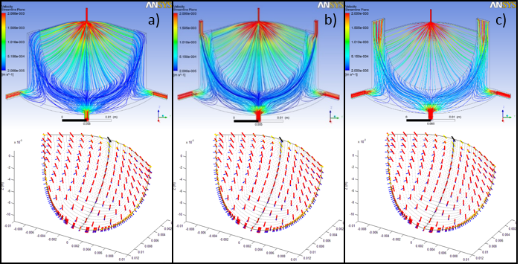  
Picture 1: Velocity streamline from CFD models (up) and polymer chains orientation (down) of the PHV mould wit Velocity streamline from CFD models (up) and polymer chains orientation (down) of the PHV mould with one (a), two (b) and three (c) injection points.

Cardiovascular CFD

**111**

**PATIENT-SPECIFIC COMPUTER MODELS AS A TRANSLATIONAL TOOL TO TAILOR CATHETER CARDIOVASCULAR INTERVENTIONS**

Claudio Capelli1, Giorgia Maria Bosi1, Sachin Khambadkone2, Graham Derrick2, Andrew M Taylor1, Silvia Schievano1

1University College London, LONDON, United Kingdom

2Great Ormond Street Hospital for Children, LONDON, United Kingdom

Aim

In this study, we explore the potential use of a patient-specific modelling framework for predicting clinical outcomes of cardiovascular interventions for the treatment of complex congenital heart diseases.

Methods

A small cohort of patients (n=10) who were referred to our Centre for percutaneous pulmonary valve implantation (PPVI) and aortic coarctation stenting, and presenting complex anatomical features, was considered in this study. Clinical image data acquired for conventional assessment were post-processed to set up the 3D patient-specific implantation site, thus modelling realistic anatomy, physiology and boundary conditions. According to the clinical indication, various cardiovascular devices including balloons, stents and valves were virtually implanted in each patient-specific model. Finite element (FE) and computational fluid dynamics (CFD) analyses were used prospectively to simulate device implantation and investigate hemodynamic changes. Clinical outcomes from the real procedures, when already performed, were compared with the predictions of the computational analysis.

Results

Simulations allowed assessment of intervention feasibility and device selection for each individual case. Potential post-operative scenarios were highlighted by the measure of contact areas between device and implantation site, and vessel wall stress distributions. Computational fluid-dynamic analyses in the coarctation patients were helpful to assess flow split after intervention using different stenting approaches. Clinical procedures were carried out in accordance with the computational predictions in all cases except one PPVI. The computational framework process was completed within a week with no requirements for additional clinical data or increase in direct costs.

Conclusions

Translation of patient-specific cardiovascular models towards their clinical use is promising to support interventional planning of complex cases. Simulations can predict outcomes of interventions reliably, rapidly, and at low costs. In addition, these tools can provide information about the performance of existing devices and potentially support the development of new ones.

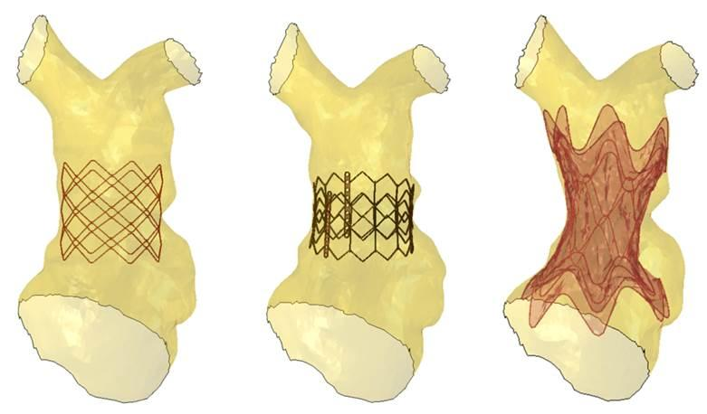Picture 1: Examples of different devices modelled within a patient-specific pulmonary arter Examples of different devices modelled within a patient-specific pulmonary artery

Cardiovascular CFD

**112**

**IN-SILICO AND IN-VITRO TESTS OF A NOVEL MODULAR HEART VALVE PROSTHESIS FOR THE PULMONARY POSITION**

Desiree Pott1, Sandrine Egron1, Janez Vodiskar2, Jaime F. Vazquez-Jimenez2, Ulrich Steinseifer1, Tim Kaufmann1, Simon Sonntag1

1Institute of Applied Medical Engineering, RWTH Aachen University, AACHEN, Germany

2Dept. of Pediatric Cardiac Surgery, University Hospital RWTH Aachen, AACHEN, Germany

**Aim:** A transcatheter modular pulmonary heart valve prosthesis was developed for the percutaneous treatment of patients with insufficient pulmonary valves, conduits etc. which have a larger anatomy and cannot be treated with the commercially available devices on the market (Medtronic Melody and Edwards Pulmonic). The modular device consists of the valve bearing basic element (BE) and an anchoring element (AE). Latter can be connected on top or bottom to the BE and adapt to the deformed anatomy. Here, the flexibility and the adaptation of the device are tested in-silico.

**Methods:** A 35mmOD nitinol BE and a 40mmOD AE were iteratively developed by means of an anatomy analysis of the pulmonary artery (PA), CAD tools and finite element analysis (FEA). The AE was designed with small curved struts in axial direction for a better flexibility during insertion via catheter through the right ventricle. A FEA model was implemented in Abaqus (Simulia, USA) to test the flexibility in axial direction of the BE and the complete device (both elements connected together) during insertion procedure. The simulation contains 3 steps: (1) crimping of the device, (2) insertion via catheter through the curved pathway, (3) deployment. A second FEA model mimics the deployment into a PA to test the adaptation. The simulation contains 3 steps: (1) crimping of the device, (2) deployment in the PA, (3) pressure on the leaflets.

**Results:** Both elements were designed as short as possible to fit into a PA. The flexibility in axial direction of the AE, tested in-silico seems to be sufficient for insertion via catheter through the curved pathway. The device adapts well to the anatomy of the PA.

**Conclusion:** The developed transcatheter modular pulmonary heart valve prosthesis showed good in-silico results. In-vitro tests are ongoing to validate the simulations and to further develop the prosthesis.

Cardiovascular CFD

**113**

**OVERSIZING PULMONARY CONDUITS IN CHILDREN: HEMODYNAMIC CONSEQUENCES**

Simon Johannes Sonntag1, Pejman Farhadi Ghalati1, Jaime Vázquez-Jiménez2, Ulrich Steinseifer1, Janez Vodiskar2

1Institute of Applied Medical Engineering, RWTH Aachen, AACHEN, Germany

2Department of Pediatric Cardiac Surgery, University hospital RWTH Aachen, AACHEN, Germany

**Aim:** Implanting the largest valved conduit possible - oversizing - for reconstruction of absent right ventricle to pulmonary artery connection in certain types of congenital heart defects was suggested as a compensating measure for somatic outgrowth of the patient. One effect that has not been investigated yet is the hemodynamic consequence of implanting a larger sized conduit in a child pulmonary artery.

**Methods:** To determine the impact of conduit oversizing on the hemodynamics, calculated wall shear stresses (WSS) of image-based Computational Fluid Dynamic (CFD) simulations were used as indicator. Three different sizes of valved conduits (20 mm, 22 mm and 24 mm), including the largest possible conduit size, virtually implanted in a child sized healthy pulmonary artery and the corresponding adult sized model were investigated. The size of the child model was chosen to correspond to the age and body surface of a child who’s body growth has become more stable, so oversizing would exert its hemodynamic effects for a longer period of time.

**Results:** The child and adult models show a decrease of the mean WSS (approx.. 26%) in the whole domain with an increase of the conduit size. When looking at the mean WSS at the anastomosis, for the child model the WSS is significantly increased (approx. 40%) when oversizing (Z-score +3.21). In contrast, the stresses are decreased for the adult model (34%) when using the largest conduit (Z-score +0.25).

**Conclusions:** Based on the results of this study, it must be considered that choosing a prosthesis size which will lead to high WSS and associated intimal reaction can defeat the benefit of having a nominally larger orifice area directly after implantation. A 40% increase of WSS is significant and could explain clinically observed problems of implanting certain types of conduits with well described outcomes of supravalvular/distal anastomotic stenosis.

Cardiovascular CFD

**114**

**CFD ANALYSIS OF PRE- AND POST-INTERVENTIONAL HEMODYNAMICS IN BAV PATIENTS UNDERGOING VALVE AND/OR AORTIC SURGERY**

Florian Hellmeier1, Leonid Goubergrits2, Jan Osman1, Pavlo Yevtushenko1, Ulrich Kertzscher1, Marcus Kelm3, Titus Kühne3, Felix Berger3

1Charité - Universitätsmedizin Berlin, BERLIN, Germany

2Charité - Universitätsmedizin Berlin, Deutsches Herzzentrum Berlin, BERLIN, Germany

3Deutsches Herzzentrum Berlin, BERLIN, Germany

**Aim:** Aortic regurgitation and dilatation are two comorbidities commonly seen in bicuspid aortic valve (BAV) patients. Both pathologies frequently require intervention. Aortic regurgitation is typically treated by aortic valve replacement to avoid congestive heart failure, while aortic dilatation is commonly treated by vascular graft implantation to prevent aortic dissection or rupture. To avoid adverse outcomes, treatment is often without alternative. Nevertheless, comparing pre- and post-interventional state in these patients can help understand the effects of valve and aortic surgery on aortic hemodynamics.

**Methods:** Pre- and post-interventional MRI data was obtained from 6 patients exhibiting BAV and at least one associated comorbidity (dilatation and/or regurgitation), who underwent valve and/or aortic surgery. Interventions included valve-sparing aortic root replacement, Ross-Konno procedure and composite aortic valve graft replacement. Aortic geometries were reconstructed from conventional MRI data and peak-systolic steady-state CFD simulation was subsequently performed on these geometries. 4D flow MRI data was used to obtain patient-specific inlet velocity profiles.

**Results:** Replacement of the dilated ascending aorta led to increased wall shear stress in two patients, likely due to the reduced vessel diameter after surgery. Few relevant differences beyond wall shear stress were seen between pre- and post-interventional flow fields, when flow rates were kept identical. When accounting for the post-interventional reduction in systolic flow rate seen in the regurgitation patients, aortic hemodynamic in this group improved compared to the pre-interventional state.

**Conclusion:** Reductions in aortic diameter due to treatment of dilatation may lead to locally increased wall shear stress. The pathological relevance of this finding remains to be evaluated. Furthermore treatment of aortic regurgitation may lead to improved aortic hemodynamics through reduction of peak systolic flow rate.

Cardiovascular CFD

**115**

**NUMERICAL INVESTIGATION OF HEMODYNAMICS AFTER VALVE REPLACEMENT IN BICUSPID AORTIC VALVE PATIENTS**

Jan Osman1, Leonid Goubergrits1, Florian Hellmeier1, Pavlo Yevtushenko1, Ulrich Kertzscher1, Marcus Kelm2, Titus Kühne2, Felix Berger2

1Charité - Universitätsmedizin Berlin, BERLIN, Germany

2Department of Congenital Heart Disease and PediatricDeutsches Herzzentrum Berlin, BERLIN, Germany

**Aim:** Bicuspid aortic valve (BAV), one of the most common congenital heart diseases, is associated with several sequelae such as: aortic dilation, aneurysm formation and regurgitation. Additionally, BAV occurs in approximately two thirds of patients suffering coarctation of the aorta. BAV treatment usually consists of replacement of the aortic valve with biological or mechanical valves. Since this procedure poses a high risk of bleeding and thrombosis, it is only performed if a significant valve stenosis or aortic regurgitation is present. Therefore, a tool to predict aortic hemodynamics after valve replacement might improve treatment outcome and life expectancy of BAV patients.

**Methods:** Cardiac MRI, including conventional structural data, as well as 4D flow data, from six patients was acquired. Three-dimensional aortic geometries of these patients were segmented including the aortic root and valve area. Biological and mechanical valve geometries were inserted virtually into these aortic geometries at the valve area. Peak systolic velocity vector fields in front of the inserted valve geometries were extracted from the 4D flow MRI data and applied as boundary condition of a steady state CFD Simulation.

**Results:** Virtual valve replacement using mechanical valves led toa decreased helicity and smaller secondary flow structures within the ascending aorta. Consequently,replacement using a biological valve resulted in approximate two-fold increase of degree of secondary flow. Other parameters, such as surface averaged wall shear stress, pressure drop and turbulence were also increased using biological valves.

**Conclusion:** Using virtual valve treatment, we were able to show striking differences in aortic hemodynamics after insertion of biological and mechanical valves. The meaning of these differences is yet unclear and needs further investigation and validation. Numerical Investigation of hemodynamic change after virtual valve replacement might be a helpful tool for patient-specific treatment planning and thus could lead to an enhanced life expectancy.

Haemocompatibility

**116**

**HAEMOCOMPATIBILITY OF DEXTRAN COATED ACTIVATED CARBON MATERIALS**

Carol Howell1, Susan Sandeman1, Yishan Zheng1, Ganesh Ingavle1, Sergey Mikhalovsky1, Eliszabeta Snezhkova2, Vladymir Nikolaev2

1University of Brighton, BRIGHTON, United Kingdom

2RE Kavetsky Institute of Experimental Pathology, Oncology and Radiobiology, KIEV, Ukraine

Aim: The surface properties of a biomaterial play a crucial role in their functionality, when used in an extracorporeal application. Activated carbon (AC) material during contact with blood can induce a range of biological responses such as; protein adsorption, thrombus formation, and inflammation resulting in unwanted clinical side effects. Our aim was to utilize pharmaceutical quality dextran, a biocompatible molecule to coat an adsorbent AC and study the coating influence on material porosity and haemocompatibility.

Methods: The granulated AC (HSGD)was obtained by pyrolysis of nitrogen containing synthetic resins with subsequent activation by IEPOR (Ukraine). A range of 5-30% dextran coated AC beads were prepared and characterised by low temperature nitrogen porosimetry to establish the effect of coating on their porosity. A comprehensive haemocompatibility study using healthy donor blood was carried out according to European standard (EN ISO 10993 part 4) including; coagulation, haematology, platelet and complement system analysis.

Results: The majority of surface area and pore volume of HSGD is represented by “small”(mean diameter 3.2nm) and “large”mesopores (mean diameter 48nm). Surface area and pore volume of both sizes of mesopore are reduced in direct relation to the percent dextran coating. The batch studies of AC incubation with blood demonstrate that coating improves haemocompatibility by reducing: AC fine formation, fibrinogen adsorption, haemolysis, complement activation and albumin adsorption. Uncoated as well as dextran coated AC in these experiments did not appreciably activate blood cells or the coagulation system.

Conclusion: These findings suggest that the AC material HSGD, particularly with a dextran coating, is a suitable adsorbent material for blood contacting extracorporeal applications.

Haemocompatibility

**117**

**THE FINE LINE IN TUNING HAEMO- AND BIO-COMPATIBILITY VIA SURFACE MODIFICATION: CASE STUDY OF GELATIN-PET SYSTEMS**

Elena Diana Giol1, Ron Unger2, Sandra Van Vlierberghe1, James Kirkpatrick2, Peter Dubruel1

1Polymer Chemistry and Biomaterials (PBM) Group, UGent, GENT, Belgium

2REPAIR LAB, Johannes Gutenberg University Mainz, MAINZ, Germany

**Aim**

More than half of the population suffers from cardiovascular diseases and the demand of synthetic grafts dramatically increased over the years1. General requirements for synthetic grafts include the presence of a non-thrombogenic surface, host compatibility and sufficient mechanical strength2-3. Poly(ethylene terephthalate), PET,fulfils the first requirements due to its excellent mechanical properties and inertness, respectivelly. Its major drawback is the poor surface properties that directly influence biological performances (eg. haemo- and bio-compatibility). Over the years, an impressive number of articles reported surface modification of PET. Most included cell tests or haemocompatibility screenings, but very few discussed both. In the present study, we show the importance of performing a complete screening of these materials. The influence of several parameters, such as substrate surface properties (eg. wettability, changed by plasma treatments) and surface modification protocols are thus herein reported. Most important, their effect over *in vitro* performance is presented.

**Methods**

Gelatin-modified PET were characterized in depth using SCA, AFM and XPS, combined with radiolabelling. Whole blood to assess preliminary haemocompatibility and HUVEC cells to investigate preliminary cell-biomaterial interactions were applied on all investigated samples.

**Results**

Synergetic effect of plasma treatment and variations of the applied surface modification protocol presented an unexpected poor haemocompatibility and ambiguous HUVEC adhesion results, while the influence of each parameter independently showed acceptable *in vitro* results.

**Conclusions**

A multi-parameter study on surface modification of PET with gelatin was performed and successfully proved the major impact that a subtle change in protocol has over *in vitro* performances.

**References**

1 European Cardiovascular Disease Statistics (2005), University of Oxford.2Wang X., et al. (2007) *World Journal of Surgery* **31**(4). 3Chaouch, W., et al. (2009) *Journal of Biomedical Materials Research Part A***91A**(3).

**Acknowledgement**

The authors would like to thank UGent (project GOA, BOF10/GOA/005) and FWO for the financial support.

Haemocompatibility

**118**

**CONTROLLED RELEASE OF HYDROPHILIC PHARMACEUTICAL AGENTS FROM COAXIALLY ELECTROSPUN FIBERS**

Marc Mueller, Alexandros Repanas, Fedaa Al Halabi, Birgit Glasmacher

Leibniz Universitaet Hannover, HANNOVER, Germany

**Aim**

Coaxial electrospinning is a novel technique to prepare polymeric core-shell fibers, enabling the direct encapsulation of drugs in the core. Electrospun fibers have received scientific attention due to their unique properties including high surface-area-to-volume ratio and structural similarity to the extracellular matrix (ECM). Aim of this work was to create polymeric fibrous carriers and investigate their structural, morphological and physical properties, as well as, the release kinetics of the encapsulated drug.

**Methods**

Bovine serum albumin (BSA) and polycaprolactone (PCL) were separately dissolved in 2,2,2-trifluoroethanol (TFE) at concentrations of 15 mg/ml and 150 mg/ml, respectively. A blend solution with both substances was prepared to serve as a control. The morphological properties of the fibers were assessed with scanning electron microscopy (SEM). Cyclic uniaxial mechanical tests were performed by a tensile testing system (LM1 Test bench, BOSE). 15x10 mm strips were tested at 0-30% strain, 1 Hz and dry conditions. The hydrophilicity of the fibers was studied using a contact angle assay. The cumulative release of BSA was assessed by UV-vis spectrometry and the release mechanism was investigated.

**Results**

The coaxially spun fibers had a smooth, “spaghetti-like”shape (Fig. 1) with an average diameter of 0.96 ±0.21 μm and a contact angle of 99.14 ±7.58o, being more hydrophobic and thinner in contrast to the control sample. Young’s modulus was significantly higher in the coaxial samples (59.78 ±2.02 MPa coaxial vs 52.18 ±1.16 MPa control). The total amount of BSA released during the first 24 hours was 42.23 %, in contrast to 49.3 % for the control, while Fickian diffusion was the release mechanism for both cases.

**Conclusion**

Thinner, more hydrophobic fibers with higher tensile strength were created with the coaxial approach, providing a more sustained release of BSA as potential candidates for drug delivery applications.

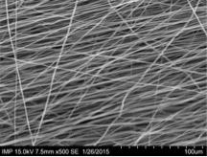Picture 1: Electrospun fibers with BS Electrospun fibers with BSA

Haemocompatibility

**119**

**AN ELECTRO-ACTUATABLE HYDROGEL VASCULAR OCCLUSION DEVICE: AN IN-VITRO AND IN-VIVO EVALUATION.**

Peter Verbrugghe1, Jelle Verhoeven1, Walter Coudyzer1, Eric Verbeken1, Peter Dubruel2, Eduardo Mendes3, Frank Stam4, Bart Meuris1, Paul Herijgers1

1UZ Leuven, LEUVEN, Belgium

2Ghent University, GHENT, Belgium

3Delft University, DELFT, Netherlands

4Tyndal National Institute, CORK, Ireland

**Aim:** Because of favourable characteristics there is a growing interest for the use of hydrogels in biomedical applications. Moreover they can be activated by various stimuli, for example electrical fields. This study evaluates an electro-responsive hydrogel for intravascular applications.

**Methods:** Pluronic methacrylic acid hydrogel was tested in-vitro for its haemolytic and cytotoxic effects, and for its swelling and occlusion capacity. Minimal invasive implantation in the carotid artery of sheep was used to evaluate its long-term biological effects, through biochemical, macroscopic, radiographic, and microscopic evaluation.

**Results:** In-vitro evaluation showed no haemolytic or cytotoxic effects. Occlusion could be obtained within a short period of time. In-vivo evaluation showed a persistent occlusion of the artery at time of autopsy with no systemic effects and mild effects on the arterial wall.

**Conclusions:** An endovascular delivered electro-responsive hydrogel can cause a long-term arterial occlusion. This material can be used as an endovascular occlusion device. More important it might be a base for future development of hydrogels for intravascular applications (e.g. intra-vascular drug delivery, aneurysm sac occlusion).

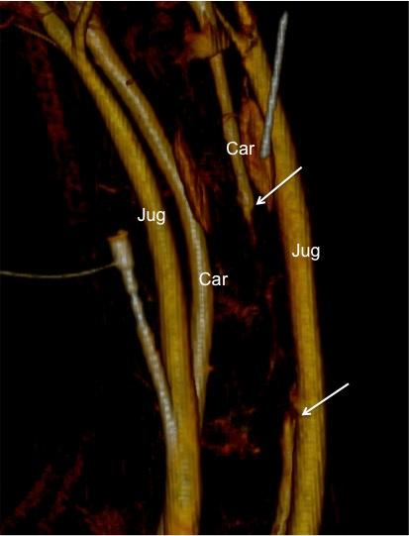Picture 1: Three-dimensiona Three-dimensional reconstruction of neck vessels four weeks after implantation. There is a complete occlusion of the carotid artery (between arrows).

Haemocompatibility

**120**

**QUANTIFICATION OF ADHERENT PLATELETS ON BIOMATERIALS. COMPARISON OF COLORIMETRIC AND MICROSCOPIC ASSESSMENT.**

Steffen Braune, Shuo Zhou, Benjamin Groth, Andreas Lendlein, Friedrich Jung

Institute of Biomaterial Science, Helmholtz-Zentrum Geesthacht, TELTOW, Germany

**Aim**: Platelet adhesion to artificial surfaces is one of the most important indicators for the thrombogenicity of implant materials and assessed by different colorimetric- or microscopy-based techniques. Here, we study how colorimetric assay data correlate with the image-based quantification of adherent platelets by comparing two colorimetric assays (lactate dehydrogenase (LDH) and acid phosphatase (ACP)) with a microscopic approach.

**Materials and Methods**: An *in vitro* static thrombogenicity test was applied to study human platelet adhesion on: medical-grade polytetrafluoroethylene (PTFE), medical-grade silicone and cell culture-grade polyethylene terephthalate (PET). For the image-based determination of platelet densities, adherent platelets were fixed and fluorescently labelled. These densities were applied as reference values for the comparisons with results from the colorimetric assay. Correlation between different platelet concentrations and ACP as well as LDH absorbance measurements were analysed to estimate accuracy and association of both parameters. ACP and LDH release from resting and ADP-stimulated platelets was studied to estimate how platelet activation influences colorimetric assay results.

**Results**: Densities of adherent platelets ranged between 15,490±3,370 platelets∙mm-2 (PTFE) and 440±110 platelets∙mm-2 (silicone) and 5,080±1,670 platelets∙mm-2 (PET) and differed significantly between all polymers (p<0.05). Correlation coefficients between microscopic and colorimetric determination of platelet densities ranged between r=0.89 (LDH, p<0.0001) and r=0.91 (ACP, p<0.0001). Comparisons of both colorimetric assays revealed a correlation of r=0.9246 (p<0.0001). ACP absorbance measurements of platelet standards corresponded well to an ideal linear regression while LDH data deviated from expected values. LDH release after platelet activation was significantly higher compared to ACP.

**Conclusion**: Acceptable correlations of both colorimetric assays and the image-based assessment of adherent platelets were achieved at low platelet concentrations. For thrombogenicity studies applying physiological platelet concentrations, the ACP assay appears more suitable due to better linearity of the standards, less variability and lower susceptibility on platelet activation.

Haemocompatibility

**121**

**FLOW SCALE AFFECTED THE SHEAR-INDUCED BLOOD TRAUMA**

Sunao Ueda, Kentaro Nagashima, Nobuo Watanabe

Shibaura Institute of Technology, SAITAMA, Japan

**[Introduction]** As suggested by many researchers, it is clear that the shear stress and its exposure time are main trigger to the blood trauma leading to the hemolysis according to the blood pump usage. Additionally, the recent study by Dr. Maruyama et al. suggested that the surface roughness would be also a key parameter for the shear induced blood trauma (**Maruyama et al. J Artif Organs2005**). If their suggestion is truth, we supposed that the flow scale should also effect on the hemolysis. We made a hypothesis that the surface roughness to flow scale ratio should have a great impact upon the shear-induced hemolysis. Therefore the purpose of this study is to examine the feasibility of our hypothesis.

**[Material and Methods]** We developed the constant shear flow generator with the three kinds of inner cylinder’s diameter for the adjustment of flow scale 1.00, 1.25, and 1.50mm. The several levels of surface roughness between 0.3 and 0.9 were given to the surface of the inner cylinder. The porcine blood bought from the Slaughter house was exposed to the constant shear stress of 8.5Pa using the shear generator under the several combination among the surface roughness and flow scale and exposure time. And then, the plasma free hemoglobin level of each condition was assessed by the light absorbance measurement.

**[Result and Discussion]** As we supposed, the hemolysis level increased with the decrease of flow scale under the similar surface roughness levels near 0.35. In addition, it was shown that the hemolysis level increased with the surface roughness to flow scale ratio. The result validated our hypothesis.

**[Conclusion]** We clearly showed that the flow scale gave an impact upon the hemolysis level, and the ratio of surface roughness scale to the flow scale would be very important for the hemolysis level.

Poster session kidney & dialysis

**122**

**IMMORTALIZED HUMAN RENAL EPITHELIAL CELLS GROWN ON HOLLOW FIBER MEMBRANES FOR BIOARTIFICIAL KIDNEY**

Michele Fedecostante, Jitske Jansen, Lambertus P. Van den Heuvel, Luuk Hilbrands, Joost Hoenderop, Rosalinde Masereeuw

Radboud UMC, NIJMEGEN, Netherlands

*Aim.* It is now recognized that renal diseases are global public health problems, with the incidences of end-stage renal diseases (ESRD) rising annually. ESRD requires long-term kidney replacement therapy. Due to dialysis treatments inefficiency in small waste molecules removal, such as uremic toxins, ESRD still lead to severe health problems, poor life quality and high mortality 1. Therefore, a cell-aided device is being developed, which goal is to achieve anionic uremic toxins removal by conditionally immortalized human renal proximal tubule epithelial cells (ciPTEC) cultured on double coated hollow fiber membranes (HFM)*.*

*Methods.* ciPTEC2 were cultured on the HFM to obtain confluent monolayers. Immunostaining for zonula occludens-1 (ZO-1) was performed in order to assess monolayer formation. For functional assessment the organic anion transporter 1 (OAT-1), involved in renal anionic uremic toxins removal was tested, using fluorescein as substrate.

*Results.* Immunostaining of ciPTEC-OAT1 cells on HFM revealed tight monolayer formation. Perfusing fibers with fluorescein (0.1 µM, 6 ml/h) resulted in a clear cellular uptake of the marker in the cells, which was increased in concomitant treatment with efflux inhibitors within the first minute (4.0±0.2 *vs.* 173±18 arbitrary fluorescence unit, AFU), indicating transepithelial transport. Moreover, fluorescein uptake was reduced when the fiber was perfused in combination with probenecid, an OAT-1 inhibitor (113±10 *vs.* 173.±18 AFU), confirming active transport.

*Conclusion.* We demonstrated functional ciPTEC on HFM as a first step in the development of the bioartificial kidney.

**References:**

1 J.Jansen. et al. Biotechnological challenges of bioartificial kidney engineering. Biotechnology Advances 32 (2014) 1317-1327.

2  J.Jansen et al. A morphological and functional comparison of proximal tubule cell lines established from human urine and kidney tissue. Exp Cell Res. 2014 Apr 15;323(1):87-99.

**Acknowledgments:**

The financial support of this research project is gratefully given by BIOART FP7-PEOPLE-2012-ITN (grant no. 316690).

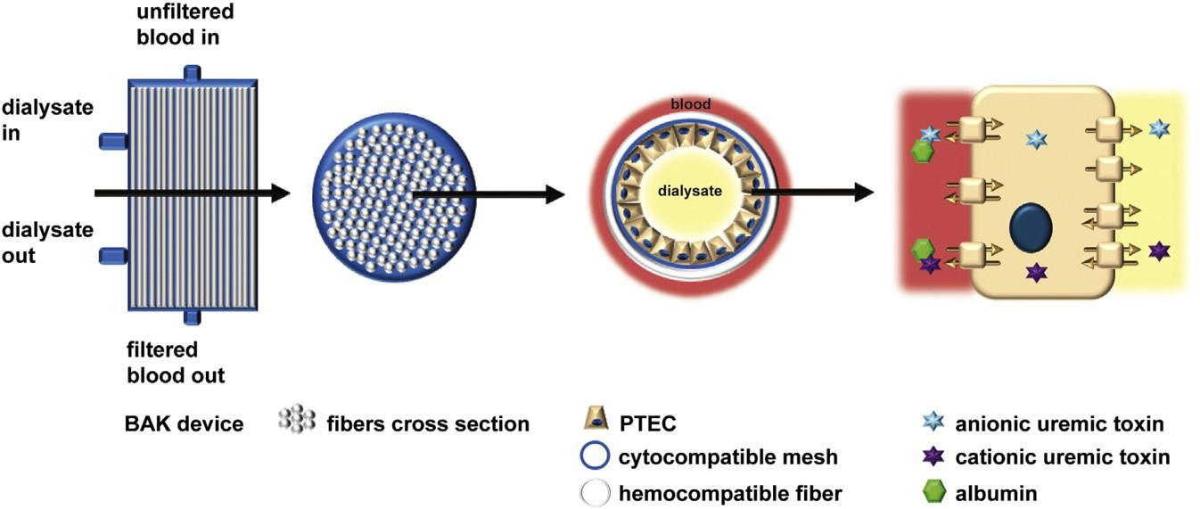Picture 1: Renal assist device (RAD) composition and mechanis Renal assist device (RAD) composition and mechanism

Poster session kidney & dialysis

**123**

**IMPACT OF TIMED INTRADIALYTIC CYCLING ON URAEMIC TOXIN REMOVAL**

Sunny Eloot, Celine De Vos, Laure Lemarcq, Griet Glorieux, Wim Van Biesen, Annemie Dhondt

Ghent University Hospital, GENT, Belgium

**Aim** Different studies already revealed the positive impact of exercise on the quality of life of haemodialysis (HD) patients, and on the removal of small solutes. Since the underlying mechanism is not yet well understood, no suggestions can be drawn about time point and/or required duration of intradialytic exercise to get optimal removal. We therefore studied the impact of different cycling schedules during HD on overall solute removal.

**Methods** This randomised cross-over study included 8 stable patients (5 male) who were dialysed with an FX800 dialyser during three consecutive midweek HD sessions of 240min: 1) without cycling; 2) cycling from 60-120min; and 3) cycling from 150-210min, with the same cycling load as in option 2. Blood and dialysate flows were, respectively, 300 and 500mL/min, while ultrafiltration was set according the patient's needs. Blood was sampled from the blood inlet line at 0, 15, 30, 60, 90, 120, 150, 180, 210 en 240min, and dialysate was partially collected (300mL/h). All samples were analysed for urea, creatinine, phosphorus and potassium, and intradialytic reduction ratios and overall removal per solute were calculated.

**Results** Urea removal seemed not influenced by 1 hour of exercise. Reduction ratio of phosphorus, potassium, and creatinine were however significantly lower during the 60-120min as well as the 150-210min cycling interval as compared to no cycling, indicating solute influx from the deeper tissues into the blood. While overall (0-240min) phosphorus reduction ratios were not different among the three options, removal was significantly larger when cycling from 150-210min, confirming the intradialytic influx.

**Conclusion** Cycling during the second half of the HD session enhances phosphorus transport from the deeper tissues into the plasma, increasing overall removal. The samples are currently being analysed for different protein-bound solutes and middle molecules.

Poster session kidney & dialysis

**124**

**ASSOCIATION BETWEEN CARDIAC VALVE CALCIFICATION AND ARTERIOVENOUS FISTULA THROMBOSIS IN HEMODIALYSIS PATIENTS**

Sasho Gelev

University Kiril i Metodij, SKOPJE, Macedonia

Aim: The objective of the present study was to evaluate whether the association between cardiac valvecalcification presence and arteriovenous fistula (AVF) thrombosis in patients on hemodialysis (HD).

Methods: Baseline echocardiography was performed in 86 patients (41 male) on regular HD to screen for calcification of the cardiac valves. The patients ware stratified according to the number of calcifiedvalves in three groups: group I (n-28, 32.6%) without valvular calcification; group II (n-34, 39.5%) with one calcified valve (either mitral or aortic); group III (n-24, 27.9%) with calcification on both valves (mitral and aortic). Prior history of AVF thrombosis was obtained through direct questioning.

Results: Thirty eight patients (44.2%) had previous episodes of AVF thrombosis. A significantly higher percentages of previous history of AVF thrombosis were observed in the group with both calcified valves (58.33 vs 21.43, p=0.000), as well as in the group with one calcified valve (52.94 vs 21.43, p=0.000) in comparison with group without cardiac valve calcification. There was no statistical difference in frequency of previous episodes of AVF thrombosis between the groups of patients having one and patients with both calcified valves. Multivariate adjusted logistic regression analyses (with group of the patients without valvular calcification as the reference value) identifiedcardiac valve calcification presence as a factor independently and significantly associated with theAVF thrombosis occurrence [OR=2.054, CI (1.039-4.108) for the group with one calcified valve / OR=2.336, CI (1.129-4.833) for the group with both calcified valves] in our HD patients.

Conclusion: Previous episodes of AVF thrombosis in HD patients are more frequent in patients with detectedcardiac valve calcification. The presence of the cardiac valve calcification on echocardiography isassociated factors for frequent occurrence of AVF thrombosis in those patients.

Poster session kidney & dialysis

**125**

**A CONNECTION BETWEEN QT INTERVAL (ECG) PROLONGATION AND CARDIAC VALV? CALCIFICATION IN HEMODIALYSIS PATIENTS**

Sasho Gelev, Lada Trajceska, Elizabeta Srbinovska, Gjulsen Selim, Pavlina Dzekova, Aleksandar Sikole

University Kiril i Metodij, SKOPJE, Macedonia

Aim: This study aimed to determine whether the presence of the cardiac valve calcification predicts posthemodialysis recorded QT interval (ECG) prolongation in hemodialysis (HD) patients.

Methods: Baseline echocardiography was performed in 106 prevalent HD patients (49 male) to screen for calcification of the cardiac valves. The patients ware stratified according to the number of calcifiedvalves in three groups: group I (n-32, 30.2%) without valvular calcification; group II (n-43, 40.6%) with one calcified valve (either mitral or aortic); group III (n-31, 29.2%) with calcification on both valves (mitral and aortic). Twelve-lead ECG were performed in all patients immediately after a single HD session to analyzed for QT intervals.

Results: A significantly longer QT and QTc intervals were observed in the group with one calcified valve(383.33±36.32 vs 359.31±38.54 ms / 442.21±39.44 vs 423.72±40.26 ms), as well as in the groupwith both calcified valves (387.74±35.75 vs 359.31±38.54 ms / 445.67±37.58 vs 423.72±40.26ms) compared with group without valve calcification. There was not found significant differencesin QT and QTc interval duration when compared the groups of the patients with one and with bothcalcified valves. Multivariate adjusted logistic regression analyses (with group of the patientswithout valvular calcification as the reference value) identified cardiac valve calcification presenceas a factor independently and significantly associated with the QT [OR=1.128, CI (1.059-1.202)for the group with one calcified valve / OR=1.225, CI (1.103-1.361) for the group with bothcalcified valves] and QTc [OR=1.067, CI (1.008-1.124) for the group with one calcified valve /OR=1.137, CI (1.050-1.224) for the group with both calcified valves] interval prolongation in ourHD patients.

Conclusion: Post-HD recorded QT / QTc interval are prolonged in HD patients with cardiac valve calcifications.The presence of valvular calcification may predispose HD patients to cardiac arrhythmias andsudden death

Poster session kidney & dialysis

**126**

**SYSTEMS THEORY APPLIED TO ISOLATED KIDNEYS DURING EXTRACORPOREAL PERFUSION**

Felix Glocker, Wolfgang Kleinekofort

RheinMain University, RUESSELSHEIM, Germany

**Aim**

In transplantation medicine the question of transplantability or viability is essential - but the term viability has yet to be defined. The aim of our work is to use a systems theory approach for organs during extracorporeal perfusion which allows a statement about the organ condition before transplantation.

**Methods**

The qualitative methods of dynamical systems are applied to extracorporeal perfused kidneys. The key idea is to view an organ as an input-output dynamical system with input u, output y and state x consisting of n state variables. The state x represents the complete information about the organ. Although the state x can be used for theoretical considerations it is not measureable because the number of state variables is immense. Our technical solution is to use a model of the organ, resulting in a simplified and measurable model state. In addition, the concepts of energy function, point of no return (irreversible organ damage) and viability are investigated.

**Results**

On the basis of systems theory we present a model for a human kidney. Although the model is incomplete in the sense of a dynamical system, it can be used to define a model state. The energy storage function is defined as the amount of available energy in the organ. According to the time dependent storage function the organ viability can be predicted for kidneys under extracorporeal perfusion. Viability parameters during extracorporeal perfusion like oxygen consumption and organ reaction to pharmacological stimuli are used to refine the viability prognosis.

**Conclusion**

First steps towards a systems theory approach to organs are shown and key concepts like state, energy function, point of no return and viability are discussed. A simple input-output model for the human kidney is presented.

Poster session kidney & dialysis

**127**

**FOUR-TIME WEEKLY HEMODIALYSIS; ITS ADVANTAGES & DISADVANTAGES**

Hiroshi Tanaka1, Aya Kita1, Tomoyuki Kita2, Rumi Sakai3

1Ashiya Sakairumi Clinic, ASHIYA, Japan

2Sakairumi Clinic, KOBE, Japan

3Motoyama Sakairumi Clinic, KOBE, Japan

**Aim:** Clinical practice, advantages and medical costs of 4-time weekly hemodialysis, HD were evaluated.

**Methods**: Subjects were 10 HD outpatients (3 females and 7 males, 36-69 y. o., HD vintages 0.4-32.7 years), who were switched from 3- time weekly to 4-time weekly HD between February 2010 and July 2014. We observed the laboratory data, monthly medical costs and changes of practice for two months before and for 4 months after HD mode change. Laboratory data were shown as mean ± S.D. Individual data were the averages of 2 months before HD mode change and of 2-4 months after. Statistical analysis was done by paired Student’s t test.

**Results**: BUN before HD (66.9±7.0 → 51.0±5.5 mg/dl, p<0.001), serum creatinine before HD (12.1±1.3 → 9.7±1.3 mg/dl, p<0.001), and CTR after HD (cardio-thoracic ratio, 47.4±3.9 → 45.4±4.3 %, p<0.02) were significantly decreased after the change of dialysis mode. Hemoglobin before HD (11.5±1.1 → 12.2±1.4 g/dl, p<0.05) and serum total cholesterol before HD (148±22 → 165±26 mg/dl, p<0.05) were significantly increased. Doses of ESAs, antihypertensive drugs, and phosphate binders were decreased in some cases. Monthly HD sessions increased by 1-4 times. Averaged medical costs for each increased session were 3,311 Japanese yen under the Japanese reimbursement system. As 3- time weekly and 4-time weekly HD patients were mixed, it was complicated to keep their HD schedule.

**Conclusion**: Four-time weekly HD was clinically useful and did not seriously influence medical costs.

Poster session kidney & dialysis

**128**

**DETECTING TOXICITY OF UREMIC SUBSTANCES IN AN HUMAN IN VITRO MODEL**

Tino Vollmer1, Andreas Fröhlich2, Vera Jankowski3, Griet Glorieux4, Leif Abramsson5, Raymond Vanholder4, Joachim Jankowski3, Bernd Stegmayr2

1Umea University,, UMEA, Sweden

2Dept. Public Health and Clinical Medicine, Umea University, UMEA, Sweden

3Institute for Cardiovascular Research, RWTH Aachen University, AACHEN, Germany

4Nephrology Section, Department of Internal Medicine, Uiversity of Ghent, GHENT, Belgium

5Surgical and Perioperative Science, Urology and Andrology, Umea University,, UMEA, Sweden

Substances retained in the body of patients with chronic kidney disease are denominated uremic toxins. Since not all may cause toxic effects this has to be clarified by various means.

**The aim** of this study was to develop an “in vivo”method, using human spermatozoa, to estimate toxic effects of various substances.

**Material and methods:** Semen from healthy donors were used as well as fluid derived from the blood of uremic patients performing hemodialysis. The semen was diluted to optimal concentration of spermatozoa to allow investigation of the motility and vitality of the spermatozoa under various conditions. The progressive motility of spermatozoa was counted using a Bürker chamber and video recording. Incubation was performed over different time points to evaluate the effect of the buffer and the toxic substances. Vitality was analyzed at different time intervals, using a Sperm VitalStainÔ kit. Adjustment calculations for the time-effect on motility and vitality were used.

**Results:** The semen was investigated for spermatozoa function in relation to various buffers used for dilution. The best buffer used was buffer 2 that had significant better maintained motility over time than the other buffers. Vitality was similar. The ultrafiltrate obtained from dialysis patients was prepared with sepharose into 6 different portions. The more hydrophobic portion 5 exhibited an overall significant toxic effect while such effect was not obvious for the first more hydrophilic portions. Additional investigation was performed of four different drugs, in concentrations that are administered to uremic patients. Drug A resulted in a significant reduction of spermatozoa motility but not vitality, while such negative effect was not found with the other drugs.

**Conclusion:** This novel “in vivo”model repeatedly showed toxic or non-toxic effects on motility and vitality of spermatozoa. It is useful to investigate toxic effects of substances but also of various drugs.

Poster session kidney & dialysis

**129**

**SAME-DOSE CVVHDF VERSUS CVVH IN SEPTIC PATIENTS WITH ACUTE RENAL FAILURE.**

SEUNG DON BAEK, HYUN KEE LEE, YOON JI KIM, JIN UK JEONG, JUNG SIK PARK, JAI WON CHANG

Asan Medical Center, University of Ulsan, SEOUL, South-Korea

**Aim :** The mortality of the ICU patients with acute renal failure(ARF) is still high. It was reported that adding a dialysis dose to continuous veno-venous hemofiltration(CVVH) increased their survival. By the way, hemofiltration is more proper for clearance of inflammatory mediators than hemodialysis in sepsis. We tested whether continuous veno-venous hemodiafiltration(CVVHDF) is really better than CVVHF at the same net effluent according to their body weight in the ICU patients with septic ARF.

**Methods :** CVVHDF was performed by Prisma(Hospal-Gambro) with multiflow 100 at the dialysate flow rate 20ml/kg/hour, in addition to the replacement fluid flow rate 20ml/kg/hour. In contrast, replacement fluid flow rate of CVVH was 40ml/kg/hour. Patient’s removal rate was individually adjusted by attending staff considering clinical status.

**Results :** In this prospective randomized pilot study, 100 patients were assigned to CVVH(n=47, M:F=25:22, age 64±15 years) or CVVHDF(n=49, M:F=30:19, age 65±11 years). There was no difference in baseline characteristics such as age, sex, body wight, serum creatinine, BUN, beta-2 microglobulin, APACHE II and SOFA score between two groups. All parameters were significantly decreased 72 hours after the initiation of CVVH or CVVHDF, compared with the baseline values. However, there was no significant difference of reduction ratio in serum creatinine, BUN, beta-2 microglobulin, APACHE II and SOFA score between two groups. Seven, Twenty-eight, and sixty days survivals were 70%, 45% and 25% in CVVH and 67%, 47%, and 31% in CVVHDF group(p=NS), respectively.

**Conclusion :** In conclusion, none of CVVH and CVVHDF was better than the other mode in clearance of waste products and survival at the same net effluent in this study. In the future, large scaled randomized prospective study will be necessary to distinguish better one from the other to give greater survival change to the critically ill patient with septic ARF.

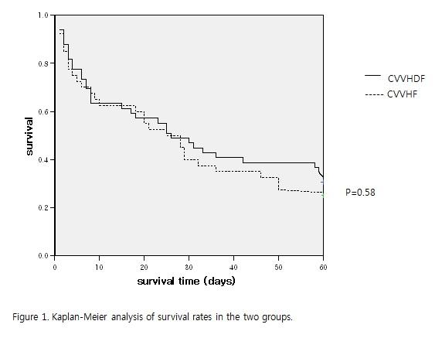

Poster session kidney & dialysis

**130**

**PRECLINICAL SAFETY EVALUATION OF IMMORTALIZED RENAL EPITHELIAL CELL LINES FOR BIOARTIFICIAL KIDNEY**

Milos Mihajlovic, Joost Hoenderop, Lambertus Van den Heuvel, Wil Allebes, Luuk Hilbrands, Rosalinde Masereeuw

Radboud university medical center, NIJMEGEN, Netherlands

**Aim:** Many patients affected by end stage renal disease (ESRD) depend on dialysis treatment for survival. However, hemodialysis incompletely removes uremic retention molecules from the circulation. Therefore, novel treatments, such as a bioartificial kidney device, are needed. We are working on a bioartificial kidney device that is based on conditionally immortalized proximal tubule epithelial cell lines (ciPTEC). Several safety issues, such as alloimmunization by the human leukocyte antigen (HLA) molecules, should be addressed prior to clinical use.

**Methods:** To assess the safety for their safe use in a kidney device, two ciPTEC lines (ciPTEC-U, ciPTEC-T1) were characterized in terms of HLA-I expression and pro-inflammatory cytokine (IL-6, TNF-α) production.HLA-I expression was measured by flow cytometry and cytokine production by ELISA after exposure to various stimulatory conditions, in static and dynamic conditions of cell culturing.

**Results:** Exposing cells to IFN-γ (300 ng/ml; 48h) resulted in an increase of HLA-I expression by 37±12% (ciPTEC-T1) and 20±8% (ciPTEC-U). LPS (10 µg/ml; 48h) increased HLA-I expression by 29±9% in ciPTEC-T1 and 15±8% in ciPTEC-U. The uremic retention solute indoxyl sulfate (1mM; 48h) did not induce a significant increment of HLA-I expression. Furthermore, the cytokine production was induced in ciPTEC-U by LPS (IL-6: 3.5±0.1 fold; TNF-α: 2.4±0.1 fold) and by indoxyl sulfate (IL-6: 1.9±0.2 fold). Remarkably, IFN-γ reduced TNF-α production (0.29±0.07 fold) and did not affect IL-6 production. An increasing trend of HLA-I and cytokine expression in dynamic with respect to static conditions was observed.

**Conclusion:** ciPTEC can have an accessory role in (allo)immune responses. However, further studies are needed to complete the characterization and to elucidate the possible effects in the context of the bioartificial kidney.

*Acknowledgements:* This work is supported by the EU Marie-Curie Initial Training Network (ITN) - BIOART project (No. 316690).

Poster session kidney & dialysis

**131**

**DEFINITION OF AN INDEX TO FORECAST INTRADIALYTIC HYPOTENSION BY A MULTI-VARIATE STATISTICAL ANALYSIS**

Vito Domenico1, Giustina Casagrande1, Camilla Bianchi1, Maria Laura Costantino1, Giuseppe Pontoriero2, Carlo Schönholzer3, Claudio Minoretti4, Giuseppe Rombolà5

1Politecnico di Milano, MILANO, Italy

2Nephrology and Dialysis, A. Manzoni Hospital, LECCO, Italy

3Nephrology and Dialysis, Regional Hospital of Lugano, LUGANO, Switzerland

4Nephrology and Dialysis, Sant’Anna Hospital, COMO, Italy

5Nephrology and Dialysis, Circolo Hospital and Macchi Foundation, VARESE, Italy

**Aim:** IntraDialysis Hypotension (IDH) is still one of the main hemodialysis related complications. The patient’s peculiar reaction to the treatment implies difficulties in preventing IDH. This work is aimed at defining an index to quantify the risk of IDH at the beginning of each session through a multivariate analysis of clinical data.

**Methods:** Data referring to 516 sessions performed on 50 patients enrolled at A. Manzoni Hospital Lecco, Italy and 20 patients at Regional Hospital of Lugano, Switzerland were collected. Clinical prescriptions, hydration status, dialysis machine and hematochemical data were recorded and stored in a unique flexible structured database.

Patients suffering from IDH in 2 or more sessions were classified as Hypotension Prone (HP), the others as Hypotension Resistant (HR). Statistical analysis was performed to identify the potential risk factor related to IDH onset.

A new index, J, was defined as a weighted patient-specific combination of the statistically relevant parameters and calculated for each session of each patient. The weight of the index coefficients can be dynamically adjourned based on the longitudinal analysis of the parameters. J>1 points out the risk of IDH. J prediction accuracy was quantified as the percentage number of predicted IDH events versus the total number of IDHs.

**Results:** Initial values of potassium concentration, systolic and diastolic blood pressure, and weight gain from the end of the previous treatment result to be statistically different between HP and HR patients. J allows recognising the 96% of the IDH episodes.

**Conclusions:** The evaluation of J at the beginning of the dialysis session can provide the clinician useful information about the risk to develop IDH during the treatment and can advise physicians about the need to modify the prescription.

Poster session kidney & dialysis

**132**

**FOUR DIFFERENT METHODS TO REDUCE EXPOSURE TO ANTICOAGULATION DURING HD.**

Malin Skagerlind1, Bernd Stegmayr2

1Umea University,, UMEA, Sweden

2Public Health and Clinical Medicine, Umea University, UMEA, Sweden

Heparin is used to prevent clotting during haemodialysis (HD). For patient at risk of bleeding heparin has to be minimized.

**The aim** of this study was to clarify the possibility to fulfil HD with any of four options, (without a bolus of heparin at start): a priming solution that is wasted of either heparin in saline (HS), heparin and albumin in saline (HA), HA in combination with citrate in the dialysate (HAC), heparin coated filter (Evodial®, Gambro).

**Method:** 25 chronic HD-patients (single centre) were enrolled in the study (17 men, 8 women). The patients were their own controls (paired statistics); first randomized to HS versus HA and the second block HAC versus Evodial. The study was approved by the Ethical committee and the Swedish Medical Product Agency. Access was AV fistula (n=12), central dialysis catheter (n=12), femoral vein catheter (n=1). Blood samples were collected at 0, 30 and 180 minutes during HD.

Dialyzer clotting was graded: 0=none, 1=mild-medium, 2=severe and 3=extensive clotting causing interruption of HD. Small heparin doses were allowed during HD.

**Results:**

More HS treatments were interrupted compared to standard HD (Table, p=0.007). The mean Activated Partial Thromboplastin-time increased at 30 minutes from 35 to 98 (sec) with standard HD, with H-priming to 40 sec (p=0.043) and HA priming (33 to 35 sec, p=0.046). Urea-Reduction-Rate at 180 minutes was significantly less with HAC (52%) versus all other methods (61-63%).

**Conclusion:** The study indicates that heparin-priming is least suitable. The Urea-Reduction-Rate was least with HAC. Individual and local experiences have to be considered.

Poster session kidney & dialysis

**133**

**BENEFIT FROM LATE CONVERSION FROM CYCLOSPORINE TO TACROLIMUS IN KIDNEY TRANSPLANTATION- SINGLE CENTER EXPERIENCE**

Galina Severova- Andreevska

University Clinic of nephrology, SKOPJE, Macedonia

Early conversion from Cyclosporine (Cyc) to Tacrolimus (Tac) from 1 week up to 3 months after transplantation, reduces rate of acute rejection in kidney transplantation and improve renal function. Some studies demonstrated improvement in long-term renal outcome after conversion to Tac. In this study we investigate the benefit on renal function from later conversion from Cyc to Tacrolimus.

Method: Mean serum creatinin (before and after conversion) was used in 30 transplant patients. The transplantation was performed 22 from related donors (parents), 5 from diseased donors and 3 non-related donors. All patients were under standard immunosuppression including induction therapy (ATG or Basiliximab) and triple drug maintenance therapy (Tacrolimus or Cyclosporine, MMF and steroids). According the time of conversion from Cy to Tac, the patients were divided in Group 1 n= 14 (> 12 months after transplantation) and Group 2 n= 16( < 3 month after transplantation). The Cy levels was 400-900 and 200-400, for Tac 8-12 and 5-8, 0-3 month after transplantation and more than 3 month after transplantation, respectively. They were following up to 12 months.

Results: Patients in Group 1 show statistical significant reducing in mean serum creatini 115 v.s 102 µmoll/l ( P= 0, 016) before and after conversion respectively. The same results was observed in Group 2, mean serum creatinin was 125 v.s 107 µmoll/l (P= 0, 022) before and after conversion respectively. There was no difference in rate of acute rejection in both groups.

Conclusion: Therapy with Tac reduced mean serum creatinin independent of time of conversion. Patients with late conversion benefit from conversion to therapy with Tac in period of 12 month follow up. We need long term follow up to evaluate the benefit in long-term renal outcome.

Poster session kidney & dialysis

**134**

**AN EXPERIMENTAL SETUP TO STUDY THE PERIVASCULAR VIBRATIONS IN ARTERIOVENOUS FISTULAS**

Ulf Krueger

Queen Elisabeth Hospital Berlin, BERLIN, Germany

Aim: An arteriovenous fistula (AVF) requires relatively high blood flow rates to guarantee adequate hemodialysis and prevent thrombosis. The high flow rate leads to flow disturbances, which are severe enough to produce perivascular vibrations. A palpable 'thrill' is traditionally associated with the creation of sufficient AVF. Nevertheless, the cause of this phenomenon remains unclear.

Methods: An AVF model was constructed from tubes and a y-connector, which simulates the circulation from the brachial artery to the brachial vein. Immediately behind the anastomosis (y-connector, respectively), a truncated finger of a latex glove (balloon) was inserted to simulate a strongly complaint vein. The non-pulsatile perfusion was performed with distilled water using a centrifugal Bio-Pump (BioMedicus, Inc., USA). A micro-semiconductor pressure transducer (IBW78, TU Dresden, Germany) with a cutoff frequency of 4 kHz was inserted into the latex balloon for local pressure measurements. The real-time frequency analysis was carried out by the LabVIEW software (National Instruments).

Results: On the balloon surface, perivascular vibrations were already palpable at laminar flow rates. The local pressure curve showed small fluctuating components superimposed to the mean pressure. The frequency analysis of the pressure fluctuations revealed the highest magnitudes between 5 and 50 Hz.

Conclusions:

The frequency spectrum of the local pressure fluctuation could not explain the vibration frequencies in the order of 1000 to 3000 Hz at laminar flow rates as noted in [1]. It remains unclear whether a full superimposition of all the local pressure fluctuations could lead to such high vibration frequencies. Further investigations are necessary.

References: 1. Fillinger MF, Reinitz ER, Schwartz RA et al. Graft geometry and venous intimal-medial hyperplasia in arteriovenous loop grafts. J Vasc Surg. 1990; 11:556-566.

Poster session kidney & dialysis

**135**

**HIGH DIALYZER INLET PRESSURE REDUCES EFFECTIVE BLOOD FLOW DURING HEMODIALYSIS**

Olaf Lebau, Wolfgang Kleinekofort

RheinMain University, RUESSELSHEIM, Germany

**Aim**

Current blood roller pumps have to meet the demand of high ﬂow rates necessary for the usage of modern, high performance dialyzers in hemodialysis therapies. For the therapy to be eﬀective, it is crucial that prescribed ﬂow rates are delivered precisely. Reduced blood ﬂow in particular always results in a diminished dialysis dose. This study examines effective blood ﬂow of roller pumps in relation to increases in dialyzer inlet pressure (DIP), associated with hemodialyzer clotting.

**Methods**

Effective blood ﬂow and its deviation from the pump setting is measured volumetrically while the pump setting is changed from 50ml/min to 600 ml/min in steady 50ml/min increments. To model the increase in ﬂow resistance due to hemodialyzer clotting, dialyzer inlet pressure is adjusted gradually from 0 mbar to 500 mbar by narrowing the diameter of the dialyzer inlet surface behind the arterial dialyzer cap.

**Results**

At a measured DIP value of 250 mbar, the effective volume flow of blood is, on average, 5% ± 1% lower than expected from the blood pump setting. DIP increase to 400mbar leads to an average flow decrease of 25% ± 1%. As a consequence, the effective dialysis dose delivered to the patient is dramatically reduced.

**Conclusion**

It is well known that low arterial pressure reduces the blood ﬂow of roller pumps, thus modern hemodialysis machines calculate effective flow on the basis of arterial pressure measurements. However, it is unknown that a decrease in effective ﬂow correlates to both negative arterial pressure and increased dialyzer inlet pressure. It follows that the development of new algorithms for the calculation of real blood flow from arterial pressure and dialyzer inlet pressure is necessary. This will help to prevent unnoticed deviations from the prescribed dialysis dose.

Poster session kidney & dialysis

**136**

**IL28B GENE POLYMORHISMS AND RESPONSE TO TREATMENT OF CHRONIC HEPATITIS C IN HEMODIALYSIS PATIENTS**

Pavlina Dzekova-Vidimliski1, Igor Nikolov1, Nadica Matevska-Geshkovska2, Lionel Rostaing3, Aleksandar Dimovski2, Aleksandar Sikole1

1University Hospital of Nephrology, SKOPJE, Macedonia

2Faculty of Farmacy, University „Ss Cyril and Methodius„, SKOPJE, Macedonia

3Department of Nephrology, Dialysis and Organ Transplantation, CHU Rangueil, TOULOUSE, France

**Background:** It has been shown that single nucleotide polymorphisms (SNPs) near the interleukin 28B (IL28B) gene were associated with sustained virological response following standard antivirological treatment of chronic hepatitis C.

**Aim:** The aim of the study was to evaluate the association between SNPs near the IL28B gene and response to treatment of chronic hepatitis C in hemodialysis patients.

**Patients and Methods:** The study group included 28 hemodialysis patients with chronic hepatitis C routinely treated with pegylated interferon α-2a. HCV genotype 1 was the cause of chronic hepatitis C in most of the patients (85.8%, 24/28). The genotyping of the three most widely studied IL28B gene polymorphisms (rs12979860, rs8099917, and rs12980275) was performed in all study participants. Sustained virological response was determined by an assay with a sensitivity of 20 IU/mL, 6 months after completion of the antivirological treatment.

**Results:** Sustained virological response was achieved in 46.4% of the treated patients. The treatment response was significantly associated with the CC genotype of rs12979860, TT genotype of rs8099917, and AA genotype of rs12980275 (p=0.009, p=0.024, and p=0.029, respectively).

**Conclusions:** The three most widely studied SNPs near the IL28B gene were associated with sustained virological response following antivirological treatment of chronic hepatitis C in hemodialysis patients.

Poster session kidney & dialysis

**137**

**CENTRAL VENOUS CATHETERS AND COMPLICATION RATES IN HEMODIALYSIS PATIENTS**

Petar Dejanov, Vesna Gerasimovska, Vladimir Pusevski

University Clinical Center, SKOPJE, Macedonia

Introduction. The use of central venous catheters is preferable because of its relative ease in hemodialysis patients (HD). They are used in acute renal failure (ARF), waiting for mature arterio-venous (AV) fistula in chronic renal failure (CRF). However, maintenance of catheters may cause some complications such as sepsis, thrombosis, arterial puncture, pneumothorax, hemathorax, etc. The aim of our study was to investigate complication rates of central venous catheters in femoral (F) and subclavian (S) cannulations in HD patients.

Material and methods. A number of 2070 cannulations were evaluated: F (n=2000); and S (n=70). The Seldinger technique was used in all cannulation procedures, and maintenance of the catheters was performed after each HD session. Tunneled F catheters were in straight and loop modification. S permanent catheters were tunelized by percuataneous insertion techniques. Used catheter types were following ones: Gamcath, Gamcath-dolphin, Medcomp, and Bard Niagra.

Results. F catheters use showed lower complication rate compared to S ones for catheter infection (p<0.001), sepsis (p<0.01), thrombosis (p<0.01), arterial puncture (p<0.001), letal outcome (p<0.01). There was no significant difference found for other complications such as letal outcome, local infection. Total complication rate for F catheters was 23% for Medcomp and 23.25% for GamCath catheters. Total complication rate for S catheters was 29.8% for Medcomp and 32.5% for GamCath catheters. Bacterial infections showed highest rate for Staphylococcus coagulase negative in both catheter types: F (58%), and S (56%), and for Staphylococcus aureus - F (18%) and S (20%).

Conclusions. Due to our experience, F catheters are type of choice when complication rate is lower, infection occurrence is less frequently, they are easily performed on outpatient basis which lead us to reduced S cannulation procedures.

Poster session kidney & dialysis

**138**

**PLASMAPHERESIS IN TREATMENT OF GOODPASTURE SYNDROME**

Vesna Ristovska

Medical Faculty-Skopje, SKOPJE, Macedonia

GoodPasture’s syndrome is a rare autoimmune disease, in which antibodies attack the lungs and kidneys, leading to kidney failure. It can be with a fatal course, even in the cases when effective therapy is administered. It may quickly result in permanent lung and kidney demage, often leading to death. It is treated with immunosuppressive therapy (corticosteroids and cyclophosphamide) and with plasmapheresis, in which antibodies are removed from the blood.

Five patients with Goodpasture syndroma, mean age 48,3+/-9,4 years, 2 of them males and 3 females. The patients were with a high level of anti GBM antibodies. Respiratory tract involvement was severe. Renal biopsy presented rapidly progressive extracapilary glomerulonephritis with crescents. We use plasmapheresis in all of the patients with Goodpasture syndrome renal and pulmonal involvement, despite the previous use of corticosteroids and cyclophosphamide. Clinical feature at start of the follow-up was as follows:

All 5 patients had rapidly progressive glomerulonephritis, diffuse extracappilar crescents on renal biopsy, hypertension 150/90 and 170/100 mmHg, regulated with therapy, serum creatinin 600-1300 micromol/l, all of them were treated with cortico-steroids, cyclophosphamide, but also with plasmapheresis and dialysis. Only 1/5 patients achieved remmission, but the other 3/10 patients started chronic haemodialysis treatment, one of them was transplanted later. The other 1/5 patients was treated also with corticosteroids, cyclophosphamide, plasmapheresis and dialysis, but he had poor prognosis and died because of respiratory complications.

In conclusion, we can say that despite the used therapy, we have different outcome of the disease, but plasmapheresis is a method that is obligated in all of the cases with this disease with positive anti GBM antibodies.

Poster session kidney & dialysis

**139**

**ACCELERATED ATHEROSCLEROSIS AND OXIDIZED LDL IN HEMODIALYSIS PATIENTS**

Beti Dejanova, Suncica Petrovska, Petar Dejanov

Medical Faculty Skope, SKOPJE, Macedonia

Accelerated atherosclerosis is well known in patients undergoing regular hemodialysis (HD) program. Impaired endothelial function due to increased oxidative stress (OS) may contribute to such condition. Our aim was to investigate the importance of low density lipoprotein - oxidized (LDL-ox) as a possible OS marker in HD patients.

We have examined a number of 43 patients with mean age of 42±12 years old (28 male and 15 female) with chronic renal failure (CRF) and compared to age and sex matched 20 controls. The patients were divided in 2 groups: with diabetes mellitus (DM) (n=23) and without DM (n=20). For LDL-ox antibodies enzyme immunoassay Biomedica grupe - Austria was used. For LDL and HDL colorimetric tests Johnson-Johnson - USA. MDA as an end product of oxidative stress on cell lipid membrane was performed by the fluorimetric assay.

LDL-ox showed the highest value in CRF patients with DM (340±45 µmol/L) (p<0.01), and lower level in CRF patients without DM (280±28 µmol/L) (p<0.03) compared to control group (240±30 µmol/L). LDL value in CRF patients with DM was 2.7±0.9 mmol/L, compared to 2.4±0.4 mmol/L in CRF patients without DM and to control group 2.1±0.2 mmol/L (p<0.05). HDL value in CRF patients with DM was 1.2±0.5 mmol/L , 0.8±0.3 mmol/L and 2.0±0.9 mmol/L (p<0.05). MDA did not show any statistical difference within all examined groups, which may be due to the later manifestations of the atherosclerotic process.

Due to our results, we may conclude that LDL-ox may be a relevant marker for atherosclerosis progression in patients with CRF. Accelerated atherosclerosis is more related to CRF patients with DM. MDA may be complementary marker to LDL-ox to determine both, the latent and the manifest phase of atherosclerosis.

Poster session kidney & dialysis

**140**

**OPTIMUM FILTRATION FLOW RATE OF NEWLY DEVELOPED 100-MICRON HOLLOW FIBRE HEMOFILTER**

Yoshitaka Kurihara1, Kenichi Kokubo1, Kozue Kobayashi1, Hiroshi Tsukao1, Takeshi Moriguchi2, Kenichi Matsuda2, Hirosuke Kobayashi1

1Kitasato University, SAGAMIHARA, Japan

2University of Yamanashi,, YAMANASHI, Japan

**Background and** **Aim:** Development of a fouling-free hemofilter is a key technology for wearable or implantable artificial kidneys. Newly developed 100-μm hollow fibre hemofilter reported to decrease fouling compared to 200-μm hollow fibre hemofilter. In the present study, the effects of filtration rate on membrane fouling were examined by continuous hemofiltration experiments for 72h.

**Methods:** Porcine blood (Ht: 30%, TP: 6.5 g/dL) was continuously filtered through hemofilter (membrane area: 0.5 m2, hollow fibre diameter: 100μm). The blood flow rate was set at 100 mL/min at varying filtration rate (150, 600, or 900 mL/hr). Transmembrane pressure (TMP) and filtration pressure were measured for 72 h during hemofiltration.

**Results:** Filtration pressure decreased with increasing filtration flow rate. Especially for the filtration rate of 900 mL/min, filtration pressure rapidly decreased with time, but for 150 mL/min, filtration pressure seldom decrease and kept positive value for 72 h. TMPs were constant at flow rates of 150 and 600 mL/hr for 72 h, but increased with time at 900 mL/min. Since more membrane fouling occurs at a higher maximum local filtration flux against the wall shear rate, it is rational that little fouling occurred at lower filtration flow rate in this experiment.

**Conclusion:** TMP of the 100-mm hollow fibre hemofilter at a flow rate of 150 mL/min did not changed during hemofiltration for 72h. The 100-mm hollow fibre hemofilter used at lower filtration flow rate will become a good option to develop wearable artificial kidney.

Poster session kidney & dialysis

**141**

**LONG-TERM QUALITY OF LIFE IN ICU PATIENTS WITH ACUTE KIDNEY INJURY TREATED WITH DIALYSIS: A CASE CONTROL STUDY**

Wouter De Corte1, Sandra Oeyen2, Dominique Benoit2, Lieven Annemans1, Johan Decruyenaere2, Eric Hoste2

1Ghent University, GENT, Belgium

2Ghent University Hospital, GHENT, Belgium

**AIM:** Acute kidney injury treated with renal replacement therapy (AKI-RRT) in ICU patients is associated with adverse outcomes. This study evaluates long-term outcome and quality of life (QOL).

**METHODS:** During a 1-year period all consecutive admitted adult ICU patients in a tertiary care university hospital were included in a prospective observational cohort study. AKI-RRT patients alive at time of this study (5 years later) were defined as cases and matched with control patients without AKI on gender, age, APACHE II score, and admission category. QOL was assessed by the EuroQoL-6D survey and the Medical Outcomes Study 36-item Short Form Health Survey before ICU admission, at 3 months, 1 and 5 years after ICU discharge.

**RESULTS:** Of1953 patients screened, 121 (6.2%) were AKI-RRT. Hospital survival was 44.6% (N=54), 5-year survival 64.8% (N=35). Of 35 long-term survivors, 28 cases were matched with 43 controls. Both had similar gender (57.1% males vs 60.5%, P=.78), age (54 yrs [IQR 45-66] vs 52 yrs [IQR 43-68], P=.86), APACHE II score (23 [IQR 20-28] vs 22 [IQR 18-25], P=.19) and admission category (medical 64.3% vs 60.5%, scheduled surgery 0% vs 16.3%, emergency surgery 25.0% vs 14.0%, burns 3.6% vs 2.3%, trauma 7.1% vs 7.3%, P=.21). Cases had higher SOFA score (6.6 [IQR 4.7-9.7] vs 4.2 [IQR 3.0-5.6], P<.001), longer ICU and hospital length of stay (24 days [IQR 13-49] vs 4 days [IQR 2-8], P<0.001) and 62 days [IQR 20-130] vs 17 days [IQR 9-31], P<0.001). QOL was similar between groups, decreased at 3 months, improved after 1 and 5 years but remained under baseline level. QOL was lower than in the general population.

**CONCLUSION:** Five years after hospital discharge 2/3 of hospital AKI-RRT survivors were alive with similar QOL compared to matched control patients. QOL improved within 1 year but remained under baseline level.

Poster session kidney & dialysis

**142**

**RELATIONS CYTOKINE CONCENTRATIONS WITH PATIENTS SURVIVAL IN SEPSIS**

Elena Sedjolkina, Tatiana Riabzeva, Aleksandr Starostin, Valeriy Kirkovski

Belarusian state medical university, MINSK, Belarus, Republic of

Aim

The study of the degree of influence of cytokines on the current and an outcome sepsis.

Methods

The subjects of the study were 19 patients with sepsis. We have studied a number of parameters, such as TNF- α, IFN-γ, IL-1β, IL-4, 6, 8, 10 and 13 (ELISA).

Results

Analysis of plasma cytokine levels in the group of survivors and the patients who died showed a statistically significant difference in the dynamic changes of TNF- α and IL-6. The IL-6 concentration in the plasma of patients who had an adverse outcome of sepsis was 101.4 (31.7, 443.1) pg/ml, which is 6.5 times greater than in survivors (15.2 (7.03, 107, 05) pg/ml) (p = 0.001). The concentrations of TNF- α in the groups of survivors and deceased patients amounted to 3.12 (1.75, 10.9) ng / mL and 20.8 (9.8, 26.75) ng/ml, respectively (p = 0.003). There was also a positive correlation between the concentrations of TNF-α and IL-6 (correlation coefficient was 0.76).

Conclusion

The results suggest the existence of a direct correlation between the concentration of TNF- α and IL-6 plasma levels and mortality in patients with sepsis. As is known, the function proinflammatory TNF- α is realized through activation of leukocytes, and stimulation of IL-1, IL-6, IL-8, INF-α. At the same time, IL-6 is a mediator for the increase in the concentration of TNF-α itself. This positive feedback between these cytokines can result in uncontrolled chain reaction, imbalance of immunoregulatory mechanisms and the development of a cytokine storm, which leads to the death on background of endotoxic shock. Thus, the value of the plasma concentration of TNF- α and IL-6 may be used as a prognostic test of patient survival and will enable the physician to adjust the therapy timely, improve the efficiency of anti-cytokine therapy.

Poster session cardiovascular I

**143**

**INTRAVALVULAR IMPEDANCE SENSOR FOR NEXT-GENERATION SMART PROSTHETIC HEART VALVES**

Emanuela Marcelli, Laura Cercenelli

University of Bologna, BOLOGNA, Italy

**Aim**:

Complications after implantation of Prosthetic Heart Valves (PHVs) remain a substantial source of morbidity and mortality despite continuing advances in surgical care and prosthetic design. None of the current available PHVs, once implanted, is able to provide information on its functionality.

We report our initial experience with a novel IntraValvular Impedance (IVI) sensor for next-generation smart PHVs to continuously monitor the operating status of the implanted prosthesis.

**Methods:**

The IVI sensor involves the use of electrodes integrated in the suture ring of PHVs to generate a local electric field (injection of current, *and record electric field variations (∆V) caused by the moving leaflets of the valve interfering with the electric field lines, from which IVI=∆* For preliminary *in vitro* evaluations we instrumented a mechanical heart valve (Carbomedics Orbis Aortic, Sorin Group) with two couples of copper electrodes (S1, S2, R1, R2) connected to an external impedance measurement system. The sensorized valve was immersed into a thorax model filled with saline solution and it was anchored to a mechanical simulator reproducing forward/backward movements that cause the cyclic opening/closing of the leaflets of the valve. IVI signal was continuously recorded by injecting current pulses (36µA, 4KHz) between S1 and S2 and measuring ∆V between R1 and R2 (Figure).

**Results**:

The recorded IVI signal has shown a cyclic increasing/decreasing pattern which reflects the opening/closing dynamics of the leaflets (Figure) and, ultimately, the functionality of the valve.

**Conclusion**:

The novel IVI sensor proved to be a feasible tool for the continuous monitoring of the functionality of PHVs. It has great potential of reducing mortality of patients reporting IVI-based early warning of malfunctioning of the prosthetic valve due to thrombosis or *pannus* ingrowth. Additional efforts are required to achieve full integration of electrodes and microelectronic circuits for IVI measurement in commercially available PHVs.

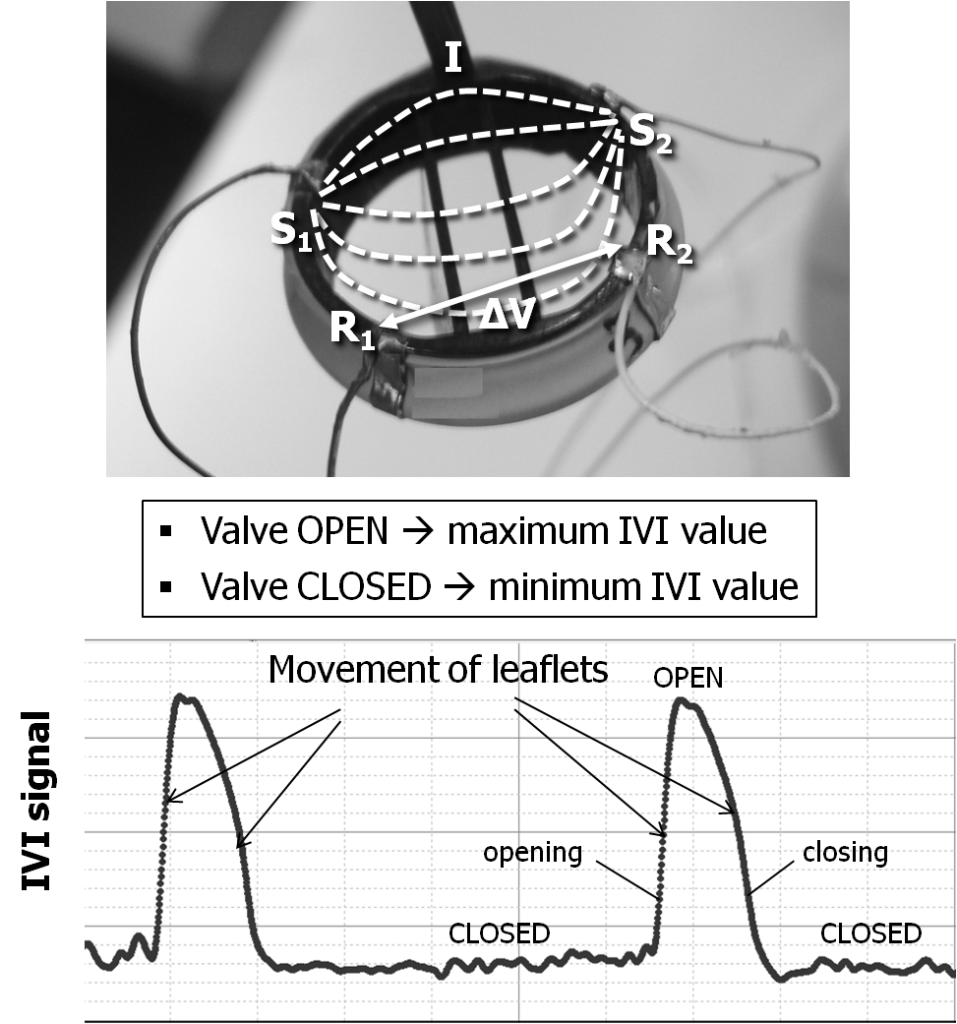  
Picture 1: sensorized prosthetic heart valve for IVI measurement and recorded IVI signa sensorized prosthetic heart valve for IVI measurement and recorded IVI signal

Poster session cardiovascular I

**144**

**VALIDATION OF MULTIPLE INERT GAS ELIMINATION TECHNIQUE IN AN IN-VITRO LUNG MODEL**

Balamurugan Varadarajan, Rakesh Vasireddy, Volker Hartwich, Balthasar Eberle, Andreas Vogt

Inselspital, University of Bern, BERN, Switzerland

**Aim**: MMIMS-MIGET was designed as a rapid and direct method for assessing the full range of V/Q distributions.1 In an in-vitro lung model (IVLM), MMIMS-MIGET shunt has been shown to correlate well with preset model shunt.2 In this study we aimed to compare normal (0.1<1) V/Q compartments determined by MMIMS-MIGET (MM-VQ) with normal reference V/Q compartments as preset in the IVLM (IVLM-VQ).

**Methods**: Using an automated setup, one oxygenator (QUADROX-i Pediatric; MAQUET) was ventilated with sweep gas (air) and perfused with saline. Inert gas solution1 (6 solubilities) was infused at a rate of 1.5 ml min-1. IVLM-VQs were generated by randomly assigning sweep gas flow to 0.2, 0.6, 0.8, 0.4, 0.1, and 1 L min-1,at a fixedperfusate flow of 1 L min-1. Perfusate samples (duplicates, 3 ml) were collected at each preset IVLM-VQ and were analyzed by MMIMS-MIGET to determine MM-VQ from retention data. V/Q ratios (mean representing MM-VQ) corresponding to the V and Q peaks were taken from MMIMS-MIGET V/Q distributions for comparison with preset IVLM-VQ.

**Results and Discussion**: The IVLM allowed stable control of compart­mental saline and gas flows, as well as reproducible inert gas transfer. All pairs (n=12) of preset IVLM-VQ (range 0.1 to 1) and MM-VQ (range 0.22 to 1.30) were determined suitable for analysis. Linear regression: MM-VQ = 1.40*IVLM-VQ - 0.03 (P< 0.0001, r2=0.96). Bland-Altman analysis: Mean bias (± 1.96 SD) = +0.18(± 0.31) with an Overall Coefficient of Variation for MM-VQ of 3.3%.

**Conclusion**: Normal V/Q compartments generated in an automated IVLM were detected by MMIMS-MIGET with good accuracy and precision. By generating known V/Q ratios, the in-vitro lung model thus presents a viable system for testing and validation of MIGET systems and their underlying assumptions.

**References:** 1. J Appl Physiol 2000; 89:1699. 2. Eur J Anaesthesiol 2012; 29:82. **Funding:** SNF 320030_133046

Poster session cardiovascular I

**145**

**IMPLEMENTATION OF ELECTRONIC CONTROL AND AUTOMATION OF AN IN-VITRO LUNG MODEL**

Balamurugan Varadarajan, Rakesh Vasireddy, Volker Hartwich, Balthasar Eberle, Andreas Vogt

Inselspital, University of Bern, BERN, Switzerland

**Aim:** An in-vitro lung model (IVLM) has been constructed and presented as convenient system to validate and test multiple inert gas elimination technique and underlying assumptions by generating known ventilation to perfusion (V/Q) relationships.1-3 Manual manipulations of IVLM gas(V) and perfusate flows(Q) were adequate to perform shunt validation, but advanced levels of accuracy and precision in producing a range of V/Q ratios could not be achieved due to inherent shortcomings of manual control. We aimed to address this by the implementation and validation of electronic control and automation.

**Methods:** In a single oxygenator circuit of the IVLM, manually operated gas flow valves and stop-cocks were replaced with electronic gas flow controllers (Vögtlin Instruments AG) in order to regulate sweep gas flows.1,2 The micro-diagonal perfusate pump (DeltaStream®DP-II, Medos) was coupled with an inline flow meter (LFS-04, Levitronix GmbH) to achieve closed loop perfusate flow control. A graphical user interface (GUI) for IVLM control was developed in LabVIEW to serve as a unified platform for real-time visualization, control and active manipulation of compartmental ventilation and perfusion parameters. In addition, the GUI was also designed to serve as a real-time data logging unit.

**Results:** The automated IVLM performed well, allowing stable and precise control of compartmental ventilation and perfusion. Randomized set points (Set-VQ, n=22) were used to generate predefined IVLM V/Q ratios (IVLM-VQ), covering a range of 0.1 to 1. The linear regression analysis returned IVLM-VQ =0.9993*Set-VQ+2.448E-5.

**Conclusion:** The current automation design has significantly improved overall accuracy, precision and reproducibility of the IVLM. With further improvements, we expect to reproduce the entire range and variability of ventilation-perfusion distributions occurring in healthy and diseased lungs.

R**eferences:** 1. Varadarajan B et al., Eur J Anaesthesiol 2012; 29:82. 2. Eur J Anaesthesiol 2013; 30:83 3. Wagner PD Intensive Care Med. 2008 34(6):994-1001

**Funding:** SNF 320030_133046

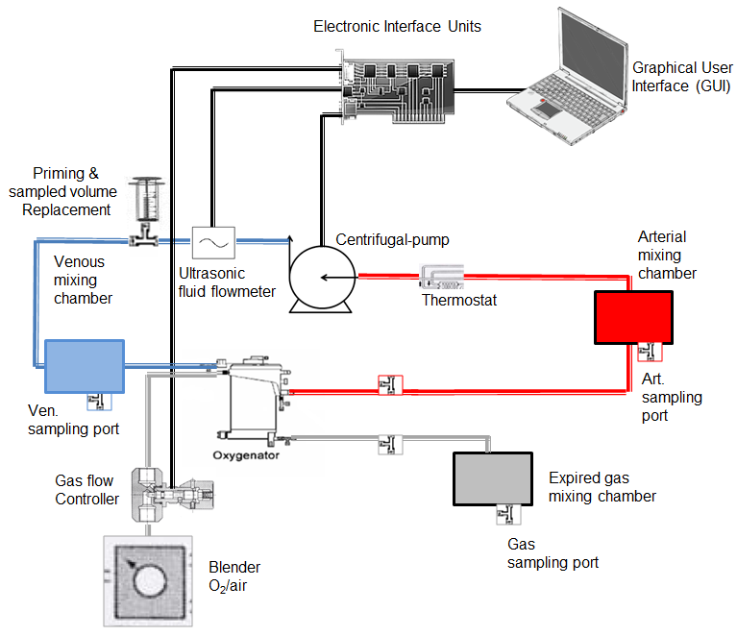  
Picture 1: Block diagram of a single oxygenator in-vitro lung model circuit Block diagram of a single oxygenator in-vitro lung model circuit.

Poster session cardiovascular I

**146**

**DRIVE OF TOTAL ARTIFICIAL HEART SYSTEMS WITH LOWER POWER CONSUMPTION**

Valentin Morozov, Alexey Zhdanov, Leonid Belyaev

Vladimir State University named after Alexander and Nikolay Stoletovs, VLADIMIR, Russian Federation

**Aim:** The improving of constructions of total artificial heart systems (TAH) deals with such problems as design of a drive providing the continuous bloody flow, creation of a digital control system, improvement of performances of the power supply. Power consumption decreasing of TAH electromechanical drives is the actual practical task.

**Method:** The perfecting of the drive for implantable pumps can go by two ways: development of small-sized motors with a high efficiency and creation of compact mechanical transformers with a high efficiency and reduction. Construction of TAH drive combining both approaches fulfilled on the basis of torque motor on permanent magnets and mechanical transformer including one or two-stage planetary screw gear and a rack. The planetary reduction gear is executed with screw links with a large angle of teeth’s inclination for noise reduction and increasing of a load capability and smoothness of operation.

**Result:** Given construction has a rather small mass (530 g) and overall sizes (60x90x150 mm). The lowering of power consumption is reached due to usage of a drive with high Energy conversion efficiency (up to 0,9…0,93) and usage of a digital system of control with a Microchip MSP430F2274 (Texas Instruments), providing an optimum regime of control in constant and impulse modes for systole/diastole ratio 1/1, 1/2, 1/3. The output travel speed varies from 60 up to 140 beats per minute and is visualized on a digital diagram board. The indicators of discharge and diagnostics are present. The TAH control system represents a box 100x65x25 mm placed on a belt of the patient.

**Conclusions:** The received results allowed to starting the laboratory researches of system.

Poster session cardiovascular I

**147**

**DEVELOPMENT OF CONTROL SYSTEM FOR MECHATRONIC UNITS OF TOTAL ARTIFICIAL HEART SYSTEMS**

Valentin Morozov, Alexey Zhdanov, Leonid Belyaev

Vladimir State University named after Alexander and Nikolay Stoletovs, VLADIMIR, Russian Federation

**Aim:** The development of control system for mechatronic unit of implantable artificial heart system, providing the required modes of working.

**Methods:** The mechatronic unit of implantable artificial heart system contains the Russian brushless DC motor, hollow rotor with rotor position sensors and roller-screw mechanism. The control system includes: bridge inverter, microcontroller, rotor position sensors and membrane position sensor of blood pump. The brushless DC motor is powered from 12V power supply via the three-phase bridge inverter. Rotor position is sensed using Hall-effect sensors. Their application gives the following opportunities: constant control of rotor position, variation of pusher-plate speed, stable work under loading, reduction of energy consumption. The microcontroller is used to generate control voltages of the inverter.

**Results:** The developed control system carries out the following functions: engine control, calculation of pusher-plate position in the range of 0 … 20 mm, reception/transfer of data in the PC. For the rotation speed control of the motor pulse-width modulator were used. This decision gives the opportunity to establish the necessary rotation speed of rotor and reduce the current consumption. For communication with the PC the UART interface is used. It is connected to the external UART/USB converter for the subsequent connection to the PC. Computer-based control of an artificial heart system was developed. At present time the developed software allows to carry out the following parameters: pulse 60. . 140 bpm, systole/diastole ratio - 1/1; 1/2; 1/3, the average speed of pressure increase in the blood chamber less than 2500 mm Hg/s and monitoring of parameters such as operating time, unit temperature, pulse of patient and monitoring of a power supply system.

**Conclusions:** The control system for mechatronic unit of implantable artificial heart system with minimum size is developed. The work time with 12V power supply is not less than 6 hours.

Poster session cardiovascular I

**148**

**INFLUENCE OF THE BULGING SINUS SIZE OF THE SIMULATED LIVESIZE EPTFE VALVE ON THE LEAFLET MOVEMENT OF THE VALVE CONDUIT**

Toshinosuke Akutsu, Hikaru Kakizaki

Kanto Gakuin University, YOKOHAMA, Japan

**Aim:** Although there is no optimal substitute for right ventricular outflow tract (RVOT) reconstruction in congenital heart defects, Contegra and Expanded polytetrafluoroethylene (ePTFE) valved conduits may be a good choice for treating this defect. ePTFE valve with bulging sinus seem to show good clinical record, however, fluid mechanical research proving the effect of bulging sinus has been limited. In the preceding experimental studies, similar shaped simulated aorta was utilized to see the effect of bulging sinus size on the flow field inside the conduit. Dynamic PIV result showed bulging sinus size and leaflet shape greatly affect on flow inside the conduit. Vortex center location relative to the leaflet tip seems to affect on valve opening mechanism. Valve opening area reduced when bulging sinus size was reduced. This paper aims to study the effect of the bulging sinus size of the simulated live-size ePTFE valve on the leaflet movement inside the conduit.

**Methods:** Three simulated live-size ePTFE valves of different bulging sinus sizes with unfan shaped leaflet were used. Effect of the bulging sinus size on flow field inside the simulated ePTFE valve was analyzed using Dynamic PIV system and valve opening and closing phenomenon were directly observed and compared using high speed digital camera running at 240 frames/s.

**Results:** Valve opened and closed quicker with normal bulging sinus compared to reduced bulging sinus. Direct observation of the opening area of the valve showed that wider opening area was observed with normal bulging sinus similar to the enlarged model of preceding research.

**Conclusion:** As in the preceding experimental studies, valve opened and closed quick with normal bulging sinus even though conduit size changed almost half of the preceding studies. Bulging sinus size greatly affect on flow inside the conduit.

Poster session cardiovascular I

**149**

**NONINVASIVE PERIPHERAL PERFUSION VALIDATION METHOD FOR ASSISTED CIRCULATION WITH ROTARY BLOOD PUMPS**

Yasuyuki Shiraishi

IDAC, Tohoku University, SENDAI, Japan

**Aim**: Rotary blood pumps are generally applied for the circulatory assist in the patients with severe heart failure. It was anticipated that the pulsatility in end-organ hemodynamics with rotary blood pumps might decrease due to the continuous assisted flow. We focused on peripheral blood flow evaluation by using a high speed CCD for the quantitative detection of hemodynamics under the rotary blood pump support conditions. **Method**: In this study, we performed the evaluation of the data in the CCD intensity levels in the static test, and we compared the blood flow changes in the skin perfusion under the rotary blood flow support. Firstly, the static examination to obtain the relationships between blood volume and intensity of the RGB signals in the urethane foam was carried out under the variable blood density conditions. Secondly, we measured the skin surface perfusion by using the CCD data and compared these data with the conventional laser Doppler flow. **Results**: Based on the calibration of the relation between the blood volume and RGB intensity of the CCD, the detection of the amount of blood that was contained in the variable peripheral volume was achieved. The pulsatile flow data could be calculated from the CCD data which was measured noninvasively in the animal experiments under the centrifugal blood pump support using the Evaheart. Moreover, the pulse wave changes were reflected by the calibrated CCD blood volume under the different rotational number conditions of the rotary blood pump.

Poster session cardiovascular I

**150**

**UTILIZATION OF EVALUATION TOOL FOR INTELLECTUAL PROPERTIES OF MEDICAL TECHNOLOGIES**

Eiki Akagawa, Eisuke Tatsumi, Haruka Nakada, Shuhei Hasegawa, Yoshiyuki Taenaka

National Cerebral and Cardiovascular Center, SUITA, Japan

**Aim:** In order to lead to the commercialization of medical technologies (including medical devices, pharmaceutical and so on), intellectual property (IP) resulting from the study must have been evaluated quantitatively under the consideration of clinical situation. Thereby, there is a possibility to promote technology transfer (TT) from academia to industry. In the conventional generic IP evaluation in Japan, patentability and business feasibility have been positioned as key indicators. In the case of TT of medical technologies, it should also be considered in medical significance except for above two indicators. To assist in the review and decision making process of IP of medical devices deliberation, we developed a scoring evaluation tool which consisted of three major criteria (1. patentability, 2. business feasibility, and 3. social aspects). The objective of this study is to implement the scoring tool which evaluates IP for the medical devices, and is to verify the utilization status of decision making process of the service invention committee.

**Methods:**In the case of patent sole-application, it was determined for the propriety of succession by using the scoring evaluation tool at the service invention committee in National Cerebral and Cardiovascular Center (NCVC). The service invention committee was held 17 times in the conditions of using this tool, and tried to deliberations of succession for the medical devices of 12 projects.

**Results:** This evaluation tool was implemented to improve objectivity to the decision making process of the service invention committee in NCVC. As results, 11 projects have been succeeded.

**Conclusions:** The scoring tool which evaluates IP for TT specifically for the medical technologies was implemented and was utilized.

Poster session cardiovascular I

**151**

**PROPOSAL AND EVALUATION OF AN AUTONOMOUS CONTROL ALGORITHM USING STOCHASTIC METHOD FOR A VENTRICULAR ASSIST DEVICE**

Kentaro Ohnuma1, Hirohito Sumikura1, Akihiko Homma2, Tomonori Tsukiya1, Toshihide Mizuno1, Yoshiaki Takewa1, Eisuke Tatsumi1

1National Cerebral and Cardiovascular Center Research Institute, SUITA, OSAKA, Japan

2Tokyo denki university, HATOYAMA-MACHI, SAITAMA, Japan

**Aim**

Automatically controlling a ventricular assist device (VAD) in the realistic situation would be difficult because it is necessary to model the whole including the VAD and the cardiovascular dynamics. To solve this problem, we have proposed a search algorithm using stochastic behaviors for an autonomous VAD control. In this study, we sought to investigate whether our proposed method was useful for the safe control of a continuous flow VAD in a pulsatile mock circulation loop.

**Methods**

The flow rate control algorithm was constructed on the basis of a stochastically control model dx(t)/dt=A (-dU(x)/dx)＋η (x(t): the parameter of the rotational speed, U(x): temporary objective function with the extreme value of the potential at x=c, A: evaluation function to indicate the desirability of a current state, η: noise). This algorithm detects desirable rotational speed via random walks; the inappropriate state reduces value of evaluation function, and noise becomes dominant. To evaluate behaviors based on the implemented algorithm, control testing on a mock circulation loop simulated a left heart bypass support and inflow sucking (unexpected event) was performed using a centrifugal pump (RotaFlow) driven by our constructed control system.

**Result**

To the change of the circuit resistance, the flow rate of the VAD reached a target value: 1) the rotational speed fluctuated by “η”, 2) “c”increased according to variations of “A”, 3) “x”was entrained to “c” by an effect of “A”. The adaptive behaviors to inflow sucking were found: the proposed method reduced frequency of the sucking up to 12-20% by behavior to searchingly decrease rotational speed.

**Conclusion**

The constructed algorithm realized autonomous bypass flow control in the situation of pulsatile circulation without designing the detailed control rule based on the experience or the model of the control target.

Poster session cardiovascular I

**152**

**FLOW PATTERN COMPUTATIONAL ANALYSIS IN PRESENCE OF AORTIC VALVE BYPASS**

Gionata Fragomeni, Francesca Condemi, Michele Rossi, Maria Vittoria Caruso, Attilio Renzulli

Magna Graecia University, CATANZARO, Italy

**Introduction**

Aortic Valve Bypass (AVB) has been performed since the early 1960s as an alternative surgical approach for symptomatic aortic stenosis (AS) and is used to shunt the systemic circulation from the left ventricle to the thoracic aorta. The technique of AVB implantation is easily reproducible, too. However, little is known about the hemodynamic changes determined by a second outlet between the heart and the great vessels. This study describes a computational model to study aorta flow pattern in cases of mixed aortic valve disease before and after AVB implantation, considering severe AS and Aortic Insufficiency (AI).

**Materials and Methods**

Three-dimensional one-way-coupled Fluid-Structure-Interaction (FSI) analyses were carried out using a patient-specific model of an aorta reconstructed from the computed tomography images of a patient with severe AS and mild AI who underwent apicoaortic conduit implantation.

Simulations were performed using the Comsol Multiphysics 5.0 software (COMSOL, Inc., Stockholm, Sweden) on a grid of 154,000 tetrahedral elements. In this study one-way-coupled FSI simulations were carried out in order to solve ﬂuid and solid problems in a sequential manner. One-way-coupled FSI analysis sequentially solves the fluid flow problem by means of Navier-Stokes equations. For the solid mechanics solution the Arbitrary Lagrangian-Eulerian (ALE) method is used to get the displacement of the aorta.

**Results**

The results of this study indicate that some stagnation areas are formed in the first section of the descending aorta, after the left subclavian artery (between region b and region c in figure). This kind of phenomena might cause thrombogenesis phenomena, maybe because of the competition of blood flow after AVB implantation.

**Bibliography**

Takahashi Y. et al Thrombus formation due to flow competition after apico-aortic conduit Eur J Cardiothorac Surg 2010 37: 978-979.

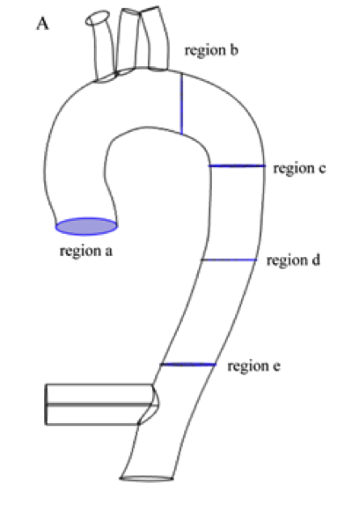  
Picture 1: Geometrical mode Geometrical model

Poster session cardiovascular II

**153**

**SLIT STRUCTURE ENABLED THE PREPARATION OF IN VIVO AUTOLOGOUS VALVED CONDUITS WITH LARGE LEAFLET AREA**

MARINA FUNAYAMA, Maya Furukoshi, Takeshi Moriwaki, Yasuhide Nakayama

National Cerebral and Cardiovascular Center, OSAKA, Japan

**Aim**

The in-body tissue architecture (IBTA) technology, novel method for autologous valved conduits named Biovalve, could be made simple, safe and reproducible implants comprises mainly autologous fibroblasts and collagen fibers. The Biovalve mold was designed with a three-dimensional (3-D) shape similar to that of the native aortic or pulmonic valve. The excellent aortic haemodynamics and beneficial leaflet movement of Biovalve was observed in a goat or beagle experiment model. However, the limited area of the leaflet formation through in vivo tissue migration using the IBTA was a serious problem, so was the size limitation of Biovalve. In this study, we designed novel Biovalve molds to activate in vivo tissue migration, regardless of size.

**Methods and Results**

A pair of convex and concave parts (outer diameter, 28 mm) were assembled. At the leaflet formation part, which had an aperture of 1 mm between the two parts, several 2-mm-slits were customized. As control, the original mold without slits was used. When these two types of molds were embedded into the subcutaneous pouches of beagles, the outer surfaces of all the molds were completely covered with connective tissues that formed a conduit tissue. Meanwhile, the perfect leaflet tissue was obtained only in the novel molds with slits. Tissue migration occurred through the silts, from the outer surface of the mold to the aperture. After removal of the mold, and cutting of the connected tissues at the slits, completely autologous connective tissue Biovalves with an internal diameter of 28 mm were obtained.

**Conclusion**

The slit structure customized to the mold was effective as entrance for cell migration, contributing to the successful formation of perfect Biovalves of various physiological sizes suitable for all required in clinical use. Application of the newly developed Biovalves is useful for preclinical evaluation for application in humans.

Poster session cardiovascular II

**154**

**EXPERIMENTAL AND NUMERICAL STUDY OF REGURGITANT FLOW JETS IN MECHANICAL HEART VALVES**

Guanglei Wang1, Yan Li2, Giuseppe D’Avenio1, Giorgio De Angelis1, Dan Rafiroiu2, Mauro Grigioni1

1ISS, ROME, Italy

2Technical University of Cluj-Napoca, CLUJ-NAPOCA, Romania

**Aim -** Regurgitant flow in mechanical heart valves (MHVs) can generate blood trauma (hemolysis, platelet activation), depending on the jets’ type and energy. . In the present study, regurgitant flow in MHVs is studied with Particle Image Velocimetry (PIV) as well as with computational fluid dynamics (CFD) to determine mechanical stresses in blood.

**Methods -** The valve under study, a 27-mm MHV, was mounted coaxially with a suitably built in-vitro tester, which allowed easy optical access. This tester was inserted in a closed flow loop, with regurgitant steady flow. The transvalvular pressure was set at a value representative of the mean aortic pressure during diastole. The 2D PIV measurements were performed in a series of planes parallel to the hinge recess plane, defined as Z=0 mm.

The model of investigated MHV was accurately reconstructed with an optical scanner, and the valve model was completed with the same adjacent chambers of the experimental setup, in order to replicate with CFD the PIV experiments.

The fluid considered in the CFD model was fully incompressible and Newtonian. A turbulent stationary flow model was used. The mesh contained over 9,700,000 elements, with a high element concentration in the area of interest.

**Results -** The distribution of jets exiting the valve, mainly from hinge corners, was observed with PIV. A repeatability analysis in vivo was performed, with a variation around 5% across 5 repetitions. The averaged experimental data were used as a guideline for model selection and mesh independence analysis in CFD simulations.

**Conclusion -** The findings confirm the importance of the experimental validation of CFD studies in the challenging biomechanical issues of cardiovascular engineering. At the same time, the results emphasize the potential contribution of the CFD approach in areas not easily measurable with experimental techniques.

Poster session cardiovascular II

**155**

**THE ESSENTIAL POINT THAT WE SHOULD BE CAREFUL FOR EFFECTIVE SINGLE-CANNULATION OF VENOVENOUS ECMO**

Konomi Togo

National Cerebral & Cardiovascular Center Research Institute, SUITA, Japan

Aim: Recently, venovenous ECMO (VV-ECMO) using the Avalon Elite® double lumen catheter (DLC) increases. DLC has few risks of bleeding and infection without requiring dual site puncture. However, bypass flow may be limited because the lumen diameter of DLC is smaller than that of catheter for dual cannulation. Therefore, gas exchange may be insufficient and return blood may become jet stream. The aim of this study is to investigate necessary bypass flow for gas exchange and observe around the heart after experiment.

Methods: 23Fr (n = 2) and 27Fr (n = 4) DLCs were inserted to adult goats (BW 60.1 ± 0.6 kg) under general anesthesia. Cannula positions were confirmed by angiography. The ventilator was stopped and ECMO was started at the same time, and sufficiency of gas exchange was examined by measuring the arterial oxygen saturation (SaO2) and carbon dioxide pressure (PaCO2). The goats were sacrificed after experiment, and they were observed the superior vena cava, inferior vena cava and heart.

Results: In the ELSO guideline, adequate support is defined as a SaO2 of greater than 80% in VV-ECMO, and that condition was fulfilled when the bypass flow rates were higher than 2 L/min. Twenty minutes after starting VV-ECMO, PaCO2 was 62.1 ± 2.8, 46.1 ± 2.3 and 38.9 ± 2.8 mmHg at 1, 2 and 3 L/min respectively. When 23Fr DLCs were used, the pressure measured between DLC and return circuit was greater than 300 mmHg at 3 L/min. The goats used 23Fr DLC were found hematoma in the right atrium at sacrifice. When 27Fr DLCs were used, the injury was not observed around the heart.

Conclusion: DLC is useful for sufficient gas exchange. However, when we intend to increase bypass flow more than necessary, complications increases. The use of DLC in the appropriate range is important.

Poster session cardiovascular II

**156**

**EFFECTS OF VAD SUPPORT ON ADIPONECTIN PLASMA LEVELS IN PAEDIATRIC PATIENTS WITH HEART FAILURE: A PILOT STUDY.**

Chiara Caselli1, Arianna Di Molfetta2, Rosetta Ragusa1, Andrea D'Amico3, Manuela Cabiati1, Massimiliano Cantinootti4, Silvia Del Ry1, Antonio Amodeo2, Maria Giovanna Trivella1

1CNR, PISA, Italy

2Ospedale Pediatrico Bambin Gesù, ROME, Italy

3Scuola Superiore Sant'Anna, PISA, Italy

4Fondazione Toscana Gabriele Monasterio, MASSA, Italy

**Aim:** Mechanical circulatory support as a bridge to heart transplantation in children has been used in many centers in both Europe and United States. Furthermore, ventricular assist device (VAD) implant unloads the failing heart and may result in modification of the end-stage HF phenotype in adults, including biohumoral profile. Changes in markers of inflammation in paediatric population are unknown. The aim of this study is to evaluate in children with HF unresponsive to medical therapy whether adiponectin, considered an emerging marker of inflammation and metabolism for HF in adults, is associated with HF presence and modified after VAD therapy.

**Methods:** Circulating adiponectin was measured in plasma samples from 9 pediatric patients submitted to VAD implant [56±27.6 (mean±SD) months, 5 males, 14±7 LVEF%, Interagency Registry for Mechanically Assisted Circulatory Support (INTERMACS) profiles 1/2] were studied. Indications for support was idiopathic dilated (n=7) and non compaction cardiomyopathy (n=2). A group of healthy age- and sex-matched children were used as controls (n=59). Adiponectin plasma levels were measured by a dedicated ELISA before (day 0) and at 4 hrs,1,3,7,14, and 30 days after VAD implant.

**Results:** Before VAD implant, adiponectin levels are highest in HF compared with healthy children (p<0.0001 HF vs. healthy children, Fig A). After device implantation adiponectin plasma levels significantly decreased during the first hours and returned to pre-implant values in one week (Fig B).

**Conclusion:** In paediatric population, circulating levels of adiponectin were associated with presence of HF and were modified by VAD implant, but remained significantly abnormal. Our results suggest the possibility for tuning the therapy in order to mitigate such abnormality and potentially induce a better outcome.

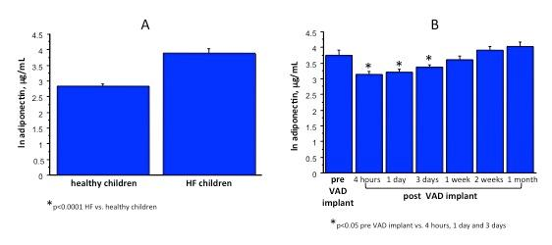Picture 1: Plasma adiponectin in pediatric patients compared to healthy children (A) and after VAD implantation (B Plasma adiponectin in pediatric patients compared to healthy children (A) and after VAD implantation (B)

Poster session cardiovascular II

**157**

**LIPOSOME-ENCAPSULATED HEMOGLOBIN REMAINS BENEFICIAL AFTER CEREBRAL ISCHEMIA AND REPERFUSION IN THE RAT**

Akira Kawaguchi1, Shunya Takizawa1, Yoichi Ohnuki1, Munetaka Haida2

1Tokai University School of Medicine, ISEHARA, Japan

2Tokai University Junior College of Nursing and Medical Technology, HIRATSUKA, Japan

**Aim**

Liposome-encapsulated hemoglobin (LEH, Terumo, Tokyo, Japan) has been reported to be protective when administered early after onset of cerebral ischemia (CI). Whereas early treatment is impractical, late administration may aggravate reperfusion injury to cause more damages than benefits. We compared late LEH administration before or after reperfusion in rats undergoing cerebral ischemia/reperfusion by thread occlusion model.

**Methods**

SD rats underwent CI for 120 min and received LEH (2 mL/kg, n=24) or saline (2 mL/kg, n=24) 5 min before (115min) or 5 min after reperfusion (125min). Cerebral perfusion patterns were monitored by transcranial Laser-Doppler flowmeter before and after onset of ischemia, medication and reperfusion. Basic neurological functions were checked with the animals awake before as the control, after CI and one-day later, when animals were sacrificed for CI area determination by TTC staining. In other rats, Oxyblot test was performed after reperfusion to determine oxidative stress in the cortex and striatum.

**Results**

Cerebral perfusion patterns were almost identical before iv medication (Figure) when the flow to the ischemic hemisphere were increased toward normal (0.8 at reperfusion and 1.0 one-day later of pre-ischemia) in rats treated before reperfusion (115min) without difference between infused solutions. In contrast, rats treated after reperfusion (125min) had perfusion patterns suppressed (0.6 at reperfusion and 0.8 one-day later) without difference between treatments. Nonetheless, volume of cerebral infarction one-day later were significantly suppressed in rats treated with LEH without functional improvements regardless of infusion timing. Oxyblot test showed no difference regardless of the timing or infused solutions.

**Summary**

The results suggest that late LEH (2 mL/kg) administration remains beneficial regardless of infusion timing before or after reperfusion in 120 min of CI model in the rat. The mechanism(s) of action of LEH appeared to be different from attenuated reperfusion injury or suppression on oxidative stress.

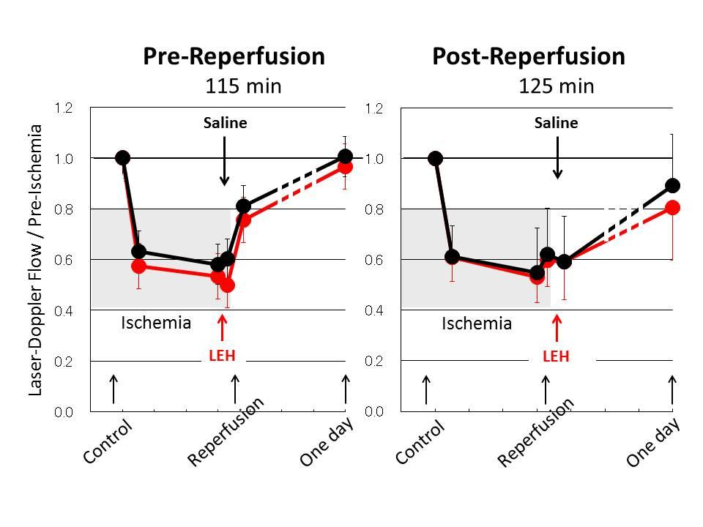Picture 1: Cerebral Perfusion Pattern Cerebral Perfusion Patterns

Poster session cardiovascular II

**158**

**EFFECT OF BLOOD VISCOSITY ON THE PERFORMANCE OF WALL-LESS VENOUS CANNULA**

Saad Abdel-sayed, Ludwig-Karl Von Segesser

Cardiuovascular research, LAUSANNE, Switzerland

**AIM:** The present study was designed to quantify the loss of performance due to the use of blood as test medium in cannula bench test.

**METHODS:** An in-vitro circuit was set-up with silicone tubing between two reservoirs. The test medium was pumped from the lower reservoir, by a centrifugal pump to the upper reservoir. The test cannula was connected to the lower reservoir, the centrifugal pump, and after to the upper reservoir. Flow rate (Q) and pump inlet-pressure (P) were measured for a wall-less *versus* thin-wall cannula using centrifugal pump in a dynamic experimental bench-test for an afterload of 40-60 mmHg using two media: blood (Hb 10 %) and water Hb 0%).

**RESULTS:** In order to reach a target dynamic volume of 200-250 in the upper reservoir at 52± 8 mmHg afterload, a pump speed of 1750±135 RPM, with an inlet-P of -11.7±14.57 mmHg allowed for 3.67±0.45 ml/min Q for the 23 F thin-wall cannula *versus* -9.33±13.65 mmHg inlet- P, allowed for Q of 3.91±0.41 ml/min for the wall-less cannula. In order to reach the same target volume of water in the upper reservoir at 50±10 mmHg after load, pump speed of 1672±152 RPM and inlet-P of -1 mmHg allowed for 4.08±0.47 ml/min Q for thin-wall cannula *versus* -0.67 ± 0.58 mmHg inlet-P, allowed for Q of 4.17 ± 0.45 ml/min for the wall-less cannula.

**Conclusion:** Walls-less cannula showed less inlet-P differences calculated between blood and water (-8.6 %), as compared to that of thin-wall cannula (-11.7 %). Q differences were 0.3 % and 0.4 % for the walls-less and thin-wall cannula respectively. We conclude that testing the cannula performance with water is a good scenario and can overestimated flow by a 10 %. However, superiority is preserved with, with water and blood.

Poster session cardiovascular II

**159**

**MONITORING TOOLS BASED ON FLOW MEASUREMENT FOR SAFETY ENHANCEMENT AND THERAPY EVALUATION IN PULSATILE FLOW VADS.**

Michal Jaworek1, Maciej Gawlikowski1, Roman Kustosz1, Marcin Lewandowski2

1Foundation of Cardiac Surgery Development, ZABRZE, Poland

2Institute of Fundamental Technological Research, Polish Academy of Sciences, WARSAW, Poland

**Background:** Currently, continuous flow pumps dominate in mechanical cardiac support (MCS). However in some cases pulsatile flow pumps are the only alternative (biventricular support, pediatric patients). Variety of methods has been developed to support monitoring and evaluation of MCS treatment with continuous flow pumps. Nevertheless, few algorithms have been implemented for pulsatile flow pumps. Fast detection of adverse events could reduce complications and also therapy evaluation might yield its better outcomes.

**Aim:** The aim of the study is to propose methods for flow signal analysis in order to detect adverse events and monitor MCS therapy with pulsatile flow pumps.

**Methods:** Following events were recognized as potential adverse events to be detected by flow signal analysis: mechanical valve malfunction, ventricular wall suction event, tamponade and cannula occlusion. Following aspects were defined as potential monitoring tools derived from flow signal and its spectrum analysis: estimation of patient aortic pressure and assessment of thrombus in blood stream (also in ECMO).

**Results:**Algorithms for automatic flow signal analysis were developed. Mechanical valve malfunction is detected by thresholding of backflow volume. Ventricular wall suction is identified by means of time-frequency signal analysis (short-time Fourier transform and wavelets transform). Long-term trends monitoring enables detection of cannula occlusion and tamponade. Thrombus in blood stream monitoring employs embolus to blood ratio model (EBR) and time-frequency analysis (marching pursuit method). Patient pressures estimation is based on mathematical model and is derived from mechanical valve backflow measurement.

**Conclusions:** Proposed methods were validated in mock circulation loop and in vitro blood experiments. They will be further evaluated during in vivo studies and clinical trials.

The research was financially supported by The National Centre of Research and Development (PBS1/A3/11/2012).

Poster session cardiovascular II

**160**

**VALIDATION TESTS OF THE HYBRID CARDIOVASCULAR SIMULATOR**

Jeison Fonseca1, Bruno Utiyama1, Juliana Leme1, Denys Nicolosi1, Jose Biscegli1, Aron Andrade1, Julio Lucchi2

1Institute Dante Pazzanese of Cardiology, SAO PAULO, Brazil

2University Sao Judas Tadeu, SAO PAULO, Brazil

**Aim**: A Hybrid (numeric and physical) Cardiovascular Simulator (HCS) was constructed in order to evaluate Left Ventricle Assist Devices (LVAD). However, before to be used as a tool for LVAD assessment, the HCS behavior needs to be validated. **Methods**: According to literature, validation tests of cardiovascular simulators are made to verify if the system is capable to follow the Frank-Starling law when left ventricle preload, afterload and elastance changes are imposed. HCS, figure 1, has a physical section composed by: reservoir, mimicking a passive left atrium; pumping chamber with two bilealeft valves, as left ventricle; an airtight compliance chamber; a proportional valve as systemic vascular resistance and a set of flexible plastic tubes. The electromagnetic actuator of pumping chamber, the air volume inside the compliance chamber and the proportional valve are controlled by computer through the numeric section, which is composed by mathematical models simulating: vena cava; right heart; pulmonary artery; lungs and pulmonary vein. All numeric section compartments have been programmed in LabVIEW®. Interaction between both sections is made using pressure and flow signals, which are acquired at physical section by sensors. **Results**: Changes in left ventricle preload, afterload and elastance had caused different effects at cardiovascular circulation that were observed through Pressure x Volume loop analysis. **Conclusion**: During validation test, we could observe that HCS behavior under preload, afterload and elastance changes were coherent with results from literature. According to our results, HCS is validated and can be used as tool in LVAD studies.

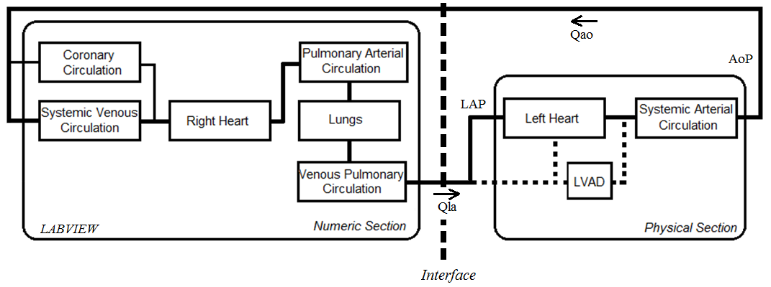  
Picture 1: Figure 1. Hybrid Cardiovascular Simulator diagram. Qao - aortic flow; Qla - left atrium flow; AoP - aorti Figure 1. Hybrid Cardiovascular Simulator diagram. Qao - aortic flow; Qla - left atrium flow; AoP - aortic pressure; LAP - left atrium pressure.

Poster session cardiovascular II

**161**

**OCT MICROSCOPIC DOPPLER MEASUREMENT OF FLOW PROFILES: APPLICATION TO THE BEARING OF HVAD**

Aleksandar Nikodijevic, Heinrich Schima, Rainer Leitgeb, Daniel Fechtig, Stoiber Martin

Medical University of Vienna, VIENNA, Austria

**Aim**

Cardiovascular diseases such as heart failure are one of the main leading causes of death worldwide. VAD support the heart function by pumping blood through the body. However such devices potentially can cause hemolysis and may lead to serious health conditions. To investigate how to minimize shear stress within the pump an insight into the interactions between the blood and VAD is required.

**Methods**

In this in-vitro study Doppler Optical Coherence Tomography (OCT) was performed to analyze the flow profile of the blood flow within a working HVAD. To begin with, an imaging window was drilled into the housing and filled with acrylic glass. Via this window a swept source laser beam probes the moving erythrocytes. Scattered and reflected signals interfere with a reference signal leading to the extraction of depth information (A-scan). By applying multiple A-scans a whole tomogram of the sample is generated (B-scan). Flow profiles and consequently shear stresses are extracted by applying Doppler analysis between two adjacent A-scans.

**Results**

This investigation confirms that it is possible to provide insight into the interactions between blood and the inner parts of a VAD. Moreover it is feasible to extract the flow profiles and shear stress acting on the blood by applying the Doppler OCT method.

**Conclusion**

This novel insight potentially can provide information on the details of the flow field and shear stress exposure in these devices, providing a better understanding of blood trauma and effects of varying working points and pulsatile load by the natural heart and their influence.

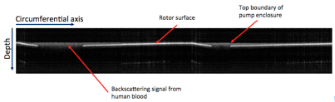  
Picture 1: B-scan image depicting the rotor of the HVAD. The image is a sequence of 1200 A-scans taken at on B-scan image depicting the rotor of the HVAD. The image is a sequence of 1200 A-scans taken at one single position through the glass window.

Poster session modelling

**162**

**INVESTIGATION OF CONTROL OBJECTIVES FOR THE HEART FAILURE TREATMENT USING THE CONTROL STRATEGY OF A ROTARY BLOOD PUMP**

Dmitry Petukhov, Dmitry Telyshev

National Research University of Electronic Technology, ZELENOGRAD, Russian Federation

**Aim:**Left ventricular assist devices (LVAD) may be implanted as bridge to transplantation (BTT), destination therapy (DT) and bridge to recovery (BTR). The listed applications of the LVAD have some general requirements (such as providing sufficient cardiac output and hemodynamic recovery), but they have an incompatible requirements also. Thus, there is a need for providing a certain conditions in the cardiovascular system for the specified LVAD application. The aim of this study is to investigation of control objectives for heart failure treatment within the selected LVAD application using the control strategy of a rotary blood pump (RBP).

**Methods:** Previously developed control strategy is based on the mathematical model of a RBP, which takes into account the inertial and viscous properties of blood. The main features of the control strategy is to flow rate estimation, maintaining the required flow rate by adjusting the pump speed and identification of pumping states: backflow of blood through the pump (BF), partial assist of the ventricle with periodically open aortic valve (PA), full assist of the ventricle (FA) and partial collapse (intermittent and continuous) of the ventricle (PVC-I and PVC-C). Lumped parameter model is used for testing proposed control objectives.

**Results:** The following control objectives are investigated: partial assist of the ventricle for BTR with BF prevention, full assist of the ventricle for BTT with the maximum pump flow and PVC-C prevention, and the combined mode, when pump operates in PA part of time and in FA another part of time. The proposed control objectives are tested under diverse physiological conditions.

**Conclusion:** This work demonstrates application of the control strategy of a RBP for investigation different control objectives. Identification of pumping states can provide selected control objective for successful treatment of heart failure within the selected LVAD application without adverse states and additional implantable sensors.

Poster session modelling

**163**

**CLINICAL CALIBRATION OF A VOLUME SENSOR BASED PHYSIOLOGICAL CONTROLLER FOR VENTRICULAR ASSIST DEVICES**

Seraina Anne Dual, Gregor Ochsner, Mirko Meboldt, Marianne Schmid Daners

ETH Zurich, ZÜRICH, Switzerland

**Aim:** In this work we provide a facile clinical calibration method for a preload sensitive controller for ventricular assist devices (VADs). The need for calibration arises firstly from the patient specific heart size, heart rate and remaining contractility and secondly from possible volume measurement errors. The calibration is done automatically while the clinician manually adjusts the pump speed as in state-of-the-art constant pump speed VADs. The current investigation further allows a deduction of measurement accuracy specifications for future left ventricular volume sensors.

**Methods:** We numerically simulated the physiologic controller’s response to altered patient conditions during preload and afterload changes. The heart’s characteristics were varied in our numerical circulation model. We analyzed two different calibration methods assuming one constant pump speed set point to be known. As the measure of quality, we compared the cardiac output response of the calibrated and the un-calibrated controllers.

**Results:** Among the patient’s variability, the heart size had the most significant effect on the control performance. Without calibration, the behavior of the controller is no longer physiological. The control parameter found to be most adequate and robust for calibration, was equivalent to the heart size. After calibration, the physiological controller’s performance showed a root mean square error of the cardiac output of 0.1 L/min, despite a relative volume sensor error of 20%. A volume sensor with solely offset error and zero relative error can be perfectly calibrated.

**Conclusion:** We have found a calibration method for a preload sensitive controller with clinical feasibility and robust behavior for different heart sizes. Furthermore, heart size changes due to post-implantation remodeling could be fully accounted for. The recalibration procedure is equivalent to the clinician’s adjustment of the pump speed.

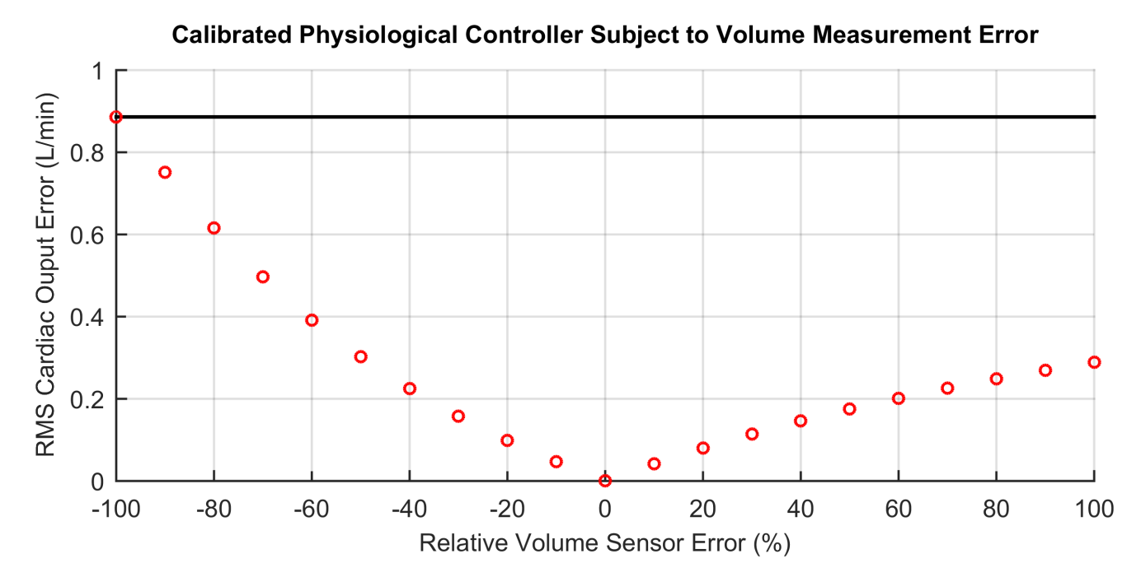  
Picture 1: Impact of relative volume sensor error on cardiac output. The reference is a physiological controller wit Impact of relative volume sensor error on cardiac output. The reference is a physiological controller with ideal LV volume measurement.

Poster session modelling

**164**

**SOME MODIFICATIONS OF THE VAD STRUCTURE TO IMPROVE FLOW PATTERNS**

Damian Obidowski, Przemyslaw Klosinski, Piotr Reorowicz, Krzysztof Józwik

Lodz Univeristy of Technology, LODZ, Poland

Aim: An evaluation of different methods used to support human heart is the only way to find the best device. Geometrical modifications of the RH_VAD based on the CFD optimization were introduced and investigated to identify crucial angular positions of inlet and outlet valves and to determine an influence of the inlet channel geometry on the flow pattern and the ASZ (area of stagnation zones) distribution inside the VAD.

Methods: The scope of investigations was divided into three parts. At the beginning, steady state simulations were performed to find an optimal geometry of inlet and outlet cannulas. In the next step, with the optimal geometry of cannulas, an optimal angular positions of valves were determined according to the ASZ and low velocity criteria. In the final step, blood flow simulations with the IBM (Immersed Body Method) modelling valves movement and the MD (Mesh Deformation) simulating the diaphragm motion were conducted for full cycles of the pneumatic VAD operation.

Results: Thanks to all the modifications introduced, the optimal geometries of inlet and outlet cannulas have been found. Likewise, an influence of the angular position of valves has been recognized. It has resulted in a significant decrease in the ASZ value which has been twice lower than the one before modifications.

Conclusions: The conducted simulations have enabled one to find critical regions inside the RH_VAD for hemolysis. It has been possible to improve a geometrical model of the RH_VAD on the basis of steady state simulation results. The results of transient simulations with the IBM and MD methods are a reliable source of information on the flow pattern inside this type of the Ventricular Assist Device.

Poster session modelling

**165**

**ESTIMATION OF VENTRICULAR FLOW DURING VAD ASSISTANCE BASING ON PRESSURE PULSATILITY: A MODEL STUDY**

Gianfranco Ferrari1, Iris Drent2, Libera Fresiello3, Arianna Di Molfetta4

1IFC-CNR, ROME, Italy

2Groningen University, GRONINGEN, Nederland

3KU Leuven, LEUVEN, Belgium

4Pediatric Hospital Bambino Gesù, ROME, Italy

**Aim:** Assessment of ventricular flow during VAD assistance is important to determine the state of the heart, to manage VAD speed and to evaluate the work distribution between the VAD and the assisted ventricle. The aim of this work is to develop an algorithm to estimate ventricular flow during VAD assistance basing on pressure pulsatility.

**Methods:** the basic assumption is that in apical connection, continuous flow VADs induce an arterial pressure pulsatility depending on pump intrinsic properties and on the contribution of ventricular flow at aortic valve opened. To verify this assumption, we used a computational model of the circulatory system connected apically to a model of a continuous flow pump (HeartMate II). The experiments were conducted with different heart rates (HR: 60-80-100-120 bpm), end-systolic ventricular elastances (Emax: 0.5,0.75 and 1.0 mmHg cm-3), systemic resistances (Rp: 600,1200 and 1800 g cm-4 sec-1) and arterial compliances (Cas: 0.8,1.0 and 1.5 cm3 mmHg-1). Pump speed was changed stepwise (1000 rpm from 8000 to 11000 rpm). Data collected include the ratio of ventricular flow to total flow (left ventricular plus pump flow), FR and pressure pulsatility, PP.

**Results:** simulated data evidence a linear relationship between FR and PP. The average correlation factor is 0.98. The parameters of the linear regression depend on HR, Cas and Rp, while they do not depend on Emax. Simulated data were assembled in a Mathcad® worksheet where the estimated FR was used (together with pump flow) to estimate ventricular flow.

**Conclusions:** the algorithm can be applied also to other connections (atrio-aortic) and should be adapted to different pump types. The clinical application is possible as all parameters (PP, pump flow, Cas and Rp) can be easily measured or estimated.

**Acknowledgments:** this work was partly supported by SensorART (N. 248763) EU project and by Marie Curie scholarship (PIEF-GA-2013-624296).

Poster session modelling

**166**

**APPLICATION OF CAD/CAE/RP-TECHNOLOGIES FOR DEVELOPMENT OF LVAD SYSTEMS**

Valentin Morozov, Alexey Zhdanov, Leonid Belyaev

Vladimir State University named after Alexander and Nikolay Stoletovs, VLADIMIR, Russian Federation

**Aim:** The Important problem in new LVAD developing to define their hemodynamic and functional characteristics and reduction of design time.

**Methods:** For determining the geometrical parameters of the blood pump were applied methods of computer modeling, and methods of the finite element analysis were used for optimization the hemodynamic parameters of LVAD system. Geometrical modelling was carried out in the CAD-system Pro/Engineer WF 5. For analysing the blood flow in the chamber of the blood pump, the CAE-system Ansys was used. The modeling was carried out with moving and stationary membrane with the task of beginning and boundary conditions. The blood was assumed as a Newtonian liquid with a constant viscosity of μ = 0.0035 kg·m-1·s-1 and density ρ = 1056 kg/m3. The mesh consisted of 101000 hexahedral elements. The motion of the flexible walls was simulated by normal flow through rigid walls. This simplification was based on the assumption that the motion of the walls does not affect the basic flow. At the final stage some models were prepared for prototyping.

**Results:** The CAD-model of the blood pump of the LVAD system is received. The critical parameters of hemodynamic gave the possibility to optimize the shape of the blood pump. The LVAD system and its components were made using various RP-technologies (FDM, PolyJet, SLA). The hydraulic tests for the performance investigation and the analysis of implantability for implantable systems were carried out for manufactured prototypes of LVAD systems.

**Conclusions:** The application of CAD/CAE/RP-technologies allows accelerating the design process of LVAD systems. The manufactured components of the LVAD system are completely operability and give the possibility to estimate the critical hemodynamic and functional parameters of a LVAD system.

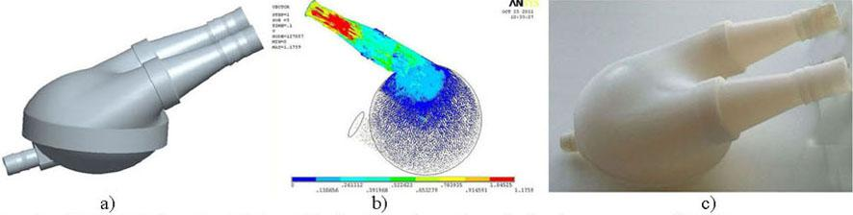Picture 1: Results of LVAD design: a) - CAD-model; b) - hemodynamic analysis; c) - prototype of LVA Results of LVAD design: a) - CAD-model; b) - hemodynamic analysis; c) - prototype of LVAD

Poster session modelling

**167**

**OPTIMISATION OF A VASCULAR MODEL WITH VARIABLE ELASTICITY**

Grischa Gabel, Sarah Schneider, Daniel Frommhold, Ulrich Kertzscher, Klaus Affeld

Charité - Universitätsmedizin Berlin, BERLIN, Germany

**Aim:** Continuous non-invasive blood pressure measurement for long-term application is highly desirable but still an unsolved technical challenge. Pulse transit times (PTTs) correlate with blood pressure, but factors like the elastic properties of the arteries demand repeated recalibration. An experimental model with variable elasticity was developed and optimised to study the effects and improve existing and new methods for blood pressure measurements.

**Methods:** The bifurcation model consists of brachial, ulnar and radial artery. Physiologic flow and pressure curves were generated. The elastic properties of the three arteries can be changed separately during the experiments by springs attached at the side of the polyurethane tubes. Increasing the force pulling on the vessel changes its cross-sectional shape. Pulse waves were detected by the movement of the vessel wall with a magnet glued on the tube and a Hall sensor above. The data was recorded by a LabView program. PTTs and pulse wave velocities (PWVs) were calculated from both the pressure and the pulse wave signals with Matlab using the base points of the curves.

**Results:** The volume elasticity coefficient increases with decreasing force on the vessel. The setup showed a problem in differentiating between several states of the model. The same PWVs can be measured at different mean arterial pressures. A frequency analysis was performed to further investigate and potentially discriminate the states of this behaviour.

**Conclusions:** The existing vascular model with physiological flow, pressure, pulse waves, flow distribution and variable elasticity could be further studied and optimised accordingly. An approach could be developed to overcome problems with the precise characterisation of the system.

Poster session modelling

**168**

**34-CHANNEL FUNCTIONAL NEAR-INFRARED SPECTROSCOPY TO DETECT HUMAN CEREBRAL AEROBIC AND PERFUSION ABNORMALITY**

Akira Kawaguchi1, Fumio Kawaguchi2, Daisaku Kurita3, Chieko Murayama1, Mitsuo Ohashi2, Yoichi Ohnuki1, Shunya Takizawa1, Munetaka Haida4

1Tokai University School of Medicine, ISEHARA, Japan

2Spectratech Inc, YOKOHAMA, Japan

3Tokai University IT Education Center, HIRATSUKA, Japan

4Tokai University Junior College of Nursing and Medical Technology, HIRATSUKA, Japan

**Aim**

Cerebrovascular accident poses urgent and critical burden to start immediate treatment based on correct diagnosis with regard to bleeding or infarction. We assembled 34-channel near-infrared spectroscopy (NIRS) probes into a head-set in order to detect aerobic and perfusion abnormality as a totally non-invasive mobile device for prompt and physiologic evaluation leading to a tentative diagnosis before MRI or CT.

**Methods**

Thirty-four channel functional NIRS systems (Spectratech) were assembled and attached to a head-gear to cover the human head to detect NIRS signals of the brain; relative changes in the amount of oxy-hemoglobin (Hb), deoxy-Hb and their sum as the total Hb. The system obtained 17-pairs of right and left signals from the brain surface (cortex and subcortical tissue) continuously every 0.65 second and displays real-time in 17-linear patterns and a projected figure to a human brain phantom (Figure). Laterality is assessed by the laterality index: (Right-signal - Left-signal) / (Right-signal + Left-signal).

**Results**

Sensitivity as well as S/N ratio is high and automatically adjusted to detect NIRS signals over the hair, scalp and skull, so as not necessitating hair removal and allowing its setting within 5 min in most of the volunteers. While holding respiration changes Hb subfraction immediately in the most of the aspects of the brain, supplemental oxygen respiration changes to the other direction, both without changes in the laterality index in normal volunteers. In contrast, pressure on the neck to the common carotid artery induced immediate changes in the laterality index and prompt recovery after release of the pressure.

**Conclusion**

The results suggest that this mobile 34-ch optical encephalography may be useful as brain oximetry to detect aerobic and perfusion abnormality and their laterality non-invasively even in emergency or ambulance and to monitor real-time changes in response to medication and/or endovascular therapy.

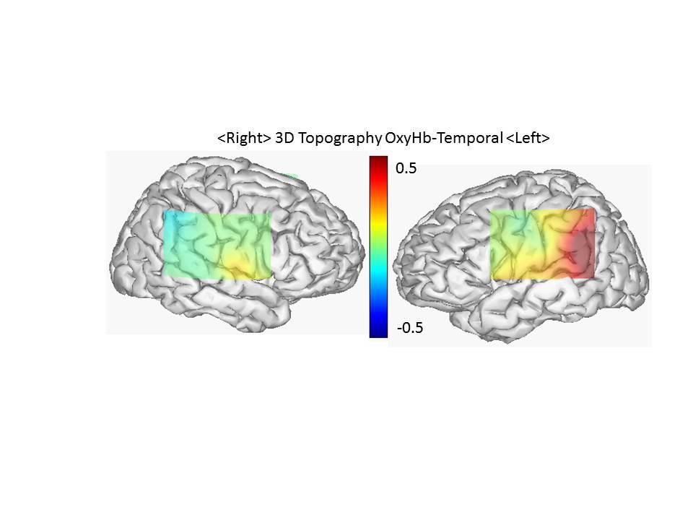Picture 1: Sample Imag Sample Image

Poster session modelling

**169**

**IN VITRO HEMODYNAMICAL EVALUATION OF MICROPOROUS COVERED STENTS FOR TREATING INTRACRANIAL ANEURYSMS**

Takeshi Moriwaki1, Ryo Hidaka2, Tsutomu Tajikawa2, Yasuhide Nakayama1

1National Cerebral and Cardiovascular Center Research Institute, OSAKA, Japan

2Kansai University, OSAKA, Japan

Aim: We have developed a microporous covered stent for the treatment of giant and wide neck intracranial aneurysms (IA). This device promotes flow reduction and induces progressive thrombosis in IA. The aim of this study is the evaluation of flow reduction by placing covered stent at various aneurysm geometries.

Methods: Two-dimensional sidewall IA models were fabricated from acrylic material. IA model geometries were changed three types: 1) Dome size of aneurysms (7.1 - 14.0 mm); 2) Neck size of aneurysms (7.9 - 18.0 mm); 3) Curvature ratio of the parent vessels (0 - 0.5). As a microporous covered stent model, microporous stainless-steel sheets (pore diameter: 0.1, 0.2, 0.4 mm, porosity: 30 %) were placed at the neck of aneurysm models. Velocity profilesand shere rate distributions of intra-aneurysmal flow were measured by PIV.

Results: In straight vessel models (curvature ratio: 0), high shear rate regions were observed around the aneurysm neck part before stenting. Area mean shear rates (AMSR) in aneurysm were higher in smaller dome or wider neck model. In the U-bend vessel model (curvature ratio: 0.5), however, high shear rate regions spread throughout intra-aneurysmal flow. AMSR became higher in sharper bend. After stenting, AMSR were significantly reduced in all models. Flow reduction was greater by using smaller pore diameters sheets.

Conclusion: The covered stents with small pore seem to have sufficient flow reduction property for the wide neck and curved position IA treatments.

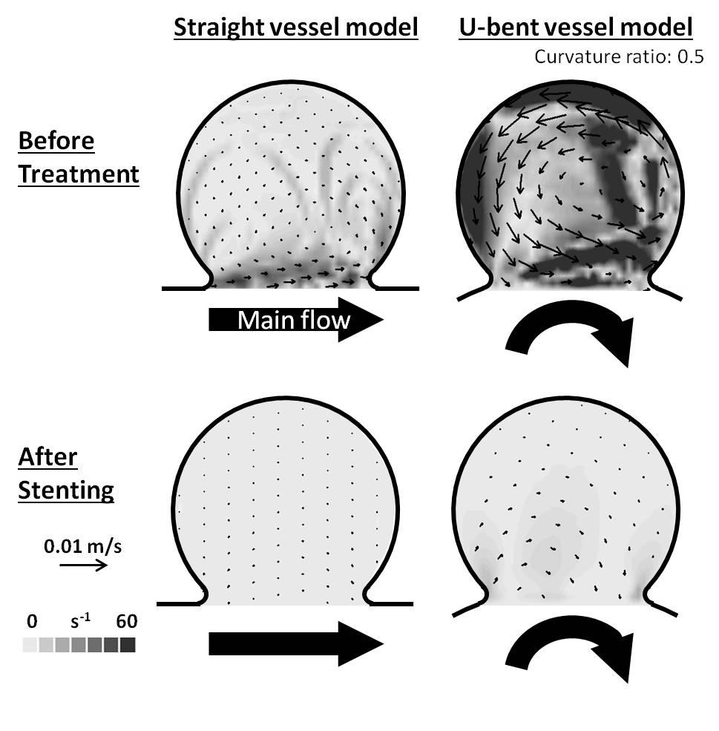Picture 1: Disribution of flowvelocity and shear rate in aneurysm model Disribution of flowvelocity and shear rate in aneurysm models

Poster session modelling

**170**

**MODELING OF THE COILED COCHLEA AND ORGAN OF CORTI - USING FOR THE COCHLEAR IMPLANTS**

Velibor Isailovic, Milica Nikolic, Zarko Milosevic, Dalibor Nikolic, Igor Saveljic, Milos Radovic, Nenad Filipovic

BioIRC, KRAGUJEVAC, Serbia

**Aim**

Cochlear implants are devices which main function is to provide sound detection to the people whose are profoundly deaf, either from birth or due to hearing loss. In distinguish to the hearing aids, they skip the outer and the middle ear in the process of hearing, and directly simulate auditory nerve. Cochlea and organ of Corti can be used for improvement of the modeling of the cochlear implants.

**Methods**

Three-dimensional finite element model of the coiled cochlea with simplified geometry (scala vestibuli, scala tympani and basilar membrane) was developed in order to simulate cochlea behavior. Model was solved with PAK finite element solver. This model can be used to simulate voltage distribution along the cochlea, which is important part in modeling of the cochlear implants. Additionally finite element model of the organ of Corti was developed separately in order to simulate more accurate electrical behavior of the cochlea. Organ of Corti model can be further simulated by cochlear implant electrodes.

**Results**

Displacement distribution along the basilar membrane for different frequencies before and after cochlear implantation is presented. The obtained results from these two models are presenting function of the healthy human cochlea and also they are using to simulate certain hearing disorders.

**Conclusion**

The final goal of these two models is to provide important information - voltage distribution and minimal voltage sufficient for auditory nerve fiber stimulation in order to improve modeling of the cochlear implants.

Poster session biomaterials

**171**

**DEVELOPMENT OLIGOPEPTIDE FOR THE SYNTHESIS OF HEMOSORBENT BINDING TNF-ALPHA**

Tatiana Ryabzeva1, Denis Makarevich2, Valeriy Kirkovsky1, Vladimir Golubovich2

1Belarusian state medical university, MINSK, Belarus, Republic of

2Institute of bioorganic chemistry NASB,, MINSK, Belarus, Republic of

Tumor necrosis factor (TNF) is an important mediator involved in the pathogenesis of sepsis. It’s known, neutralization of proinflammatory cytokines, such as tumor necrosis factor- α (TNF-α) or interleukin-1 (IL-1), decreases mortality in several animal models of sepsis. But almost all randomized studies using anti-TNF therapy during sepsis show a small benefit in decreasing mortality. A recent study in 2634 septic patients using a murine anti-TNF antibody shows a 3.6% significant benefit in reducing mortality. Insufficient anti-TNF therapy effectiveness may be related to the destruction of the monoclonal antibodies used in therapy because they are inherently foreign to the body. One of the promising areas is the use of extracorporeal biospecific hemosorbent.

The aim is to develop an oligopeptide capable of binding TNF-α.

Methods. Amino acid sequence for the synthesis of the oligopeptide was adjusted using the method of mathematical modeling. As a model of interaction we used the structure of the complex TNF-α with poxvirus L2 protein (PDB ID 3IT8). With the help of the software was made to highlight the interaction of amino acid residues TNF-α and poxvirus L2 protein, which were at a distance sufficient for the non-covalent interactions. It was synthesized three oligopeptides.

Results. Percent inhibition of TNF-α peptide 1 was 89,76±2.4%. Significant difference in the extent of binding using peptide-1 in various concentrations was not detected. Peptide 2 is also able to bind TNF-α in the model solution. Percent inhibition was 88,11±3.4%. Percent inhibition of TNF-α by peptide-3 - 87,88±1.4%.

Conclusion. Thus, we have developed experimental oligopeptides are able to bind TNF-α in the model solution and can be recommended as ligands for the synthesis of hemosorbents.

Poster session biomaterials

**172**

**STUDY OF MODIFIED XENOPERICARDIUM POSSIBILE APPLICATION IN BLADDER WALL DEFECT PLASTY.**

Anna Manchenko, Irina Mikhailova, Nikolay Repin, Boris Sandomirsky

Institute for Problems of Cryobiology and Cryomedicine of NAS of Ukraine, KHARKOV, Ukraine

**Aim:** Research aim was to study the integration features of devitalized xenopericardium (DXP) in an experimental model «in vivo»: to evaluate the biocompatibility, the repopulation rate, functional efficiency. DXP has been derived via low temperature and β--irradiation.

**Methods:** As a transplantation model there was performed prostheses of urinary bladder (UB) defect in 18th Chinchilla rabbits of 3,100-4,100g. The experiment consisted of placing the 2x2.7 cm patch to the UB wall. Animals have been withdrawn from the experiment in 14 days, 1, 3, 6 months after surgery. The animals were evaluated macroscopically and by USD. Tissue samples of fragments containing the implant were morphologically studied. Micropreparations were H&E stained. Tissue ultrastructure was examined by TEM.

**Results:** All animals survived surgery and showed a normal physiological activity. USD demonstrated normal fullness of UB, stone formation was absent. Macroscopically urine was with no blood. No implant failure, post-surgery period complications have been detected. By 3 months the collagen structure is re-arranged, mucous membrane is epithelized in the implant. Folding has already formed, germination of narrow layers of smooth muscle cells from the native tissue was noted in deeper layers. Epithelium starts growing by a narrow layer onto a patch from the native tissue side, it has no accurately expressed layers. By 6 months the inner wall surface of UB is represented by normal mucosa, lined with a completely formed epithelium, that is embedded into the wall structure, restoring its integrity; there is a complete epithelialization of the defect with no signs of scar deformity.

**Conclusion:** Pericardial graft has the potential to cell repopulation «in vivo», which is manifested in active endogenous regeneration. The modified tissue is able of adaption to urinary tract tissues and demonstrates inert properties. Thus modified xenopericardium by cryoirradiation method can be used as tissue implants.

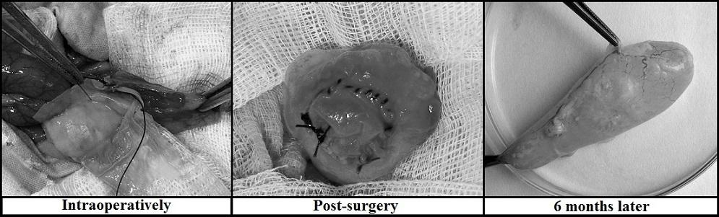

Poster session biomaterials

**173**

**BIOMATERIAL-INDUCED LEUKOCYTE ACTIVATION IN REFERENCE TO VENTRICULAR ASSIST DEVICES**

Gemma Radley1, Ina Laura Pieper2, Graham Foster2, Karl Hawkins1, Catherine Thornton1

1Swansea University, SWANSEA, United Kingdom

2Calon Cardio - Technology Ltd, SWANSEA, United Kingdom

**Aim:** To evaluate the effect of various biomaterials used in ventricular assist devices (VADs) on leukocyte behaviour to identify the most biocompatible. The results will impact future VAD designs to reduce common complications such as thromboembolism and infection.

**Methods:** Discs of biomaterials used in VAD designs - single-crystal sapphire (SAP), silicon nitride (SIN), zirconia toughened-alumina (ZTA) and titanium alloy (TI) - were suspended on polypropylene beads in petri dishes; beads only served as a negative control. Heparinised human peripheral blood was added to each dish and incubated at 37°C on a shaking plate. After 2h, the blood was removed and used for cell count analysis using the Cell-DYN Ruby haematology analyser; haemolysis using the Harboe assay (plasma-free haemoglobin, g/L); viability through flow cytometry using CyTRAK Orange[TRADEMARK] and DRAQ7[TRADEMARK]; and whole blood cultures with 10 ng/mL LPS stimulation for 24hrs to yield supernatants for cytokine analysis using ELISA.

**Results:** Preliminary data shown as fold change from negative control. Cell viability between the biomaterials (n=3) did not vary but a decrease in leukocyte numbers (n=6) was noted: 0.89±0.6 (SAP); 0.88±0.6 (SIN); 0.91±0.2 (TI); and 0.92±0.5 (ZTA). Haemolysis increased for every biomaterial (n=5): 1.41±0.25 (SAP); 2.12±0.66 (SIN); 1.52±0.84 (TI); and 1.39±0.64 (ZTA). Interleukin-8 (IL-8) concentration in LPS-stimulated samples varies by biomaterial (n=3): 0.90±0.54 (SAP); 1.53±1.08 (SIN); 1.24±0.23 (TI); and 1.15±0.29 (ZTA).

**Conclusions:** The decrease in leukocyte numbers could be due to activation and adhesion of these cells, particularly monocytes and neutrophils, caused by the biomaterials and not simply cell death. Silicon nitride so far has shown higher haemolysis, a greater decrease in leukocyte count, and a higher concentration of IL-8 indicating poorer biocompatibility than the other biomaterials. Ongoing work includes flow cytometry for cell activation markers and microscopy for adhesion.

Poster session biomaterials

**174**

**BIOMECHANICAL ANALYSIS OF THE EFFECTS OF CROSS-LINKING TREATMENTS FOR TRACHEAL BIO-PROSTHESES**

Paola Bagnoli1, Matteo Pecchiari2, Luca Possenti1, Chaolun Shao1, Marco Stefanati1, Daniela Tommasin1, Fabio Acocella2

1Politecnico di Milano, MILAN, Italy

2Università degli Studi di Milano, MILAN, Italy

**Aim**: This study was aimed at characterizing the mechanical behaviour of tracheal tissues, in order to evaluate the effects exerted by two treatments used to cross-link biological tissues before transplantation.

**Methods**: The tracheas of 8 sheep from local abattoir were used to perform mechanical uniaxial tensile tests, using a Synergie 200 MTS Axial machine. Each trachea was divided into 3 parts: (A) cross-inked with 2% glutaraldehyde solution, that is the standard treatment for biological tissue crosslinking, (B) with EDC-NHS solution that we propose as elective treatment for tracheal bio-prostheses and (C) with ringer lactate (fresh control). Mechanical tests were performed at room temperature on samples moisturized with saline.

The stress-strain relationships were evaluated separately for the cartilaginous rings (n=164) and the smooth muscles (n=126).

Six load/unload cycles were applied to each sample to precondition the tissues (test speed V=(0.02*L0)*60 mm/min, with L0=initial length; maximum strain: εmax=0.07 for cartilage and 0.2 for muscle), before applying the tensile load. The tensile tests, performed at test speed V, were terminated at the reaching of the breaking strength.

**Results**: The stress-strain curves obtained from the two tissues show the typical viscoelastic behaviour, characterized by an increasing structural stiffness of the tissue with increasing strain, until ultimate stress is reached. Statistical analyses performed to compare the 2 treatments to the fresh tracheas show that glutaraldehyde significantly affects the mechanical properties of both cartilage and muscle, resulting in a stiffer stress-strain curve and lower breaking strain. EDC-NHS solution does not affect the cartilage behaviour, while an increase in the stiffness of the muscle is observed, with respect to the fresh control, but significantly lower than the stiffening induced by glutaraldehyde.

**Conclusion**: The results of the mechanical characterization suggest EDC-NHS as a promising alternative to glutaraldehyde for the cross-linking treatment of biological tracheal prostheses.

Poster session biomaterials

**175**

**SYNTHESIS AND CHARACTERIZATION OF PHEMA SUPRAMOLECULAR HYDROGEL FOR BIOMEDICAL APPLICATION**

Parvin Shokrollahi

Iran Polymer and Petrochemical Institute, TEHRAN, Iran

**Introduction**

Inspired by nature, there is dramatically increasing demand for synthetic biocompatible hydrogels that are three-dimensional hydrophilic networks that swell upon immersion in water, forming highly permeable, soft solids. Improving control over hydrogel swelling properties is essential for advancing biomedical applications in areas such as wound dressing, prosthetics, tissue engineering scaffolds, as well as drug delivery and release systems. Conventional hydrogels, when swollen, are typically weak and brittle because they cannot effectively dissipate energy. Recently, hydrophobic associating groups have been integrated into hydrogels. Such hydrophobic groups form temporary or physical hydrogels. Multiple hydrogen bonding motifs have been extensively applied to engineer supramolecular polymers and networks.

**Methods**

The ureidopyrimidinone (UPy) group, for example, provides directionality and strength through an array of H-bonding donors and acceptors (DDAA). UPy groups are popular synthons because they are easily introduced onto polymer chains as end-groups and side-groups, and they are capable of self- dimerization with remarkably high association constants. In this report the swelling and mechanical properties of a hydrophilic polymer containing reversibly associating hydrogen bonding side-groups is examined. Ureidopyrimidinone (UPy) moieties self- associate to form hydrogen-bonded dimers (DDAA) in non-polar media. Poly (hydroxyethyl methacrylate) (pHEMA), polymers with varying UPy side-group content, were prepared using conventional free radical polymerization.

**Results and conclusion**

Water swelling experiments revealed that UPy side-groups promote swelling. The hydrogels can be considered as suitable candidates as bone tissue engineering scaffold.

Poster session biomaterials

**176**

**EFFECT OF METHACRYL POLYHEDRAL OLIGOMERIC SILSESQUIOXANES ON PROTEIN ADSORPTION OF SILICONE ACRYLATE CONTACT LENS**

Mohammad Zobeydi, mojgan Zandi, parvin Shokrolahi, Mohammad Atai

Iran Polymer and Petrochemical, TEHRAN, Iran

**Aim:** Siliconeacrylatelenses are usedwidelyto improve eyerefractive errors due tohigh levelofoxygenpermeability.In this studythe crosslink agent methacryl polyhedral oligomeric silsesquioxanes (MA-POSS),is usedincombinationwith otheracrylate monomers and its effect was investigated on mechanical properties andprotein deposition onthe surface of the resulting lensmaterial.

**Methods:** MA-POSS at various ratios0,0.5, 1, 1.5 and2(wt%), was reacted with methyl methacrylate(MMA), 2-hydroxyethyl methacrylate(HEMA)and3-(Trimethoxysilyl) propyl methacrylate(TESMA), usingfree radicalpolymerization in the presence of 2,2′-Azobis-2-methylpropionitrile (AIBN), as initiator at 70° Cin aTeflonmold.To quantify protein deposition onthelenses, BCAproteinkit and an ELISA reader were used withlysozymeandalbumin as model proteins.Also, hydrophobicityandmorphology of the lenses werestudied withcontactanglemeasurement(CA) andTEM observation.

**Results:** The mechanical and CA measurement results showedthat both the mechanical properties and the hydrophobicity of the lenses increased with MA-POSS content, which was translated in reduced proteinadsorptionon thesurface of the lenses. However, protein deposition was increased after an optimum MA-POSScontent, presumably due to especial cage structure of the MA-POSS that is susptible to protein entrapment.

**Conclusion:** The effect ofMA-POSS on themechanical and proteinadsorption properties ofcontact lenses strongly depends onconcentration, for which an optimum range of about 1wt%, was determined based on the results of this.

Poster session biomaterials

**177**

**SURFACE MODIFICATION OF POLY HEMA HYDROGEL AS CONTACT LENS WITH ANTI-FOULING PROPERTIES**

Mojgan Zandi, Mohammad Kazemi Ashtiani, Parvin Shokrollahi, Morteza Ehsani

Iran Polymer and Petrochemical Institute, TEHRAN, Iran

**Aim**

Recently, the strategies for designing materials that prevent protein adsorption have received many attentions in biomedical applications. One of the most important applications of such biomaterials is providing contact lenses with anti-fouling properties. In this study we address the possibility of modifying the poly (2-hydroxyethyl methacrylate) (pHEMA), hydrogel -as a major component of soft lenses- for reducing protein adsorption from artificial tear fluid (ATF).

**Methods**

pHEMA hydrogel was synthesized through mixing of the monomer, HEMA with ethylene glycol dimethacrylate and asobis isobutyronitrtile followed by heating at 70ºC for 8 hours. For chemical modification of pHEMA, the hydrogel was immersed in a solution of sulfuric acid in deionized water (30 % v/v) for 20 hours. Moreover, the carboxylic acid groups of the hydrolyzed pHEMA was activated by N-Hydroxysuccinimide (NHS) and (1-ethyl-3-(3-dimethylamino propyl)carbodiimide hydrochloride) (EDC), followed by functionalization with 1,4-Butanediamine. Finally, aminated-pHEMA was reacted with EDC/NHS-activated betaine. Protein adsorption of the neat and the modified pHEMA in contact with ATF was determined by BCA method.

**Results**

The results showed that the betaine-conjugated pHEMA (6.4 ± 2.1 μg/cm2), has less adsorbed proteins compared with neat pHEMA (16.6 ± 7.7 μg/cm2).

**Conclusion**

We successfully introduce an easy and cost-effective approach for modification of pHEMA with improved anti-fouling properties which is promising for biomedical applications such as soft contact lenses.

**References**

Long TJ,etal, J. Biomaterials, 2014, 35, 28, 8164-74

Kostina NY,etal, J. Mater. Chem. B. 2013, 5644-5650.

Podko!cielna B, etal, J. eXPRESS Polymer Letters, 2012,.9, 759-771

Poster session biomaterials

**178**

**EFFECT OF METHACRYL-POSS ON LYSOZYME ADSORPTION OF SILICONE ACRYLATE CONTACT LENSES**

Mojgan Zandi, Mohammad Zobeydi, Parvin Shokrollahi, Mohammad Ataei

Iran Polymer and Petrochemical Institute, TEHRAN, Iran

**Aim:** Silicone acrylate lenses are widely used to improve the eye refractive errors due to high level of oxygen permeability. In this study the crosslink agent methacryl polyhedral oligomeric silsesquioxanes(MA-POSS) is used in radical polymerization of silicon acrylate in combination with other acrylate monomers and its effect on lysosome absorption on lenses surface was investigated.

**Methods:** MA-POSS at various ratios 0, 0.5, 1, 1.5 and 2 (wt%),was reacted with methyl methacrylate, 2-hydroxyethyl methacrylate and 3-(trimethoxysilyl) propyl methacrylate via free radical polymerization in the presence of 2,2′-Azobis (2-methylpropionitrile) as an initiator at 70°C in a Teflon mold. To quantify the lysosyme concentration, BCA protein assay was used. Also, hydrophobicity of the prepared lenses was evaluated using contact angle (CA) measurement.

**Results:** The CA results show that hydrophilicity of the lenses increases by increasing the MA-POSS content which was translated in reduced protein adsorption on the surface of the lenses. In this research the most appropriate amount of MA-POSS was introduced by considering the minimal protein adsorption.

**Conclusion:** Surface wettability and also protein absorption are strongly influenced by variation of MA-POSS contents and we found out that 1% shows the least protein absorption presumably due to especial cage structure of the MA-POSS that is susceptible to protein entrapment**.**

**References:**

1. Wang B., Lin Q., Shen C, Tang J, Chen H, RSC Adv., 2014, 4, 52959-52966

2. Rafiqul Islam M, Bach LG, Park JM, Hong SS, Lim KTl., J App.l Polym. Sci., 2013, 127, 1569-1577

Poster session biomaterials

**179**

**SURFACE PROPERTY OF DIFERULOYLMETHANE SEGMENTED ISOPHORONE DIISOCYANATE THERMOPLASTIC POLYURETHANE**

Mojgan Zandi, Maryam Faghih Abdolahi, Parvin Shokrollahi, Morteza Ehsani

Iran Polymer and Petrochemical Institute, TEHRAN, Iran

**Aim:** Recently, biodegradable polyurethane has made significant progress for many biomedical applications in soft and hard tissue engineering. Diferuloylmethane (DIF) is a natural product which has a wide pharmacological use. The goal of this work was the synthesis of biodegradable segmented polyurethane elastomers (PU) based on poly (ε-caprolactone) diol (PCL-diol), isophorone diisocyanate (IPDI) and different molar ratio of 1,4-butandiol (BDO) and DIF as chain extenders. The chemical structure and the surface property were investigated using FTIR spectroscopy and water contact angle (CA) techniques. Prepared material would have a great potential in medical applications.

**Methods:** PCL-diol and BDO were dried at 80°C under vacuum for 24h and dissolved in dried Chloroform under a dry nitrogen atmosphere and stirred continuously at appropriate temperature to obtain prepolymer. Then a proper amount of BDO and DIF (0.4:0, 0.3:0.1, 0.2:0.2 molar ratio, respectively) was dissolved in solvent and introduced to the prepolymer solution. The stoichiometry ratios of PCL: BDO/DIF: IPDI in the reaction were 0.6:0.4:1, respectively.

**Results:** The chemical structure of PUs was evaluated by FTIR spectroscopy in which the absence of NCO absorbance peak at 2267 cm-1 indicated end of the reaction. Peaks correspond to the absorption of -NH, -CO, -CHN at 3300, 1730 and 1464 cm-1, respectively indicated the urethane groups (-NHCO). The hydrophilicity of PUs decreased as the ratio of DIF increased (PU0: 86°, PU0.1: 92°, PU0.2: 97°).

**Conclusion:** The main determining factor in this research is introducing the DIF in polymer backbone which allow us modify the polyurethane elastomer structure.

**References:**

1. Rueda-Larraz L, etal., Eur. Polym. J*.*, 2009, 45, 2096-2109

2. Nagarajan S, etal., J Biomed Mater Res A, 2011, 99, 3, 410-7

Poster session tissue engineering in vitro

**180**

**VISUALIZATION OF ALGINATE BEADS WITH ENCAPSULATED CELLS FOR CRYOPRESERVATION AND CELL-BASED THERAPIES**

Oleksandr Gryshkov1, Maksim Tymkovych2, Oleg Avrunin2, Nicola Hofmann3, Birgit Glasmacher3

1Leibniz University Hannover, HANNOVER, Germany

2Department of Biomedical Engineering, Kharkiv University of Radioelectronics, KHARKIV, Ukraine

3Institute for Multiphase Processes, Leibniz University Hannover, HANNOVER, Germany

**Aims**

Cryopreservation is the method to freeze rare cell types for their long-term availability. Application of alginate encapsulation may improve cell viability by protecting the cells from the ice re-crystallization upon freezing and thawing. In this work, we aim at designing software that could allow visualization of alginate beads with encapsulated cells to evaluate their viability after long-term culture and cryopreservation.

**Methods**

The alginate beads with a diameter of 300µm were generated using a high voltage method. The alginate-encapsulated cells were cryopreserved using previously published protocol [1]. After thawing, the encapsulated cells were stained with CaceinAM and Ethidium Homodimer-1 viability assay and visualized using a fluorescent microscope. The images were taken over a z-axis with a step of 10 µm separately for live and dead cells and reconstructed using a GPU engine.

**Results**

The encapsulated cells survived well the cryopreservation procedures. Designed software allowed determining the size of alginate beads, detecting live and dead cells within the beads as well as analyzing the viability of cells. The results of visualization can be presented in two and three dimensions and correlate well with initial images of cells within the alginate beads (Figure 1). Moreover, this method allowed determining the number of live and dead cells with regard to their location from the center of a bead.

**Conclusions**

We have introduced a new approach of reconstruction of alginate beads with encapsulated cells. It is specialized, but can be applied for the analysis of other microscopic fluorescent multimodal images and to develop appropriate freezing/thawing protocols to improve the viability of cells after cryopreservation and long-term culture.

**References**

[1] O. Gryshkov, D. Pogozhykh, N. Hofmann et al. (2014). PLoS One 9, e107911.

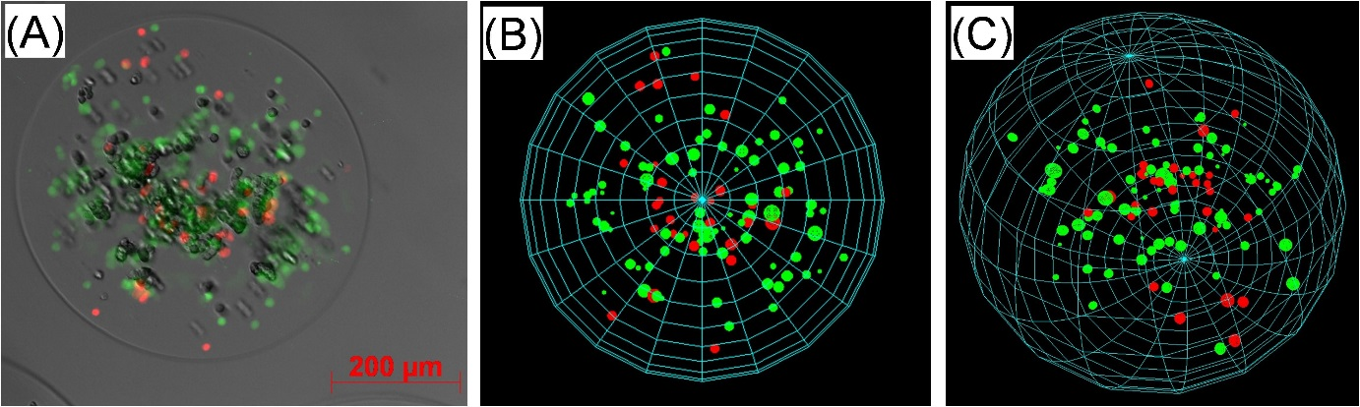Picture 1: Alginate bead with encapsulated live (green) and dead (red) cells (A) and its reconstruction in 2D (B) an Alginate bead with encapsulated live (green) and dead (red) cells (A) and its reconstruction in 2D (B) and 3D (C)

Poster session tissue engineering in vitro

**181**

**MICRO SLIT MADE BY PHOTOLITHOGRAPHY TECHNIQUE FOR CELL SORTING**

SHIGEHIRO HASHIMOTO, Haruka Hino, Mizoi Atsushi, Yusuke Takahashi

Kogakuin University, TOKYO, Japan

**Aim**: Biological cells might pass through a path narrower than their diameter in vivo. The spleen, for example, has the slits. The narrow path is able to sort cells, according to their size and deformability. The photolithography technique enables manufacturing a micro slit. In the present study, the micro slit has been designed to observe behavior of a biological cell passing through the narrow path in vitro.

**Methods**: A silicone disk was used for a photolithography mold. Both a laser drawing system and a dry etching process were applied for the micro-fabrication. The slit, of which width is 0.050 mm and height is 0.001 mm, has been designed between two parts of transparent polydimethylsiloxane disks. The disks have rectangular micro ridges on the inner surface. The dimension of the fabricated micro ridges was measured with a laser microscope. The suspension of volunteer human red blood cells, swine red blood cells or C2C12 (mouse myoblast cell line originated with cross-striated muscle of C3H mouse) has alternatively been introduced to the slits by drawing with a syringe pump. The behavior of cells passing through the micro slit has been observed with an inverted phase-contrast microscope.

**Results**: The mean height of the ridges measured with the microscope is 0.0010 mm, which keeps space of the slit. Several red blood cells can pass through the micro slit, although C2C12 cannot pass through the micro slit.

**Conclusion**: The experimental results show that the micro slit can be fabricated with photolithography technique and has a potential on sorting biological cells with deformability.

Poster session tissue engineering in vitro

**182**

**MICRO RIDGES WITH ULTRASONIC VIBRATION CAN CONTROL ORIENTATION OF CULTURED CELL**

Haruka Hino1, SHIGEHIRO HASHIMOTO1, Shoma Nishino1, Yusuke Takahashi1, Toshitaka Yasuda2

1Kogakuin University, TOKYO, Japan

2Tokyo National College of Technology, TOKYO, Japan

**Aim:** The acceleration technique for orientation of cells would be applied to regenerative tissue technology. In the previous studies, the orientation of cells was controlled by sandwiching the cells between walls: in grooves, or in capillaries. The cell, on the other hand, might sense the direction of micromorphology of the scaffold. In the present study, the cell has been cultured on the surface with ultrasonically vibrating micro linear ridges, and the effect of ridges on orientation of cultured cells has been studied in vitro.

**Methods:** Several patterns of micro ridges have been fabricated on a transparent polydimethylsiloxane disk with the photo lithography technique. The ridges consist of several lines of rectangular column: width of 0.003 mm, interval of 0.007 mm. Variation has been made on the height of the ridge between 0.0003 mm and 0.0035 mm. C2C12 (mouse myoblast cell line originated with cross-striated muscle of C3H mouse), 3T3-L1 (fibroblast-like cell from 3T3 mouse) was cultured on the disk with the micro ridges for one hour with ultrasonic vibration (1 MHz) and was observed with an inverted phase contrast microscope.

**Results:** Cells adsorb on the top of the ridge, extend pseudopodia along the longitudinal direction of the ridge, and align against the longitudinal direction of the micro ridges with the height between 0.0015 mm and 0.0025 mm.

**Conclusion:** The experimental results show that cells sense micro morphology of the ridge and that the optimum size of micro ridges can control orientation of cells. The behaviour depends on kinds of cells.

Poster session tissue engineering in vitro

**183**

**FLEXIBLE, CELL-INTERACTIVE HYBRID SCAFFOLDS FOR TISSUE ENGINEERING PURPOSES**

Annemie Houben1, Oscar Kreps1, Patrice Roose2, Huges Vandenberghe2, Manuel Dierick1, Heidi Declerq1, Maria Cornelissen1, Dirk Bontinck2, Sandra Van Vlierberghe1, Peter Dubruel1

1Ghent University, GHENT, Belgium

2Allnex, DROGENBOS, Belgium

**Aim**

The aim of the present work included the development of porous scaffolds using a novel type of photocurable hydrogel precursor combining the flexibility and strength of polyurethanes with the biocompatibility and hydrophilicity of poly(ethylene glycol) (PEG). To enhance cell adhesion, the materials were combined with methacrylamide-modified gelatin (GM). Porous tissue engineering scaffolds were obtained by using a 3D-printed Poly-e-(caprolactone) (PCL) template.

**Methods**

Acrylate endcapped, urethane based polyethylene glycol (AUP) was used as hydrogel precursor. PCL templates were 3D printed using the BioplotterTM technology and immersed in a solution (30 wt% AUP, 1wt% GM, 2 mol% Irgacure 2959). After 30 min UV-A irradiation, PCL was extracted in chloroform. Human Foreskin Fibroblast (HFF) cell attachment on hydrogel disks was assessed after 24h (using calcein AM staining).

**Results**

Strong, yet flexible porous scaffolds were obtained using the PCL template (left part figure). Optical microscopy, SEM and µCT show the existence of a fully interconnected porous network.

Cell assays on hydrogel disks (center part figure) showed that no cell adhesion occurs on the AUP, while addition of 1 wt% GM results in a uniform cell adhesion. Higher GM concentrations give rise to different adhesion zones, most likely due to phase separation between the AUP and GM.

The storage modulus of crosslinked hydrogel films starting from 30 to 50 wt% AUP aqueous solutions were compared in the absence or presence of GM (right part figure). As anticipated, higher AUP concentrations resulted in stronger materials while the addition of GM did not have a negative impact on the mechanical properties.

**Conclusion**

Strong hybrid materials were obtained using the AUP precursor. The addition of GM results in uniform cell adhesion at low protein concentrations, without affecting the mechanical properties. Porous scaffolds were developed starting from 3D printed PCL as negative template.

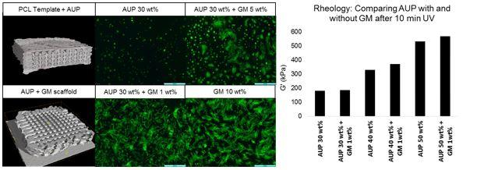Picture 1: µCT images of the AUP scaffold with (top) and without (bottom) PCL template; Calcein AM staining o µCT images of the AUP scaffold with (top) and without (bottom) PCL template; Calcein AM staining of HFF cells on hydrogel films; Rheology results.

Poster session tissue engineering in vitro

**184**

**ENDOTHELIAL NETWORK FORMATION WITHIN HUMAN TISSUE-ENGINEERED SKELETAL MUSCLE**

Dacha Gholobova1, Lieselot Decroix1, Vicky Van Muylder1, Linda Desender1, Melanie Gerard1, Gilles Carpentier2, Herman Vandenburgh3, Lieven Thorrez1

1KU Leuven @ Kulak, KORTRIJK, Belgium

2Université Paris Est Créteil, CRÉTEIL, France

3Brown University, PROVIDENCE, United States of America

**Aim**

The size of *in vitro* engineered human skeletal muscle tissue is still limited due to the lack of a vascular network *in vitro*. We propose a technique by co-culturing muscle progenitor cells with endothelial cells in a fibrin extracellular matrix (ECM). This way, we aim to create endothelial networks within a bio-artificial muscle (BAM) with well aligned myofibers.

**Methods**

Human myoblasts and human umbilical vein endothelial cells (HUVECs) labeled with Green Fluorescent Protein (GFP) were mixed in different ratios in a fibrin hydrogel. The mix was cast into custom-made 25-mm-long silicone rubber molds with end attachment sites to stimulate myofiber alignment. Seven days after casting, BAMs were fixed and stained by immunohistochemistry to evaluate cell survival, myofiber formation and endothelial network formation. Several parameters were quantified by image analysis in ImageJ.

**Results**

The optimal medium condition for co-culturing myoblasts with HUVECs was determined. 2D and 3D fusion assays showed that endothelial growth medium is the best compromise for co-culturing both cell types, without affecting the myoblast fusion index. Addition of 10% matrigel to the fibrin ECM was evaluated, but found to have an adverse affect on homogenous cell distribution. Different total cell numbers and different myoblast-HUVEC ratios in the co-culture BAMs were assayed. Optimal myofiber and endothelial network formation was seen in co-culture BAMs with a fibrin ECM containing 30% HUVECs and 70% myoblasts and a total cell number of 2.106. Endothelial networks displayed extensive branching, junction and lumen formation.

**Conclusion**

To our knowledge, this is the first report of tissue engineered skeletal muscle with advanced endothelial networks between human aligned myofibers.

Poster session tissue engineering in vitro

**185**

**ROLE OF MICROPOROSITY ON THE MECHANICAL PERFORMANCE OF GEL-FILLED PCL SCAFFOLDS FOR CARTILAGE REGENERATION**

Gloria Gallego-Ferrer, Line Vikingsson, Babeth Claessens, José Antonio Gómez-Tejedor, José Luis Gómez Ribelles

Universitat Politècnica de València, VALENCIA, Spain

**Aim**

Design and optimization of biodegradable scaffolds is an important problem in tissue engineering. We aim to evaluate the effect of micro porosity and tissue growth on the mechanical properties and permeability of a polycaprolactone (PCL) scaffold for cartilage regeneration. In order to make mechanical testing representative of the outcome of the scaffold during tissue regeneration a poly(vinyl alcohol) (PVA) hydrogel with tailored mechanical modulus has been used to simulate the growing cartilage tissue inside the pores of the scaffold.

**Methods**

A series of PCL scaffolds with macro and micro pores has been prepared and tested in unconfined and confined compression conditions and immersed in water. Double porosity was obtained via freeze extraction and porogen leaching. Hydrogel stiffness was modulated by cross-linking density.

**Results**

The mechanical properties of the scaffold increase with the hydrogel filling and decreasing micro porosity. The permeability decreases with increasing micro porosity in the scaffolds but is unchanged when introducing the hydrogel. The stress relaxation is faster for the hydrogel filled scaffold than for the empty one. The stress relaxation tests show that the stress response of the scaffold/hydrogel construct is a consequence of the synergy between the components. Confined compression results show that the compliance of the scaffold is mainly controlled by the micro porosity of the scaffold and less by the hydrogel density in the scaffold pores.

**Conclusions**

Our model predicts that the *in vivo* outcome of the scaffold depends on the growing tissue inside the pores of the scaffold (here simulated by the hydrogel filling), and is highly influenced by scaffold microporosity. Our results bring together valuable information for customizing the optimal scaffold and to predict its *in vivo* mechanical behavior.

**Acknowledgments**

EU-FP7 PIAP-GA-2012-324386 and MINECO MAT2013-46467-C4-1-R projects and CIBER-BBN-Instituto de Salud Carlos III are acknowledged.

Poster session tissue engineering in vitro

**186**

**INFLUENCE OF IN SITU FORMED HYDROXYAPATITE CONTENT ON FREEZE-GELLED CHITOSAN/HYDROXYAPATITE SCAFFOLDS**

Gloria Gallego-Ferrer1, Anamarija Rogina2, Patricia Rico1, Marica Ivankovic2, Hrvoje Ivankovic2

1Universitat Politècnica de València, VALENCIA, Spain

2Faculty of Chemical Engineering and Technology, University of Zagreb, ZAGREB, Croatia

**Aim**

Tissue engineering requires suitable biocompatible scaffolds that can mimic natural bone tissue for cell seeding and neotissue growth. The aim of this research is to synthesize nano-structured composite biomaterials with highly porous structure on the basis of biodegradable polymer chitosan (CS) and *in situ* formed hydroxyapatite (HA) as a bioactive ceramic.

**Methods**

Wet precipitation method has been used for *in situ* HA formation within chitosan solution, while highly porous structure has been obtained by freeze-gelation technique. The influence of *in situ* HA weight ratio on scaffold’s composition and microstructure was investigated by FTIR and XRD identification and SEM imaging. Mechanical properties of different CS/HA scaffolds were determined in physiological conditions. Cytotoxicity test of composite scaffolds was carried out by MTS assay, while osteogenic property was evaluated by *in vitro* culture of MC3T3-E1 preosteoblasts.

**Results**

FTIR and XRD identification confirmed *in situ* formation of HA as well as the influence of HA precursor’s fraction on mineralogical composition of scaffolds. Freeze-gelation has shown to be optimal technique for producing highly porous structure with good pore interconnectivity. Negative cytotoxicity assay indicated no harmful effect and good biocompatibility. Mechanical testing shows higher Young’s modulus with lower *in situ* HA weight ratio. Cell culture confirmed cell viability during 14 days and indicates MC3T3-E1 cells differentiation on different CS/HA scaffolds.

**Conclusion**

*In situ* precipitation has shown to be favourable method for nano-structured chitosan/HA biomaterial formation. High porosity and good pore interconnectivity of prepared scaffolds are important factors for cell and nutrient transport and new tissue formation. Positive osteogenic signal of composite scaffolds indicates a potential application in bone tissue repair.

**Acknowledgments**

The Ministry of Science, Education and Sports of the Republic of Croatia ('Bioceramic, Polymer and Composite Nanostructured Materials' project), the MINECO MAT2013-46467-C4-1-R project and the CIBER-BBN-Instituto de Salud Carlos III are acknowledged.

Poster session tissue engineering in vitro

**187**

**MICROSCOPIC OBSERVATION OF MYOBLAST CULTURED ON MICRO COIL SPRING OF TITANIUM**

Yusuke Takahashi1, Shigehiro Hashimoto1, Yuto Yarimizu1, Kenta Noda1, Haruka Hino1, Toshitaka Yasuda2

1Kogakuin University, TOKYO, Japan

2Tokyo National College of Technology, TOKYO, Japan

Aim: The acceleration technique for proliferation of cells would be applied to regenerative tissue technology. In the present study, myoblasts have been cultured on the surface of a micro coil with electric pulses, and the effect of electric stimulation on proliferation and differentiation of cultured cells has been studied in vitro.

Methods: A micro coil spring made of titanium wire of 0.085 mm was used for the scaffold for the cell culture. The coil has the dimension as follows: 0.65 mm diameter, 0.05 mm pitch, 5 mm length. C2C12 (mouse myoblast cell line originated with cross-striated muscle of C3H mouse) was seeded at the concentration of 10000 cells per cm2, and cultured in Dulbecco’s Modified Eagle Medium with 10 percent of fetal bovine serum. An electric stimulator was used to generate electric pulses with period of 1 s, pulse width of 0.001 s, and current amplitude of 0.02 A. The electric pulses were applied to the coil for thirty minutes per a day. The cells around the coil were observed with an inverted phase contrast microscope during the cell culture. The morphology of cells was observed with a scanning electric microscope at the end of the test. The tissue around the coil was observed with the microscope after the Giemsa stain technique.

Results: Myoblasts are able to adhere around the coil, proliferate, differentiate into myotubes, make cylindrical layers around the coil, and bridge between the pitches of coils. Both adhesion and proliferation of cells decrease with electric current pulses. Differentiation is delayed with electric current pulses.

Conclusion: The experimental results show that micro coil of titanium can be scaffold of myoblasts and that electric current stimulation can control proliferation and differentiation of myoblasts.

Poster session tissue engineering in vitro

**188**

**CELL PROLIFERATION INFLUENCE ON RADIAL FLUX DISTRIBUTION ALONG RPBBS FOR BONE TE BASED ON A 3D TRANSIENT MEDIUM MODEL**

Giuseppe Falvo D’Urso Labate1, Francesco Torchia1, Patrick Segers2, Gerardo Catapano1

1University of Calabria, RENDE (CS), Italy

2Ghent University, GHENT, Belgium

**Aim:** Annular porous scaffolds seeded with osteogenic cells in radial-flow packed-bed bioreactors (rPBB) is a strategy to engineer substitutes for large bone defects. Scaffold perfusion will be a critical component, with uniform distribution of radial medium flux along the construct length promoting even tissue formation. In a companion paper, we propose a criterion to design axisymmetric rPBBs enabling uniform radial flux distribution under steady operation. However, during culture cells proliferate and deposit extracellular matrix, changing construct transport properties. We investigated the influence of cell proliferation on radial flux distribution with a 3D multi-compartment transient model of medium transport in rPBBs.

**Methods**: A 3D mathematical model was developed to describe medium transport in the three compartments (inner cavity, peripheral annulus and construct) of rPBBs with a lateral port according to Navier-Stokes and Darcy-Brinkman equations. Cell mass increase in the construct during culture was expressed as a time function obtained from experimental data for human mesenchymal stem cells cultured in axial packed-bed bioreactors. Increasing cell mass was assumed to uniformly and continuously decrease pore size, thus changing construct porosity and Darcy permeability. Equations were solved numerically for geometries and operating conditions typical of bone tissue engineering.

**Results and conclusions:** Model predictions showed that cell proliferation decreases construct porosity and Darcy permeability. Continuously decreasing Darcy permeability equalizes radial fluxes along the construct length and offsets possible radial flux maldistribution at the start of culture. The effect is more evident at inlet flow rates and rPBB geometries not satisfying the design criterion for radial flux uniformity under steady conditions. This suggests that optimization of rPBB geometry is more critical at culture start when cell concentration is lowest and the construct is more permeable.

**Acknowledgments:** Study co-funded by the Italian Ministry of Instruction and University (Project PRIN 2010/MIND). GFDL was supported by a ARUE scholarship.

Poster session tissue engineering in vitro

**189**

**REPROGRAMMING HUMAN MESENCHYMAL STEM CELLS ON NATURAL-BASED SCAFFOLDS FOR NERVOUS SYSTEM ENGINEERING.**

Katherine Carvalho1, Ana Carolina Irioda1, Bassam Felipe Mogharbel1, Daiany de Souza1, Felipe Azevedo Borges2, Carlos Frederico de Oliveira Graeff2, Rondinelli Donizetti Herculano2

1Pelé Pequeno Príncipe Research Institute, CURITIBA, Brazil

2UNESP, ARARAQUARA, Brazil

Aim: The aim was to develop a new protocol of Neurospheres from natural-based scaffolds from Brazil.

Material and Methods: Human adipose-derived mesenchymal stem cells (h-ADMSCs) were obtained from adipose tissue of woman adult healthy donor by liposuction performed by plastic surgeons with informed consent. The isolation procedure was performed by enzymatic digestion with collagenase type I. The cells were cultured on DMEN/F12 supplemented with 10% of Calf Fetal serum, 100 units/mL of penicillin and 100μg/mL of Streptomycin. The Flow Cytometric analysis was done in h-ADMSC fraction. The cell viability and integrity by Annexin conjugated with 7-AAD were done as well tri-lineage pluripotency test. The Natural-based scaffolds, the NPTX were prepared in different concentrations: 30%, 40%, 50%, 60%, 80% and 100% of natural polymer of Amazon Plant and seeded on the flasks and dried in Incubator at 37,5°C overnight to obtain different thicknesses of scaffolds. The h-ADMSCs, 2 x 104/mL were seeded on DMEN/F12 supplemented with 10% of Calf Fetal serum, 100 units/mL of penicillin and 100μg/mL of Streptomycin, on different scaffolds. The cultures were cultivated and observed during three weeks, each sample in triplicate. The Neurospheres were identified by morphology and immunoassay by antibody anti-nestine (FITC) and Hoescht in Inverted and Fluorescent microscopies.

Results: The Cytometric analysis demonstrated: CD34-, CD45-, CD49d+, CD73+, CD90+, CD105+ and 85% of viability; the tri-lineage test demonstrated: h-ADMSCs were capable to differentiated in adipocytes, osteogenic cells and chondrocytes by oil red, alizarin and alcian blue, respectively. The Neurospheres were observed since the ninth day in all concentration, except in 100% and the Neurospheres were observed in more quantity in 50% concentration than others.

Conclusion: The Natural-Based Scaffolds of Amazon Plant, NPTX were capable to reprogramme the undifferentiated h-ADMSCs to Neurospheres and could be used in Nervous System Tissue Engineering.

Poster session tissue engineering in vitro

**190**

**DENTAL BONE TISSUE ENGINEERING: THE SYNERGY OF AUTOLOGOUS BIOMATERIALS AND ARTIFICIALLY DESIGNED SCAFFOLDS**

Dmitry Bulgin

Polyclinic ME-DENT, the Center for Regenerative Medicine, ROVINJ, Croatia

Autologous biomaterials enriched with progenitor/stem cells and growth factors can be produced from components of bone marrow, peripheral blood, adipose tissue, cancellous bone, and represent a very interesting research field for dental bone regeneration and *supposed to be* excellent practical tools for bone tissue engineering in oral surgery and dental applications. The adjunctive clinical benefit of the autologous biomaterials preparation can be explained on the basis of tissue engineering, i.e., tissue engineering generally combines three key elements for regeneration: 1) scaffolds or matrices, 2) signaling molecules or growth factors, and 3) cells. Stem cells need a scaffolds that facility their integration, differentiation, matrix synthesis and promote multiple specific interactions between cells. Synthetic or artificially designed bone substitutes has numerous interconnecting pathways similar to cancellous bone and facilitates bone formation by providing an exceptional osteoconductive scaffolding which results from the retention of the natural porous architecture and trabeculation of human cancellous bone. Synthetic scaffolds show resorbable characters during bone regeneration, and can be completely substituted for the bone tissue after stimulation of bone formation. The use of autologous biomaterials combined with synthetic scaffolds is a recent and promising innovation in bone tissue engineering. Our experience with autologous biomaterials combined with artificially designed calcium phosphate scaffolds in the treatment of various dental bone defects is presented. The techniques are based on stimulation of natural events continuously present in living bone, that is, the process of bone remodeling and offering both osteoinduction and osteoconductive features.

Poster session tissue engineering in vivo

**191**

**CRYOPRESERVED CORD BLOOD DERIVED STEM CELLS INTRAVITREAL TRANSPLANTATION IN NEOVASCULAR RETINOPATHY ANIMAL MODEL**

Angel Argilés1, Igor Gapunin2

, Belgium

2International Diagnostic and Treatment Center LORITOM, KHARKIV, Ukraine

-The effect of cryopreserved cord blood derived nuclear cells (CCBNC) on neovascular retinopathy in experimental rats was studied.

-In our study we used newborn Wistar rats (n=40). Brinzolamide-induced retinopathy was applied. Rats were randomized to 4 groups (10 rats, 20 eyes in each) : 1. - intact animals, 2. - rats with NV retinopathy on 13th day of observation, 3. - rats with neovascular retinopathy on 45th day of observation, 4. - rats with neovascular retinopathy, intravitreal injected CCBNC on day 13th of observation. Six paraffin-embedded sections prepared and stained with hematoxylin and eosin. To investigate the damage, we evaluated the number of cells and the thicknesses of the retinal layers. To determine gene expression levels of Vascular endothelial growth factor (VEGF) and Pigment epithelial growth factor (PEDF) in the rats retinas real-time PCR (RT-PCR) was performed.

-Retinas from group 1 were negative for NV, and showed low levels of fold expression VEGF and PEDF (0,062 and 0,065 respectively). In the rat eyes from the group 2 morphological patterns of NV were revealed, it was a dramatic fold expression increase of the VEGF gene and a slight increase in PEDF (2,878 and 0,099, respectively). Retinas from group 3 were positive for developed proliferative retinopathy. In this group PEDF gene was increased (1,165), despite VEGF gene overweight. In the rat eyes from group 4 at the mid-peripheral retina we observed NV at different stages of involution. Latter formed conglomerates of membrane structures with the nuclei of endothelial cells. This group revealed a sharp increase in PEDF gene expression and its dominance in comparison with VEGF (1,875 and 0,199 respectively).

-Regression of neovascular tissue, retinal structure normalization was found after 45 day post single intravitreal injection of cryopreserved cord blood derived nuclear cells. Retinal structure changes corresponded with antiangiogenic gene expression prevalence.

Poster session tissue engineering in vivo

**192**

**KEY FACTOR FOR HIGH PATENCY IN IN VIVO TISSUE-ENGINEERED 'BIOTUBE' VASCULAR GRAFTS**

Maya Furukoshi

National Cerebral and Cardiovascular Center, SUITA, OSAKA, Japan

**Purpose**

Biotubes are formed with autologous connective tissues by means of “in body tissue architecture”technology, that is tissue encapsulation phenomenon when molds are embedded in living bodies. Their preparation is simple with no need of cell culturing. However, biotubes have limited collagen wall thickness because encapsulation occurred only on the surface of the molds, which may leads to low patency when implantation into low blood flow or low blood pressure area due to low mechanical strength to maintain luminal structure. In this study, the novel mold with slits was developed for wall thickening in biotubes, and their patency was examined after 1-month implantation into a beagle model.

**Methods and Results**

The novel mold with slits was assembled with silicone rod (diameter 2 mm, length 30 mm) and an acrylate cover with longitudinal side-slits prepared by 3D inkjet printing system, with an aperture of 1 mm between them. A simple silicone rod (diameter 2mm) was prepared for control. They were embedded into dorsal subcutaneous pouches into beagles for 4 weeks, and then harvested. After removing the molds, wall thickness of new biotubes were approximately 1 mm, by contrast, traditional biotubes were approximately 0.05 mm. Their mechanical strength was 2 times higher than that of traditional one. Both types of biotubes (length; 10 mm) were implanted into femoral artery of beagles. Angiography performed after 4 weeks, new biotubes showed complete patency (100 %, n=5), in contrast traditional biotubes were low patency rate (33 %, n=6). All patent biotubes were harvested, no aneurysm or stenosis was found and vascular reconstruction was observed by immunohistologically.

**Conclusion**

New biotubes with thick wall was robust and that was a key factor for high patency rate. The biotubes may be useful for peripheral artery or vein grafts in addition to aortic grafts.

Poster session tissue engineering in vivo

**193**

**PEPTIDIC COMPOSITION AND BIOLOGICAL ACTION OF EXTRACTS OF CRYOPRESERVED FRAGMENTS OF PIGLETS' HEART AND SKIN**

Liliia Rohoza, Iryna Bespalova, Nikolai Chizh, Sergiy Galchenko, Boris Sandomirsky

Institute for Problems of Cryobiology and Cryomedicine of the NAS of Ukraine, KHARKIV, Ukraine

**The research aim** was to determine the peptidic composition and biological action of extracts of cryopreserved fragments of piglets’ skin (PISE) and piglets’ heart (PIHE).

**Methods.** All investigations were performed in male white laboratory rats. The extracts were obtained from cryopreserved organ fragments by the incubation in physiological saline solution (PSS) for 60 min, removed from thermolabile proteins and sterilized. To study peptidic composition of the extracts MALDI-ToF method was used.

Cold injury of skin was modeled in rats by cooper applicator of 10 mm diameter cooled in liquid nitrogen. Animals were divided into 2 groups: experimental (injections of PISE) and control ones (injections of the same volume of PSS).

Animals with myocardial ischemia (MI) have been selected according to the analysis of ECG indices against the background of spontaneously arisen pathology in the vivarium conditions. To the experimental group PIHE was injected. Extracts were injected to rats in the abdominal cavity once per day in amount 1 ml during whole experiment. The dose of peptides was 50μg / 100g of weight.

**Results.** The PISE and PIHE were established to contain the compounds of peptidic nature of a wide range of molecular weights. It was established that the PISE injections increased the rate of healing of cold wound, accelerated regeneration of epithelium and formation of skin derivates in derma in comparison with the injections of PSS; decreased expression of inflammation and destructive processes in wound. Injection of PIHE to the rats with MI promotes the normalization of ECG indices, that testifies about restoration of blood supply to heart muscle and increases the proliferative activity of myocardium cells.

**Conclusion.** Investigated extracts have a high biological effect and can find application in designing drugs for regenerative medicine.

Poster session tissue engineering in vivo

**194**

**ULTRAVIOLET BLOOD MODIFICATION IN TREATMENT OF HCV-INFECTED PATIENTS**

Irina Kolesnikova, Valery Kirkovsky, Leonid Kirkovsky

9th Clinical Hospital, MINSK, Belarus, Republic of

Aim:

The aim of the study is to examine the nature of ultraviolet blood modification (UBM) therapeutic effect on the clinical condition, the level of the main markers of the liver damage, viral load in patients with hepatitis C virus genesis liver cirrhosis (HCV-GLC).

Methods:

Fifty-six consecutive cases of HCV-GLC (30 Child-Turcotte-Pugh score class A and 26 class B cases) were studied. The viral load HCV-RNA reached 8*106 -107 IU/ml

Serum levels of total protein, total bilirubin, ALT, AST, urea, creatinine, glucose were measured, quantitative PCR for HCV was performed before the course of UBM-treatment and after its ending. To conduct UBM apparatus was used with sources that emit ultraviolet light in the wavelength range 280-420 nm. Treatment procedure carried out every day for 6 days. All patients did not receive any antiviral therapy (AT) and 20 patients underwent a course of AT without any result earlier.

Results:

After the course of UBM patients felt better, weakness reduced, pruritus decreased, appetite improved. The overall response was obtained in 91% of the patients. The viral load decreased less than baseline HCV-RNA level (< 8*105 IU/ml) on 70-98% (p<0,05). Serum levels of some biochemical parameters decreased: total bilirubin (30%), ALT (40%), AST (35%), urea (40%), creatinine (50%), glucose (30%) if it was increased (p<0,05). Also, patients showed increased levels of total protein (18%).

Conclusion:

Thus, UBM effectively reduces the level of HCV viral load, improves blood biochemistry, helps to reduce the severity of symptoms of HCV liver disease. The obtained results allow us to recommend this method for the treatment of patients with HCV.

Poster session tissue engineering in vivo

**195**

**AUTOMATED 3D RECONSTRUCTION OF THE CIRRHOTIC RAT MICROCIRCULATION USING CONFOCAL MICROSCOPY: A FEASIBILITY STUDY**

Geert Peeters1, Charlotte Debbaut1, Jan Detrez2, Winnok De Vos2, Wim Laleman3, Patrick Segers1

1Ghent University, GENT, Belgium

2University of Antwerp, ANTWERP, Belgium

3University Hospitals Leuven, LEUVEN, Belgium

**AIM** Liver cirrhosis is a chronic disease of the liver, comprising a wide spectrum of pathological characteristics affecting the hepatic architecture and function. To date, little is known about the hemodynamic consequences caused by cirrhosis, especially at the microscopic level. In order to analyze the adaptive morphology and perform computational flow simulations, 3D reconstructions of the hepatic microcirculation are essential. In this work, we show that the combination of immunohistochemistry and confocal laser microscopy enables acquiring detailed 3D geometrical data of the liver microarchitecture.

**METHODS** After whole animal perfusion fixation with 4% paraformaldehyde, normal and cirrhotic livers were resected from male Wistar rats. Subsequently, immunohistochemistry was applied to 200 µm thick slices by staining the endothelial cells with the monoclonal antibody RECA (Rat Endothelial Cell Antigen) and the fluorescent cyanine dye Cy3. 2D image stacks were recorded with a confocal microscope at magnifications of 40x. Afterwards, the resulting datasets were automatically processed and segmented with an in-house developed software using ITK and Qt libraries (see Figure 1) in order to visualize the liver sinusoids in 3D.

**RESULTS** The results indicate that automatic reconstruction of the hepatic vascular network is feasible for normal and cirrhotic livers (see Figure 1). Currently, the visualization depth is limited to 40 - 50 µm for rat livers. Several techniques (stitching, registration, bidirectional imaging etc.) are being explored to increase the imaging depth.

**CONCLUSION** The aforementioned technique provides a useful tool to reconstruct the 3D architecture of the hepatic microcirculation, which may lead to new insights in the adaptive morphology of liver cirrhosis. In addition, immunohistochemistry of liver slices is not restricted to the vascular network, but can be extended to the simultaneous staining of the biliary network as this ramifying tree and its respective functions are also affected by cirrhosis.

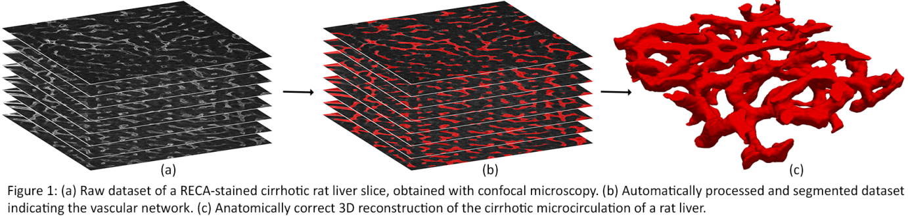

Poster session tissue engineering in vivo

**196**

**EFFECTS OF LIPOSOME-ENCAPSULATED HEMOGLOBIN ON RAT SKELETAL MUSCLE IN SITU CONTRACTILITY WITH OR WITHOUT ISCHEMIA**

Akira Kawaguchi, Tetsuro Tamaki

Tokai University School of Medicine, ISEHARA, Japan

**Background**

Although liposome-encapsulated hemoglobin (LEH, Terumo Co Ltd, Japan) has been reported to be beneficial in ischemia and/or reperfusion injury in various organs, only a salutatory effect was so far reported in the skeletal muscle. We tested the effects of LEH with high oxygen affinity (h-LEH, P50=8.5 mmHg) on in situ fatigue-resistance test of the fast Plantaris and slow Soleus muscles in rat under occlusion of the femoral artery (ischemia) and intact (normal) conditions.

**Methods**

The sciatic nerve, femoral artery, and distal tendons for Plantaris and Soleus muscles are isolated. Both muscle tendons are individually attached to the force-transducers, and the fatigue-resistance test (tetanus train) was simultaneously performed via electrical stimulations of sciatic nerve under isoflurane anesthesia. The test was composed of serial tetanic stimuli, as 80-120Hz, 0.5-s duration at 1.5-s intervals for 1.5 min/session, which were repeated 5 times with 2-min rest in between. The attenuation rate in the tetanus train of each set (Test-1), and the similar ratio of initial and final tensions between sets were compared under ischemia or normal condition with or without intravenous administration of h-LEH (10 ml/kg).

**Results**

While occlusion of the femoral artery (ischemia) significantly reduced overall tension outputs of either muscle, the presence of h-LEH made no protective effect under ischemia, and there was no effect for the Test-1 in both muscles in either condition. However, h-LEH showed a tendency toward prevention of set-by-set decrease in the initial (Figure) and last tension in the Soleus muscle, which appeared to be more prominent under ischemia than in normal condition.

**Summary**

Although there was no significant effect of h-LEH infusion on in situ skeletal muscle fatigue-resistance test, there was a trend toward the prevention of force decrease set-by-set in the slow Soleus muscle, suggesting potentially enhanced effect(s) under in vivo exercising state.

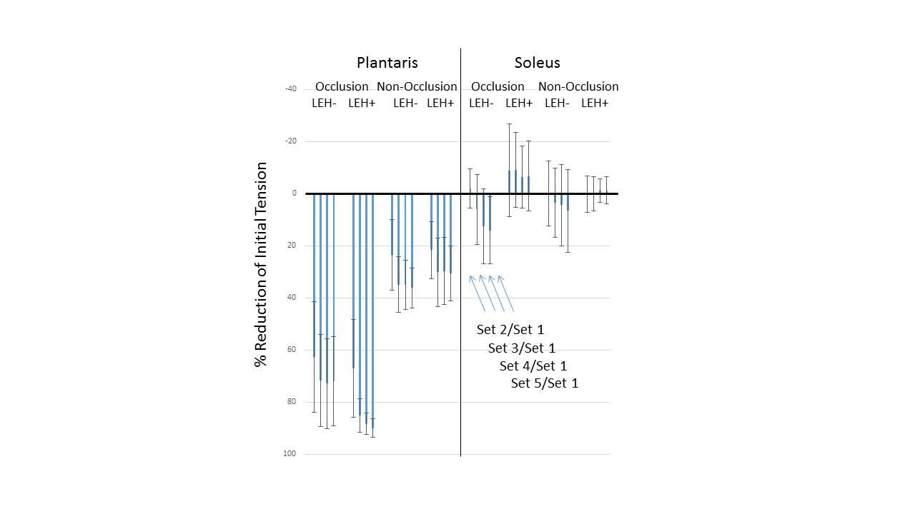Picture 1: Reduction of Initial Tensio Reduction of Initial Tension

Poster session tissue engineering in vivo

**197**

**IMPROVED ISOLATED LIVER PERFUSION SYSTEM WITH AUTONOMOUS CONTROLS: PRELIMINARY RESULTS**

Lucia Gullon, Judith G. Gutierrez, Robert T. Sanchez del Arco, Juan Bañares, Pablo Lozano, Alvaro Morales, JM Asencio, Jose Zamorano, Juan F. Del Cañizo

Hospital Gregorio Marañon, MADRID, Spain

**Aims.-**

Our main objective is to develop a completely autonomous perfusion system that is able to work without human supervision. This is a critical step for further research on organ recovery and recellularization of extracellular matrices.

**Methods.-**

Within the circuit, perfusate enters the hepatic artery and the portal vein. Circulation is driven by low-hemolysis centrifugal pumps providing flow and pressure controls at each vessel.

An oxygenator and a hemofilter permit homeostasis maintenance, which is assessed through a real-time monitor of blood parameters. From this information, pH is regulated automatically by the addition of bicarbonate. The total volume is controlled by means of a level sensor located at the reservoir. Three pulsatile pumps are in charge of these required infusions as well as of the extraction rate. A user-friendly interface allows real-time monitoring and remote control access.

Five normothermic minipig liver perfusions were performed for 10 hours. Perfusate was composed of autologous blood and diverse intravenous solutions. The functionality of the perfusion controls was tested and the organ viability was evaluated by hemodynamics, metabolic and histologic analysis.

**Results.-**

The system showed rapid stabilization of controlled parameters and quick responses to changes during the perfusion.

The livers proved to maintain suitable and stable hemodynamic parameters during 10 hours of normothermic *ex-vivo* perfusions. High flow rates were achieved with low pressure values within the physiological range. Along different perfusions, hepatic enzymes, lactate and glucose showed a gradual decrease. Histological results are still pending.

**Conclusions.-**

The perfusion system provides an adequate normothermic liver support for 10 hours. It allows autonomous and remote control access of hemodynamic and physiological parameters with low blood requirements.

This circuit is meant to work not only for organ preservation, but also for suboptimal grafts recovery and as a biorreactor for organ engineering procedures such as decellularization.

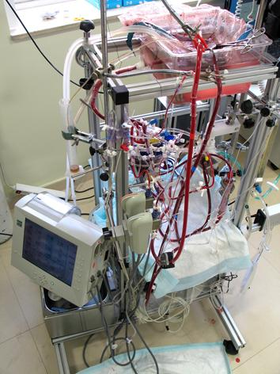Picture 1: Working system during perfusio Working system during perfusion

Poster session tissue engineering in vivo

**198**

**DEVELOPMENT OF SHELF-READY XENOGENEIC VASCULAR GRAFTS; XENOBIOTUBES**

Masashi Yamanami1, Taiji Watanabe1, Hidetake Kawajiri1, Keiichi Kanda1, Yasuhide Nakayama2, Hitoshi Yaku1

1Kyoto Prefectural University of Medicine, KYOTO, Japan

2National Cerebral and Cardiovascular Center Research Institute, SUITA, Japan

**Aim:** We have developed *in vivo* tissue-engineered autologous small-caliber (1.5 - 6 mm) vascular grafts, named 'Biotubes' for the use of CABG or peripheral arterial bypass grafting. However, since it takes at least 4 weeks to prepare biotubes, they can not be applied to emergency operations. In this study, we present the first use of a xenogeneic Biotube vascular graft “XenoBiotube”for the application as a “shelf-ready graft”.**Methods:** Silicone rod molds (diameter: 2mm, length: 20 mm) were placed into subcutaneous pouches of beagle dogs, and after 4 weeks the implants with their surrounded connective tissues were removed. Biotubes with internal diameter of 2 mm were obtained as tubular connective tissues from the implants after pulling out the impregnated molds. After treatment with 0.6% glutaraldehyde solutions, followed by an anti-thrombogenic coating with argatroban, the XenoBiotube was implanted to the abdominal aorta of a Wister rat. After implantation, neither antiplatelet, anticoagulant nor immunosuppressive agents were administered. Graft status was evaluated by the ultrasonic Doppler flow meter and echocardiography.**Results:** After implantation, the rat survived without any signs of abnormal inflammation or immunological problems due to the xenogeneic material. After 3 months, echocardiography revealed no stenosis of the XenoBiotube. Around the implanted graft, no abnormal inflammatory findings or degenerative changes were observed. After 6 months, the ultrasonic Doppler flow meter showed the graft was patent.**Conclusions:** The XenoBiotube functioned as a small diameter vascular graft as well as an autologous Biotube graft. Because of no graft degradation or immunosensitization due to xenogeneic materials, the XenoBiotube graft is safe from an immune perspective. Xenobiotube vascular grafts could be a promising alternative as shelf-ready small caliber arterial grafts.

Poster session tissue engineering in vivo

**199**

**ADIPOSE-DERIVED STEM CELLS SPHEROIDS SIGNIFICANTLY ACCELERATED TISSUE-ENGINEERED VASCULAR GRAFTS REMODELING**

Ryosuke Iwai1, Takeshi Mizuno2, Maya Furukoshi1, Yasushi Nemoto3, Yasuhide Nakayama1

1National Cerebral and Cardiovascular Center Research Institute, OSAKA, Japan

2JASMINE Animal Cardiovascular Center, YOKOHAMA, Japan

3Development Department, Chemical Products Division, Bridgestone Corporation, TOKYO, Japan

**Introduction:** Adipose-derived mesenchymal stem cells (ADSCs) are considered to be a promising cell source for vascular tissue regeneration because of their angiogenic potential. We have proposed a novel cell transplantation method, that is the pasting of ADSCs as spheroids on collagen-based vascular grafts, in which rapid remodeling of vascular grafts within 3-week was obtained in rat short grafting model. In this study, we examined the application potency of ADSCs spheroids for the acceleration of longer graft remodeling using beagle dog artery-vein (A-V) bypass model.

**Methods and Results:** ADSCs spheroids composed of 1.0×106 cells were prepared by one day culturing of beagle ADSCs on our developed cell-self-assembly inducible culture dishes. As a vascular graft model, biotube grafts (d: 4.0 mm, l: 10 cm) were prepared by placing silicone rods into subcutaneous pouches in beagles for 4-week. After femoral A-V bypassing with biotubes, ten drops of ADSCs spheroids were pasted locally (within 2 cm in length) on outer surface at the mid portion of the grafts. After 4-week of implantation, spheroids could not be observed macroscopically. Immunohistochemical analysis revealed that the endothelium formation more than half-length of grafts (ca. 6 cm) was observed when the spheroids were pasted, while it was beginning to occur within 1 cm from both anastomosis sites of grafts without pasting spheroids. In addition, the cells layer stained positive for smooth muscle-maker was formed entire length of spheroids pasted grafts, whereas original collagenous tissue with low cellularity was still remained over half of grafts without pasting spheroids.

**Conclusions:** The significant potential of ADSCs spheroids as the accelerator for vascular grafts remodeling was confirmed in beagle A-V bypass model. Our findings could promise to obtain high patency of vascular grafts even in longer and smaller caliber ones by only multiple regional pasting of ADSCs spheroids.

Poster session tissue engineering in vivo

**200**

**DEVELOPMENT OF A MINIMALLY INVASIVE EXTRACTION DEVICE FOR THE SUBCUTANEOUSLY PREPARED 'BIOTUBE' VASCULAR GRAFTS**

Tomonori Oie, Maya Furukoshi, yasuhide Nakayama

National cerabre and cardiovascular research cnter, SUITA, Japan

**Aim**

The autologous biotube, using in-body tissue architecture technology, is one of the most promising tissue-engineered, small-diameter vascular grafts. There is still an issue to solve, in which skin incision length in the traditional method needed longer than that of the formed biotube for its extraction without damage. The aim of this study is to develop a minimally invasive device for extraction of the formed biotube.

**Methods and Results**

A novel mold was assembled by silicone tube (outer diameter, 5 mm; length, 50 mm) with stainless cylindrical shell with an array of slits for the opening of cell migration, and a clearance for tissue formation is kept constant at a distance of 0.5 mm. The extraction device was consisting of a pullout tool and a round blade cutting tool (inner diameter was optimized for the cylindrical shell). The molds were placed into the respective dorsal subcutaneous pouches of beagle dogs from short incisions (length, approximately 1 cm). After 6 weeks of embedding, the molds could be harvested using the device from the short incision, which was less than one sixth of traditional method. The pullout tool was easily connected with the mold and guided the cutting tool, and the surrounding fragile tissue around the cylindrical shell was smoothly dissected by inserting the cutting edge of the round blade to the shell, subcutaneously. There was no accidental intraoperative bleed and subcutaneous postoperative bleed. A series of the operation was completed within several minutes without damage. The obtained biotube was formed in the gap of the internal silicone tube and the cylindrical shell, and its wall was thick and robust.

**Conclusion**

The developed minimally invasive extraction device needed the short length incision in short operation time without damage. This study will accelerate the study of in-body tissue architecture technology for clinical practice.

Poster session tissue engineering in vivo

**201**

**A COMPARISON OF INSULIN DOSE CALCULATED BY PATIENT WITH DIABETES BY THE VOICEDIAB SYSTEM**

Piotr Foltynski1, Ewa Pankowska2, Karolina Mazurczak2, Milena Gabka2, Piotr Ladyzynski1

1Nalecz Institute of Biocybernetics and Biomedical Engineering, WARSAW, Poland

2Department of Pediatrics, The Institute of Mother and Child, WARSAW, Poland

**Aim**. Patients with diabetes need to calculate amount of insulin to compensate food intake. They estimate the amount of food and using nutrition tables calculate the amount of carbohydrates in the meal and then the amount of insulin. There are insulin bolus calculators which facilitate such a task, but their use may be troublesome and time consuming. Therefore we developed the VoiceDiab system (VDS) enabling insulin dose calculation based on voice description of meal. In this study we compare the insulin dose calculated by a patient with and without the support of the VDS to the reference dose calculated by a diabetic nurse.

**Methods**. Twenty six patients (11 adults and 15 children) aged 16.8 (10 to 36) years analyzed 96 meals and calculated insulin doses. Patients used also the VDS based on the Android smartphone application which was managing data transfer to the remote servers for voice recognition, text analysis and insulin dose calculation. Differences between the doses estimated by patient manually or with the support of the VDS and the reference dose were analyzed.

**Results**. The mean difference between the insulin dose estimated by the patient manually and with support of the VDS in relation to the reference doses were -0.18 (SD=1.11) IU (Insulin Unit) and -0.12 (SD=0.87) IU, respectively. There was no significant difference between these two means and they were not significantly different from zero. The analysis of homogeneity of variances revealed no significant difference between the SDs for both ways of insulin estimation.

**Conclusion**. Patients were able to estimate correctly (on average) insulin doses using the VDS or using their own knowledge. The VDS did not bring in additional errors in insulin dose calculation, as the SD of doses calculated with the VDS support was not larger than in the case of patients’ manual calculations.

Poster session tissue engineering in vivo

**202**

**QUALITY CONTROL OF IN VIVO TISSUE-ENGINEERED VASCULAR GRAFTS 'BIOTUBES' BY USING OPTICAL COHERENCE TOMOGRAPHY**

Takeshi Moriwaki1, Maya Furukoshi1, Ryosuke Iwai1, Mari Kobayashi2, Hiroto Kawata2, Yasushi Hirai2, Kiminori Mizuuti2, Yasuhide Nakayama1

1National Cerebral and Cardiovascular Center Research Institute, OSAKA, Japan

2Panasonic Healthcare Co., Ltd., TOKYO, Japan

Aim: Vascular grafts prepared by tissue engineering or cell processing require quality control in non-invasive measurement methods. Optical coherence tomography (OCT) is an established medical imaging technique used to visualize 3-dimensional structures of biological tissues. We previously developed in vivo tissue-engineered autologous tubular tissues (called Biotubes) using 'in-body tissue architecture technology,' which is a simple and safe approach based on tissue encapsulation of foreign materials in living bodies. In this study, OCT observation of Biotubes was performed to evaluate its usefulness as a quality control method.

Methods: Silicone rod molds (diameter 5 mm, n = 6) were embedded into dorsal subcutaneous pouches of beagles. After 1 month, the molds, which were covered with connective tissue, were harvested as Biotubes. Using OCT, the 3-dimentional structure of Biotubes was observed. In addition, OCT observations were performed to analyze the Biotube rupture process by internal pressure loading.

Results: The Biotubes consisted of parenchymal connective tissue and surrounding fragile connective tissue. Based on OCT observations, both tissue types were clearly segregated with respect to brightness. After OCT scanning of the Biotubes, the 3-dimentional structures (400 × 400 × 250 pixels) were visualized within 10 seconds. Biotube thickness ranged from 0.07 to 0.15 mm. None of the Biotubes exhibited deficiencies including pores or tears in the wall. On the other hand, internal pressure loading (e.g., 1,125 mmHg) caused small cracks in the Biotube walls. Bursting occurred for a larger increase in pressure (e.g., 2,530 mmHg) than that needed to generate cracks.

Conclusion: OCT measurements are useful for the observation of graft structures, detection of internal defects, and understanding of graft failure. OCT is expected to be a powerful method for the quality control of artificial tissues.

Poster session tissue engineering in vivo

**203**

**DE NOVO LIVER TISSUE FORMATION BY IMPLANTATION OF CELL ENGINEERING CONSTRUCTION FOR THE TREATMENT OF CHRONIC LF**

Murat Shagidulin1, Nina Onishenko1, Mikhail Krasheninnikov1, Ludmila Davydova2, Vladimir Bogush2, Igor Agapov1, Sergey Gautier3

1Shumakov Federal Research Center for Transplantology and Artificial Organs, MOSCOW, Russian Federation

2The State Research Institute for Genetics and Selection of Industrial Microorgan, MOSCOW, Russian Federation

3I.M.Setchenov Moscow state Medical University, MOSCOW, Russian Federation

**Aim:** Development of new functionally active liver tissue for the treatment of chronic liver failure is an actual problem of tissue engineering and regenerative medicine.

**Methods:** Chronic liver failure (LF) was modeled on Wistar rats by means of ССl4. Wistar rats were used as cell donors. Isolated liver cells (LC) and multipotent mesenchymal stromal cells (MMSC) were obtained by standard procedure. LC (2,5-4,0х106cells/cm3) and MMSC (0,5-0,8х106cells/cm3) were immobilized on the recombinant spidroin based microgel. Formed cell engineering construction (CEC) was imlanted into damaged rat liver. The animals were divided into 2 groups: control group (1st gr, without treatment) and experimental group (2nd gr, with implanted CEC). Dynamics reduction of LF; liver and CEC morphologywere examined 90 days after implantation.

**Results:** LF in control gr.was characterized by ALT, AST and ALP increase Morphology was characterized by fatty, lymphoid-cellular infiltration, a proliferation histioblasts and macrophages, porto-portal sclerosis, hydropic dystrophia, focal necrosis of hepatocytes and cirrhosis formation. In the 2nd gr all biochemical indices have returned to normal levels by day 30-60. In the expeerimental group, the degree of liver damage (dystrophia, safe structure of a liver, beam structure, futty vacuoles at alias) was significantly reduced comparing to the control group. Restoration of a hepatic lobe structure also was better in the experimental group.

**Conclusion:** Our preliminary studies demonstrate formation of *de novo* architecture in CEC compatible with the liver architecture (viable cell, vessels, bile ducts) after implantation in a damaged liver. This technique allows organotypical remodeling of the CEC and stimulation of reparative process in damaged liver. Thereby we consider that this technique is prospective and can be used as a technology for building of intracorporeal CEC for the long-term auxiliary support of the damaged liver.